“Secure and Scalable Healthcare Appointment Scheduling Through Distributed Backend Development”
A Project Report Submitted in the partial fulfillment of the requirements for the award of the degree of

BACHELOR OF TECHNOLOGY
In

DEPARTMENT OF COMPUTER SCIENCE ENGINNERING
&
DEPARTMENT OF COMPUTER SCIENCE AND INFORMATION TECHNOLOGY
By

MONISHA RAGHINI CHELLE 2520030537
BHUPATHIRAJU DEVI CHARITHA 2520030462
PRASHANTHI DABBUGUNTA 2520030301

Under the Esteemed Guidance of

Dr Yerragudipadu Subbarayudu Assistant Professor
Department of Computer Science and Engineering




K L (Deemed to be) University DEPARTMENT OF COMPUTER SCIENCE ENGINEERING
&

DEPARTMENT OF COMPUTER SCIENCE AND INFORMATION TECHNOL

Declaration

The Project Report entitled “Secure and Scalable Healthcare Appointment Scheduling Through Distributed Backend Development” is a record of Bonafide work of MONISHA RAGHINI CHELLE -2520030537, BHUPATHIRAJU DEVI CHARITHA-2520030462 ,PRASHANTHI DABBUGUNTA - 2520030301 submitted in partial fulfillment for the award of B. Tech in Computer Science and Engineering (or) Computer Science and Information Technology to the K L University. The results embodied in this report have not been copied from any other departments/University/Institute.

MONISHA RAGHINI CHELLE – 2520030537

BHUPATHIRAJU DEVI CHARITHA -2520030462

PRASHANTHI DABBUGUNTA - 2520030301

K L (Deemed to be) University

DEPARTMENT OF COMPUTER SCIENCE ENGINEERING

&

DEPARTMENT OF COMPUTER SCIENCE AND INFORMATION TECHNOLOGY

CERTIFICATE

This is certify that the mini project-based report entitled“Secure and Scalable Healthcare Appointment Scheduling Through Distributed Backend Development” is a bonafide work done and submitted by MONISHA RAGHINI CHELLE -2520030537, BHUPATHIRAJU DEVI CHARITHA-2520030462, PRASHANTHI DABBUGUNTA - 2520030301
in partial fulfillment of the requirements for the award of the degree of BACHELOR OF TECHNOLOGY in Department of Computer Science Engineering, K L (Deemed to be University), during the academic year 2024-2025.

Signature of the Guide

Signature of the Course Coordinator Signature of the HOD
ACKNOWLEDGEMENT
The success in this project would not have been possible but for the timely help and guidance rendered by many people. Our wish to express my sincere thanks to all those who has assisted us in one way or the other for the completion of my project.

Our greatest appreciation to my Course Coordinator Dr Yerragudipadu Subbarayudu, and my guide Dr Yerragudipadu Subbarayudu, Department of Computer Science which cannot be expressed in words for his/her tremendous support, encouragement and guidance for this project.

We express our gratitude to Dr. P Venkateshwara Roa (CSE)/Dr. Kaja Shareef (CSIT), Head of the Department for Computer Science Engineering/ Department for Computer Science and Information Technology for providing us with adequate facilities, ways and means by which we are able to complete this project-based Lab.

We thank all the members of teaching and non-teaching staff members, and also who have assisted me directly or indirectly for successful completion of this project. Finally, I sincerely thank my parents, friends and classmates for their kind help and cooperation during my work.

MONISHA RAGHINI CHELLE – 2520030537

BHUPATHIRAJU DEVI CHARITHA -2520030462

PRASHANTHI DABBUGUNTA - 2520030301

Abstract

Secure and Scalable Healthcare Appointment Scheduling Through Distributed Backend Development is a web-based application designed to simplify the process of booking and managing medical appointments. The system provides a centralized platform through which patients can access doctor information, check appointment availability, and manage their appointments online.
The application allows patients to register, log in securely, view doctors and their specializations, check available appointment slots, and book, reschedule, or cancel appointments. Patients can also view their appointment history and receive appointment-related notifications. Administrators can manage patient records, doctor profiles, doctor availability, appointment statuses, and other administrative operations through a dedicated dashboard. The system also includes a demonstration payment workflow with payment history and receipt information.
The frontend is developed using React.js, HTML, CSS, and JavaScript, with Vite as the development tool. The backend is implemented using Python and FastAPI to provide REST APIs, while MySQL is used for relational database management. JWT-based authentication and role-based authorization control access to protected functionalities.
The application follows a layered architecture that separates the frontend, backend, and database components. This modular design supports maintainability and future expansion. By integrating appointment scheduling, doctor availability, notifications, authentication, and administrative management, the project aims to reduce manual work, minimize scheduling conflicts, and improve the organization of healthcare appointments.

Index

S.  No. | Chapters | Topics | Page.no
 |  | Acknowledgement
 |  | Abstract
1 | Introduction | - Background of the project  - Problem statement  - Scope of the project  - Objective(s)  - Importance of the application  - Target users/audience
2 | System Requirements | - Hardware requirements  - Software requirements  - Development tools and frameworks
3 | Technology Stack | - Front-end-HTML, CSS, JavaScript  - Back-end -Python, FastAPI  - Database -MySQL  - Authentication- JWT  - Rest API  - Version Control -Git, GitHub  - API Testing – Postman  - Integrated Technology Stack  - Summary
4 | System Architecture | - High-level System architecture  - Frontend Layer  - FastAPI Backend Layer  - MySQL Database Layer  - Authentication and Authorization  - Notification Module  - System Workflow
5 | Design | 5.1 Use Case Diagram  5.2 ER Diagram  5.3 Database schema  5.4 Data Flow Diagram  5.5 Module Design
6 | Implementation | - Module-wise implementation  - Frontend Implementation  - FastAPI REST API Implementation  - MySQL Database Integration  - Authentication Implementation  - Notification Implementation
7 | Features/Modules | - Authentication Module  - Patient Module  - Doctor Module  - Appointment Module  - Notification Module  - Admin Module
8 | Testing | - API Testing using Postman  - Database Testing  - Integration testing  - Authentication Testing  - Test cases and results
9 | Deployment | - Project Setup and Installation  - Environment configuration  - Running the Frontend, Backend and Database
10 | Challenges & Limitations | - Challenges faced during development  - Solutions applied  - Current limitations or known bugs
11 | Future Enhancements | - Advanced Notification Features  - Reports and Analytics  - Cloud Deployment  - MongoDB Integration if Required
12 | Conclusion | - Summary of the project  - Major Feacture Implemented  - DBMS Concepts Applied  - Backend and API Concepts Applied  - Overall Outcome  - Skills Applied
13 | References | 13.1Books,  13.2 Tutorials  13.3 FastAPI Documentation  13.4MySQL Documentation  13.5 Postman Documentation  13.6 Other resources used
14 | Appendices | Appendix A:Screenshots of the application  Appendix B:Sample SQL Queries  Appendix C: API Testing Screenshots  Appendix D: Installation/setup instructions  Appendix E: User manual or guide  Appendix F: Geo Tag photos with guide

CHAPTER -1 INTRODUCTION

1.1Background of the Project
Healthcare is an essential part of everyday life, and timely access to doctors and medical services is important for effective healthcare delivery. With the increasing use of digital technologies, healthcare services are gradually moving from traditional manual processes toward online platforms. Appointment scheduling is one of the areas where digitalization can significantly improve convenience for both patients and healthcare providers.
Traditionally, patients often need to contact hospitals or clinics through phone calls, direct visits, reception desks, or manual registration systems to schedule appointments. These methods can be time-consuming and may result in long waiting times, scheduling conflicts, difficulty in tracking appointments, and additional administrative work. Patients may also have limited information about doctor availability and specialization before making an appointment.
The proposed project, “Secure and Scalable Healthcare Appointment Scheduling Through Distributed Backend Development,” is designed to address these challenges by providing a centralized web-based appointment scheduling platform. The system allows patients to register, securely log in, view available doctors and their specializations, check appointment slots, and manage their appointments online.
The system also provides administrative functionality for managing patient information, doctor information, appointments, and notifications. Appointment status management and notification features are included to support communication between patients, doctors, and healthcare services.
From a technical perspective, the application follows a layered architecture that separates the frontend, backend and database components. The main frontend is developed using React.js, HTML, CSS and JavaScript, with Vite as the development tool. Python and FastAPI are used to develop the backend REST APIs, while MySQL stores patient, doctor, appointment and other application data. JWT-based authentication and role-based authorization help protect access to patient and administrative functionality.
The project combines several important areas of computer science, including:
- Web application development
- REST API development
- Database management
- Authentication and authorization
- Distributed backend development
- Software engineering and modular design
- User interface and user experience design
The overall purpose of the project is to create a reliable, secure, and scalable digital solution that reduces manual appointment management and makes healthcare scheduling more convenient.

1.2 Problem Statement
Traditional healthcare appointment scheduling often depends on phone calls, physical visits, reception desks, or manually maintained records. These processes can create several difficulties for patients and healthcare administrators.
Patients may not have easy access to information about available doctors, their specializations, or available appointment slots. They may need to repeatedly contact the hospital or clinic to confirm availability. Manual scheduling can also result in duplicate bookings, scheduling conflicts, missed appointments, and difficulties in maintaining accurate records.
The system must provide patients with accurate doctor information and available appointment slots while enabling authorized administrators to maintain doctor profiles, availability and appointment records. It should also support secure authentication, appointment updates, cancellations and appointment-related notifications.
From the administrative perspective, managing patient information, doctor availability, appointment schedules, and notifications manually requires significant effort. Maintaining separate records can also make it difficult to retrieve updated information quickly.
Another major problem is the lack of centralized appointment management. When information is stored across different systems or maintained manually, communication between patients, doctors, and administrators becomes less efficient.
Security is also an important concern because healthcare applications handle personal information. Unauthorized access to patient records and appointment information must be prevented through appropriate authentication and authorization mechanisms.
Therefore, there is a need for a centralized healthcare appointment scheduling system that can:
- Reduce dependency on manual appointment booking.
- Allow patients to view doctors and their specializations.
- Display available appointment slots.
- Allow patients to book, update, and cancel appointments.
- Help administrators manage healthcare-related information.
- Provide appointment status and notification features.
- Protect user information through secure authentication.
- Provide a scalable backend capable of handling multiple requests.
The proposed system addresses these requirements through a secure web-based platform using REST APIs, FastAPI, MySQL, and JWT authentication.

1.3 Scope of the Project
The scope of the project covers the development of a web-based healthcare appointment scheduling application that connects patients, doctors, and administrators through a centralized platform.
The primary scope includes patient registration and authentication. Patients can create accounts, log in securely, and manage their personal information.
The system also covers doctor management, where doctor information, specializations, and availability can be maintained. Patients can use this information to identify suitable doctors and available appointment slots.
The appointment management functionality allows patients to book appointments according to available slots. Patients can also view their appointments and update or cancel them when required.
The system includes a notification module that can provide appointment-related notifications, reminders, and status updates. This helps improve communication between the healthcare service and patients.
An administrator module is included for managing patient, doctor, appointment, and notification-related information. This provides centralized control over important system operations.
1.3.1 Patient Management
The patient management component allows patients to create accounts and access the system securely.
The patient-related functionality includes:
- Patient registration
- Patient login
- Secure authentication
- Viewing doctor information
- Viewing doctor specializations
- Checking appointment availability
- Booking appointments
- Viewing appointments
- Updating appointments
- Cancelling appointments
- Receiving appointment-related notifications
1.3.2 Doctor Management
The Doctor Management Module allows authorized administrators to create and update doctor profiles, maintain specialization information and configure available appointment slots. Patients can view doctor details and check availability before booking appointments. The current implementation does not include a separate doctor login or doctor dashboard.
The doctor-related functionality includes:
- Managing doctor information
- Maintaining specialization details
- Managing doctor availability
- Viewing appointment-related information according to authorized access
This functionality allows patients to identify doctors and available appointment slots before making an appointment.

1.3.3 Appointment Management
Appointment management is one of the primary functions of the application.
The system allows patients to select an available doctor and appointment slot and create an appointment. Appointment information is maintained in the database and can be retrieved when required.
The appointment management functionality includes:
- Appointment booking
- Viewing appointments
- Appointment status management
- Appointment updating
- Appointment cancellation
- Maintaining appointment information
- Generating appointment-related notifications
1.3.4 Notification Management
The notification module supports communication related to appointments.
Notifications may be associated with events such as:
- Appointment confirmation
- Appointment updates
- Appointment cancellation
- Appointment reminders
- Appointment status changes
This functionality helps users remain informed about important appointment-related activities.
1.3.5 Administrator Management
The Administrator Module provides a centralized interface for managing patients, doctors, doctor availability, appointments, holidays and payment records. Administrative operations are protected using authentication and role-based authorization.
Administrators can manage relevant information related to:
- Patients
- Doctors
- Appointments
- Notifications
- Other system-related records
Administrative functionality is protected through authentication and authorization mechanisms.
1.3.6 Technical Scope
The technical scope of the project includes:
- Frontend development using HTML, CSS, and JavaScript
- Backend development using Python and FastAPI
- REST API development
- MySQL database integration
- JWT-based authentication
- Role-based access control
- Appointment management
- Notification management
- API testing using Postman
- Version control using Git and GitHub
The application follows a modular architecture that separates the frontend, backend, authentication, and database components. This organization supports easier development, testing, maintenance, and future extension.
1.3.7 Limitations of the Current Scope
The current application includes a demonstration payment workflow, payment history and receipt information. However, it does not integrate a live payment gateway or process verified real-money transactions. Video consultations, electronic medical records and external hospital-system integration are outside the current scope.
Advanced healthcare features such as online payment processing, video consultation, electronic medical records, AI-based diagnosis, and integration with external hospital systems are outside the current scope unless they are specifically implemented as part of the project.
The system is therefore focused on providing the core functionality required for appointment scheduling and related management activities.

1.4 Objectives of the Project
The main objective of the project is to develop a secure, scalable, and user-friendly healthcare appointment scheduling system that simplifies the process of booking and managing medical appointments.
Frontend Development: To develop an interactive and responsive frontend using React.js, HTML, CSS and JavaScript, with Vite as the development tool.
Backend Development: To implement REST APIs using Python and FastAPI for authentication, doctor information, appointment scheduling and administrative operations.
Database Management: To use MySQL for storing and managing application records.
Security: To implement JWT-based authentication and role-based authorization for protected operations.
Appointment Management: To allow patients to book, view, reschedule and cancel appointments.
Payment Demonstration: To implement a simulated payment workflow with payment history and receipt information.

The specific objectives of the project are:
- To develop a centralized healthcare appointment platform for managing patients, doctors, and appointments.
- To provide secure patient registration and login using JWT-based authentication.
- To allow patients to view doctors and their specializations before booking appointments.
- To provide appointment slot availability so that patients can select suitable appointment times.
- To enable online appointment booking, updating, and cancellation.
- To provide appointment status management for better tracking of scheduled appointments.
- To implement notification functionality for appointment confirmations, updates, cancellations, reminders, and status changes.
- To provide administrative functionality for managing patients, doctors, appointments, and notifications.
- To use MySQL for structured and reliable data management.
- To develop REST APIs using FastAPI for communication between the frontend and backend.
- To reduce manual administrative work associated with appointment scheduling.
- To minimize scheduling conflicts by providing centralized appointment and availability management.
- To provide secure access to system functionality based on user roles.
- To provide a modular architecture in which the frontend, backend, authentication, and database components are logically separated.
- To support future scalability and enhancement of the healthcare appointment scheduling system.
These objectives are consistent with the documented project functionality, including patient management, doctor availability, appointment booking, notifications, administration, MySQL, FastAPI, REST APIs, and JWT authentication.

1.5 Importance of the Application
The proposed healthcare appointment scheduling application is important because it provides a centralized digital platform for managing appointments and related healthcare scheduling information.
Traditional appointment management can require patients to make phone calls or visit healthcare facilities simply to check availability or schedule an appointment. A web-based system provides a more organized way of accessing doctor information and managing appointments.
The application provides patients with a centralized interface for finding doctors, checking availability and managing appointments. It also provides administrators with tools for maintaining doctor information, availability and appointment records. Its layered architecture separates the React frontend, FastAPI backend and MySQL database, supporting maintainability and future development.

1.5.1 Importance for Patients
For patients, the system provides convenient access to healthcare appointment information.
Patients can:
- View available doctors
- View doctor specializations
- Check appointment availability
- Book appointments
- View scheduled appointments
- Update appointments
- Cancel appointments
- Receive appointment-related notifications
This reduces the need for repeated communication with healthcare staff for routine appointment management.
1.5.2 Importance for Doctors
For doctors and healthcare providers, the system provides an organized method of managing information related to their specialization, availability, and scheduled appointments.
Maintaining structured appointment information can help doctors and healthcare providers access relevant scheduling information through the system according to their authorized roles.

1.5.3 Importance for Administrators
For administrators, the system provides centralized management of important healthcare scheduling information.
Administrators can manage:
- Patient information
- Doctor information
- Appointment information
- Notification-related information
This can reduce the dependence on separate manual records and make appointment-related information easier to manage.
1.5.4 Security Importance
Security is an important part of the application because the system handles user and appointment-related information.
The implementation of JWT-based authentication and authorization provides a mechanism for identifying authenticated users and controlling access to protected functionality.
Role-based access helps ensure that patients, doctors, and administrators access functionality appropriate to their respective roles.
1.5.5 Technical Importance
The project is also important from a technical and academic perspective because it demonstrates the practical implementation of several computer science concepts.
These concepts include:
- Web application development
- Frontend development
- Backend development
- REST API development
- Database management
- Authentication
- Authorization
- Role-based access
- API testing
- Version control
- Modular software architecture
The project therefore provides practical experience in developing a multi-layer web application using commonly used software development technologies.

1.5.6 Maintainability and Scalability
The separation of frontend, backend, authentication, and database components provides an organized architecture.
The frontend is responsible for user interaction, the FastAPI backend processes application requests, JWT provides authentication and authorization, and MySQL provides structured data storage.
This separation makes the application easier to maintain because changes to one component can be managed independently of other components where appropriate.
The modular architecture also provides a foundation for adding additional features in the future without completely redesigning the existing application.
1.5.7 Overall Importance
Overall, the application is intended to:
- Reduce manual appointment management
- Improve appointment accessibility
- Provide centralized appointment information
- Help users track appointments
- Improve appointment-related communication
- Provide controlled access to system functionality
- Support organized management of patients and doctors
- Provide a structured backend architecture
- Provide a foundation for future enhancements
The documented project specifically identifies improved accessibility, reduced manual work, appointment tracking, notifications, secure access, and future scalability as important aspects of the application.

1.6 Target Users / Audience
The healthcare appointment scheduling system is designed primarily for patients, doctors or healthcare providers, and administrators. Each category of user has different responsibilities and access requirements within the application.
The system uses authentication and role-based access so that users can access functionality appropriate to their roles.

1.6.1 Patients
Patients are the primary users of the healthcare appointment scheduling system.
The main purpose of the system for patients is to provide a convenient method of finding doctors, checking availability, and managing appointments.
Patients can:
- Register for an account
- Log in securely
- View doctor information
- View doctor specializations
- Check available appointment slots
- Book appointments
- View scheduled appointments
- Update appointments
- Cancel appointments
- View appointment status
- Receive appointment-related notifications
The patient can access their own appointment-related information through the authenticated system.

1.6.2 Doctors / Healthcare Providers
Doctors and healthcare providers are another important category of users.
The system allows doctors to maintain relevant professional information and availability.
Doctors and healthcare providers are represented in the application through their professional profiles, specializations and available appointment slots. Patients use this information to identify doctors and schedule appointments. In the current implementation, authorized administrators maintain doctor information and availability. A separate doctor account or doctor-facing dashboard is not provided.
Doctor-related activities can include:
- Managing doctor profile information
- Maintaining specialization information
- Managing availability
- Viewing scheduled appointment information
- Managing appointment-related information according to authorized permissions
Doctor information is important because patients use the available doctor details and specialization information when selecting a suitable appointment.

1.6.3 Administrators
Administrators are responsible for managing important system information and administrative operations.
The administrator can manage relevant information related to:
- Patients
- Doctors
- Appointments
- Notifications
- Other system-related operations
Administrative functions are protected through authentication and authorization so that only authorized users can perform administrative operations.

1.6.4 Healthcare Organizations
Healthcare organizations such as clinics or hospitals can be considered potential organizational users of the system.
The system provides a centralized structure for managing appointment-related information and can support the organization of:
- Doctor information
- Patient information
- Appointment schedules
- Appointment status
- Notifications
- Administrative activities
The application can therefore provide a foundation for digital appointment management within a healthcare organization, depending on the deployment and configuration of the system.
The documented project identifies patients, doctors or healthcare providers, administrators, and healthcare organizations as the intended target audience.

1.7 Chapter Summary
This chapter introduced the Secure and Scalable Healthcare Appointment Scheduling Through Distributed Backend Development project and explained the need for an online healthcare appointment scheduling platform. It discussed the limitations of manual appointment management, including scheduling conflicts, limited visibility of doctor availability and difficulties in maintaining appointment records.
The scope and objectives of the application cover patient registration and authentication, doctor discovery, appointment booking and management, notifications, administrator-managed doctor information and availability, and a demonstration payment workflow. The application uses React.js, HTML, CSS and JavaScript with Vite for the frontend, Python and FastAPI for backend REST APIs, MySQL for database management, and JWT for authentication and authorization.
The chapter also described the application's importance and identified patients and administrators as its implemented user roles, with doctors and healthcare organizations represented through the services and information managed by the system.

CHAPTER -2 SYSTEM REQUIREMENTS

2.1 Hardware Requirements
Hardware requirements define the physical resources required to develop, test, and operate the Secure and Scalable Healthcare Appointment Scheduling Through Distributed Backend Development application.
Since the proposed system is a web-based application, it does not require specialized hardware. A standard computer with sufficient processing power, memory, storage, and network connectivity is adequate for development and testing.
The development environment may need to run several applications simultaneously, including Visual Studio Code, Python, FastAPI, MySQL, a web browser, and Postman. Therefore, a moderately powerful computer is recommended for smooth development and testing.

2.1.1 Development Computer
The development computer is used by the project team to write source code, run the FastAPI backend, manage the MySQL database, test APIs, and access the frontend.
The following configuration provides a suitable development environment:
Hardware Component | Minimum Requirement | Recommended Requirement
Processor | Intel Core i3 / Equivalent | Intel Core i5 or higher
RAM | 8 GB | 16 GB
Storage | 256 GB | 512 GB SSD
Display | 1366 × 768 | 1920 × 1080
Network | Stable Internet | High-speed Internet
Keyboard | Standard keyboard | Standard keyboard
Mouse | Standard mouse | Standard mouse
A multi-core processor is useful because several development processes may run simultaneously. For example, the FastAPI server, MySQL database, Postman, web browser, and code editor may all be active during development.
At least 8 GB of RAM is suitable for basic development, while 16 GB of RAM provides better performance when multiple applications are running simultaneously. SSD storage is preferred because it provides faster file access and improves application startup and database operations.
2.1.2 Storage Requirements
Storage is required for maintaining the different components and resources associated with the project.

The storage requirements include:
- Project source code
- Python packages and dependencies
- MySQL database files
- API testing data
- Application documentation
- Application screenshots
- Git repositories
- Backup files
A minimum of 256 GB of storage is sufficient for basic development, while 512 GB SSD storage is recommended for smoother operation and future project expansion.
The source code can also be maintained using Git and GitHub, which helps preserve development history and reduce the risk of losing important project files.
2.1.3 Internet Connectivity
A stable Internet connection is required during development and testing.
Internet connectivity may be required for:
- Installing Python packages and dependencies
- Accessing technical documentation
- Synchronizing code with GitHub
- API testing
- Downloading development tools
- Sharing project resources
- Future cloud deployment
A reliable Internet connection is also useful if the application is later extended to communicate with external healthcare services or cloud-based services.
2.1.4 Client Hardware Requirements
Patients, doctors, and administrators do not require high-end hardware because the application is accessed through a web browser.
The system can be accessed using:
- Desktop computers
- Laptops
- Tablets
- Smartphones
A basic client device with approximately 4 GB RAM, a modern web browser, and a stable Internet connection should be sufficient for normal usage.
Since the application is web-based, most application processing is handled by the backend server rather than requiring high processing capability on the user's device.

2.1.5 Server Hardware Requirements
During development, the FastAPI backend and MySQL database can run on the development computer. For larger-scale deployment, the backend and database can be hosted on a dedicated server or cloud infrastructure.
A basic server configuration may include:
- Multi-core processor
- 8–16 GB RAM
- SSD storage
- Stable network connection
- Appropriate operating system
- Database storage and backup facilities
As the number of patients, doctors, and appointments increases, server resources can be upgraded according to the requirements of the deployed application.

2.2 Software Requirements
Software requirements define the software environment required to develop, test, run, and maintain the healthcare appointment scheduling application.
The proposed system uses a combination of frontend technologies, backend frameworks, database software, authentication mechanisms, API testing tools, version-control tools, and web browsers.

2.2.1 Operating System
The application can be developed and tested using commonly available operating systems such as:
- Windows 10
- Windows 11
- Ubuntu Linux
- macOS
Windows provides convenient access to Visual Studio Code, Python, MySQL, web browsers, and Postman. Linux can also be used, particularly for backend and server deployment environments.
The operating system should support the installation and execution of the project's development tools and dependencies.

2.2.2 Frontend Software
The frontend of the healthcare appointment scheduling system is developed using:

The main frontend of the healthcare appointment scheduling system is developed using React.js, HTML, CSS and JavaScript. Vite is used as the frontend development and build tool. Node.js and npm are required to install frontend dependencies and run the development server.
React.js is used to develop reusable components and interactive interfaces for patient registration, login, doctor discovery, appointment booking, appointment management, notifications and administrative operations.
HTML defines the structure of the application's pages and components, CSS controls their appearance and layout, and JavaScript handles interactive functionality and communication with the FastAPI backend through REST APIs.

React.js and Vite
React.js is a JavaScript library used to build component-based user interfaces. It allows the application to organize its frontend into reusable components and update the displayed information when application data changes.
Vite provides the frontend development environment and build tooling. Node.js and npm are used to install the required dependencies and execute the project's frontend development commands.

HTML, CSS, and JavaScript
HTML
HTML is used to define the structure of the web application.
It can be used to create:
- Login forms
- Registration forms
- Navigation menus
- Doctor information sections
- Appointment forms
- Appointment tables
- Patient dashboards
- Administrative interfaces
- Notification sections
CSS
CSS is used to control the visual presentation and layout of the application.
It provides styling for:
- Buttons
- Forms
- Tables
- Navigation elements
- Doctor information cards
- Appointment sections
- Spacing and alignment
- Responsive layouts
JavaScript
JavaScript provides dynamic functionality for the frontend.
It can be used to:
- Validate user inputs
- Send requests to the FastAPI backend
- Receive API responses
- Display doctor information
- Retrieve appointment availability
- Submit appointment requests
- Update appointment information
- Cancel appointments
- Display notifications dynamically
- Handle authentication-related information
The frontend communicates with the FastAPI backend through REST APIs.

2.2.3 Backend Software
The backend is developed using:
Python and FastAPI
Python provides the programming environment for implementing the business logic of the application.
FastAPI is used to develop RESTful APIs that handle communication between the frontend and the database.
The backend is responsible for functions such as:
- User registration
- User login
- Authentication
- Authorization
- Patient management
- Doctor management
- Doctor availability
- Appointment management
- Appointment status management
- Notification management
- Administrative operations
The backend acts as an intermediary between the frontend and the MySQL database.

2.2.4 Database Software
MySQL is used as the relational database management system for the project.
The database stores important information required by the application, including:
- Patient details
- Doctor details
- Doctor specialization
- Appointment details
- Appointment date and time
- Appointment status
- Notification information
- User authentication information
MySQL provides structured data storage and supports relationships between different entities.
For example, an appointment can be associated with a particular patient and doctor. This relationship allows the system to identify which patient has booked an appointment with which doctor.

2.2.5 Authentication Software
The system uses JSON Web Token (JWT) for authentication.
JWT provides a mechanism for verifying whether a user has successfully logged in before allowing access to protected resources.
The authentication process can be represented as:
User Login → Credential Verification → JWT Generation → Token Sent to Client → Protected API Access
After successful login, the backend generates a JWT token. The token can then be used when accessing protected API endpoints.
Authentication is particularly important because different users have different levels of access within the application.

2.2.6 Web Browser
A modern web browser is required to access and test the web application.
Supported browsers can include:
- Google Chrome
- Microsoft Edge
- Mozilla Firefox
The browser is used to:
- Access the frontend
- Test registration and login forms
- Check the user interface
- Verify application responses
- Test responsive layouts
- Debug JavaScript functionality
A modern browser also provides developer tools that can help identify frontend errors and inspect API requests and responses.

2.2.7 API Testing Software
Postman is used for testing the REST APIs developed using FastAPI.
Postman allows developers to send different HTTP requests, including:
- GET
- POST
- PUT
- DELETE
Postman can be used to test APIs such as:
- Registration API
- Login API
- Doctor API
- Doctor availability API
- Appointment booking API
- Appointment update API
- Appointment cancellation API
- Notification API
- Administrative APIs
Testing the backend APIs independently helps identify errors before connecting the APIs to the frontend.

2.3 Development Tools and Frameworks
Development tools provide the environment required to create, test, manage, and maintain the application.
2.3.1 Visual Studio Code
Visual Studio Code (VS Code) is used as the primary code editor for development.
It provides a convenient environment for working with:
- HTML
- CSS
- JavaScript
- Python
- FastAPI
- SQL
VS Code also provides features such as:
- Syntax highlighting
- Debugging
- Extensions
- Integrated terminal
- Project file management
- Code navigation
These features make it suitable for managing the different components of the project.

2.3.2 Python
Python is the main programming language used for backend development.
Python is used to implement:
- Authentication logic
- Appointment processing
- Doctor management
- Database communication
- Notification logic
- REST API endpoints
Python provides a relatively simple programming environment and supports libraries and frameworks required for backend application development.

2.3.3 FastAPI
FastAPI is the main backend framework used in the project.
It provides a structured approach for creating REST APIs and handling HTTP requests.
The backend can be organized into different API components, such a

Authentication APIs

↓
Patient APIs
↓
Doctor APIs
↓
Appointment APIs
↓
Notification APIs
↓
Admin APIs

This modular approach makes the backend easier to develop, test, debug, and maintain.

2.3.4 MySQL
MySQL is used for database management.
It provides features such as:
- Structured data storage
- SQL querying
- Table relationships
- Data retrieval
- Data modification
- Data consistency
- Database administration
The database acts as the permanent storage layer for patient, doctor, appointment, and notification information.

2.3.5 Git
Git is used for version control.
Git allows the development team to:
- Track changes
- Create branches
- Commit code
- Merge changes
- Restore earlier versions
- Maintain development history
Since the project contains multiple modules, version control helps the development team manage changes to the project source code.

2.3.6 GitHub
GitHub is used as the remote repository for the project.
It provides:
- Online source-code storage
- Team collaboration
- Backup
- Version history
- Repository management
- Code sharing
GitHub allows project team members to synchronize their work and maintain a centralized copy of the source code.

2.3.7 Postman
Postman is used throughout backend development and testing.
The development team can create and test an API in Postman before integrating it with the frontend.
Examples of API operations include:
POST /login
POST /register
GET /doctors
GET /appointments
POST /appointments
PUT /appointments/{id}
DELETE /appointments/{id}
GET /notifications
Postman makes it easier to verify whether individual backend services are functioning correctly.

2.3.8 MySQL Database Management Tools
Database management tools are used to create tables, execute SQL queries, inspect records, and troubleshoot database-related problems.
They help developers verify whether:
- Patient records are stored correctly.
- Doctor records are available.
- Appointment records are created.
- Appointment updates are reflected.
- Cancelled appointments are updated correctly.
- Notification records are stored properly.
These tools are useful during database development and testing.

2.4 Summary of System Requirements
The major system requirements can be summarized as follows:
Category | Technologies / Requirements
Operating System | Windows / Linux / macOS
Frontend | HTML, CSS, JavaScript
Backend | Python, FastAPI
Database | MySQL
Authentication | JWT
Code Editor | Visual Studio Code
API Testing | Postman
Version Control | Git
Repository | GitHub
Browser | Chrome / Edge / Firefox
RAM | 8 GB minimum, 16 GB recommended
Storage | 256 GB minimum, SSD recommended
Internet | Stable Internet connection
The combination of HTML, CSS, JavaScript, Python, FastAPI, MySQL, JWT, Postman, Git, and GitHub provides the required development and testing environment for the healthcare appointment scheduling application.

2.5 Overall Requirement Conclusion
The proposed healthcare appointment scheduling system requires moderate hardware resources and commonly available software tools. The development environment can support the frontend, backend, database, authentication, API testing, and version-control requirements of the project.
The combination of HTML, CSS, and JavaScript provides the frontend environment, while Python and FastAPI provide the backend services. MySQL provides structured database management, and JWT provides authentication and authorization. Postman supports API testing, while Git and GitHub support version control and collaborative development.

CHAPTER 3 – TECHNOLOGY STACK
The technology stack defines the programming languages, frameworks, database technologies, authentication mechanisms, testing tools, and development platforms used to build the Secure and Scalable Healthcare Appointment Scheduling Through Distributed Backend Development project.
The project uses a relatively simple and practical technology stack consisting of HTML, CSS, JavaScript, Python, FastAPI, MySQL, JWT, Git, GitHub, and Postman. This matches the technology stack specified in the project submission.

3.1 Front-End Design – React.js, HTML, CSS and JavaScript
The frontend is the user interface layer of the healthcare appointment scheduling system. It allows patients to register, log in, view doctors, check appointment availability, book appointments, manage existing appointments and view notifications. It also provides a separate administrative interface for managing doctors, patients and appointments.
The main frontend is developed using React.js, HTML, CSS and JavaScript. React.js is used to build reusable components and interactive interfaces, while HTML provides page structure, CSS controls presentation and JavaScript handles user interactions and communication with the backend. Vite is used as the frontend development and build tool.
The React frontend communicates with the FastAPI backend through REST APIs. This separation allows frontend components and backend services to be developed and maintained independently.

The main responsibilities of the frontend include:
Providing registration and login pages.
Displaying patient information.
Displaying doctor information and specializations.
Showing available appointment slots.
Providing appointment booking forms.
- Displaying booked appointments.
- Allowing appointment updates and cancellation.
- Displaying notifications.
- Providing administrative interfaces.
The frontend communicates with the FastAPI backend through REST APIs. When a user performs an operation, the frontend sends a request to the backend, receives the response, and updates the interface accordingly.
3.1.1 HTML
HTML (HyperText Markup Language) provides the basic structure of the application.
It is used to create:
- Login pages
- Registration pages
- Navigation bars
- Forms
- Doctor information sections
- Appointment tables
- Patient dashboards
- Admin dashboards
- Notification sections
HTML forms allow users to enter information such as their name, email, contact details, appointment date, and other required information.
The semantic structure of HTML also makes the application easier to organize and maintain.
3.1.2 CSS
CSS (Cascading Style Sheets) is used to control the visual appearance of the application.
CSS is responsible for:
- Colors and fonts
- Page layouts
- Buttons
- Forms
- Tables
- Navigation menus
- Doctor cards
- Appointment cards
- Spacing and alignment
- Responsive layouts
Responsive CSS allows the application to adapt to different screen sizes such as desktops, laptops, tablets, and smartphones.
The objective is to provide a simple interface in which users can easily find doctors, appointments, and notifications.
3.1.3 JavaScript
JavaScript provides the interactive functionality of the frontend.
It can be used to:
- Validate form inputs.
- Send requests to FastAPI APIs.
- Receive API responses.
- Display doctor information.
- Retrieve available appointment slots.
- Submit appointment booking requests.
- Update appointment information.
- Cancel appointments.
- Display notifications dynamically.
- Handle login and authentication information.
For example, when a patient selects a doctor, JavaScript can send a request to the backend to retrieve that doctor's available appointment slots and display them on the webpage.

3.1.4 React.js and Vite
React.js is a JavaScript library used to develop component-based user interfaces. In this project, React.js provides reusable components for authentication, doctor discovery, appointment booking, appointment management, notifications and administrative operations.
React's component-based structure helps organize the frontend and update displayed information in response to user interactions and backend API responses.
Vite is used as the frontend development and build tool. Node.js and npm are used to install frontend dependencies and run the development server.

3.2 Back-End – Python and FastAPI
The backend is the main processing layer of the healthcare appointment scheduling application.
The project uses Python as the backend programming language and FastAPI as the web framework.
The backend acts as an intermediary between the frontend and MySQL database.
The basic communication structure is:
Frontend
FastAPI Backend
Business Logic
MySQL Database
FastAPI Response
Frontend
Rest API Request
↓
↓
↓
↓
↓
↓

↓

The backend is responsible for implementing the main functionality of the system.
These functions include:
- User registration
- User login
- Authentication
- Authorization
- Patient management
- Doctor management
- Doctor availability
- Appointment booking
- Appointment updating
- Appointment cancellation
- Appointment status management
- Notification management
- Administrative operations
The project specifically identifies Python and FastAPI as its backend technologies.

3.2.1 Python
Python is used to implement the backend logic of the application.
Python is responsible for processing user requests and performing operations such as:
- Checking login credentials
- Generating authentication tokens
- Validating appointment requests
- Checking doctor availability
- Storing appointment information
- Retrieving patient information
- Updating appointment status
- Generating notifications
Python also provides access to libraries and frameworks that simplify database communication, authentication, and API development.
3.2.2 FastAPI
FastAPI is the framework used to build the REST API layer.
It receives HTTP requests from the frontend and sends appropriate responses.
The backend can be divided into multiple API groups:
- Authentication APIs
- Patient APIs
- Doctor APIs
- Appointment APIs
- Notification APIs
- Admin APIs
This modular structure makes the backend easier to develop and maintain.
FastAPI also provides automatic API documentation and structured request handling, which helps during development and API testing.

3.3 Database – MySQL

MySQL is used as the database management system for the project.The database stores and manages the information required for the healthcare appointment system.The main types of information stored include:
- Patient information
- Doctor information
- Specialization information
- Appointment information
- Appointment status
- Notification information
- User authentication information
A relational database is suitable for this application because patients, doctors, and appointments have clearly defined relationships.
For example:
↓
↓
↓
Patient
Books
Appointment
Assigned to
Doctor

↓

This relationship allows the system to identify which patient has booked an appointment with which doctor.

3.3.1 Patient Data
The patient-related table can store information such as:
- Patient ID
- Patient name
- Email
- Contact details
- Password information
- Other required profile details
Each patient can have multiple appointment records.

3.3.2 Doctor Data
The doctor-related table can contain:
- Doctor ID
- Doctor name
- Specialization
- Availability
- Contact information
This information allows patients to identify suitable doctors before booking appointments.

3.3.3 Appointment Data
The appointment table is one of the most important components of the database.
It can contain:
- Appointment ID
- Patient ID
- Doctor ID
- Appointment date
- Appointment time
- Appointment status
The appointment status can help identify whether an appointment is booked, updated, cancelled, or completed.

3.3.4 Notification Data
The notification table stores appointment-related messages.
It can contain:
- Notification ID
- User ID
- Notification message
- Notification date
- Notification status
This allows users to view important updates related to their appointments.

3.4 Authentication – JWT
JSON Web Token (JWT) is used for secure authentication in the application.
Authentication ensures that only registered and authorized users can access protected parts of the system.
The authentication process can be represented as:
↓
↓
User
Token Sent to User
Generate JWT Token
Verify Credentials
Enter Email and Password
Acess Protected APIs
FastAPI

↓

↓

↓

↓

When a user logs in successfully, the backend generates a JWT token.
The token can then be used when accessing protected API endpoints.
For example, a patient may need authentication before accessing their appointment information.

3.4.1 Authorization
Authentication verifies who the user is, while authorization determines what the user is allowed to access.
The system can provide different access levels for different users.
User | Main Access
Patient | Profile and own appointments
Doctor | Doctor and availability-related functions
Administrator | Patient, doctor, appointment and notification management
This helps prevent unauthorized users from accessing administrative functions or another user's private information.
JWT authentication and authorization are included in the project's defined technology stack.

3.5 REST API
REST APIs provide communication between the frontend and backend.
The frontend sends HTTP requests to FastAPI, and FastAPI processes those requests and returns responses.
Typical operations include:
HTTP Method | Purpose
GET | Retrieve information
POST | Create new information
PUT | Update existing information
DELETE | Remove or cancel information
Examples of possible API operations include:
POST /register
POST /login
GET /doctors
GET /doctors/{id}/availability
GET /appointments
POST /appointments
PUT /appointments/{id}
DELETE /appointments/{id}
GET /notifications
Using REST APIs keeps the frontend and backend separate. This makes the system easier to maintain and allows the backend to potentially serve other applications in the future.

3.6 Version Control – Git and GitHub
Git is used for version control, while GitHub is used to store and collaborate on the project's source code.
Git allows the development team to track changes made to the project.
Important Git operations include:
- Creating repositories
- Committing changes
- Creating branches
- Merging changes
- Tracking previous versions
- Restoring earlier versions
GitHub provides a centralized location where the project code can be stored and shared among team members.
The work is divided into three major modules:
- Authentication & Patient Module
- Doctor & Appointment Module
- Notification & Admin Module
Each team member can work on their assigned component and synchronize their changes through GitHub.

3.7 API Testing – Postman
Postman is used to test the REST APIs developed using FastAPI.
Before connecting the backend to the frontend, individual API endpoints can be tested using Postman.
Postman is an API testing tool that can be used to send HTTP requests, inspect responses and verify backend functionality. FastAPI also provides interactive Swagger documentation, which allows developers to inspect available endpoints and test API requests. The project includes evidence of selected backend responses, API documentation and protected-endpoint authorization behavior.

Registration Testing

POST/register
↓
Send patient details
↓
FastAPI
↓
Store data in MySQL
↓
Return response

Login Testing

POST /login
↓
Send email + password
↓
Verify credentials
↓
Generate JWT
↓
Return authentication
response

Appointment Testing

POST /appointments
↓
Send appointment details
↓
Check doctor availability
↓
Store appointment
↓
Return appointment status

Postman helps developers identify API errors, incorrect responses, authentication problems, and database-related issues before frontend integration.

3.8 Integrated Technology Stack
The complete technology stack of the proposed system can be represented as:

USERS

│
▼

FRONTEND
HTML + CSS + JS

│

REST API

│
▼

BACKEND
Python + FastAPI

│
┌─────┴──────┐
│ │
▼ ▼

JWT MySQL
Authentication Database

│
▼

Notifications

The development and testing environment is supported by:
VS Code → Development
Git/GitHub → Version Control
Postman → API Testing

3.9 Summary
This chapter described the technologies used to develop the healthcare appointment scheduling system. The main frontend uses React.js, HTML, CSS and JavaScript, with Vite providing development and build tooling. Python and FastAPI implement the backend REST APIs, while MySQL provides relational database storage.
JWT-based authentication and role-based authorization protect patient and administrative functionality. Postman and FastAPI Swagger UI support API inspection and testing, while Git and GitHub support source-code management. Together, these technologies provide a modular foundation for the application's appointment scheduling, doctor availability, notification and administrative features.

CHAPTER -4 SYSTEM ARCHITECTURE

4.1High-level architecture diagram

Figure 4.1: System Architecture
USERS

Admin
Doctor
Patient

FRONTEND (React.js ,HTML, CSS, JavaScript)
Login / Register

Book Appointment

Admin Dashboard
Notifications
My Appointments

REST API communication
BACKEND (Python, FastAPI)
Notification APIs

Appointment APIs
Authentication APIs

Patient APIs

Doctor APIs

Admin APIs

JWT Authentication & Authorization

DATABASE (MySQL)
Appointments

Users (Patient)

Doctors

Availability

Notifications

Admins

Development and testing tools

Postman
API Testing
GitHub
Repository
Git
Version Control

The proposed Secure and Scalable Healthcare Appointment Scheduling System follows a layered architecture in which the frontend, backend, database, authentication, and supporting tools work together to provide a complete appointment scheduling platform.
The system consists of three main layers:
- Frontend Layer
- Backend Layer
- Database Layer
The frontend provides the user interface, the backend processes requests and implements the application logic, and the database stores and manages the system information. The frontend communicates with the backend through REST APIs, while the backend communicates with the MySQL database to store and retrieve information.
The architecture also includes JWT authentication and authorization to protect user accounts and restricted system functions. Postman is used for API testing, while Git and GitHub support version control and collaborative development.

The healthcare appointment scheduling system follows a layered architecture consisting of a React.js frontend, a Python and FastAPI backend, and a MySQL database. The frontend communicates with the backend through REST APIs. The backend processes requests, performs application logic, verifies access to protected resources and interacts with the database.
The system provides interfaces for patients and administrators. Patients can search for doctors, check appointment availability, book appointments and manage their bookings. Administrators can manage doctor information, availability, patients and appointments.
JWT-based authentication and role-based authorization protect restricted functionality. Separating the frontend, backend and database supports modular development, maintenance and future expansion.

4.2 Users of the System
The system is designed for three main categories of users:
4.2.1 Patient
Patients are the primary users of the appointment scheduling system. They can:
- Register for an account.
- Log into the system.
- View available doctors.
- View doctor specializations.
- Check available appointment slots.
- Book appointments.
- View their appointments.
- Update appointments.
- Cancel appointments.
- Receive appointment notifications.
The patient interacts with the system through the frontend, while all appointment-related processing is performed by the FastAPI backend.

4.2.2 Doctor
Doctors are responsible for providing healthcare services through the appointment platform.
The doctor-related functionality includes:
- Maintaining doctor information.
- Providing specialization details.
- Managing availability.
- Viewing scheduled appointments.
Doctor information and availability are stored in the MySQL database and can be accessed through the appropriate backend APIs.

4.2.3 Administrator
The administrator is responsible for managing the overall application.
The administrator can manage:
- Patient information.
- Doctor information.
- Appointment information.
- Notifications.
- Other administrative operations.
The admin functions provide centralized management of the healthcare appointment scheduling system.
These three user groups and their associated functions are consistent with the project's defined modules and requirements.

4.3 Frontend Layer
The frontend is the presentation layer of the system and is developed using React.js, HTML, CSS and JavaScript, with Vite as the development tool. It provides separate interfaces for patients and administrators.
The frontend supports registration, login, doctor discovery, appointment booking, appointment management, notifications and administrative operations. React components communicate with the FastAPI backend through REST APIs and display the responses to users.

The main frontend functions include:
- Login and registration
- Doctor information
- Appointment booking
- Appointment management
- Notifications
- Admin dashboard
When a user performs an action, JavaScript sends a request to the FastAPI backend through a REST API. The response received from the backend is then displayed on the frontend.

4.4 Backend Layer
The backend is developed using Python and FastAPI.
It acts as the central processing layer between the frontend and the database. The backend receives requests, validates information, performs business logic, communicates with MySQL, and sends responses back to the frontend.
The backend also supports the demonstration payment workflow, receipt information and administrator-managed holidays. Administrative APIs provide protected operations for managing patient records, doctor information, doctor availability and appointment statuses.

The backend contains different API components:

Authentication APIs
Handle:
- Registration
- Login
- JWT generation
- Authentication
- Authorization

Patient APIs
Handle:
- Patient information
- Patient profile
- Patient appointments

Doctor APIs
Handle:
- Doctor information
- Specializations
- Doctor availability

Appointment APIs
Handle:
- Appointment creation
- Appointment retrieval
- Appointment updating
- Appointment cancellation
- Appointment status

Notification APIs

Handle:
- Appointment notifications
- Status updates

Admin APIs
Handle administrative operations related to patients, doctors, appointments, and notifications.
The project's submission specifically defines FastAPI as the backend framework and REST APIs as the communication mechanism.

4.5 JWT Authentication and Authorization
JWT (JSON Web Token) is used to provide secure authentication.
When a user logs in, the FastAPI backend verifies the submitted credentials. After successful authentication, a JWT token is generated.
The process is:

User Login
↓
Credential Verification
↓
JWT Token Generated
↓
Token Sent to User
↓
Protected API Access

The token is used when accessing protected resources.
Authorization is used to control access based on the user's role. For example, a patient should not be able to access administrative functions.
JWT authentication is part of the specified project technology stack.
JWT-based authentication verifies users before they access protected resources. Role-based authorization restricts administrative operations to authorized administrator accounts. Patients can access their permitted appointment and profile functionality but cannot access protected administrator endpoints.

4.6 Database Layer
The database layer uses MySQL to store the information required by the application.
The major information stored includes:
- Patient details
- Doctor details
- Doctor specializations
- Doctor availability
- Appointment details
- Appointment status
- Notification information
- Administrator information
The backend communicates with MySQL whenever information needs to be created, retrieved, updated, or deleted.
A simplified relationship is:

Patient ──────── Appointment ──────── Doctor
│
│
▼

Notification

This structure allows appointments to connect patients with doctors and allows appointment-related notifications to be maintained.

4.7 Doctor and Appointment Management
The Doctor and Appointment module forms a major part of the system.
Patients can first view doctors and their specializations and then check their availability.
The appointment process is:

View Doctors

↓
Select Specialization

↓
Select Doctor

↓

Check Available Slots
↓
Select Date and Time

↓
Book Appointment

↓
Store Appointment in MySQL

↓

Generate Notification

The system also allows patients to update or cancel appointments according to the implemented functionality.
The project requirements specifically include doctor availability, appointment booking, updating, cancellation, and appointment status management.

4.8 Notification and Admin Module
The notification module provides appointment-related updates to users.
Notifications can be associated with:
- Successful appointment booking
- Appointment updates
- Appointment cancellation
- Appointment status changes
- Appointment reminders
The admin component provides centralized management of system information.
Administrators can manage:
- Patients
- Doctors
- Appointments
- Notifications
This module improves communication and allows the system to be managed from a centralized interface.
The administrator module provides centralized management of patient records, doctor profiles, doctor availability and appointment statuses. It also supports holiday management and access to payment records. Appointment-related notifications are available through the application's notification functionality.

4.9 API Testing and Development Tools
The architecture also includes supporting development tools.

Postman
Postman is used to test FastAPI REST endpoints independently from the frontend.
It can be used to test:
- Registration
- Login
- Doctor APIs
- Appointment APIs
- Notification APIs
- Admin APIs

Git
Git is used for tracking changes in the project source code and managing different versions.

GitHub
GitHub is used as the remote repository for storing and sharing the project source code among team members.
These tools support testing, collaboration, and version management throughout the development process.

4.10 Overall Data Flow
The complete data flow of the system can be summarized as:

Patient / Doctor / Admin

↓
Frontend
HTML + CSS + JavaScript
↓
REST API

↓
Python + FastAPI

↓
JWT Authentication

↓
Business Logic

↓
MySQL

↓
Database Response

↓
Python + FastAPI

↓
REST API

↓
Frontend

↓

User

This architecture ensures that users do not directly access the database. All requests pass through the backend, where authentication, validation, and business logic are applied.

4.11 Summary
This chapter explained the layered architecture of the healthcare appointment scheduling system. The React.js frontend provides patient and administrator interfaces, while the Python and FastAPI backend handles REST API requests, application logic, authentication and database operations. MySQL provides persistent storage for the application's records.

JWT-based authentication and role-based authorization protect restricted functionality. The appointment, notification, demonstration payment and administrative modules support the main application workflows. The separation of frontend, backend and database components provides a maintainable foundation for future development.

CHAPTER -5 DESIGN

HEALTHCARE APPOINTMENT SCHEDULING SYSTEM

START
↓
Open Application
↓
Register / Login
↓
Select User Role
PATIENT | ADMINISTRATOR
View Doctors | Open Admin Dashboard
↓ | ↓
Check Doctor Availability | Manage Patients
↓ | ↓
Book Appointment | Manage Doctors and Availability
↓ | ↓
View / Update / Cancel Appointment | Manage Appointments
↓ | ↓
View Notifications | View Dashboard
↓ | ↓
Logout | Logout
↓ | ↓
END
Figure 5.1: Patient and Administrator Workflow

This chapter describes the design of the Secure and Scalable Healthcare Appointment Scheduling Through Distributed Backend Development project. The system design explains how patients, doctors, and administrators interact with the application and how the frontend, backend, authentication, database, appointment, and notification components work together.

The main design components covered in this chapter are the Use Case Diagram, Entity Relationship (ER) Diagram, Database Schema, Data Flow Diagram, Module Design, and System Workflow.

5.1 Use Case Diagram
This chapter explained the layered architecture of the healthcare appointment scheduling system. The React.js frontend provides patient and administrator interfaces, while the Python and FastAPI backend handles REST API requests, application logic, authentication and database operations. MySQL provides persistent storage for the application's records.
JWT-based authentication and role-based authorization protect restricted functionality. The appointment, notification, demonstration payment and administrative modules support the main application workflows. The separation of frontend, backend and database components provides a maintainable foundation for future development.

5.1.1 Patient Use Cases
The patient interacts with the system to perform the following activities:
- Register an account
- Login securely
- View profile
- View doctors
- View doctor specializations
- Check doctor availability
- Book an appointment
- View appointments
- Update an appointment
- Cancel an appointment
- View appointment status
- View notifications
The patient is therefore the main user who uses the system to search for available doctors and manage appointments.
5.1.2 Doctor Use Cases
The doctor interacts with the system to perform activities related to doctor information and appointments.
Doctors are represented in the system through their professional information, specialization and available appointment slots. In the current implementation, this information is maintained by authorized administrators rather than through a separate doctor login or doctor dashboard.
Patients can view doctor information and availability when selecting an appointment.

The major doctor functions include:
- Login
- Manage doctor profile
- Manage specialization information
- Manage availability
- View scheduled appointments
- Update appointment status
- View appointment-related notifications
These functions allow doctors to maintain their availability and manage appointments assigned to them.
5.1.3 Administrator Use Cases
The administrator has access to centralized management functionality.
The administrator can:
- Login
- Manage patient information
- Manage doctor information
- Manage doctor specializations
- Manage appointments
- Manage appointment status
- Manage notifications
- Monitor the overall system information
5.1.4 Use Case Representation
The overall interaction can be represented as:

HEALTHCARE APPOINTMENT
SYSTEM
│
┌────────────────────┼────────────────────┐
│ │ │
▼ ▼ ▼
PATIENT DOCTOR ADMINISTRATOR
│ │ │
┌─────┴─────┐ ┌─────┴─────┐ ┌─────┴─────┐
│ │ │ │ │ │
Register Login Login Profile Login Manage Users
│ │ │ │ │ │
▼ ▼ ▼ ▼ ▼ ▼
View Doctors Book Manage Availability Manage Appointments
│ Appointment Profile │ Doctors │
▼ │ │ ▼ │ ▼
Check ▼ ▼ Scheduled ▼ Notifications
Availability Manage Manage Appointments Manage
│ Booking Availability Notifications
▼
Notifications

Figure 5.2: Use Case Representation of the Healthcare Appointment Scheduling System
The diagram should be inserted as an actual figure in the final Word document if you have a prepared use case diagram. Do not manually recreate the diagram using large amounts of spaces.

5.2 Entity Relationship (ER) Diagram
The Entity Relationship (ER) Diagram represents the major entities used by the healthcare appointment scheduling system and the relationships between them. The design represents patient information, doctor information, specialization, appointments and notifications. The relationships allow appointment records to associate patients with selected doctors and allow appointment-related information to be maintained.
The major entities include:
- Patient
- Doctor
- Specialization
- Appointment
- Notification
- User / Authentication information
The ER design helps organize the database and establishes relationships between patients, doctors, appointments, and notifications.
5.2.1 Patient Entity
The Patient entity stores information related to registered patients.
Typical information includes:
- Patient ID
- Patient name
- Email
- Contact details
- Password information
- Profile information
A patient can have multiple appointments.
5.2.2 Doctor Entity
The Doctor entity stores information about healthcare providers.
Typical information includes:
- Doctor ID
- Doctor name
- Specialization
- Contact information
- Availability information
A doctor can have multiple appointments.
5.2.3 Specialization Entity
The Specialization entity represents the medical specialization associated with doctors.
Examples may include:
- Cardiology
- Dermatology
- General Medicine
- Orthopedics
The exact specializations depend on the data implemented in the project.
5.2.4 Appointment Entity
The Appointment entity connects patients and doctors.
It can contain:
- Appointment ID
- Patient ID
- Doctor ID
- Appointment date
- Appointment time
- Appointment status
An appointment belongs to a patient and is associated with a doctor.
5.2.5 Notification Entity
The Notification entity stores messages related to system activities and appointments.
It can contain:
- Notification ID
- User ID
- Notification message
- Notification date
- Notification status
Notifications allow users to receive important appointment-related information.
5.2.6 Entity Relationships
The major relationships can be represented as:

PATIENT
│
│ books
▼
APPOINTMENT
│
│ assigned to
▼
DOCTOR
│
│ belongs to
▼
SPECIALIZATION

PATIENT / DOCTOR
│
│ receives
▼
NOTIFICATION

Figure 5.3: Major Entity Relationships
The relationship between patient, appointment, and doctor is particularly important because the appointment record connects the patient with the selected doctor.

5.3 Database Schema
The database schema defines how the application's information is organized into tables.
The main tables required by the system include:
- Patient
- Doctor
- Specialization
- Appointment
- Notification
- User / Authentication information, where applicable
The actual table and column names should match the database implemented in the project.

5.3.1 Patient Table
The Patient table stores registered patient information.
Attribute | Description
Patient ID | Unique identifier of the patient
Name | Patient name
Email | Patient email address
Contact | Patient contact information
Password | Authentication-related information
Profile Details | Additional patient information

5.3.2 Doctor Table
The Doctor table stores information about doctors.
Attribute | Description
Doctor ID | Unique identifier of the doctor
Name | Doctor name
Specialization ID | Associated medical specialization
Contact | Doctor contact information
Availability | Doctor availability information

5.3.3 Specialization Table
The Specialization table stores medical specialization information.
Attribute | Description
Specialization ID | Unique identifier
Specialization Name | Name of the specialization
Description | Description, if implemented

5.3.4 Appointment Table
The Appointment table stores appointment information.
Attribute | Description
Appointment ID | Unique appointment identifier
Patient ID | Patient associated with the appointment
Doctor ID | Doctor associated with the appointment
Appointment Date | Date of appointment
Appointment Time | Time of appointment
Status | Current appointment status
Possible appointment statuses may include:
- Booked
- Updated
- Cancelled
- Completed
The exact status values should match the values actually implemented in your database.

5.3.5 Notification Table
The Notification table stores notifications generated for users.
Attribute | Description
Notification ID | Unique notification identifier
User ID | User receiving the notification
Message | Notification content
Notification Date | Date/time of notification
Status | Notification status

5.4 Data Flow Diagram
The Data Flow Diagram represents how information moves through the healthcare appointment scheduling system.
The system receives information from patients, doctors, and administrators through the frontend. The frontend sends requests to the FastAPI backend through REST APIs. The backend processes the request and communicates with the MySQL database.
5.4.1 Level 0 Data Flow
At the highest level, the system can be represented as:

PATIENT
│
│
▼
┌─────────────────┐
│ │
│ HEALTHCARE │
│ APPOINTMENT │
│ SYSTEM │
│ │
└─────────────────┘
▲ │
│ ▼
DOCTOR ADMINISTRATOR

Figure 5.4: Level 0 Data Flow Diagram
The three primary external entities interact with the healthcare appointment scheduling system.

5.4.2 Level 1 Data Flow
The internal flow of the system can be represented as:
Patient / Doctor / Administrator
│
▼
┌─────────────────┐
│Frontend React.js│
│ HTML/CSS/JS │
└────────┬────────┘
│
▼
┌─────────────────┐
│ REST APIs │
└────────┬────────┘
│
▼
┌─────────────────┐
│ FastAPI Backend │
└────────┬────────┘
│
┌─────────┼─────────┐
▼ ▼ ▼
Authentication Appointment Notifications
│ │ │
└─────────┼─────────┘
▼
MySQL
Database

Figure 5.4: Level 1 Data Flow Diagram
The backend acts as the main processing layer between the frontend and database.

5.5 Module Design
The healthcare appointment scheduling system is divided into functional modules. Modular design makes the application easier to develop, test, maintain, and extend.
The major modules are:
- Authentication and Patient Module
- Doctor Module
- Appointment Module
- Notification Module
- Administrator Module
5.5.1 Authentication and Patient Module
This module handles user authentication and patient-related functionality.
Main functions
- Patient registration
- Patient login
- JWT authentication
- Patient profile management
- Access to protected patient functionality
- Viewing appointments
- Viewing notifications
The authentication component verifies user credentials and provides the required authentication token for protected operations.
5.5.2 Doctor Module
The Doctor Module manages doctor-related information used by the appointment scheduling system. In the current implementation, doctor records and availability are maintained by authorized administrators.
Main functions include:
- Adding and updating doctor information
- Managing specialization information
- Managing doctor availability
- Displaying doctor information to patients
- Providing available appointment slots for booking
A separate doctor login and doctor-facing dashboard are not included in the current implementation.

5.5.3 Appointment Module
The Appointment Module is one of the main modules of the system.
It handles the complete appointment management process.
Main functions
- View available doctors
- Check doctor availability
- Book appointments
- View appointments
- Update appointments
- Cancel appointments
- Manage appointment status
Associate appointments with patients and doctors
The basic appointment process is:

Patient Login
↓
View Doctors
↓
Select Doctor
↓
Check Availability
↓
Select Date and Time
↓
Book Appointment
↓
Store Appointment in MySQL
↓
Generate / Display Notification

Figure 5.5: Appointment Booking Workflow
The appointment module helps organize the relationship between patients and doctors.
5.5.4 Notification Module
The Notification Module handles appointment-related notifications.
Notifications may be generated for events such as:
- Appointment booking
- Appointment updates
- Appointment cancellation
- Appointment status changes
The notification information is stored and made available to the appropriate user through the application.
This module helps users remain informed about important appointment activities.
5.5.5 Administrator Module
The Administrator Module provides centralized management functionality.
The administrator can manage:
- Patient information
- Doctor information
- Appointments
- Notifications

Other administrative information supported by the application
The administrator module provides a centralized view of important system information.

5.6 System Workflow
The overall workflow of the healthcare appointment scheduling system can be described in several stages.
5.6.1 User Registration
A new patient provides the required registration information through the frontend.
The frontend sends the information to the FastAPI backend.
The backend validates the request and stores the required information in the MySQL database.

Patient
↓
Registration Form
↓
Frontend
↓
REST API
↓
FastAPI
↓
MySQL

5.6.2 User Login
The registered user enters their login credentials.
The backend verifies the credentials. If authentication is successful, a JWT token is generated and provided to the user.
User
↓
Email + Password
↓
FastAPI
↓
Credential Verification
↓
JWT Token
↓
Authenticated User

5.6.3 Doctor Selection
After authentication, the patient can view available doctors and their specializations.
The patient selects a suitable doctor and checks the available appointment slots.
Patient
↓
View Doctors
↓
Select Specialization / Doctor
↓
View Availability
↓
Select Appointment Slot

5.6.4 Appointment Booking
After selecting an available slot, the patient submits the appointment request.The backend processes the request and stores the appointment information in MySQL.
Appointment Request
↓
FastAPI Backend
↓
Check Required Information
↓
Check Doctor Availability
↓
Store Appointment
↓
Return Appointment Status

5.6.5 Appointment Update and Cancellation
A patient can access their appointment information and perform supported update or cancellation operations.
The request is sent through the REST API to the backend, where the appointment information is updated in the database.
Existing Appointment

↓
Update / Cancel Request

↓
FastAPI Backend

↓
MySQL

↓
Updated Appointment Status

↓
Frontend

5.6.6 Notification Workflow
When an appointment-related event occurs, the system can generate or display an appropriate notification.

Appointment Event
↓
Backend Processing
↓
Notification Generated
↓
Notification Stored
↓
User Views Notification

5.6.7 Overall System Workflow
The complete workflow can be summarized as:

USER
│
▼
Registration / Login
│
▼
JWT Authentication
│
▼
User Dashboard
│
┌──────────┼──────────┐
│ │ │
▼ ▼ ▼
Doctors Appointments Notifications
│ │
▼ ▼
Availability Booking
│
▼
FastAPI Backend
│
▼
MySQL Database
│
▼
Response / Status
│
▼
Frontend
Figure 5.6: Overall System Workflow

5.7 Summary
The system design defines the structure and interaction of the healthcare appointment scheduling application. The design includes the major users, system use cases, database entities, data flow, functional modules, and application workflow.
The Patient, Doctor, and Administrator are the primary users of the system. The frontend provides the user interface, while REST APIs connect the frontend with the FastAPI backend. The backend performs business operations and communicates with the MySQL database. JWT provides authentication and authorization for protected functionality.
The system is divided into authentication and patient, doctor, appointment, notification, and administrator modules. This modular design provides a structured approach for implementing the healthcare appointment scheduling system and supports easier development, testing, maintenance, and future enhancement.

CHAPTER -6 IMPLEMENTATION

6.1 – Module-Wise Implementation

The implementation of the Secure and Scalable Healthcare Appointment Scheduling Through Distributed Backend Development system was systematically structured into interconnected modules that together form a unified healthcare appointment management platform. Each module was developed with a specific functional responsibility while maintaining communication with the other modules through a common backend architecture and database. This modular approach improves maintainability, simplifies development, and allows individual components to be modified without affecting the complete system.

The healthcare appointment scheduling platform is organized into interconnected functional modules that together support the complete appointment management workflow. The major implementation areas include authentication and patient management, doctor information and appointment management, notification handling, and administrator management.
The frontend is implemented using React.js, HTML, CSS, JavaScript, and Vite. It provides the user interface for patients and administrators. Doctor information and availability are maintained through the administrator functionality rather than through a separate doctor portal.
The backend is implemented using Python with FastAPI and provides REST API services for authentication, doctor information, appointment management, notifications, and administrative operations. MySQL provides persistent data storage, while JWT-based authentication and role-based authorization protect authenticated and administrative operations.
These modules collectively support the complete appointment lifecycle, beginning with user registration and authentication and continuing through doctor discovery, appointment booking, appointment management, notifications, and administrative supervision.

The frontend provides the interaction layer through which patients, doctors, and administrators access the system. HTML, CSS, and JavaScript are used to create the user interface and handle user interactions.
The backend is implemented using Python FastAPI, which provides RESTful API endpoints for processing requests, validating data, performing business logic, and communicating with the database. MySQL serves as the central database for storing structured information related to users, doctors, appointments, availability, and notifications.

The implementation follows a layered structure in which the presentation layer communicates with the backend API, while the backend communicates with the database through structured operations. This separation reduces dependency between components and provides a clear development structure. Authentication is implemented using JSON Web Tokens, allowing protected resources to be accessed only by authenticated users with the appropriate permissions.

6.1.1 Authentication and Patient Module

The Authentication and Patient Module is responsible for managing patient registration, login, authentication, and patient-related operations. Since healthcare applications handle personal information, secure access to the platform is an important requirement. The module ensures that only registered users can access protected services and that user information is handled according to the defined access rules.

During registration, a patient provides the required information through the registration interface. The frontend collects the input and sends it to the FastAPI backend through an appropriate REST API request. The backend validates the submitted information before storing it in the MySQL database. Validation helps prevent incomplete or incorrect records from entering the system.

After registration, the patient can log in using the registered credentials. The backend verifies the credentials against the stored user information. Once authentication is successful, a JWT token is generated and returned to the client. The token is used in subsequent requests to access protected resources. This approach avoids relying on a traditional server-side session for every request and provides a structured mechanism for authentication.

The patient module also provides access to patient-specific information. After successful login, the patient can view available doctors, search according to specialization, check doctor availability, and select an appropriate appointment slot. The patient can also view previously created appointments and perform permitted operations such as updating or cancelling an appointment.

Role-based access is maintained so that patient operations remain separate from administrative operations. A patient should not be able to access administrative functions such as deleting doctor records or managing all appointments. The backend therefore verifies the authenticated user's role before processing protected requests.

The module also maintains appropriate responses for invalid input, incorrect login credentials, missing authentication tokens, and unauthorized access. These responses help users understand the reason for unsuccessful operations while providing developers with meaningful API responses during testing.

From a frontend perspective, the patient module includes registration, login, patient dashboard, doctor search, appointment booking, appointment details, and notification views. JavaScript handles form submission and communication with the backend APIs. The interface provides feedback after important operations so that users can understand whether registration, login, booking, updating, or cancellation has been completed successfully.

The patient module therefore acts as the primary entry point into the healthcare appointment scheduling system. It combines authentication, patient information, doctor discovery, and appointment interaction into a single user-oriented workflow.

6.1.2 Doctor and Appointment Module

The Doctor and Appointment Module manages doctor information, specialization, availability, and appointment-related operations. In the implemented system, doctor information and availability are managed through the administrator interface. Patients use this information to identify suitable doctors and available appointment slots.
Doctor records contain relevant information such as doctor name, specialization, contact information, professional details, and availability. These records are maintained in the database and retrieved through backend API services when patients browse or search for doctors.

The appointment process allows an authenticated patient to select a doctor, view available appointment slots, and submit an appointment request. The backend validates the request and checks the selected appointment information before storing the appointment in the database.

The doctor search process begins when a patient selects or enters a required specialization. The frontend sends the search request to the backend, where the corresponding doctor information is retrieved from MySQL. The backend returns structured data to the frontend, allowing the available doctors to be displayed in an organized format.

Doctor availability is an important component of the appointment process. The system maintains information regarding available appointment slots so that patients can select a suitable time. Before confirming an appointment, the backend checks the selected doctor, date, and time against the available appointment information.

The appointment booking operation follows a controlled sequence. First, the authenticated patient selects a doctor. Next, the patient views the available appointment slots. After selecting a suitable slot, the booking request is submitted to the backend. The backend validates the request and checks whether the selected slot is still available. If the required conditions are satisfied, an appointment record is created in the database.

The appointment record connects the patient and doctor through their respective identifiers. It also stores information such as appointment date, appointment time, and appointment status. This relational approach allows appointments to be retrieved efficiently and provides a clear connection between patients, doctors, and scheduled visits.

Appointment status is used to represent the current state of an appointment. Depending on the operation performed, an appointment may be active, updated, cancelled, or otherwise maintained according to the application's workflow. Status information helps users and administrators understand the current state of each appointment without deleting important historical records unnecessarily.

The update operation allows an authenticated patient to modify permitted appointment details. Before applying an update, the backend verifies that the appointment belongs to the requesting patient and that the requested changes are valid. This prevents unauthorized modification of another patient's appointment.

Cancellation is handled in a similar controlled manner. When a patient requests cancellation, the backend verifies the appointment and updates its status accordingly. The system can then make the corresponding slot available according to the defined scheduling logic

The appointment module is also responsible for preventing basic scheduling conflicts. A doctor should not have multiple active appointments assigned to the same time slot. Therefore, appointment creation includes a validation step that checks existing records before confirming a new booking.

From the user perspective, the module provides a simple workflow: search for a doctor, view specialization and availability, select an available slot, confirm the appointment, and receive confirmation. This workflow reduces unnecessary manual coordination and provides a structured digital scheduling process.

From the technical perspective, the module demonstrates the importance of communication between the frontend, backend, and database. JavaScript sends requests to FastAPI, FastAPI performs validation and business logic, and MySQL stores the resulting appointment information. This layered communication forms an important part of the distributed backend structure.

6.1.3 Notification and Admin Module

The Notification and Admin Module provides administrative control over the healthcare appointment platform while also managing communication related to appointment activities. The administrator has a broader level of access than normal patients and can manage important records required for system operation.

The administrative component allows authorized administrators to view and manage patient records, doctor information, appointments, and notification-related information. Access to these operations is protected through authentication and role-based authorization.

The administrator can review registered patients and doctors through the administrative interface. Doctor records can be maintained with relevant information such as specialization and availability. Appointment records can also be reviewed to understand the current scheduling status.

Notifications are generated for important appointment-related events. For example, when an appointment is successfully created, a confirmation notification can be associated with the patient. When an appointment is updated or cancelled, the corresponding notification information can be recorded. Reminder-related notifications can also be incorporated into the workflow to help patients remember upcoming appointments.

The notification system is connected with the appointment module. When a significant appointment event occurs, the backend processes the corresponding notification operationThis separation allows appointment processing and notification handling to remain logically organized while still working together.

The administrator can also review notification records when necessary. This provides better visibility into system communication and helps maintain a clear history of important appointment-related events.

The administrative interface is designed to provide a centralized view of the system. Instead of managing individual records manually through the database, administrators can interact with structured screens that communicate with backend APIs. This improves usability and reduces the possibility of direct database manipulation by non-technical users.

Security is particularly important in this module because administrative operations can affect multiple users. The backend verifies the JWT token and role information before allowing administrative requests. Unauthorized users attempting to access protected administrative endpoints receive an appropriate authorization response.

Together, the Authentication and Patient Module, Doctor and Appointment Module, and Notification and Admin Module provide the primary implementation structure of the healthcare appointment scheduling platform. Their separation into functional components makes the system easier to understand, develop, test, and maintain.

6.2 Front-End Logic and User Interface Implementation
The frontend of the healthcare appointment scheduling system is implemented using React.js, HTML, CSS, and JavaScript, with Vite used as the frontend development and build tool. The frontend acts as the primary interaction layer between users and the FastAPI backend.
React components are used to organize the user interface into reusable sections. The application provides interfaces for patient registration, login, doctor browsing, appointment scheduling, appointment management, notifications, and administrative operations.
The frontend communicates with the FastAPI backend through REST APIs. User actions such as registration, login, doctor search, appointment booking, updating, cancellation, and notification retrieval result in API requests to the backend.

The frontend includes screens for registration, login, doctor browsing, appointment scheduling, appointment management, notifications, and administrative operations. Each screen is connected to the relevant backend API through JavaScript-based requests.

The frontend includes screens for registration, login, doctor browsing, appointment scheduling, appointment management, notifications, and administrative operations. Each screen is connected to the relevant backend API through JavaScript-based requests.the user can move to the login interface. Following authentication, the patient is directed to the relevant dashboard where available healthcare services can be accessed.

Form handling is an important part of frontend implementation. Registration and login forms collect user input and perform basic validation before sending requests to the backend. Required fields are checked to reduce incomplete submissions. Appointment forms similarly validate selections such as doctor, date, and available time slot.
The frontend communicates asynchronously with the FastAPI backend. When a user searches for a doctor, the browser sends a request to the relevant API and waits for the response without unnecessarily refreshing the entire page. The returned information is then displayed dynamically.

Doctor information can be presented using organized cards or structured sections containing doctor name, specialization, contact information, and availability. This allows patients to compare available options before selecting an appointment.

The appointment booking interface is designed to reduce confusion by presenting only relevant information at each stage. After selecting a doctor, the user can view available appointment slots. Once a slot is selected, the patient can confirm the booking. The frontend then displays the result returned by the backend.

Appointment management also follows the same interaction pattern. Existing appointments are retrieved from the backend and displayed in the patient dashboard. Update and cancellation actions are made available only when permitted by the application workflow.

Real-time validation and contextual feedback are used to improve the user experience. For example, missing fields can be highlighted before a request is submitted. If the backend reports that a selected appointment slot is unavailable, the frontend can display an appropriate message instead of treating the operation as successful

The interface also maintains clear separation between different user roles. Patients are provided with patient-related functionality, while administrative users can access management screens. This frontend separation complements the backend authorization mechanism.

Error handling is another important part of frontend logic. Network errors, invalid responses, failed authentication, and unsuccessful appointment operations are communicated to users through understandable messages. This reduces confusion and provides a more reliable interaction experience.

The frontend therefore serves more than a visual purpose. It acts as an interaction controller that collects user input, communicates with backend services, processes responses, and updates the interface according to the current state of the system.

6.3 API Integration
The API integration layer forms the communication backbone of the Secure and Scalable Healthcare Appointment Scheduling system. It connects the frontend interface with the FastAPI backend and enables structured communication between users, application logic, and the MySQL database. The API layer provides a clear separation between the user interface and the internal processing of healthcare appointment operations.

The backend is implemented using Python FastAPI, which provides a framework for developing RESTful application programming interfaces. REST principles are used to organize different resources and operations through HTTP requests. Separate API endpoints are created for authentication, patient management, doctor management, appointment scheduling, notifications, and administrative functions.

The authentication APIs are responsible for handling patient registration and login operations. During registration, the information submitted through the frontend is received by the backend and validated before being stored in the database. During login, the backend verifies the submitted credentials and provides an authentication token when the credentials are valid.
Patient-related APIs are used to retrieve and manage patient-specific information. After successful authentication, the patient can access permitted information through protected endpoints. These endpoints can also be used to retrieve the patient's appointment records and relevant notifications.

Doctor-related APIs provide information about registered doctors, their specializations, contact details, and availability. When a patient searches for a doctor, the frontend sends the request to the appropriate FastAPI endpoint. The backend processes the request and retrieves the required doctor information from MySQL before returning the response.

Appointment APIs are responsible for the main scheduling operations. These operations include creating an appointment, viewing appointment details, updating appointment information, and cancelling an appointment. Each operation is processed through a specific backend endpoint so that the frontend does not directly communicate with the database.

HTTP methods are selected according to the purpose of each API operation. GET requests are used for retrieving information, POST requests are used for creating new records, PUT requests are used for modifying existing records, and DELETE requests can be used when an operation requires removal of a record. In appointment management, cancellation can also be implemented by changing the appointment status rather than permanently deleting the record.

The use of structured API endpoints makes communication between different components easier to manage. For example, a patient booking an appointment follows a sequence in which the frontend collects the selected doctor and appointment information, sends the data to the backend, and receives a response indicating whether the booking was successful.

The API layer also performs input validation. Data received from the frontend is checked before any database operation is performed. This is important because frontend validation alone cannot guarantee that every request received by the backend is valid. Backend validation therefore acts as an additional layer of protection.

Appointment validation requires additional processing because an appointment is related to a specific patient, doctor, date, and time. Before creating an appointment, the backend can verify that the selected doctor exists and that the requested appointment slot is available. This helps reduce scheduling conflicts.

The API also verifies authentication for protected operations. A patient must be authenticated before accessing personal appointment information or performing operations on their appointments. Administrative endpoints require the appropriate administrative role.

Responses are returned to the frontend in a structured format. Successful operations provide the relevant information or confirmation message, while unsuccessful operations provide an appropriate response indicating the reason for failure. HTTP status codes can be used to distinguish successful requests from invalid, unauthorized, or forbidden requests.

For example, an unauthenticated request to a protected appointment endpoint should not be processed as a normal request. Similarly, a patient attempting to access an administrative endpoint should not receive administrative information. These checks are performed by the backend before the requested operation is completed.

Postman is used during development to test the REST APIs independently from the frontend. This allows individual endpoints to be verified before complete frontend integration. Registration, login, doctor information, appointment operations, and notification-related endpoints can be tested using appropriate request methods and sample data.

API testing also helps identify incorrect endpoint paths, request formats, missing parameters, authentication problems, and unexpected responses. Testing the backend independently makes it easier to locate the source of a problem before integrating the complete application.

The API architecture also supports maintainability. Since the frontend communicates with the backend through defined endpoints, changes to the internal database logic do not necessarily require changes to the user interface. Similarly, frontend components can be redesigned while continuing to use the same backend API structure.

The API integration therefore establishes a clear communication boundary between the frontend, backend, and database. It supports authentication, doctor discovery, appointment scheduling, notification management, and administrative operations while maintaining a modular structure.

6.4 Database Integration

MySQL is used as the primary database for the healthcare appointment scheduling system. The database provides persistent storage for the information required by the application, including user details, patient records, doctor information, doctor availability, appointments, and notifications.
The database is organized using related tables so that different types of information can be stored separately while maintaining relationships between them. This structure supports the relational database requirements of the project and demonstrates important DBMS concepts such as primary keys, foreign keys, relationships, and structured SQL operations.
Patient information is stored in the appropriate database structure so that registered users can be identified and their appointment information can be associated with their records. Doctor information is maintained separately because doctors have different attributes such as specialization, contact details, and availability.

Each important table contains a primary key that uniquely identifies its records. For example, a patient record can be identified using a patient identifier, while a doctor record can have its own doctor identifier. These identifiers are used when connecting information across different tables.
Foreign keys are used to establish relationships between related records. An appointment can contain references to both the patient and doctor associated with that appointment. This creates a relationship between patients, doctors, and appointments without unnecessarily repeating complete patient or doctor information inside every appointment record.

Doctor availability is also maintained as structured information. Availability records can be associated with a particular doctor and can contain information about the available date or time period. This information is used during appointment scheduling to determine whether a requested slot can be selected.
Appointment records store the information necessary to represent a scheduled healthcare appointment. Important information can include appointment identifier, patient identifier, doctor identifier, appointment date, appointment time, and appointment status.

The appointment status helps the system identify the current condition of an appointment. For example, an appointment can be represented as active, updated, or cancelled depending on the operation performed. Maintaining status information provides a better record of appointment activity than simply removing every cancelled record.

Notification records are also stored in the database. These records can be associated with a user and an appointment so that the system can identify which notification belongs to which user and event.
The FastAPI backend acts as the intermediary between the application and the MySQL database. The frontend does not directly connect to the database. Instead, the frontend sends a request to the backend, the backend validates and processes the request, and the required database operation is performed by the server.

For example, when a patient books an appointment, the frontend sends the selected appointment information to the FastAPI backend. The backend checks the request and performs the necessary database operations. If the booking is valid, an appointment record is created and the result is returned to the frontend.

Database queries are also used when retrieving doctor information. When a patient searches for a specific specialization, the backend can query the doctor-related table and return matching records. This allows the frontend to display only the relevant doctors.

Database integration is also important when retrieving a patient's appointments. The backend can use the authenticated patient's identifier to retrieve the appointments associated with that patient. This prevents one patient from automatically receiving another patient's appointment information.

The same principle applies to administrative operations. Administrative requests can retrieve broader information because administrators have the required permissions. However, the backend should still control these operations through authentication and authorization.

Database relationships help maintain data consistency. Instead of storing duplicate doctor information inside every appointment, the appointment record can refer to the doctor through the doctor identifier. If doctor information changes, it can be updated in the doctor record without requiring unnecessary changes to every appointment record.

The relational structure also supports SQL operations such as inserting new records, retrieving existing records, updating information, and joining related tables. These operations demonstrate the practical use of DBMS concepts within the healthcare application.

Database connectivity must also be configured correctly in the backend. The application requires the correct database name, username, password, host, and connection configuration. Incorrect configuration can prevent the backend from retrieving or storing application information.

Error handling is important during database operations. If a database operation cannot be completed, the backend should return an appropriate response instead of incorrectly informing the user that the operation was successful.
Appointment conflict checking is another important database operation. Before creating a new appointment, the backend can check whether an active appointment already exists for the same doctor, date, and time. If the selected slot is already occupied, the booking can be rejected.

The database therefore forms the persistent storage layer of the system. Its structured design allows the healthcare appointment scheduling platform to manage patients, doctors, appointments, availability, and notifications in an organized manner.

6.5 Authentication and Authorization Implementation
Authentication and authorization are implemented to protect the healthcare appointment scheduling system from unauthorized access. Authentication identifies the user who is accessing the application, while authorization determines which operations that authenticated user is permitted to perform.

The system uses JSON Web Token-based authentication for protected API access. When a registered user submits valid login credentials, the FastAPI backend verifies the credentials and generates an authentication token.
The generated JWT token is returned to the client after successful authentication. The client can then include the token when making requests to protected backend endpoints.

When a protected request reaches the backend, the authentication mechanism checks the submitted token. If the token is valid, the backend can identify the authenticated user and continue processing the request. If the token is missing or invalid, the protected operation is rejected.

This approach provides a stateless authentication mechanism in which the backend can verify the identity associated with a request without depending on a traditional session for every operation.
Authentication begins with user registration. A new patient provides the required information through the registration interface. The information is validated and stored in the database. The patient can then use the registered credentials to log in.

During login, the backend compares the submitted credentials with the stored authentication information. If the credentials are correct, authentication succeeds and a JWT token is generated. If the credentials are incorrect, the login operation is rejected.

Authorization is implemented using user roles. The healthcare appointment system contains different categories of users, such as patients, doctors, and administrators. Each role has a different set of permitted operations.
Patients are allowed to perform patient-related activities such as viewing doctors, checking availability, creating appointments, viewing their appointments, and updating or cancelling permitted appointments.
Doctors can access functions related to their professional information, availability, and appointment information according to the system's defined permissions.

Administrators have broader access to system management operations. They can manage important patient and doctor information, review appointments, and handle administrative functions.
Role-based authorization is enforced at the backend level. This is important because hiding a button or page on the frontend is not enough to secure an operation. A user could attempt to directly call an API endpoint without using the visible interface.

The backend therefore checks the user's role before allowing access to restricted resources. If a patient attempts to access an administrative operation, the backend rejects the request.
Authentication and authorization also protect patient-specific information. A patient should only be able to retrieve or modify appointments associated with their own account. The backend can use the authenticated user identity when performing these operations.

Appropriate HTTP responses are returned when authentication or authorization fails. An unauthenticated request can result in an unauthorized response, while an authenticated user who does not have the required role can receive a forbidden response.

Token-based authentication also supports communication between the frontend and backend through REST APIs. The frontend does not need to send the user's password with every request. Instead, the authentication token is used to identify the authenticated session.

The authentication system contributes significantly to the security of the healthcare appointment scheduling platform. It provides a structured mechanism for verifying users, protecting API endpoints, and controlling access to different system functions.

The implemented application primarily provides authenticated access for patients and administrators. Doctor information is managed by authorized administrators and is presented to patients as part of the appointment scheduling workflow. There is no separate doctor login or doctor dashboard in the submitted implementation.

6.6 Notification Implementation

The notification module is implemented to provide appointment-related information to users. Notifications help patients remain informed about important changes to their appointments and provide a structured communication mechanism within the healthcare scheduling system.

The notification process is connected with the appointment management workflow. When an important appointment event occurs, the backend can create an associated notification record.

For example, after a successful appointment booking, the system can create a confirmation notification for the patient. This allows the patient to verify that the appointment has been successfully recorded.

When an appointment is updated, the system can create an update notification. Similarly, when an appointment is cancelled, the cancellation can be reflected through a notification.

Reminder notifications can also be included in the system to inform users about upcoming appointments. These reminders can contain relevant information such as the doctor name, appointment date, and appointment time.
Notification records are stored in the MySQL database. Each notification can be associated with the relevant user and, where required, the corresponding appointment. This relationship allows the system to retrieve notifications for the correct user.

The notification interface displays the available messages to the authenticated user. Patients can therefore review important appointment-related information without having to repeatedly search through the appointment section.

The backend controls notification creation so that notifications are generated according to defined application events. This prevents the frontend from directly creating or modifying notification records in the database.

Notification handling is separated from the core appointment logic while remaining connected to it. This modular approach allows the notification functionality to be extended in the future without requiring major changes to the appointment module.

The administrator can also access notification-related information through the administrative interface when required. This provides additional visibility into appointment communication.

The current notification implementation primarily focuses on application-level appointment notifications. External communication channels such as SMS or email can be considered as future enhancements if additional services and configurations are introduced.

Overall, the notification module improves the communication flow of the healthcare appointment scheduling system. It ensures that important appointment events can be communicated to users in an organized manner.

The implementation of Sections 6.3 to 6.6 demonstrates the integration of the major backend components of the system. FastAPI provides the REST API layer, MySQL provides persistent data storage, JWT supports authentication, role-based authorization controls access, and the notification module provides appointment-related communication. Together, these components support the secure and structured operation of the healthcare appointment scheduling platform.

CHAPTER 7- FEATURES

7.1 List of Main Features
The Secure and Scalable Healthcare Appointment Scheduling system provides a set of features designed to simplify appointment management for patients, doctors, and administrators. The major features of the system include:

- User Registration and Login
- Patient Management
- Doctor Management
- Doctor Availability
- Appointment Scheduling
- Appointment Management
- Notification Management
- Admin Management
- Security and Role-Based Authorization
- Database Integration and Data Management
- API-Based System Communication
These features work together to provide a structured healthcare appointment scheduling platform.

7.2How Each Feature Works

1. User Registration and Login Feature
User Perspective:
The registration and login feature allows patients to create an account and securely access the healthcare appointment scheduling system. During registration, the patient provides the required personal and login information. After successful registration, the patient can use the registered credentials to log in to the system.
The login interface provides a simple method for entering the required credentials. After successful authentication, the patient is directed to the appropriate part of the application. This allows authenticated users to access appointment-related services and their personal information.

The registration and login interfaces are implemented using React.js. The frontend communicates with the FastAPI backend through REST APIs, while JWT is used for authenticated access to protected resources.

Technical Description:
The authentication functionality is implemented using the FastAPI backend. Registration requests are sent from the frontend to the backend through REST APIs. The backend validates the submitted information before storing the required user information in the MySQL database.
During login, the backend verifies the submitted credentials. After successful authentication, a JSON Web Token (JWT) is generated and provided to the authenticated user. The token is then used when accessing protected API endpoints.
Authentication prevents unauthorized users from accessing protected resources. The backend also performs authorization checks to ensure that users can access only the functions permitted for their roles.

2. Patient Management Feature
User Perspective:
The patient management feature allows registered patients to manage their interaction with the healthcare appointment system. Patients can access their account information and view their appointment-related details after logging in.

Patients can browse available doctors, check their specialization and availability, and select an appropriate doctor for an appointment. They can also view their previously scheduled appointments and their current appointment status.

The patient interface is designed to keep important information organized so that users can easily navigate between doctor information, appointments, and notifications.
Technical Description:

Patient-related information is stored in the MySQL database and accessed through FastAPI endpoints. The backend identifies the authenticated patient using the authentication information associated with the request.
Protected APIs ensure that a patient can access only the information associated with their account. Database queries are used to retrieve patient details and appointment records.

The patient module communicates with the doctor, appointment, and notification modules through the backend API layer. This modular approach allows patient functionality to operate independently while remaining connected to other parts of the application.

3.Doctor Management Feature

User Perspective:
The doctor management feature allows patients to browse registered doctors and view important information before selecting an appointment. Doctor profiles can contain details such as doctor name, specialization, contact information, and availability.
Patients can use the available doctor information to identify a doctor based on their healthcare requirement. The system organizes doctor information so that users can easily understand the available options.
Doctors can also have their professional information maintained through the system according to the permissions provided to their role.

Technical Description:
Doctor information is maintained in the MySQL database. Each doctor is represented using a unique identifier, allowing doctor information to be connected with appointments and availability records.
The FastAPI backend provides APIs for retrieving doctor information. When a patient requests doctor details, the backend processes the request and retrieves the required information from the database.
Doctor information can also be filtered according to available attributes such as specialization. This allows the frontend to display relevant doctors to the patient.
The use of a separate doctor module prevents unnecessary duplication of doctor information across the system and maintains a clear relationship between doctors and appointments.

4. Doctor Availability Feature
User Perspective:
The doctor availability feature allows patients to identify suitable dates and time slots before booking an appointment. Availability information helps patients select a time that is suitable for both the patient and the doctor.
The system displays available appointment options so that users do not have to depend on manual communication to determine whether a doctor is available.
This feature improves the appointment selection process by providing availability information as part of the booking workflow.

Technical Description:
Doctor availability is maintained as structured data in the backend and database. Availability records are associated with the corresponding doctor using a unique doctor identifier.
When a patient selects a doctor, the frontend requests the available appointment information from the FastAPI backend. The backend retrieves the relevant availability data and returns it to the frontend.
Before confirming an appointment, the backend can check whether the selected date and time are still available. This validation helps reduce appointment conflicts.
The availability feature is closely connected with the appointment module because availability information directly affects whether an appointment can be created.

5. Appointment Scheduling Feature
User Perspective:
Appointment scheduling is one of the main features of the healthcare system. Patients can select a doctor, choose an available date and time, and submit the appointment request through the application.
The system provides a structured booking process instead of requiring patients to call or visit a healthcare facility to request an appointment.
After successful booking, the appointment details can be displayed to the patient. These details may include the selected doctor, appointment date, appointment time, and appointment status.

Technical Description:
The appointment scheduling process is handled by the FastAPI backend and MySQL database. When a patient submits an appointment request, the frontend sends the required information to the appropriate API endpoint.
The backend validates the request before creating the appointment record. It verifies that the patient and doctor information are valid and checks the availability of the selected time slot.
If the requested slot is available, a new appointment record is stored in the database. The appointment is associated with both the patient and doctor through their respective identifiers.
If the selected slot is not available, the backend rejects the booking request and returns an appropriate response to the frontend.
This validation process helps prevent duplicate or conflicting appointment bookings.

6.Appointment Management Feature

User Perspective:
The appointment management feature allows patients to view and manage their scheduled appointments. Patients can review appointment information and perform permitted actions such as updating or cancelling an appointment.
The appointment status helps users understand the current condition of their booking. This provides a clear record of appointment activity.
Doctors and administrators can also access appointment information according to their respective roles and permissions.

Technical Description:
Appointment records are stored in the MySQL database and linked to patient and doctor records through foreign keys.
The FastAPI backend provides endpoints for retrieving appointment information and performing permitted appointment operations.
When a patient requests their appointments, the backend identifies the authenticated patient and retrieves only the records associated with that patient.
For appointment updates, the backend validates the new information before modifying the existing record. During cancellation, the appointment status can be updated to indicate that the appointment is no longer active.
Maintaining appointment status instead of immediately deleting appointment records provides a more organized way to track appointment activity.

7.Notification Management Feature

User Perspective:
The notification feature keeps users informed about important appointment events. Patients can receive notifications related to successful bookings, appointment updates, cancellations, and reminders.
For example, after successfully scheduling an appointment, the system can provide a confirmation notification. If an appointment is changed or cancelled, the user can receive a corresponding notification.
The notification feature reduces the need for users to repeatedly check their appointment information and helps them remain aware of important updates.

Technical Description:
Notifications are generated by the backend when specific appointment-related events occur. The notification information is stored in the MySQL database.
Each notification can be associated with the relevant user and appointment. This relationship allows the backend to retrieve notifications for the correct user.
The frontend requests notification information through the FastAPI API and displays the available messages to the authenticated user.
The current implementation focuses on application-level notifications. External services such as SMS or email notification systems can be considered as future enhancements.
8. Admin Management Feature
User Perspective:
The administrator module provides authorized administrators with tools for managing important parts of the healthcare appointment system.
Administrators can monitor patient information, doctor information, appointment records, and notification-related information according to the functions implemented in the system.
The administrative interface provides a centralized way to manage the application rather than requiring separate manual records.

Technical Description:
Administrative operations are protected through authentication and role-based authorization. Only users with the appropriate administrative role can access restricted administrative endpoints.
The FastAPI backend verifies the user's authentication token and role before processing an administrative request.
The administrator can perform permitted database operations such as retrieving, updating, or managing relevant records. These operations are performed through backend APIs rather than allowing direct access to the database from the frontend.
Role-based access control ensures that patients and other unauthorized users cannot access administrative functions.
9. Security and Role-Based Authorization Feature
User Perspective:
Security is integrated throughout the healthcare appointment scheduling system. Users are required to authenticate before accessing protected features.
Different users receive access according to their roles. Patients, doctors, and administrators do not have identical permissions because their responsibilities within the system are different.
This approach helps protect personal information and prevents users from accessing functions that are not intended for their role.

Technical Description:
JWT-based authentication is used to verify authenticated users. After successful login, the generated token is used to access protected API endpoints.
Role-based authorization is implemented at the backend level. Before processing a protected request, the system verifies the user's identity and role.
For example, a patient can access their appointment information but should not be able to access administrative operations. Similarly, an administrative endpoint is protected from normal patient access.
Backend authorization is important because frontend restrictions alone cannot provide sufficient protection. A user could attempt to directly send a request to an API endpoint, so authorization must be enforced by the backend.
The security structure therefore provides an additional layer of protection for healthcare-related application data.
10. Database Integration and Data Management Feature
User Perspective:
The database management feature allows the system to store and retrieve healthcare scheduling information in an organized manner.
Patients do not directly interact with the database. Instead, they use the application interface while the backend handles the required database operations.
The system can store information related to patients, doctors, appointments, doctor availability, and notifications.

Technical Description:
MySQL is used as the relational database management system. Different tables are used to maintain different types of application data.
Primary keys provide unique identification for records, while foreign keys establish relationships between related tables.
For example, an appointment can contain references to the patient and doctor associated with the appointment. This creates a structured relationship between the different modules.
The FastAPI backend communicates with MySQL and performs the required operations based on requests received from the frontend.
Database validation and appropriate error handling are used to ensure that invalid operations do not result in incorrect application responses.
The database structure supports the modular design of the application and provides persistent storage for the healthcare scheduling information.
11.API-Based System Communication Feature

User Perspective:
The application provides a smooth experience by allowing the frontend to communicate with the backend through APIs. Users interact with the graphical interface without needing to understand the underlying database or backend processes.
For example, when a patient books an appointment, the patient simply selects the doctor, date, and time and submits the request. The underlying API communication takes place automatically.

Technical Description:
REST APIs developed using FastAPI provide communication between the frontend and backend. Different HTTP methods are used according to the required operation.
GET requests are used to retrieve information, POST requests are used to create new records, PUT requests are used to update existing information, and appropriate deletion or status-update operations can be used for cancellation-related functionality.

The API layer separates frontend presentation from backend processing. This makes the system easier to maintain because changes to the user interface do not require direct changes to database operations.
API testing can be performed using Postman to verify request formats, authentication, responses, and endpoint functionality.
The API-based architecture therefore provides a structured communication mechanism between the different layers of the healthcare appointment scheduling system.

7.3Feature Integration

The individual features of the healthcare appointment scheduling system are interconnected to form a complete application workflow.

A typical patient workflow begins with registration and login. After successful authentication, the patient can browse doctors and view their specialization and availability. The patient can then select an available appointment slot and submit a booking request.

The backend validates the request and stores the appointment in the MySQL database. After successful scheduling, the notification module can generate an appointment confirmation.

The patient can later access the appointment management section to view, update, or cancel the appointment according to the available functionality. Changes to the appointment can also result in corresponding notification updates.

The doctor module provides the information required during appointment selection, while the admin module provides centralized management of system records.

Authentication and role-based authorization operate across the different modules to ensure that users access only the features permitted for their roles.

The API layer connects the frontend with the backend, while the MySQL database provides persistent storage. This creates a modular architecture in which each feature has a defined responsibility while remaining connected to the overall healthcare scheduling workflow.

The combination of these features provides a structured digital solution for managing healthcare appointments and reduces dependence on manual scheduling processes.

CHAPTER -8 TESTING

8.1. Postman Testing (Frontend/Backend)

Testing is an important stage in the development of the Secure and Scalable Healthcare Appointment Scheduling system. The primary purpose of testing is to verify that the frontend, backend, database, authentication system, and API communication work correctly together.

Postman is used as an API testing tool to verify the communication between the frontend and FastAPI backend. It allows individual API endpoints to be tested without depending completely on the graphical user interface. This makes it easier to identify errors in backend processing, request formats, authentication, and database operations.

The testing process begins by identifying the major API endpoints available in the application. These include endpoints related to user registration, login, patient information, doctor information, doctor availability, appointment scheduling, appointment management, notifications, and administrative operations.

Different HTTP methods are used according to the purpose of each API. GET requests are used to retrieve information, POST requests are used to create new records, PUT requests are used to update existing information, and appropriate DELETE or status-update operations can be used for cancellation-related functionality.

User Registration Testing

The registration API is tested by sending valid patient information through a POST request. The response is checked to determine whether the backend correctly accepts the information and creates the required user record.

Invalid inputs are also considered during testing. Missing required fields, incomplete information, or incorrectly formatted values should be rejected by the backend rather than being stored as valid records.

This testing verifies that the registration process performs the required validation before interacting with the database.

Login and Authentication Testing

The login API is tested using valid and invalid credentials. When correct credentials are provided, the backend should authenticate the user and generate an appropriate JWT authentication token.

When incorrect credentials are provided, the request should not result in successful authentication. The backend should return an appropriate response indicating that authentication was unsuccessful.

Protected API endpoints are also tested without a token to verify that unauthorized requests are rejected.
A valid token is then included in the request header to confirm that an authenticated user can access the permitted resources.

Doctor Information Testing
The doctor-related APIs are tested to verify that registered doctor information can be retrieved correctly.

Requests can be used to retrieve doctor information such as name, specialization, contact details, and availability. The returned information is checked to ensure that the response structure is correct.

Search or filtering functionality based on doctor specialization can also be tested where implemented.

Appointment Booking Testing
Appointment booking is one of the most important parts of the application and therefore requires careful API testing.

A valid appointment request is submitted with the required patient, doctor, date, and time information. The backend is expected to validate the request and create an appointment when the selected slot is available.

The API is also tested using an unavailable or already occupied appointment slot. The backend should prevent conflicting bookings and return an appropriate response.

Testing appointment creation in this way helps ensure that the scheduling system maintains correct appointment information.

Appointment Update and Cancellation Testing
Existing appointment records are tested for update and cancellation operations.

For an update request, the backend verifies whether the requested appointment exists and whether the authenticated user is permitted to modify it.

For cancellation, the system verifies the appointment and updates its status according to the implemented functionality.

The testing also verifies that unauthorized users cannot modify or cancel appointments belonging to another patient.

Notification Testing
Notification-related APIs are tested to verify that appropriate notification information is created and retrieved.

For example, after a successful appointment booking, the system can generate an appointment confirmation notification. Similar checks can be performed for appointment updates and cancellations.

The notification response is checked to ensure that it is associated with the appropriate user and appointment.

Administrative API Testing
Administrative endpoints are tested using an authorized administrator account. The tests verify whether permitted administrative operations can be performed successfully.

The same endpoints are also tested using a normal patient account. These requests should be rejected when the patient does not have the required administrative role.

This verifies that role-based authorization is being applied at the backend level.

Error and Validation Testing
The APIs are also tested using incorrect or incomplete request data. Examples include missing required fields, invalid identifiers, unavailable appointment slots, invalid authentication tokens, and unauthorized role access.

The objective is to ensure that the backend does not process invalid requests as successful operations.

Appropriate HTTP response codes and messages are checked during testing so that the frontend can correctly identify successful and unsuccessful operations.

Postman therefore provides a controlled environment for verifying the behaviour of the healthcare application's REST APIs.

8.2 Integration Testing
Integration testing is performed to verify that the different modules of the healthcare appointment scheduling system work together correctly.

The application contains several interconnected components, including authentication, patient management, doctor management, appointment scheduling, notifications, database operations, and administrative functions.
Although each module can be tested independently, the complete application requires these modules to communicate correctly. Integration testing therefore focuses on the flow of information between different components.

Frontend and Backend Integration
The first stage of integration testing verifies communication between the frontend and FastAPI backend.

When a user performs an operation through the frontend, the application sends a request to the appropriate backend API. The backend processes the request and returns a response.

The response is then used by the frontend to update the interface.

For example, when a patient requests a list of doctors, the frontend sends a request to the backend. The backend retrieves the required information from the database and returns the response. The frontend then displays the doctor information.

This process is tested to ensure that the request and response formats remain consistent.

Authentication Integration
Authentication is tested as an integrated process between the frontend, backend, and database.
A patient first registers through the frontend. The registration information is sent to the backend and stored in the database.

The patient then logs in using the registered credentials. The backend verifies the information and returns the authentication token.

The frontend uses the token for subsequent protected requests.

Testing this complete sequence verifies that authentication information is correctly transferred between the different layers of the application.

Doctor and Availability Integration
The doctor management and availability modules are connected with appointment scheduling.

When a patient selects a doctor, the system should retrieve the appropriate doctor information and available appointment slots.

The integration test verifies that the selected doctor identifier is correctly transferred to the availability and appointment modules.

Incorrect or unavailable doctor information should not result in a successful appointment.

Appointment and Database Integration
Appointment scheduling requires communication between the frontend, backend, and MySQL database.

When the patient submits a booking request, the backend validates the information and performs the required database operation.

The resulting appointment should then be retrievable through the patient's appointment section.

Integration testing checks whether the appointment created through the booking interface is correctly stored and later retrieved from the database.

Appointment and Notification Integration
The notification module is integrated with appointment operations.

When an appointment is successfully created, the system can generate a confirmation notification.

If an appointment is updated or cancelled, the corresponding notification information can also be generated.
Integration testing verifies that the correct user and appointment information is associated with the notification.

Role-Based Authorization Integration
The authentication and authorization modules are tested together.

After a user logs in, the backend identifies the user's role. The role is then used to determine which endpoints the user can access.

A patient account is tested against patient-specific operations and administrative operations.

Similarly, administrative access is tested using an authorized administrator account.

This ensures that authentication and authorization work together instead of functioning as separate systems.

Database Integration
The database is tested as part of the complete application workflow.

Patient records, doctor records, appointment records, availability information, and notifications are checked to ensure that relationships between them are maintained.

For example, an appointment should contain the correct relationship between the selected patient and doctor.
Database integration testing helps identify problems such as incorrect identifiers, missing records, invalid relationships, or unsuccessful database operations.

End-to-End Integration
The complete patient workflow is also considered during integration testing.

A typical end-to-end sequence includes:
- Patient registration.
- Patient login.
- Doctor search.
- Viewing doctor availability.
- Selecting an appointment slot.
- Booking the appointment.
- Storing the appointment in the database.
- Generating the appropriate notification.
- Viewing the appointment.
Updating or cancelling the appointment when permitted.

Testing this complete sequence helps verify that the modules operate together as one system.

Integration testing therefore ensures that the application does not only contain individually working modules but also provides correct communication between those modules.

8.3 Tools Used for Testing
Different tools are used during the development and testing of the healthcare appointment scheduling system. Each tool supports a particular part of the testing process.

1. Postman
Postman is the primary tool used for API testing.

It allows developers to send HTTP requests directly to FastAPI endpoints and inspect the returned responses. It can be used to test registration, login, doctor information, appointment operations, notifications, and administrative APIs.

Postman also allows authentication headers and request parameters to be added during testing. This is useful for testing protected endpoints that require JWT authentication.

2. Swagger UI
FastAPI provides interactive API documentation through Swagger UI. It can be used to view the available API endpoints, request parameters, request methods, and response structures.

Swagger UI is useful during development because developers can inspect and test API endpoints directly through the generated documentation interface.

It also helps maintain a clear understanding of the backend API structure.

3. Web Browser
A web browser is used for testing the frontend interface of the healthcare application.

The browser allows developers to verify navigation, forms, buttons, appointment interfaces, doctor information, notifications, and other user-facing components.

Different user actions can be performed manually to check whether the frontend communicates correctly with the backend.

4. MySQL Database Tools
MySQL tools are used to verify database records created or modified by the application.

For example, after a patient registers, the corresponding database record can be checked. Similarly, after an appointment is created, the appointment table can be inspected to verify that the correct information has been stored.

Database tools also help identify problems related to relationships, missing records, or incorrect values.

5. Visual Studio Code
Visual Studio Code is used as the development environment for working with the project's frontend and backend source code.

During testing and debugging, developers can inspect application code, identify errors, modify implementation logic, and run the backend application.

The integrated terminal also provides a convenient environment for running development commands and checking application output.

6. Git and GitHub
Git can be used for version control during the development process. It allows team members to maintain different versions of the project source code and track changes.

GitHub can be used to maintain the project repository and support collaboration between team members.
Version control is useful during testing because changes can be tracked and previous versions can be reviewed when required.

7. FastAPI
FastAPI is not only the backend framework but also supports the testing process through its API structure and automatically generated documentation.

Its validation mechanisms help identify invalid request data before backend operations are completed.
The framework also provides clear API responses that can be examined during testing.
8.4 Test Cases and Results
The testing phase of the Secure and Scalable Healthcare Appointment Scheduling system focuses on verifying the main functional modules and their interactions.

The test cases are designed around the major operations performed by patients, doctors, and administrators.
Test Case | Test Scenario | Expected Result
TC01 | Register with valid patient details | Patient registration should be accepted
TC02 | Register with incomplete details | Invalid registration should be rejected
TC03 | Login with valid credentials | User should be authenticated
TC04 | Login with incorrect credentials | Authentication should fail
TC05 | Access protected API without token | Request should be rejected
TC06 | Access protected API with valid token | Authorized request should be processed
TC07 | Retrieve doctor information | Correct doctor details should be displayed
TC08 | View doctor availability | Available slots should be displayed
TC09 | Book an available appointment | Appointment should be created successfully
TC10 | Book an unavailable appointment slot | Conflicting booking should be rejected
TC11 | View patient's appointments | Patient's appointment records should be displayed
TC12 | Update permitted appointment | Appointment should be updated correctly
TC13 | Cancel permitted appointment | Appointment status should be updated/cancelled
TC14 | Generate appointment notification | Appropriate notification should be created
TC15 | Access admin function as patient | Access should be denied
TC16 | Access admin function as authorized administrator | Request should be processed
TC17 | Retrieve notification information | Correct notifications should be displayed
TC18 | Verify database appointment record | Appointment data should be stored correctly
Authentication Test Results
Authentication testing verifies registration, login, token generation, and protected endpoint access.

Valid registration and login requests are expected to proceed successfully when the required information is provided. Invalid credentials and incomplete requests are expected to be rejected.

Protected endpoints are checked with and without authentication tokens to verify that unauthorized access is not permitted.

Appointment Test Results
Appointment testing focuses on the core scheduling functionality.

The system is expected to create an appointment when a valid doctor, patient, date, and available time slot are provided.

When the selected slot is already occupied or otherwise unavailable, the booking request should not be accepted.

Appointment retrieval is also tested to verify that users can access the appropriate appointment records.

Authorization Test Results
Role-based authorization testing verifies that users cannot access functions outside their permitted roles.

A patient account is tested against administrative endpoints to confirm that restricted operations are rejected.

An authorized administrator is tested against the same operations to verify that permitted access is available.

Database Test Results
Database testing verifies that information submitted through the application is correctly stored and retrieved.
Patient registration should create the appropriate patient record. Doctor information should be retrievable from the relevant database records.

When an appointment is created, the appointment record should contain the correct patient and doctor relationships.

Notification records should also be associated with the appropriate user and appointment.

Integration Test Results

Integration testing verifies that the frontend, backend, authentication, database, appointment, doctor, and notification modules communicate correctly.

The complete patient workflow is tested from registration and login through doctor selection and appointment booking.

The purpose of these tests is to ensure that data remains consistent as it moves between the different layers of the application.

Overall Testing Outcome
The testing process provides a structured method for identifying functional, integration, authentication, authorization, and database-related issues in the healthcare appointment scheduling system.

Postman is used to verify backend APIs, the browser is used to validate the frontend, Swagger UI supports API inspection, and MySQL tools help verify stored data.

The test cases are designed to ensure that the main healthcare scheduling operations work according to the intended system design.

Since the project documentation does not provide a verified numerical pass percentage or production test report, no specific success percentage is claimed here. The results should be updated with the team's actual execution results if formal test records are available.

Overall, the testing stage helps verify the reliability of the system and provides confidence that the major modules can communicate correctly through the FastAPI backend and MySQL database.

CHAPTER -9 DEPLOYMENT

9.1Steps to Deploy
The deployment of the Secure and Scalable Healthcare Appointment Scheduling system represents the transition of the developed application from the development environment to an environment where it can be accessed and used as intended. Deployment involves preparing the frontend, backend, database, configuration files, and required dependencies so that all components can communicate correctly.

The deployment process begins with preparing the project environment. The development team verifies that the source code, required dependencies, database configuration, and application settings are available and correctly configured. The project is maintained using a structured source-code organization so that the frontend and backend components can be managed independently.

The first step is to prepare the backend application developed using Python FastAPI. The required Python packages are installed according to the project's dependency configuration. The backend is then started using the appropriate development server command. Once the server is running, the available API endpoints can be accessed for testing.

The next step involves preparing the MySQL database. The database must be created and configured before the backend application can perform database operations. The required tables for patients, doctors, appointments, doctor availability, and notifications are created according to the database design.

Database connection information is configured in the backend so that FastAPI can communicate with MySQL. The connection configuration includes the required database host, database name, username, and authentication information.

After database configuration, the backend connection is verified. The application is tested to ensure that it can successfully establish a connection with the database and perform basic operations such as inserting, retrieving, and updating records.

The frontend application is then configured to communicate with the FastAPI backend. The frontend must use the correct backend API address so that requests generated through the user interface reach the appropriate API endpoints.

After configuring the frontend and backend, the complete application workflow is tested. This includes registration, login, doctor browsing, availability checking, appointment booking, appointment management, and notification operations.

Authentication is also verified during deployment preparation. JWT-based authentication is checked to ensure that protected endpoints require valid authentication information.

Role-based access is tested to ensure that patients, doctors, and administrators receive the appropriate permissions. Administrative functions should remain protected from unauthorized users.

Once the application has been configured, API testing is performed using Postman. Important endpoints are tested to verify that the backend is responding correctly and that database operations are functioning as expected.

The frontend is then tested through a web browser. The main pages are opened and user workflows are performed to verify that the frontend successfully communicates with the backend.

A final verification is performed after all components have been connected. This ensures that the frontend, FastAPI backend, MySQL database, authentication mechanism, and notification module work together as a complete system.

The deployment process therefore consists of environment preparation, dependency installation, database configuration, backend setup, frontend configuration, authentication verification, API testing, and final system validation.

9.2 Environment Configuration
Environment configuration is an important part of deploying the healthcare appointment scheduling system because the frontend, backend, and database must operate using compatible settings.

The development environment contains the software and tools required to build and test the application. The backend uses Python and FastAPI, while MySQL is used for persistent data storage.

The frontend environment contains the technologies required to display the application interface and communicate with the backend APIs. The frontend sends requests to FastAPI rather than directly connecting to the MySQL database.

The backend environment requires the appropriate Python version and project dependencies. These dependencies are installed before starting the application.

The FastAPI application is configured with the required database connection information. The configuration allows the backend to establish communication with the MySQL database.

Sensitive configuration information should not be directly written into application source code. Database credentials, authentication secrets, and other private configuration values should be maintained separately from publicly shared source files.

Environment variables can be used to store configuration values that may change between development and deployment environments. This makes the application easier to configure without modifying the main source code.

The database environment contains the tables required by the application. The main data categories include patient information, doctor information, appointment information, doctor availability, and notification information.

The database connection is verified before the application is started. If the connection is not correctly configured, database-dependent functions such as registration and appointment booking cannot operate correctly.

The API environment is also configured so that the frontend knows the address of the FastAPI backend. This is particularly important when the frontend and backend are running separately.

Authentication configuration is another important part of the environment. JWT-related configuration values must be available to the backend so that authentication tokens can be generated and validated correctly.

The development environment can be used for implementing and debugging the system. A separate deployment environment can later be configured when the application is moved to a hosted server.

The configuration should remain consistent across environments wherever possible. Differences in database configuration, API addresses, or dependencies can result in unexpected behaviour after deployment.

Version control can also be used to maintain the application source code and configuration templates. Sensitive values should not be committed to a public repository.

The environment configuration therefore provides the foundation required for reliable execution of the healthcare appointment scheduling application.

9.3 Hosting of Frontend and Backend
Hosting is the process of making the developed application available through an appropriate server or hosting environment. The current project documentation focuses on the development and backend architecture of the healthcare appointment scheduling system and does not specify a particular production hosting provider.
Therefore, the application can be prepared for hosting without claiming that it has already been deployed to a specific cloud platform.
Frontend Hosting
The frontend contains the user interface through which patients, doctors, and administrators interact with the application.

For deployment, the frontend application can be built into the required production files and hosted on a suitable web server or frontend hosting platform.

The frontend must be configured with the correct FastAPI backend address. This allows user actions such as login, doctor search, appointment booking, and appointment management to generate requests to the backend.
Before hosting the frontend, the interface should be tested to ensure that all required API calls use the correct backend configuration.
The frontend should also be checked for responsive behaviour so that the healthcare scheduling interface remains usable on different screen sizes.
Backend Hosting
The backend is developed using Python FastAPI. It acts as the central application layer between the frontend and the MySQL database.

For deployment, the FastAPI application can be run using a suitable production server configuration. The backend server must have access to the required Python dependencies and database configuration.

The backend should expose the API endpoints required by the frontend. These endpoints include authentication, patient management, doctor management, appointment scheduling, appointment management, notification management, and administrative operations.

The backend should not expose the MySQL database directly to frontend users. All database operations should pass through the backend API layer.

Database Hosting
The MySQL database provides persistent storage for the application.

In a deployment environment, the database can be hosted on the same server or on a separately managed database server depending on the final infrastructure configuration.

Database access should be restricted so that only the backend application has the required permissions to perform application-level operations.

Regular database backups should also be considered when the system is moved to a production environment.

Frontend–Backend Communication
After hosting the frontend and backend, communication between them must be verified.

A patient registering through the frontend should generate a request to the FastAPI backend. The backend should validate the request and store the information in MySQL.

Similarly, when a patient books an appointment, the request should travel from the frontend to the backend, be validated by the backend, and then be stored in the database.

The response from the backend should then be returned to the frontend so that the user can see the result of the operation.

Security During Hosting
Security is an important consideration when hosting a healthcare-related application.

Authentication and authorization must remain active after deployment. Protected API endpoints should continue to require valid JWT authentication.

Database credentials and authentication secrets should be kept confidential and should not be exposed through the frontend.

HTTPS should be used when the application is deployed publicly so that information exchanged between users and the server is protected during transmission.

Access to administrative functions should also remain restricted through role-based authorization.

Post-Deployment Verification
After hosting, the main application workflows should be tested again.

The verification process should include:
- Patient registration
- Patient login
- Doctor information retrieval
- Doctor availability
- Appointment booking
- Appointment viewing
- Appointment update
- Appointment cancellation
- Notification retrieval
- Administrative access
- Unauthorized access attempts

The API endpoints can be tested using Postman, while the complete user workflow can be tested through the frontend.

Any configuration issue discovered during deployment should be corrected before the application is considered ready for regular use.
Maintenance
After deployment, the application requires regular maintenance. Backend dependencies, frontend components, database configuration, and security-related settings should be reviewed periodically.

Application logs can be monitored to identify unexpected errors or failed requests. Database backups should be maintained to reduce the risk of data loss.

When new features or changes are introduced, they should first be tested before being included in the deployed version.

The deployment process therefore provides a structured transition from development to a usable application environment. It ensures that the frontend, FastAPI backend, MySQL database, authentication system, and API layer are correctly configured and able to operate together.

The current project documentation does not provide evidence of a completed public production deployment, specific cloud hosting provider, domain name, or live deployment URL. Therefore, these details are intentionally not claimed as completed deployment activities.

CHAPTER -10 CHALLENGES & LIMITATIONS

Challenges Faced During Development

During the development of the Secure and Scalable Healthcare Appointment Scheduling Through Distributed Backend Development system, the team needs to integrate several components, including the frontend, FastAPI backend, MySQL database, authentication, REST APIs, appointment management, and notifications. Integrating these components into a single working application presents several technical and organizational challenges.

10.1.1 Frontend–Backend Integration
One of the major challenges is connecting the frontend developed using HTML, CSS, and JavaScript with the FastAPI backend.
The frontend sends requests to the backend through REST APIs. The backend processes these requests, communicates with the MySQL database, and returns the required response to the frontend.
Incorrect API URLs, request formats, parameters, or response handling can result in communication errors.
One of the major challenges was integrating the React.js frontend with the FastAPI backend. The frontend was developed using React.js, HTML, CSS, and JavaScript with Vite as the development and build tool. The frontend communicates with the backend through REST APIs.
Incorrect API URLs, request formats, parameters, authentication information, or response handling can result in communication errors. Maintaining consistent communication between the React.js components and FastAPI endpoints was therefore an important part of the development process.
10.1.2 Database Connectivity
The FastAPI backend needs to communicate correctly with the MySQL database.
The system performs database operations such as:
- Creating users.
- Storing patient information.
- Storing doctor information.
- Managing doctor availability.
- Creating appointments.
- Updating appointments.
- Storing notifications.
- Retrieving appointment information.
Correct database configuration and proper SQL queries are therefore important.

10.1.3 Authentication and Authorization
The implemented application provides authenticated functionality for patients and administrators. Doctor information and availability are managed through the administrator functionality rather than through a separate doctor login or doctor dashboard.
The system needs to ensure that:
- Users can log in using valid credentials.
- Invalid credentials are rejected.
- Protected resources are not accessible without authentication.
- Patients can access only permitted patient-related functions.
- Administrative functions are restricted to authorized administrators.

10.1.4 Appointment Scheduling
Appointment scheduling requires careful management of doctor availability, appointment dates, and appointment times.
The system must check whether a doctor is available before an appointment is booked. It should also reduce the possibility of two patients attempting to book the same doctor and time slot.
10.1.5 Notification Management
The system includes a notification module to provide appointment-related information.
Notifications may be generated for events such as:
- Appointment booking.
- Appointment confirmation.
- Appointment update.
- Appointment cancellation.
Ensuring that the correct notification is associated with the correct user and appointment is an important part of the system.

10.1.6 API Testing
The REST APIs need to be tested before complete frontend integration.
Postman can be used to test:
- Registration.
- Login.
- Doctor information.
- Doctor availability.
- Appointment operations.
- Notifications.
Testing APIs individually helps identify backend problems before they affect the complete application.
10.1.7 Team Integration
Since the project contains frontend, backend, and database components, combining the work of multiple team members can be challenging.
Differences in:
- File names.
- Folder structures.
- API names.
- Database column names.
- Coding approaches.
can cause integration problems.
Git and GitHub can be used to maintain a common codebase and coordinate development.

10.2Solutions Applied
The project uses several approaches to handle the development challenges.
10.2.1 Layered Architecture
The frontend–backend integration challenge was addressed by using React.js and Vite for the frontend and FastAPI REST APIs for backend communication. The frontend sends structured requests to the backend, while the backend validates the requests and returns structured responses.
The system separates the frontend, backend, and database.
Frontend
↓
FastAPI Backend
↓
MySQL Database
This makes the system easier to understand, develop, test, and maintain.

10.2.2 REST API Communication
FastAPI REST APIs are used to provide communication between the frontend and backend.
This creates a clear interface between the user interface and backend operations.
10.2.3 Database Relationships
Primary keys and foreign keys are used to maintain relationships between:
- Users.
- Patients.
- Doctors.
- Doctor Availability.
- Appointments.
- Notifications.
10.2.4 Authentication
Authentication is used to control access to protected resources.
Role-based authorization is used to distinguish between patient, doctor, and administrator operations.
10.2.5 Appointment Validation
Before creating an appointment, the backend can check doctor availability and existing appointment records.
This helps reduce appointment conflicts.
10.2.6 API Testing
Postman is used to test APIs independently before connecting all frontend components.
API testing was performed using FastAPI's Swagger UI and browser-based API verification, with Postman used where applicable during development. Testing the API independently helped identify request-format, authentication, validation, and response-handling issues before complete frontend integration.

10.2.7 Version Control
Git and GitHub are used to maintain the source code and coordinate work between team members.

10.3Current Limitations or Known Bugs

The current system includes a demonstration payment workflow and receipt-related functionality. However, it does not integrate with a live external payment gateway or process real financial transactions.
Then keep the genuinely out-of-scope items:
- Video consultation
- Pharmacy management
- Ambulance management
- Medical billing, if not implemented
- Electronic medical records
- AI-based medical diagnosis
- Advanced hospital management

These features can be considered for future development but are not necessary for the current DBMS project.

10.3.1 Deployment Limitation
The initial version of the project is primarily intended for academic demonstration and local development. Large-scale production deployment would require additional infrastructure and security configuration.

10.3.2 Notification Limitation
The basic notification functionality focuses on appointment-related notifications. Integration with external SMS or email providers may require additional services and configuration.

10.3.3 Scalability Limitation
The system architecture is designed with scalability in mind, but actual large-scale performance would require further load testing and infrastructure optimization.

CHAPTER -11 FUTURE ENHANCEMENTS

The Secure and Scalable Healthcare Appointment Scheduling Through Distributed Backend Development project provides the basic functionality required for managing patients, doctors, appointments, authentication, and notifications. However, additional features can be introduced in the future to improve the system's usability, scalability, security, and overall performance.
11.1 Advanced Notification Features
The notification system can be enhanced to provide more advanced and timely communication between the healthcare system and its users. At present, the system focuses on appointment-related notifications.
Future enhancements can include:
- Appointment confirmation notifications.
- Appointment cancellation notifications.
- Appointment rescheduling notifications.
- Automatic appointment reminders.
- Notifications when a doctor changes availability.
- Email notifications for important appointment updates.
- SMS notifications for appointment reminders.
- Notifications for doctors when a new appointment is booked.
- Notifications for patients when an appointment status changes.
These enhancements can help patients and doctors stay informed about important appointment-related activities and reduce missed appointments.

11.2 Reports and Analytics
A reporting and analytics module can be added to provide useful information about the healthcare appointment system.
The system can generate reports such as:
- Total number of registered patients.
- Total number of doctors.
- Total number of appointments.
- Completed appointments.
- Cancelled appointments.
- Pending appointments.
- Doctor-wise appointment statistics.
- Patient-wise appointment history.
- Daily, weekly, and monthly appointment reports.
- Frequently selected doctors or specializations.
The administrator can use these reports to understand appointment patterns and monitor system usage. Graphs and dashboards can also be introduced to make the information easier to understand.

11.3 Cloud Deployment
In the future, the healthcare appointment system can be deployed on a cloud platform instead of running only in a local development environment.
Cloud deployment can provide:
- Remote access to the application.
- Better availability.
- Easier system maintenance.
- Scalable backend infrastructure.
- Centralized database access.
- Improved deployment and backup capabilities.
The FastAPI backend, frontend, and MySQL database can be deployed using suitable cloud services when the system is ready for larger-scale usage.
Cloud deployment can therefore help the system support a larger number of users and provide better availability.
11.4 MongoDB Integration if Required
MySQL is used as the primary database for the current project because the system requires structured relationships between patients, doctors, appointments, availability, and notifications.
If required in the future, MongoDB can be evaluated as an alternative or additional database technology for selected use cases.
MongoDB may be useful for storing flexible or semi-structured information such as:
- Notification records.
- Activity logs.
- Application logs.
- Additional user preferences.
- Other dynamically structured data.
However, MongoDB integration is considered a future enhancement and is not part of the current implementation unless it is specifically approved and developed.
The current project continues to use MySQL as the primary database.

CHAPTER -12 CONCLUSION

12.1Summary of the Project

The Secure and Scalable Healthcare Appointment Scheduling Through Distributed Backend Development project provides a web-based platform for managing healthcare appointments. The system allows patients to register, authenticate, browse doctor information, view availability, book and manage appointments, and receive application-level notifications.
The system also provides administrative functionality for managing patient information, doctor information, availability, appointments, and other implemented administrative records. The application separates frontend presentation, backend processing, authentication and authorization, and database storage into distinct layers.

The system separates the frontend, backend, and database responsibilities.
User
↓
React.js Frontend/Vite
↓
FastAPI REST API
↓
MySQL
This architecture provides a clear separation between the user interface, application logic, and data storage.

12.2 Major Features Implemented
The proposed system contains the following major features:
Patient Management
Patients can register, log in, view doctors, check availability, and manage appointments.
Doctor Management
[Doctor Information Management]
Doctor information, specialization, and availability are maintained through the administrator functionality. Patients can view available doctor information while selecting an appointment. The submitted implementation does not provide a separate doctor login or doctor dashboard.
Doctors can maintain their information and availability and view their appointments.
Appointment Management
The system supports:
- Appointment booking.
- Appointment viewing.
- Appointment updating.
- Appointment cancellation.
- Appointment status management.
Authentication
The system provides authentication and authorization to control access to protected functions.
Notification Management
The system provides appointment-related notifications such as:
- Booking confirmation.
- Appointment updates.
- Cancellation notifications.

Admin Management
The administrator can manage important system information and monitor appointment-related activities.
Demonstration Payment Workflow
The application includes a simulated payment workflow with payment-related records and receipt information. It does not integrate with a live external payment gateway.

12.3 DBMS Concepts Applied
The project demonstrates several important Database Management System concepts.
Database Design
The system uses a relational database structure to organize healthcare appointment information.
Primary Keys
Primary keys uniquely identify records in each table.
Foreign Keys
Foreign keys establish relationships between related tables.
Relationships
The system contains relationships between:
- Users and Patients.
- Users and Doctors.
- Doctors and Availability.
- Patients and Appointments.
- Doctors and Appointments.
- Users and Notifications.
- Appointments and Notifications.
SQL
SQL is used for:
- Creating tables.
- Inserting records.
- Retrieving records.
- Updating records.
- Joining related tables.
Normalization
The database separates different types of information into appropriate tables to reduce unnecessary data duplication and maintain data consistency.

12.4 Backend and API Concepts Applied
The project also demonstrates backend development concepts.
FastAPI is used to create REST APIs that connect the React.js frontend with the application logic and MySQL database. The backend is responsible for processing requests, validating input, performing JWT-based authentication and authorization, applying business logic, communicating with MySQL, and returning responses to the frontend.
The backend is responsible for:
- Processing requests.
- Validating input.
- Performing authentication.
- Applying business logic.
- Communicating with MySQL.
- Returning responses to the frontend.

12.5 Overall Outcome
The project provides a structured approach to healthcare appointment scheduling by integrating:
- Frontend development.
- Backend development.
- REST APIs.
- Database management.
- Authentication.
- Appointment scheduling.
- Notifications.
- Administrative management.
The project demonstrates how DBMS concepts can be combined with backend and frontend technologies to create a practical healthcare application.

12.6 Skills Applied
Through the project, the team applies knowledge of:
- Database Management Systems.
- SQL.
- ER modelling.
- Database normalization.
- Primary and foreign keys.
- HTML.
- CSS.
- JavaScript.
- Python.
- FastAPI.
- REST APIs.
- Authentication.
- API testing.
- Git and GitHub.
- Frontend–backend integration.
- React.js
- Vite
- Node.js/npm, if actually used in the project

CHAPTER -13 REFERENCES

13.1 Books
- Elmasri, R. and Navathe, S. B., Fundamentals of Database Systems, Pearson.
- Silberschatz, A., Korth, H. F. and Sudarshan, S., Database System Concepts, McGraw-Hill.
These books are relevant to the DBMS concepts, database design, ER diagrams, relationships, normalization, and SQL used in your project.

13.2 Tutorials
The team referred to relevant tutorials for understanding and implementing:
- Python backend development
- FastAPI REST API development
- MySQL and SQL queries
- HTML, CSS, and JavaScript
- Frontend–backend integration
- REST API testing
- Git and GitHub

13.3 FastAPI Documentation
FastAPI documentation was referred to for implementing the backend REST APIs, including:
- API routing
- Request and response handling
- Data validation
- API endpoints
- Automatic API documentation
- Backend application development

13.4 MySQL Documentation
MySQL documentation was referred to for:
- Database creation
- Table creation
- Primary keys
- Foreign keys
- Relationships
- SQL queries
- Data insertion
- Data retrieval
- Data updating
- Database management

13.5 Postman Documentation
Postman documentation was referred to for testing and validating the REST APIs of the healthcare appointment scheduling system.
The API testing included operations related to:
- User registration
- User login
- Doctor information
- Doctor availability
- Appointment management
- Notifications

13.6 Other Resources Used
Other technical resources used during the development of the project included:
- Python documentation
- HTML documentation
- CSS documentation
- JavaScript documentation
- Git documentation
- GitHub documentation
- VS Code resources
- Other technical resources consulted during development and testing

CHAPTER -14 APPENDICES

The appendices contain supporting materials related to the Secure and Scalable Healthcare Appointment Scheduling Through Distributed Backend Development project.
Appendix A – Screenshots of the Application
This appendix contains screenshots of the developed healthcare appointment scheduling system.
A.1 Home Page
Include the screenshot of the main home page of the application.
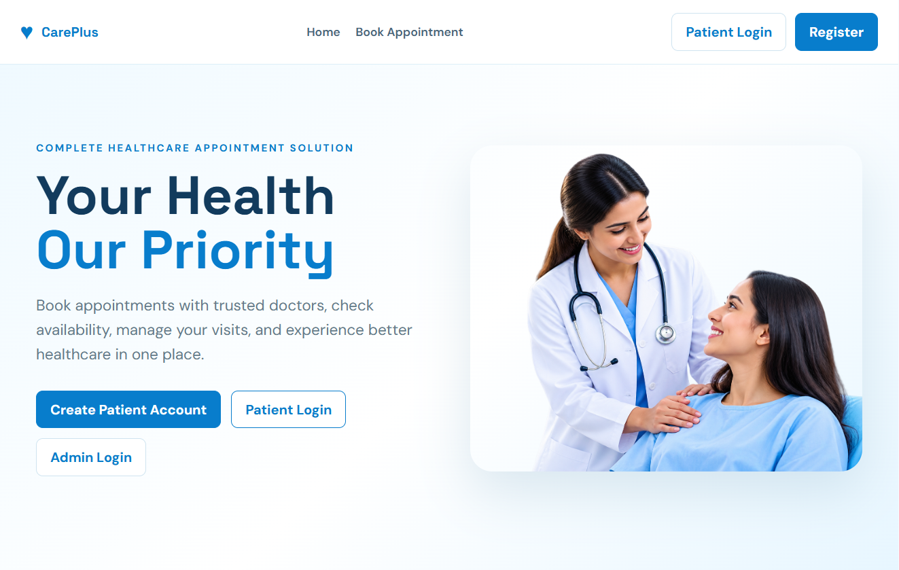

Figure A.1: Healthcare Appointment System Home Page
A.2 Registration Page
Include the screenshot of the patient registration page.
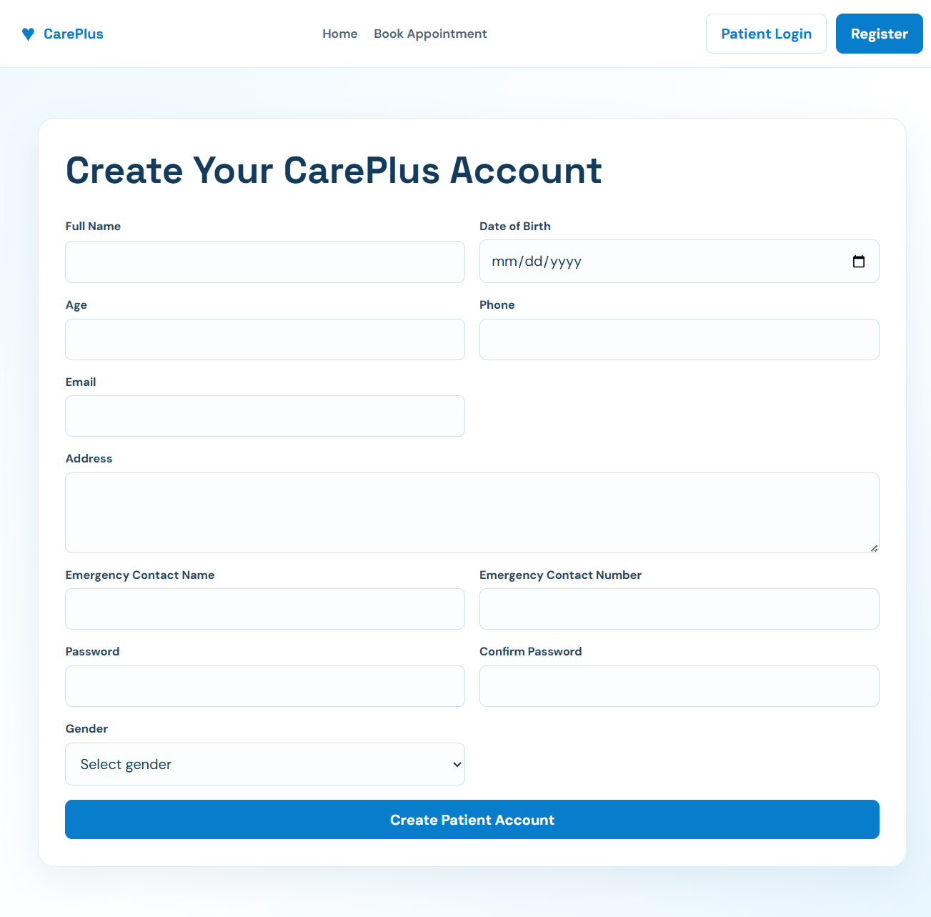
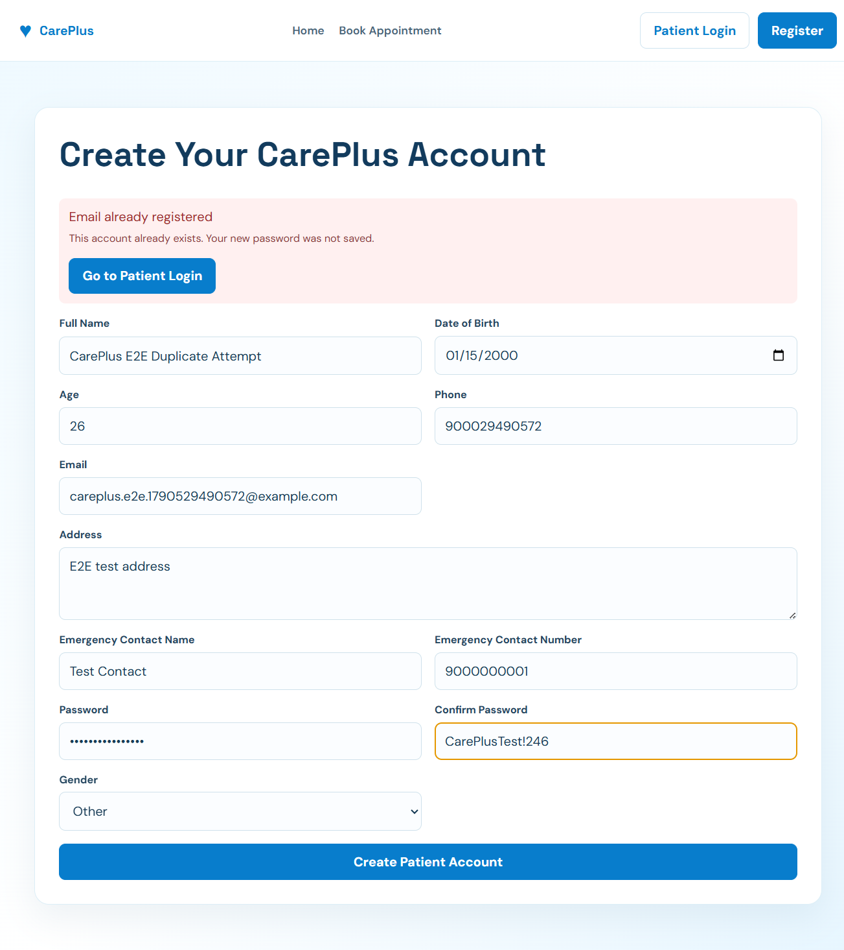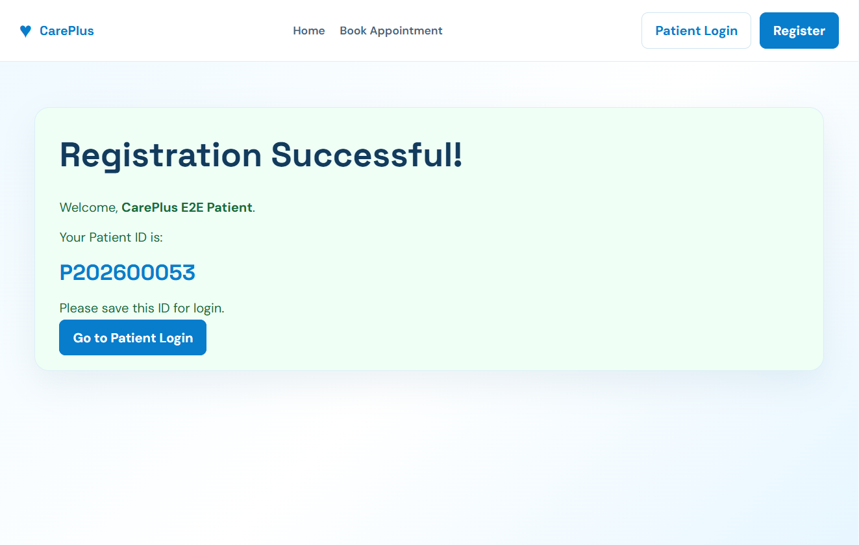

Figure A.2: Patient Registration Page
A.3 Login Page
Include the screenshot of the user login page.
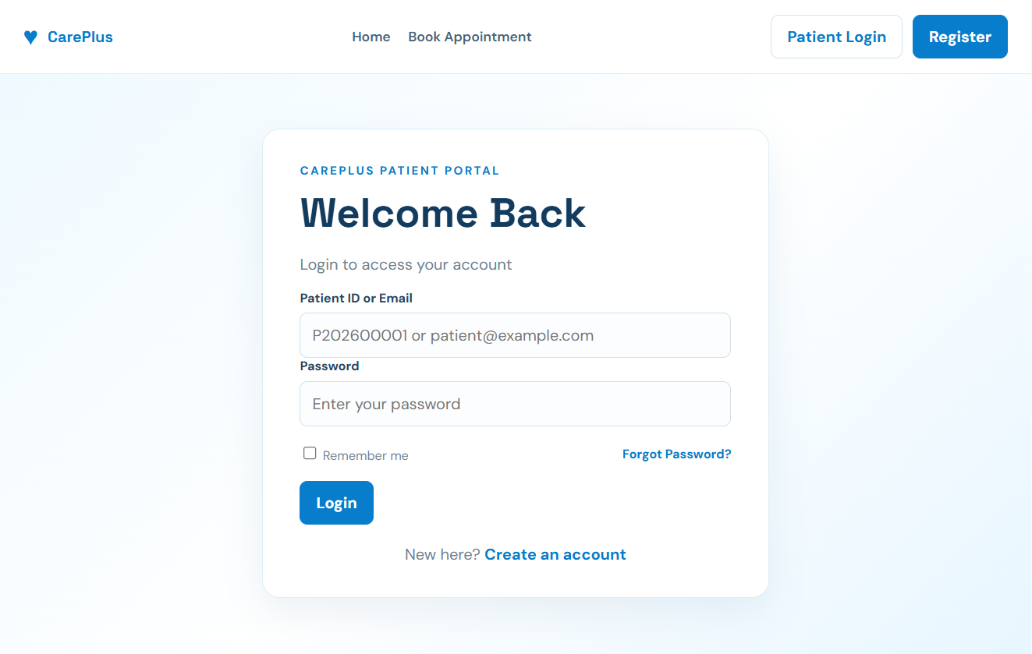

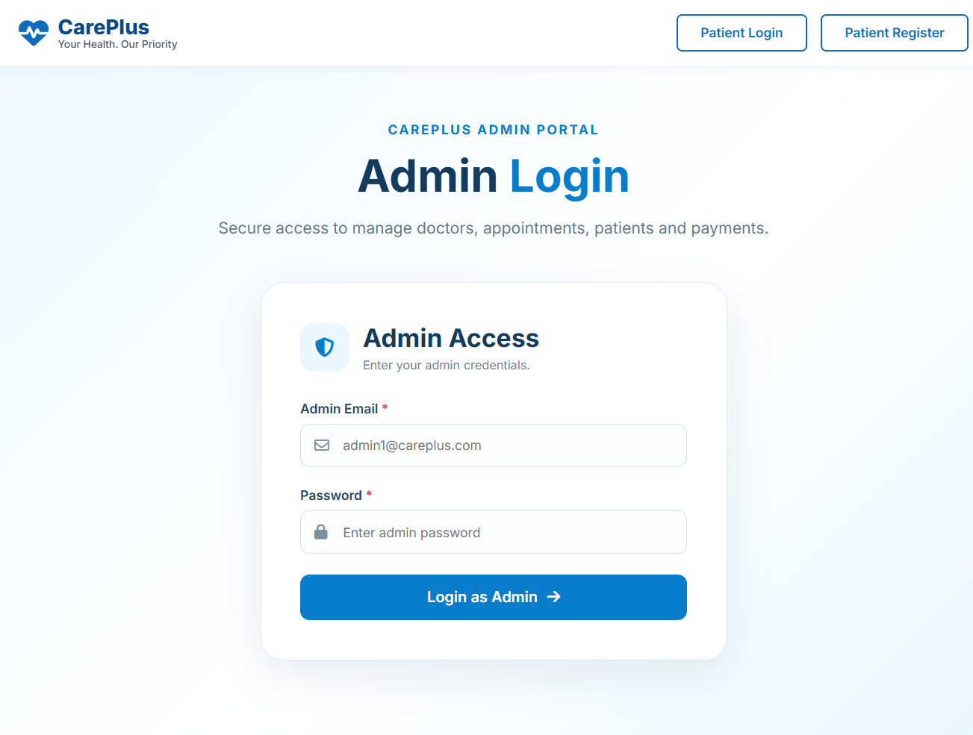

Figure A.3: User Login Page
A.4 Patient Dashboard
Include the screenshot of the patient dashboard after successful login.
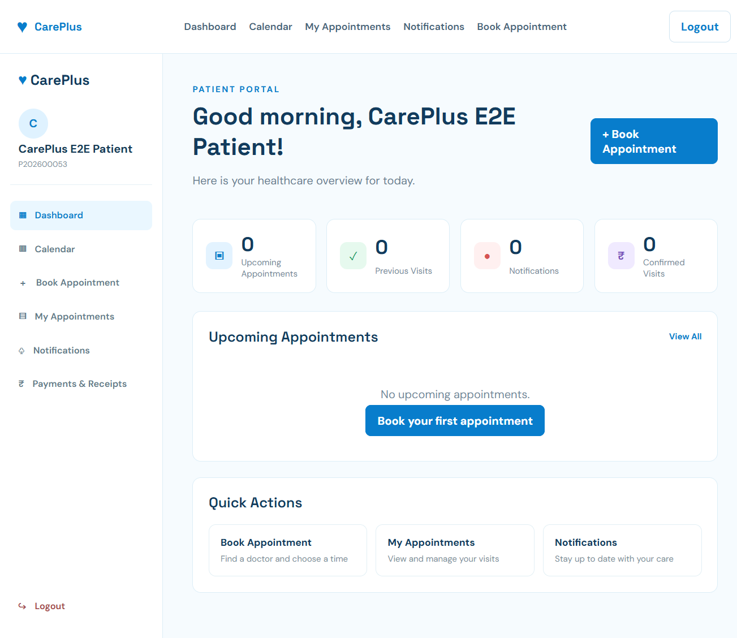
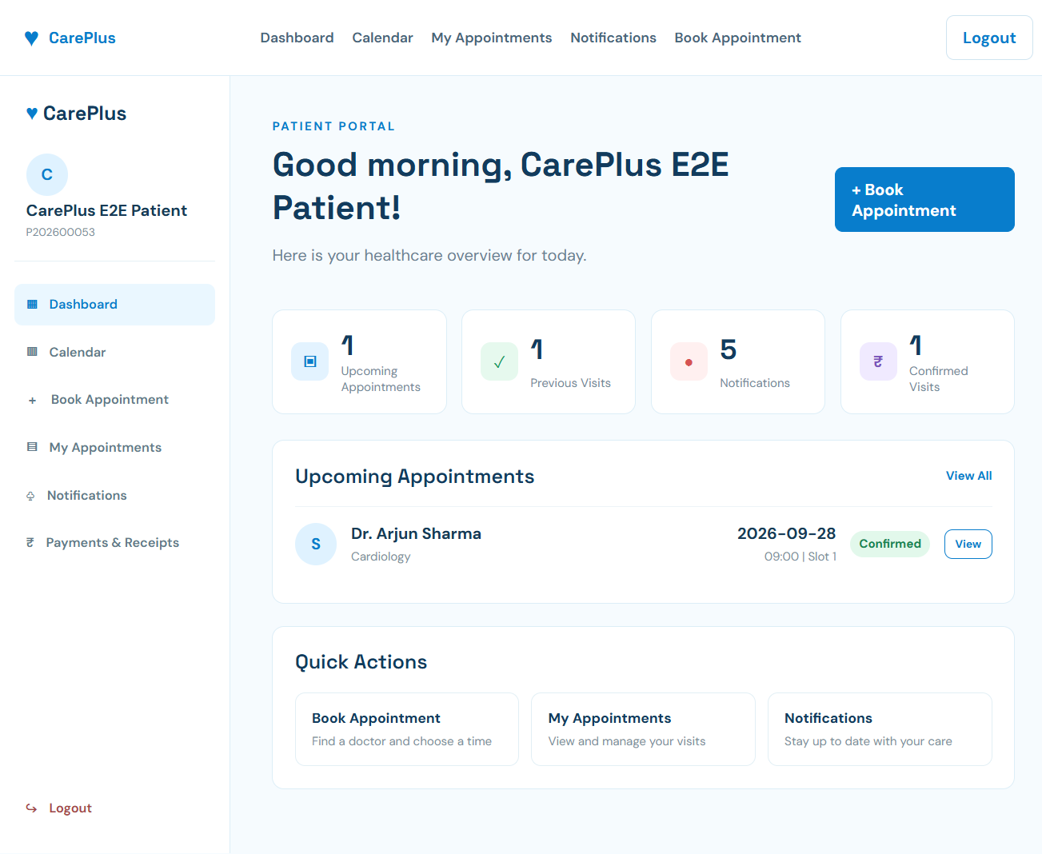

Figure A.4: Patient Dashboard
A.5 Doctor List
Include the screenshot showing the available doctors.
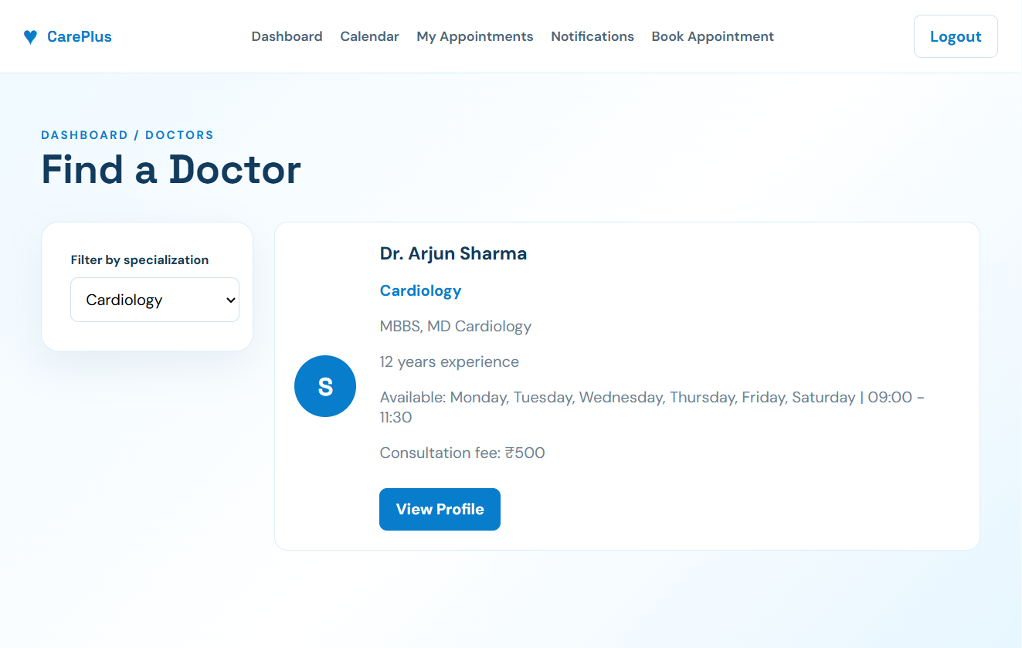




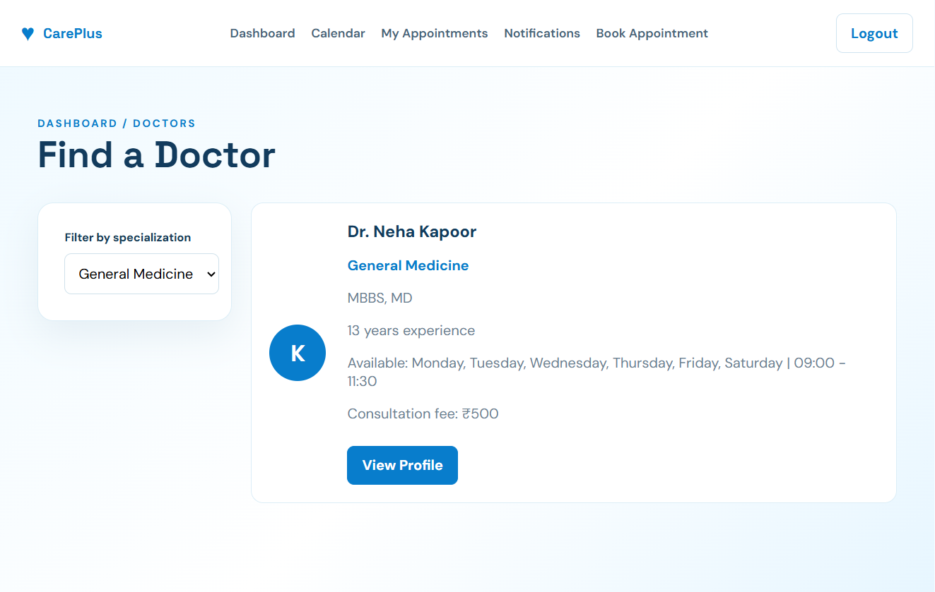

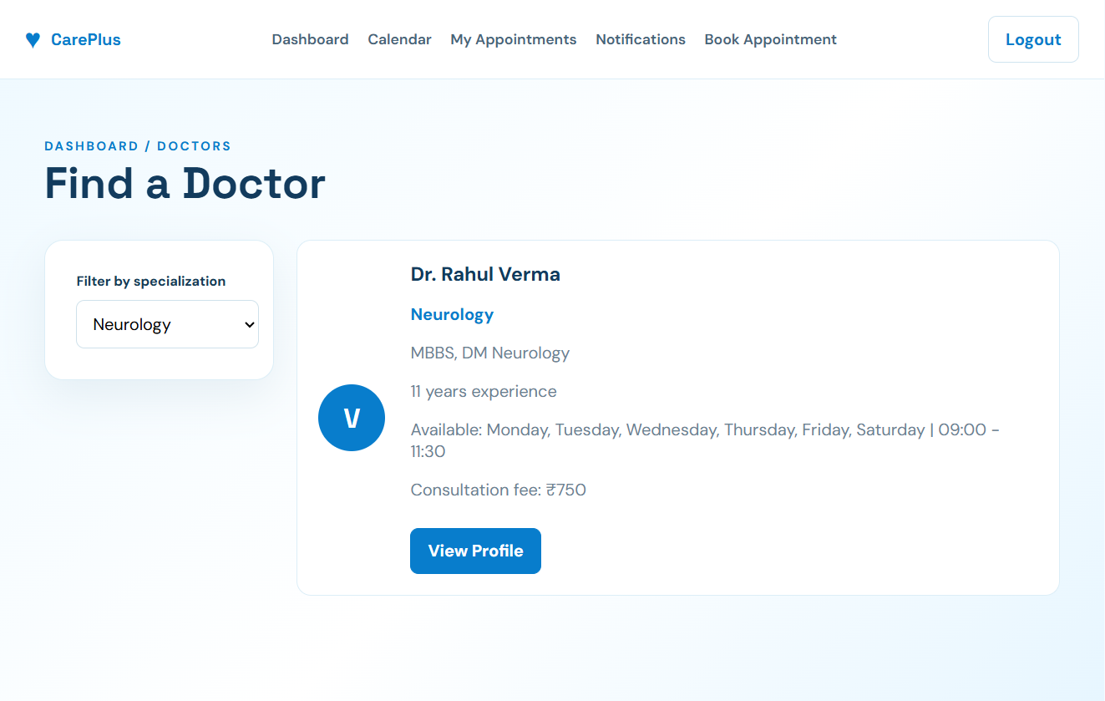

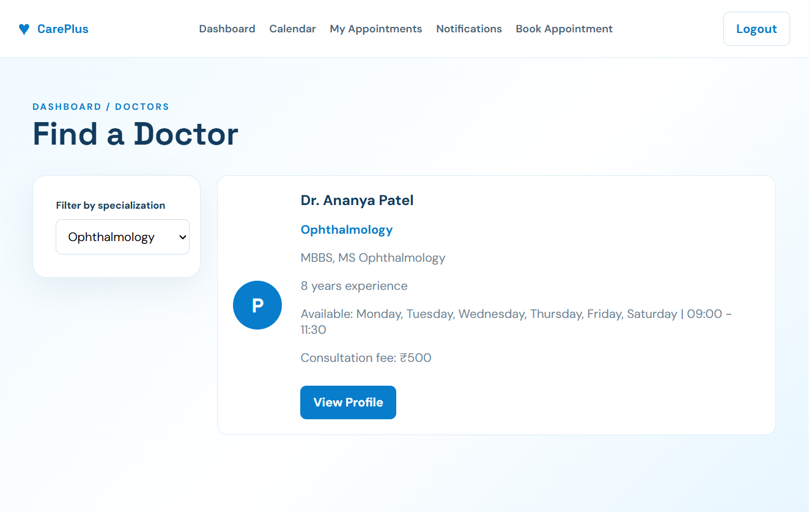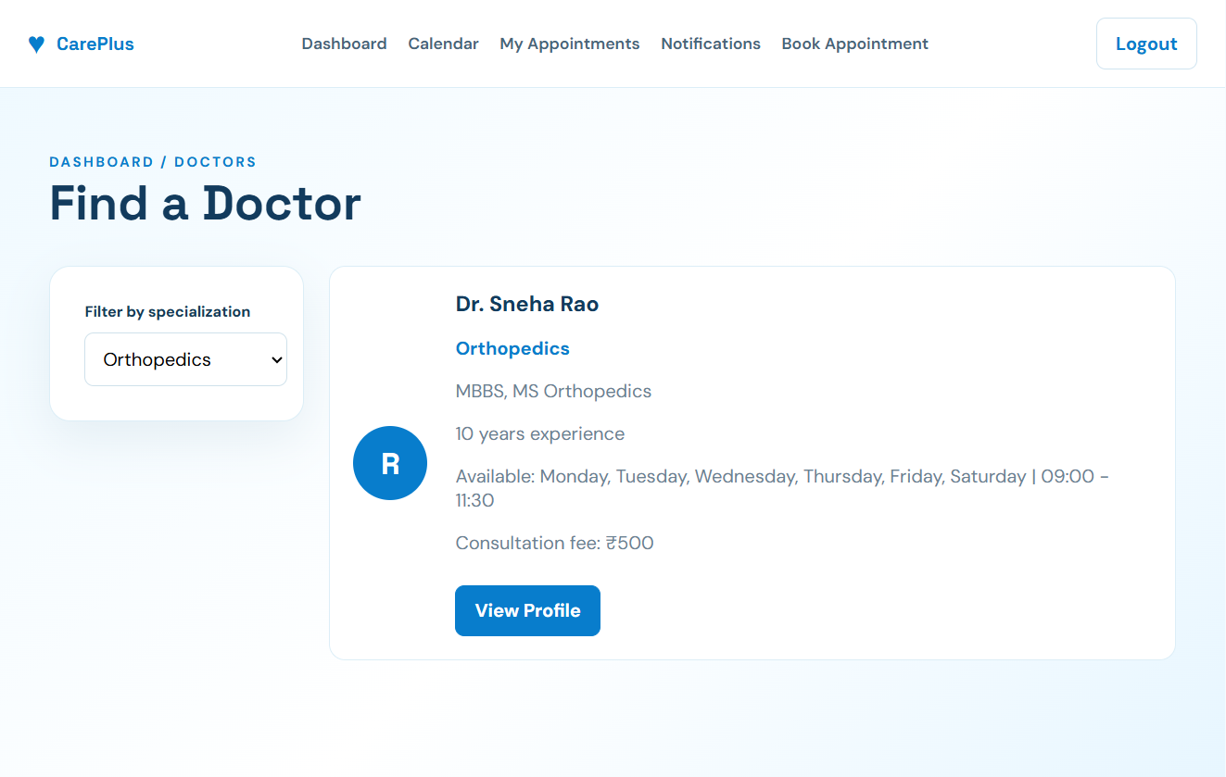

Figure A.5: Doctor List
A.6 Doctor Availability
Include the screenshot showing the available dates and time slots of a doctor.
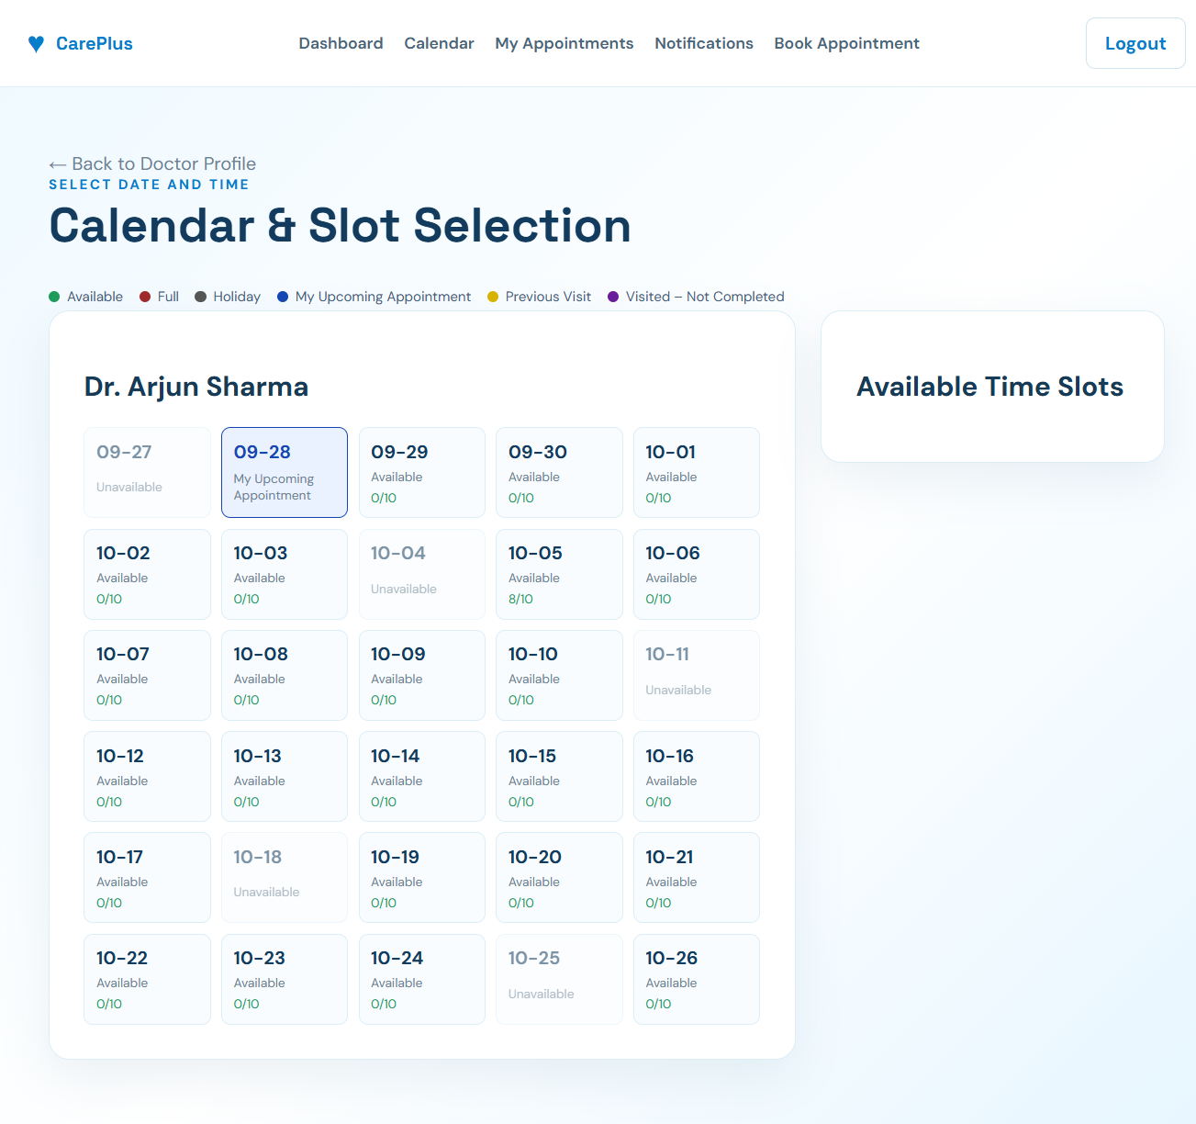
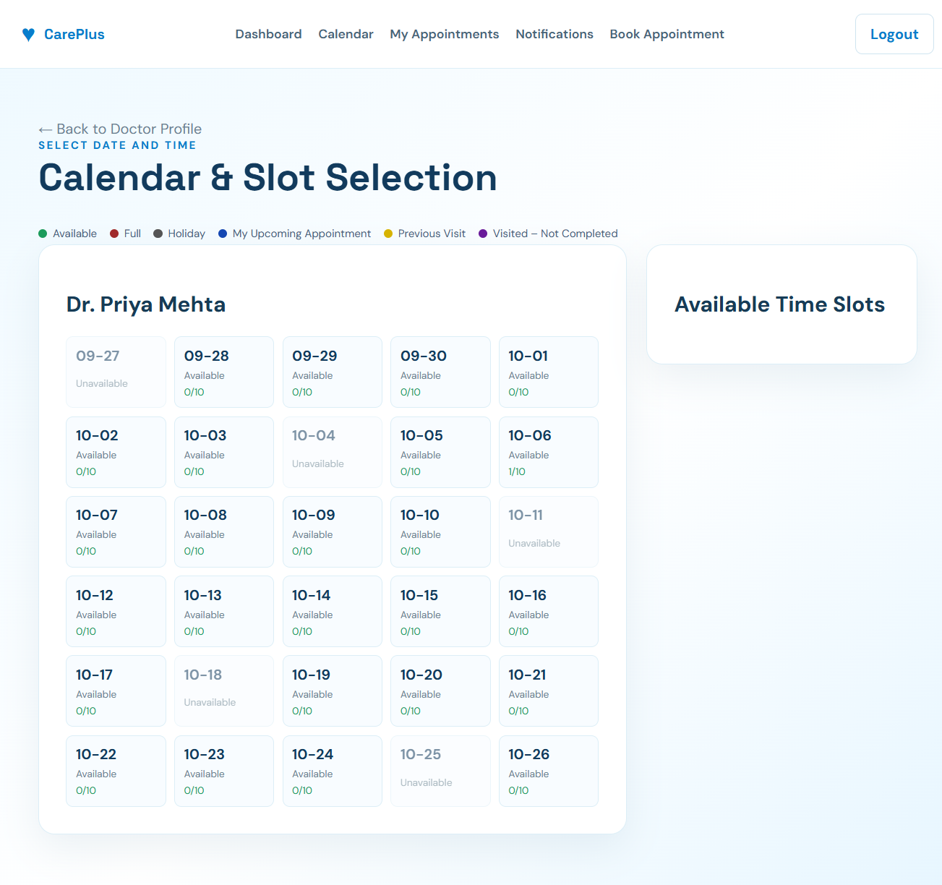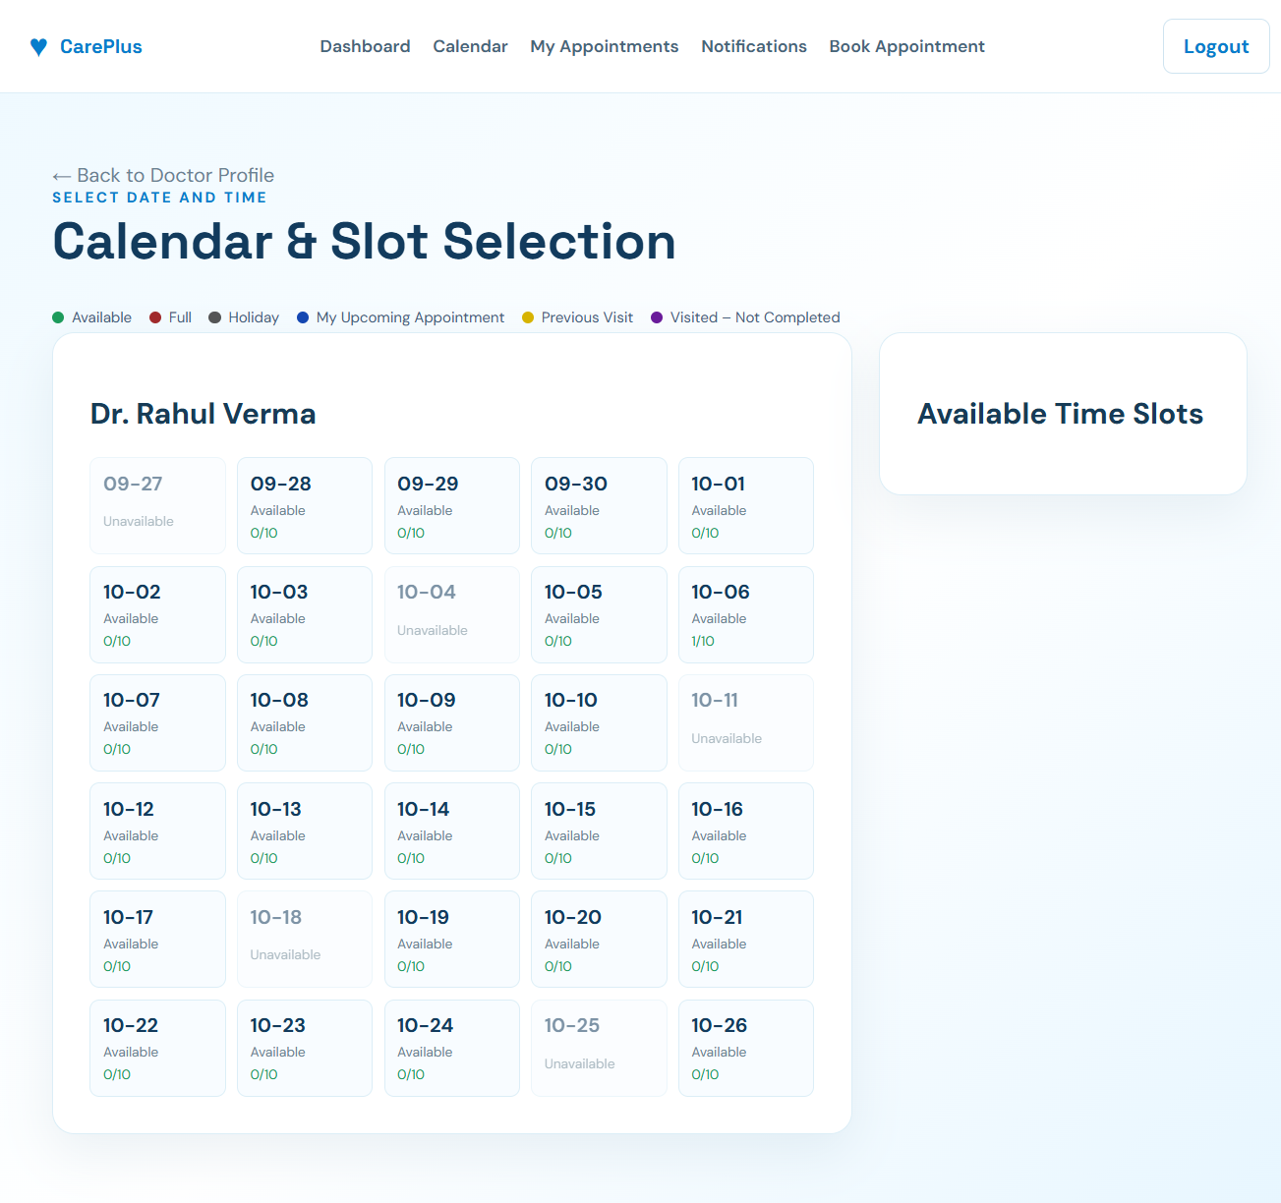
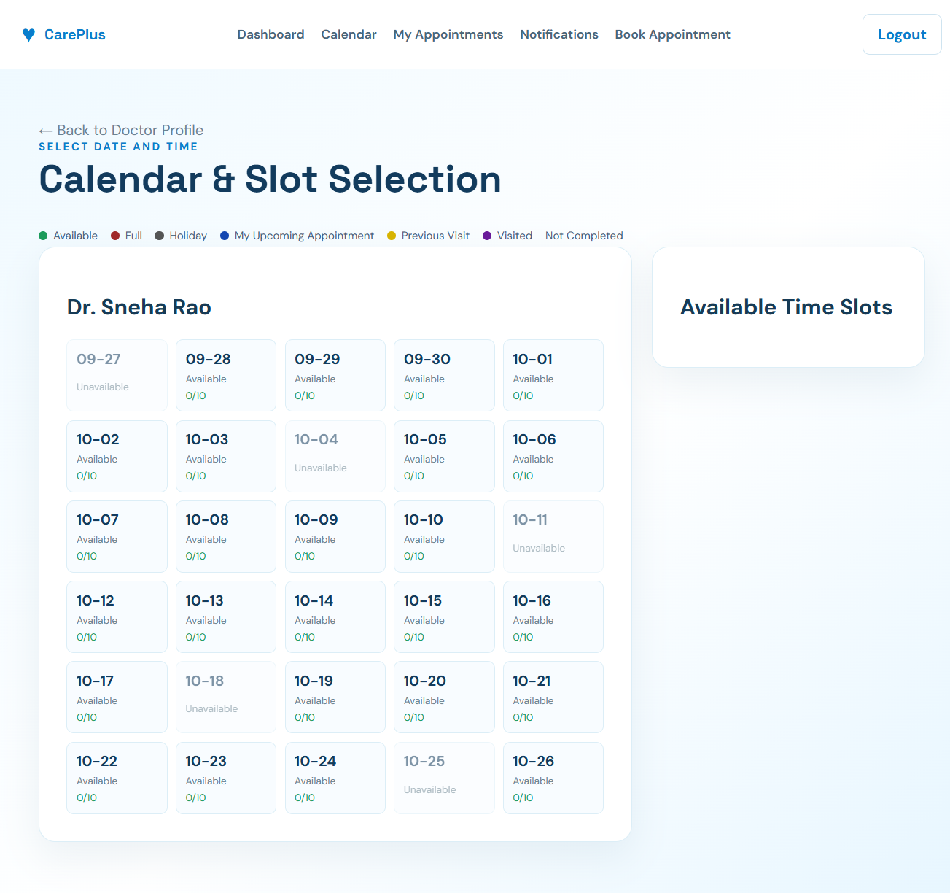
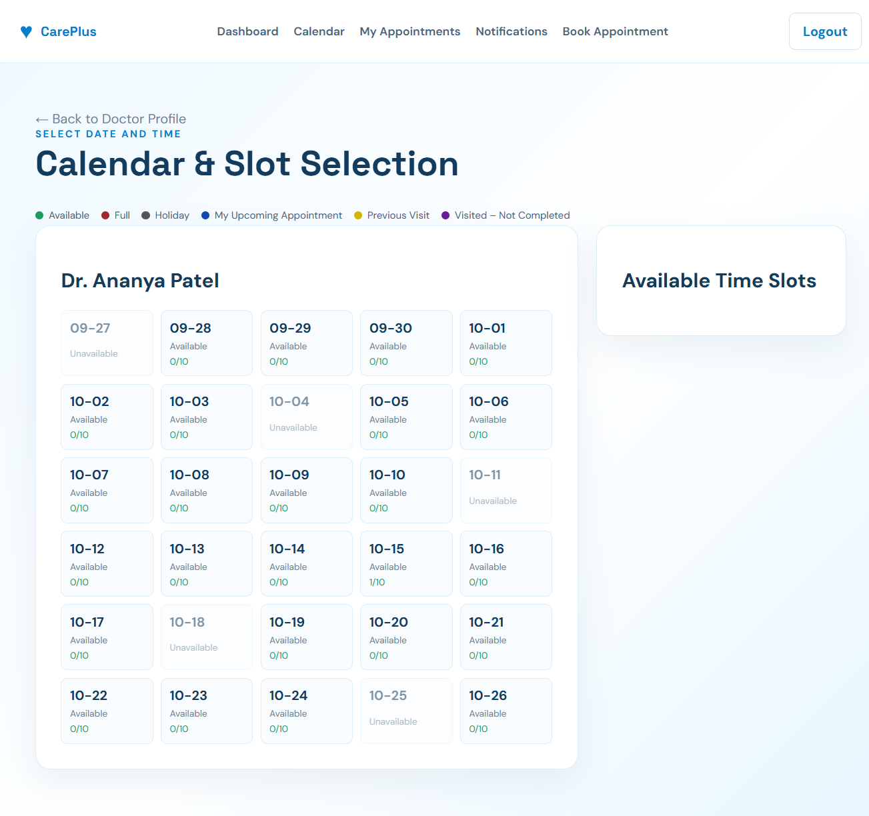
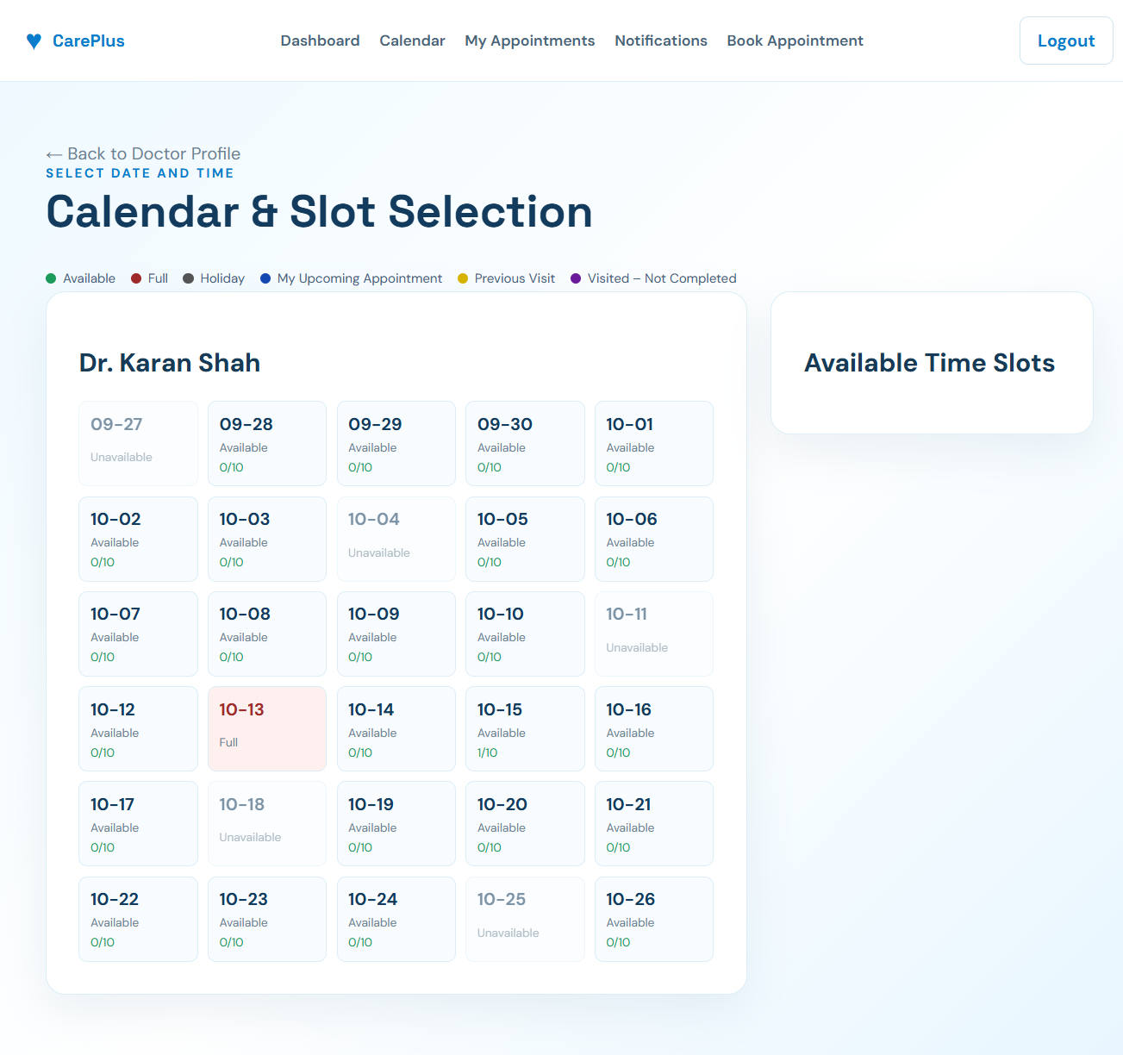
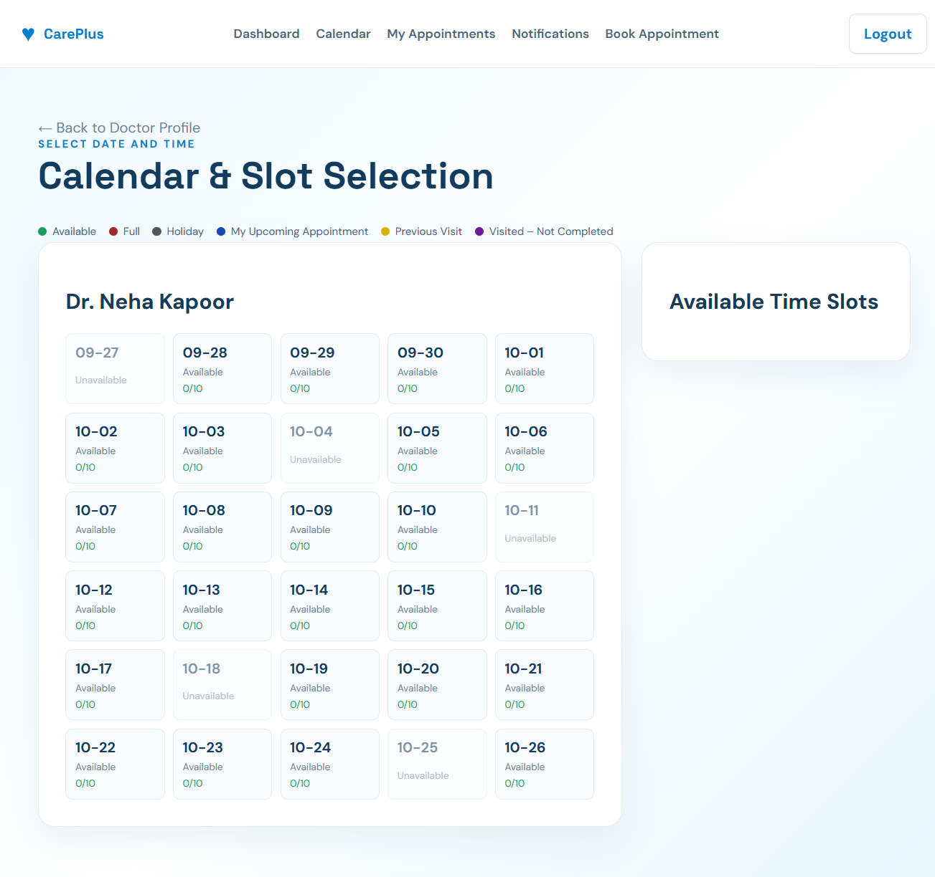
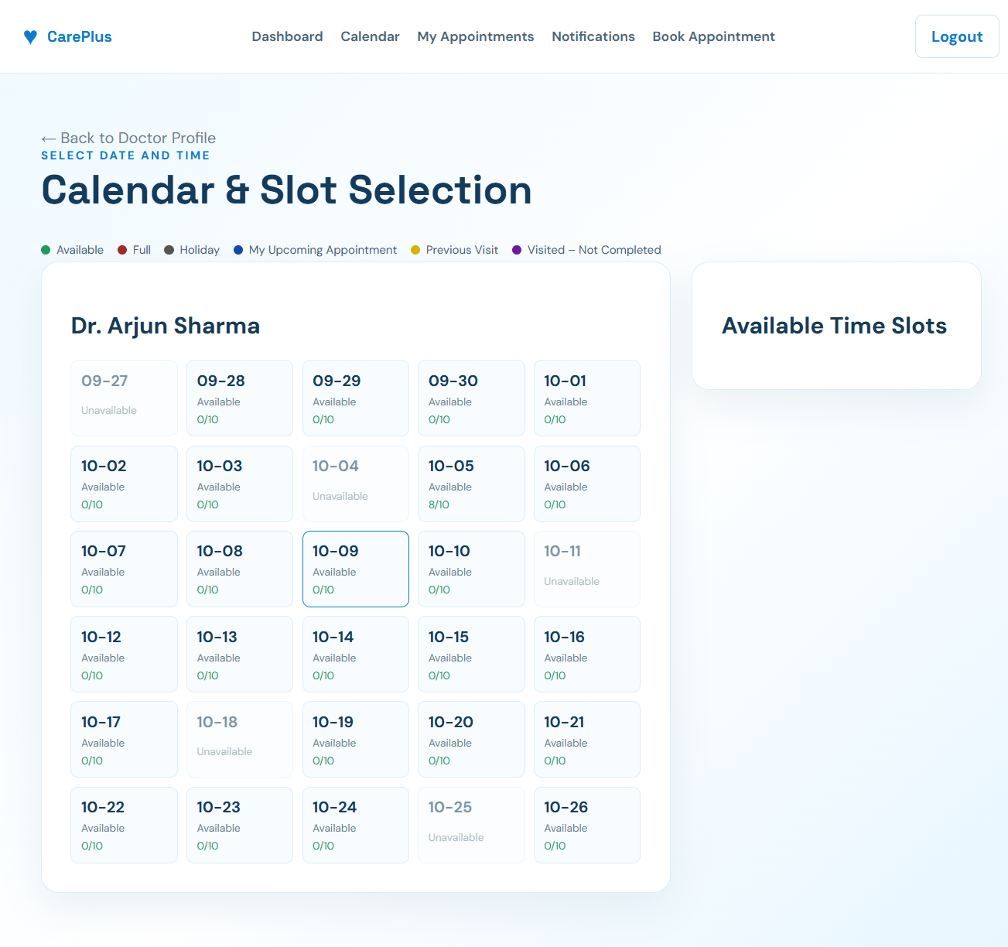

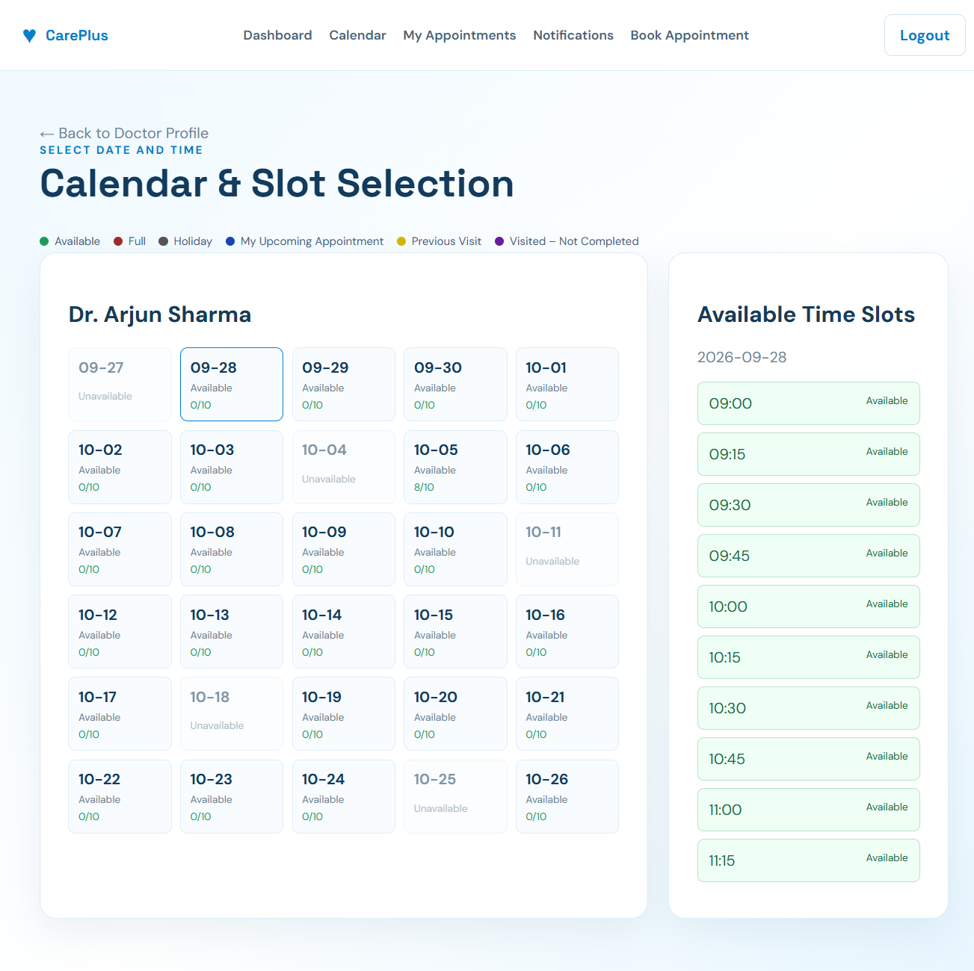

Figure A.6: Doctor Availability
A.7 Appointment Booking
Include the screenshot of the appointment booking page.
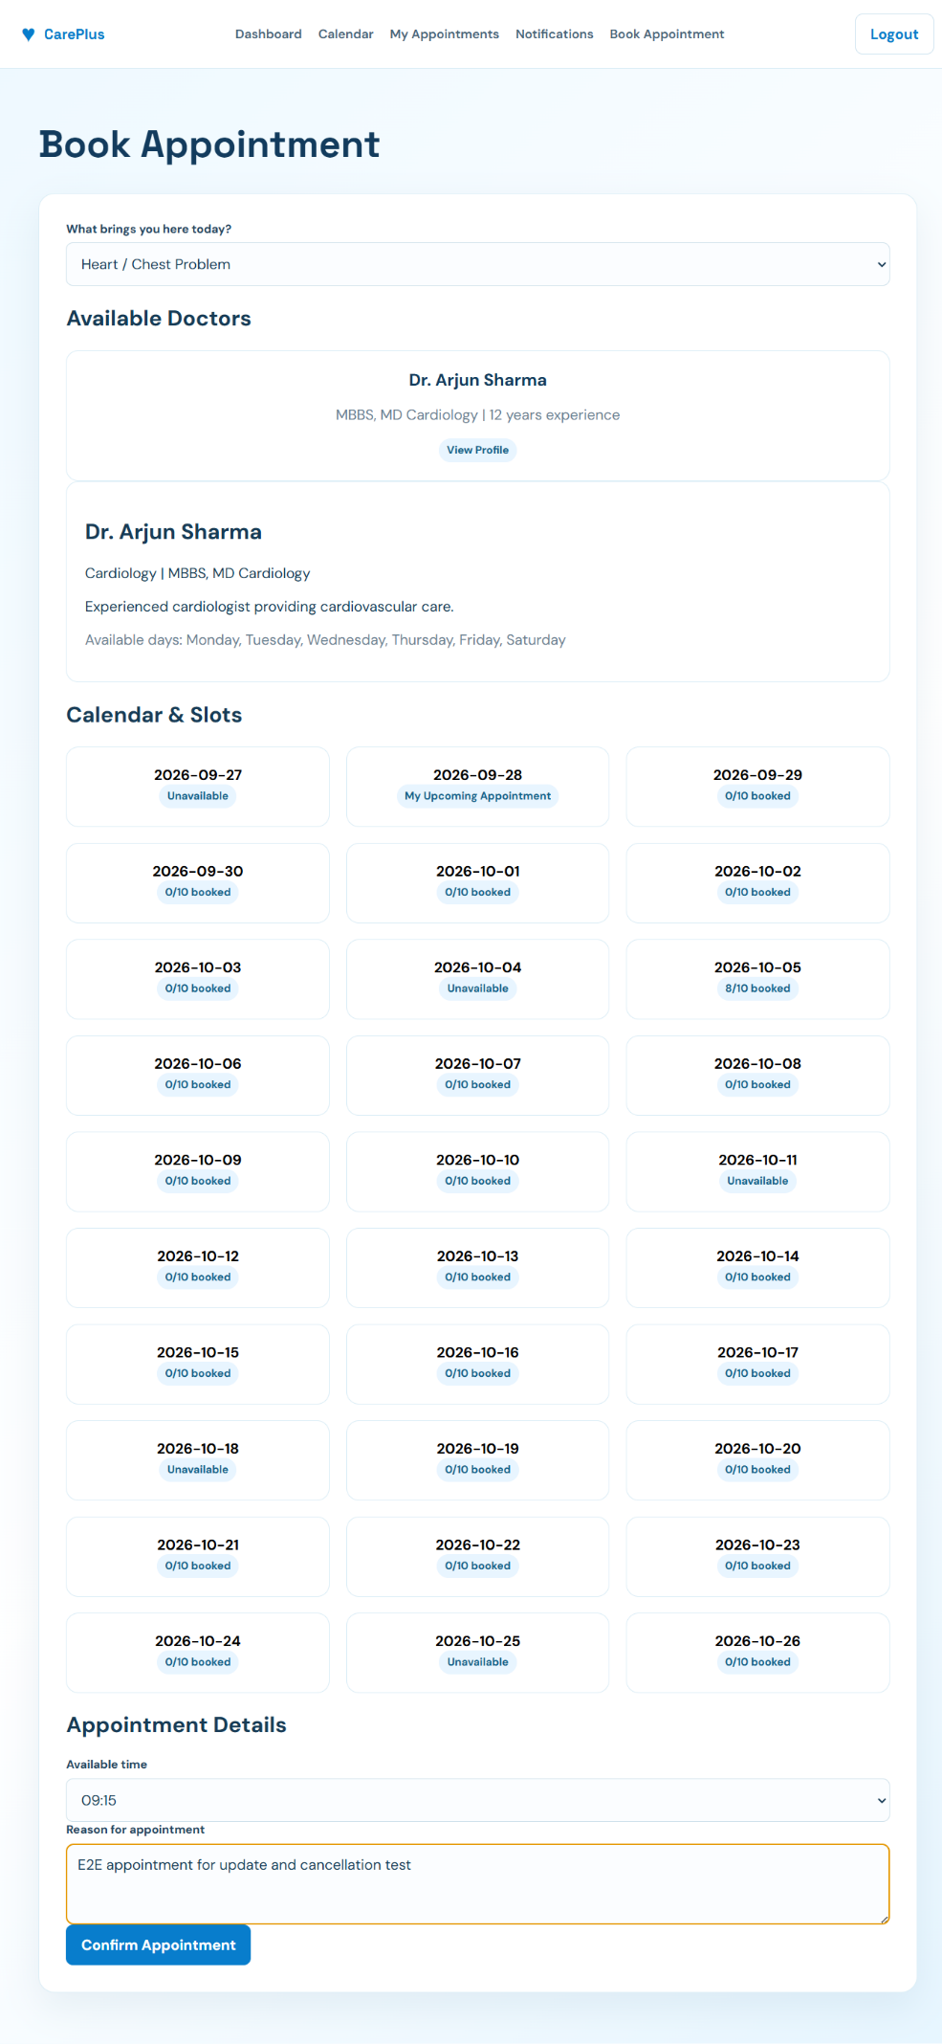

Figure A.7: Appointment Booking Page
A.8 Appointment Details
Include the screenshot showing the patient's appointment information.
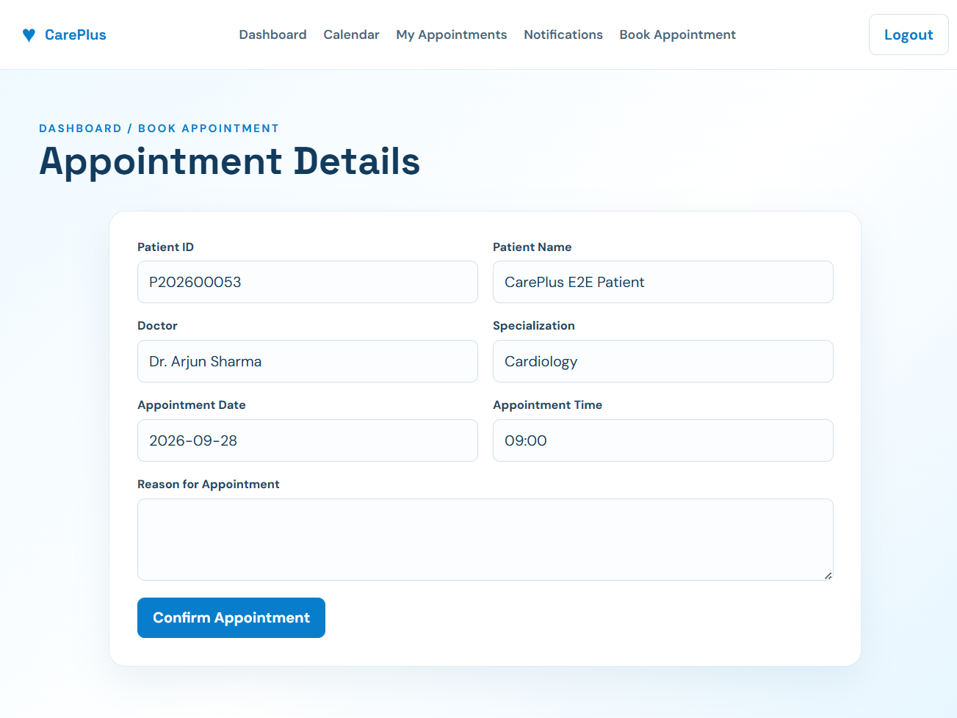
Figure A.8: Appointment Details
A.9 Notifications
Include the screenshot showing appointment-related notifications.
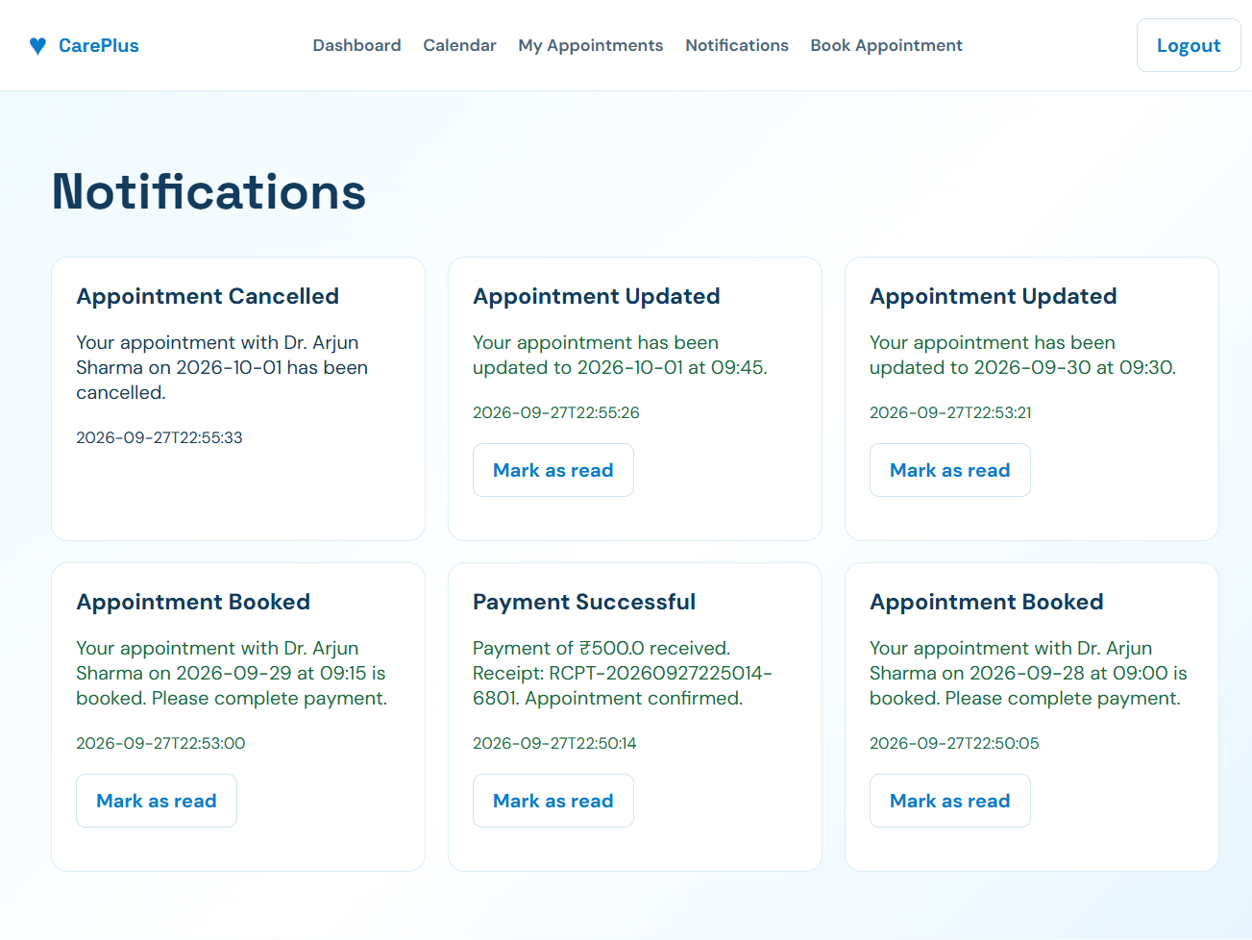

Figure A.9: Notification Page
A.10 Doctor Dashboard
Include the screenshot of the doctor dashboard.
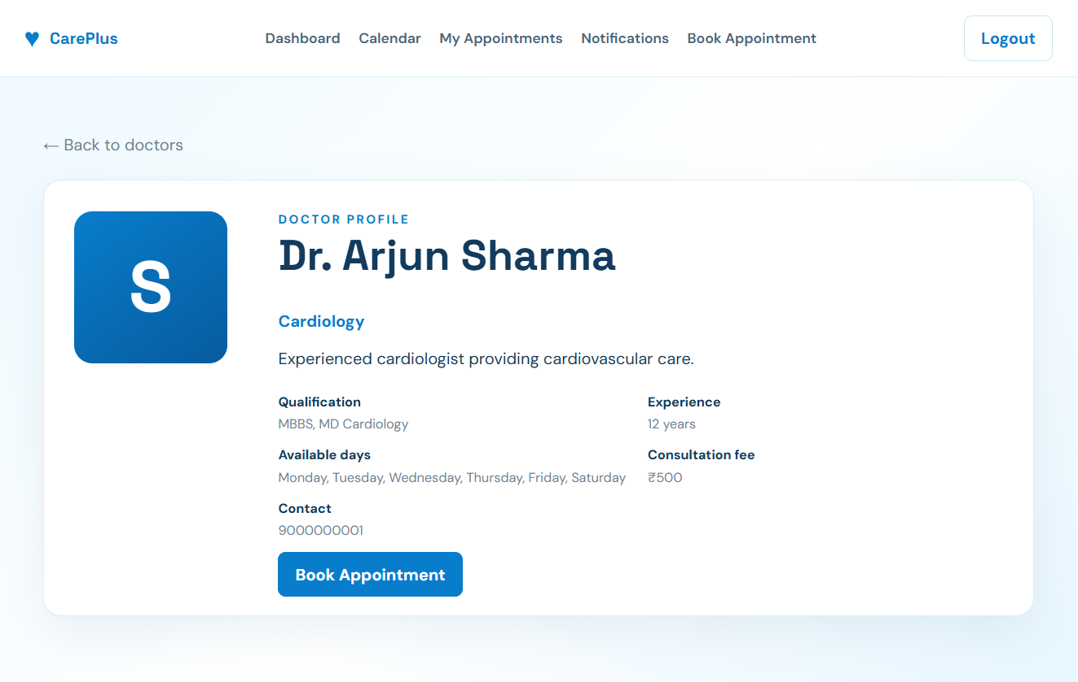
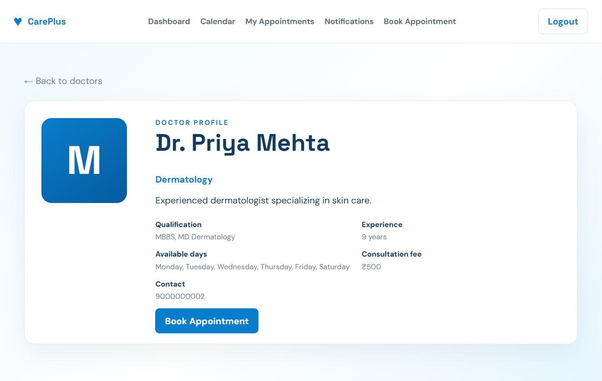

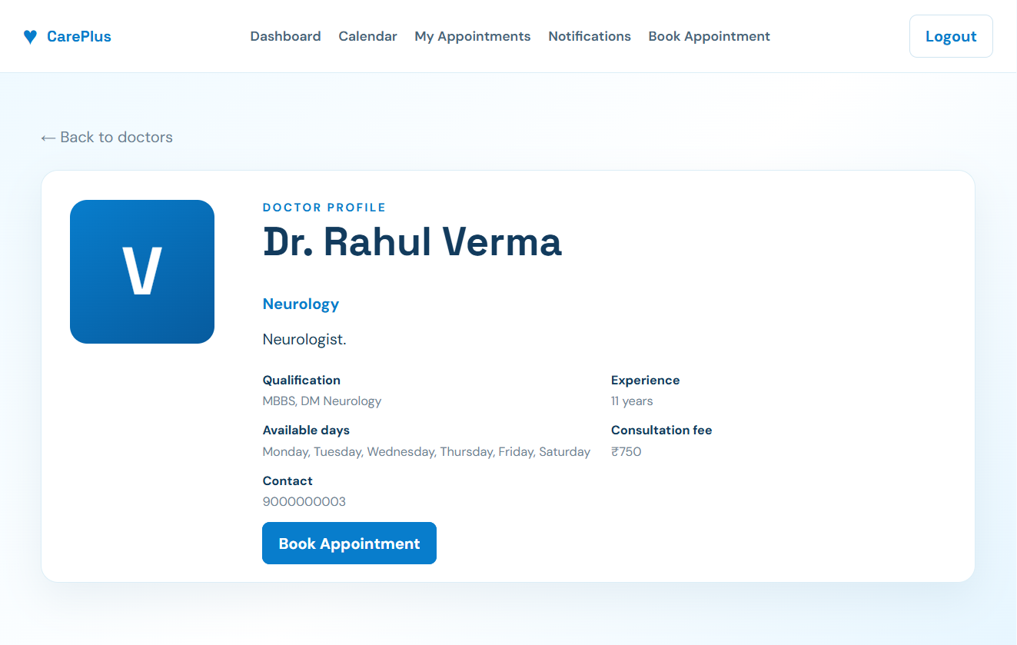

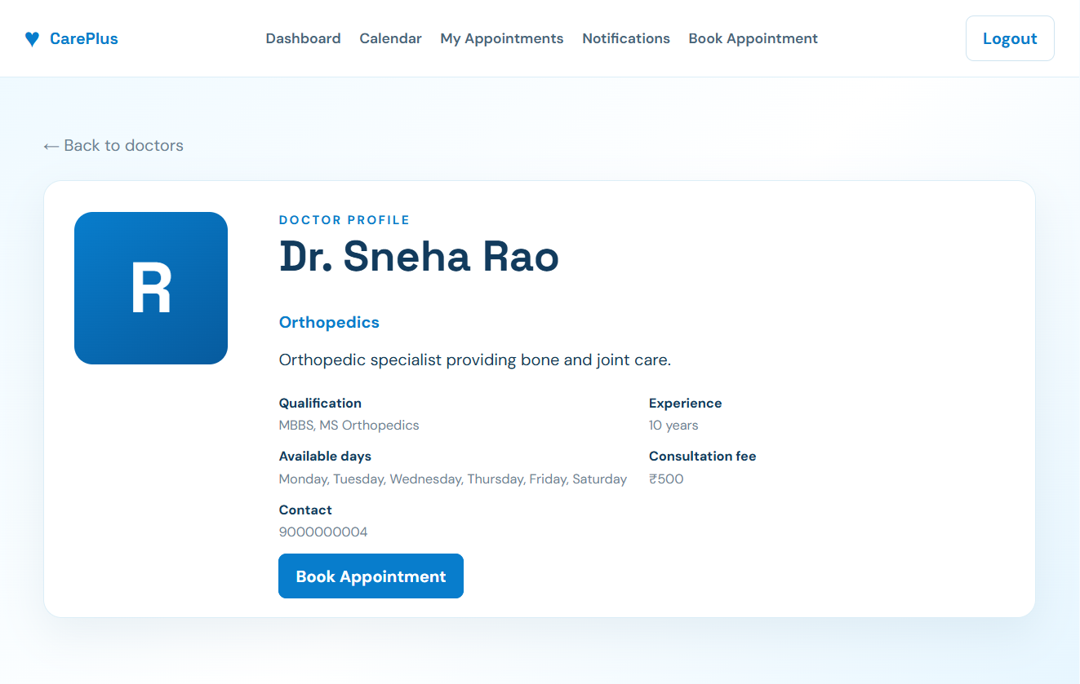

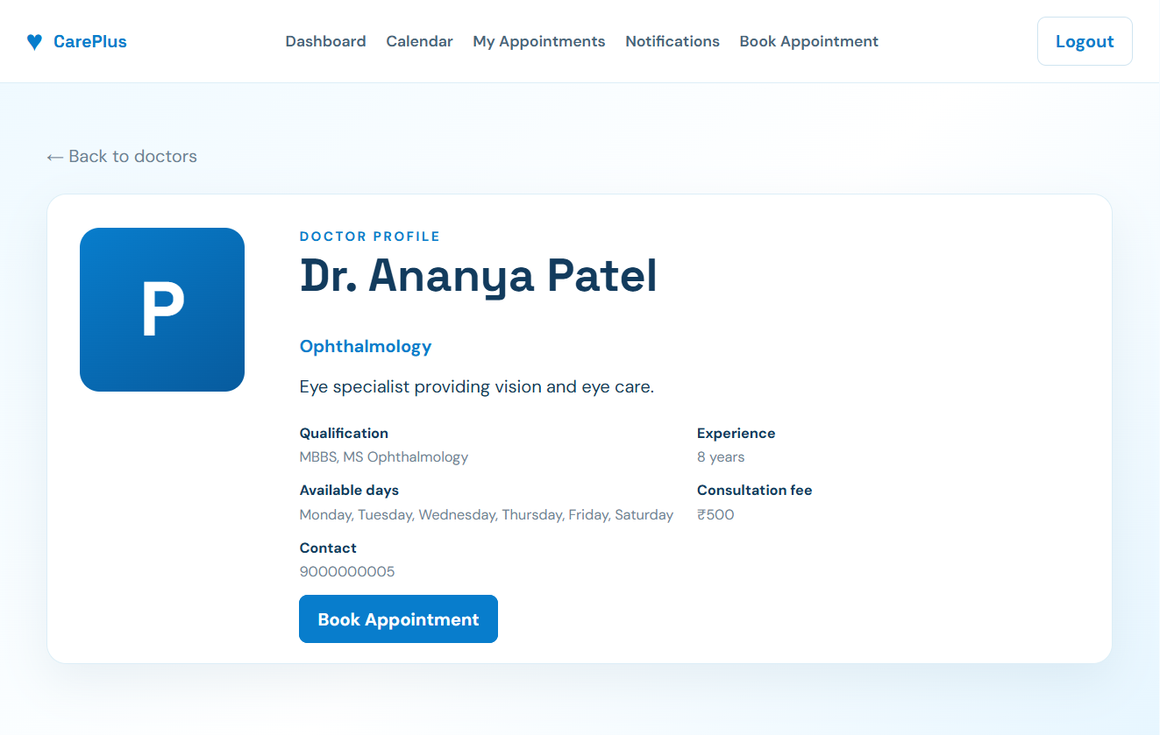
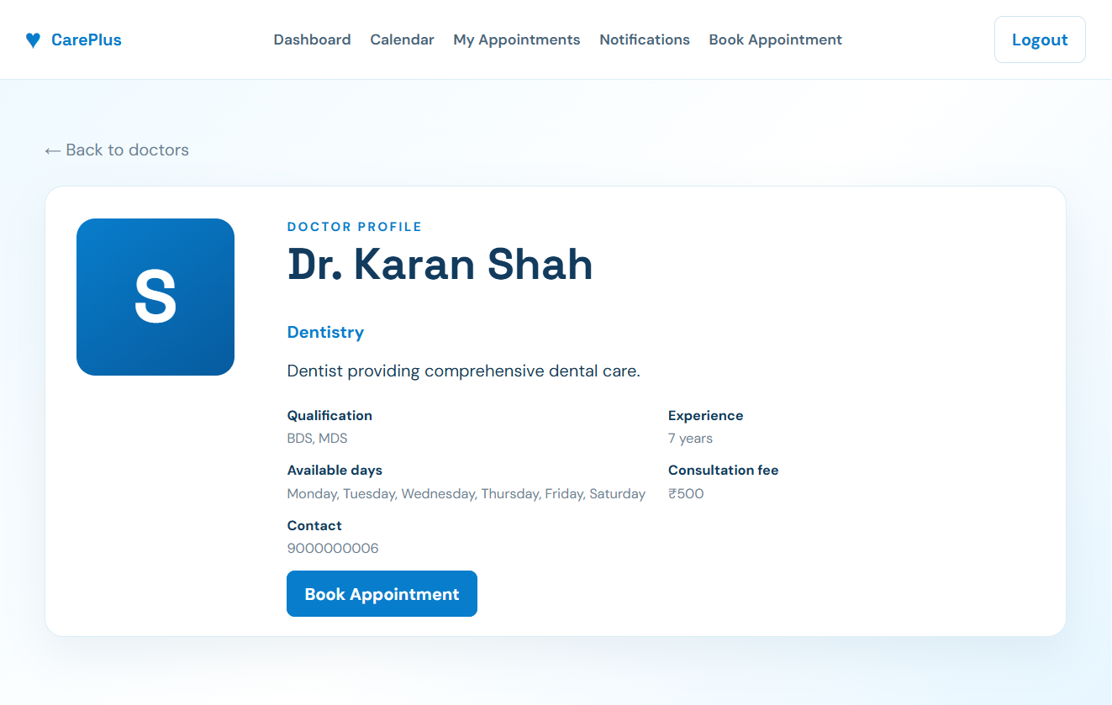

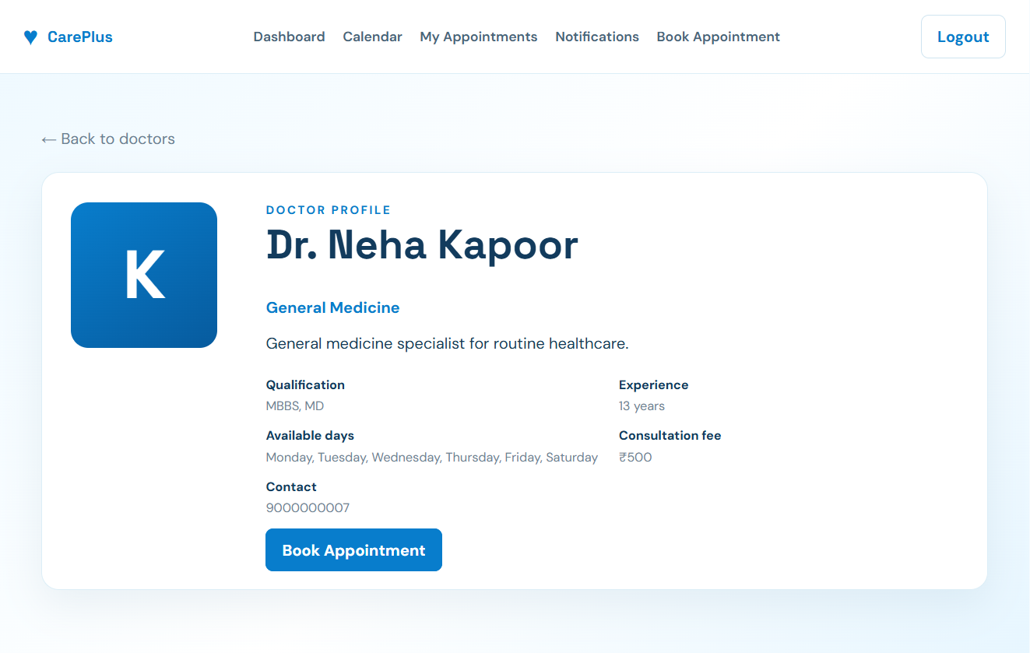

Figure A.10: Doctor Dashboard
A.11 Admin Dashboard
Include the screenshot of the administrator dashboard.
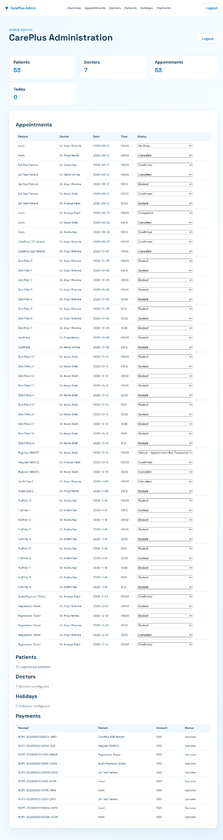

Figure A.11: Admin Dashboard
Use only the screens that you actually implement. If a particular page is not present in your final application, don't include it.

Appendix B – Sample SQL Queries
This appendix contains the SQL queries used for managing the healthcare appointment database.
B.1 Database Creation
CREATE DATABASE healthcare_appointment_db;
B.2 Table Creation
Include the actual CREATE TABLE queries from your schema.sql file.
The database should contain the tables that are actually implemented in your project, such as:
- Users
- Patients
- Doctors
- Doctor Availability
- Appointments
- Notifications
B.3 Insert Queries
Include the actual queries used to insert sample or required records.
INSERT INTO doctors (...);
B.4 Select Queries
Include queries used to retrieve information.
SELECT * FROM doctors;
SELECT * FROM appointments;
B.5 Update Queries
Include queries used to update appointment or other system information.
UPDATE appointments
SET status = 'Cancelled'
WHERE appointment_id = 1;
B.6 Join Queries
Include important queries used to retrieve information from related tables.
SELECT ...
FROM appointments
JOIN doctors ...
JOIN patients ...;
Important: Replace these examples with your actual SQL queries when your database is completed.

Appendix C – API Testing Screenshots
This appendix contains screenshots of the REST API testing performed using Postman.
C.1 FastAPI Swagger Documentation
Screenshot: API Testing/Swagger_API_Documentation.png
FastAPI provides interactive API documentation through Swagger UI. The screenshot shows the available backend endpoints and their supported HTTP methods.
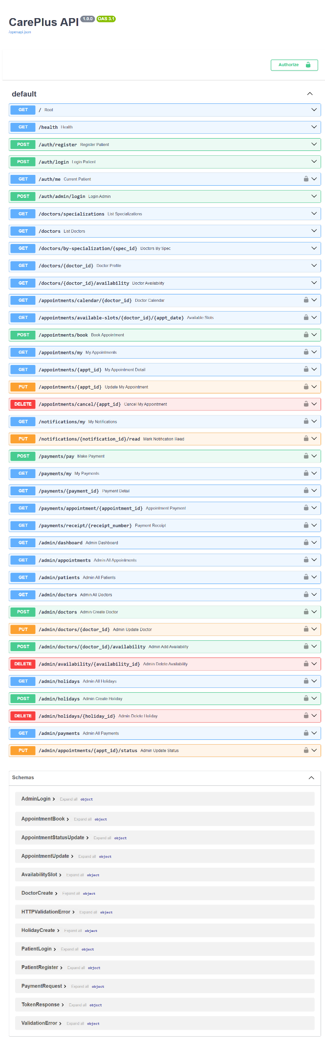

Figure C.1: FastAPI Swagger API Documentation
C.2 API Health Check
Screenshot: API Testing/API_Health_Response.png
The API health-check endpoint was accessed to inspect the backend service response. The screenshot records the response returned by the running application.


Figure C.2: API Health Check Response
C.3 Doctor API Response
Screenshot: API Testing/Public_Doctor_API_Response.png
The public doctor API was accessed to inspect the doctor information returned by the backend. This endpoint supports the application's doctor-listing functionality.
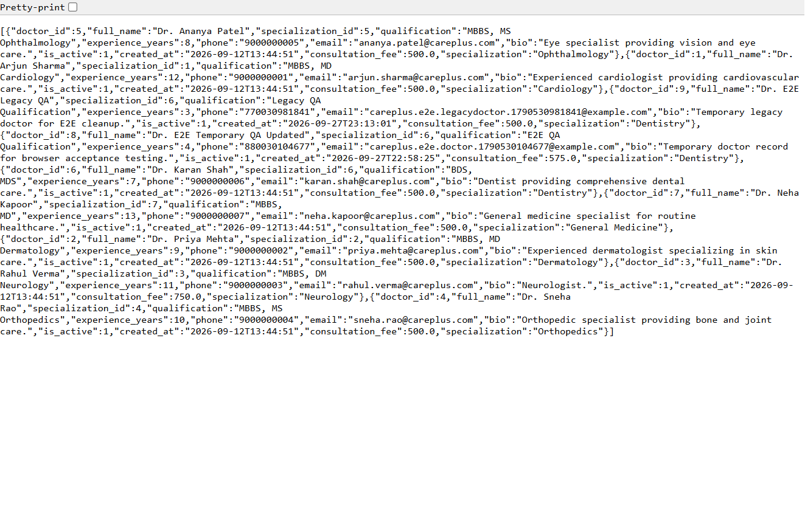

Figure C.3: Public Doctor API Response
C.4 Protected Admin API — Unauthorized Access
Screenshot: API Testing/Protected_Admin_API_Unauthorized.png
A protected administrator API endpoint was accessed without the required authorization. The screenshot records the backend's response to the unauthorized request, providing evidence of access-control testing.
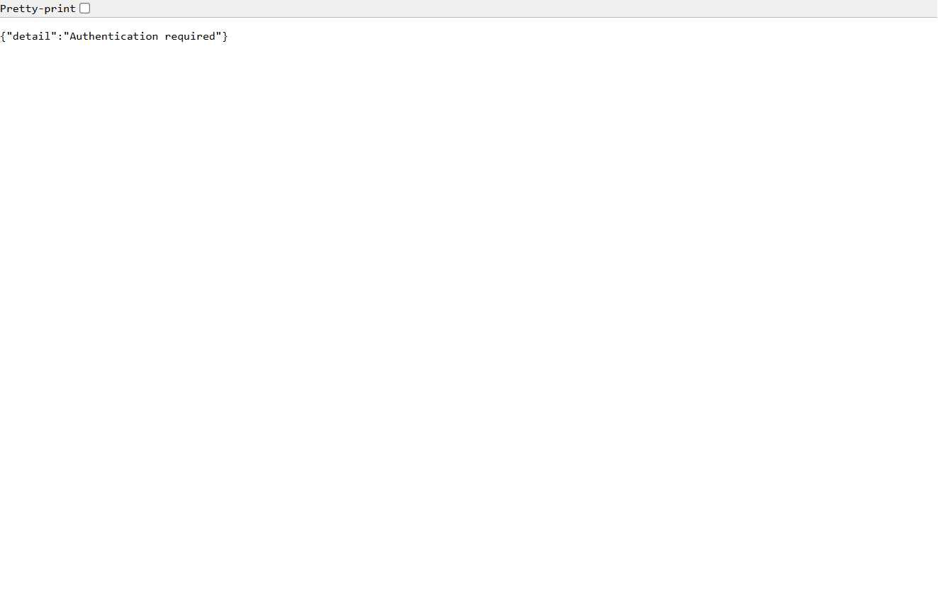

Figure C.4: Unauthorized Access Response from Protected Admin API
C.5 OpenAPI Schema
Screenshot: API Testing/OpenAPI_Raw_Schema.png
FastAPI generates an OpenAPI schema describing the application's documented endpoints, request structures and response definitions. The screenshot shows the schema returned by the backend.
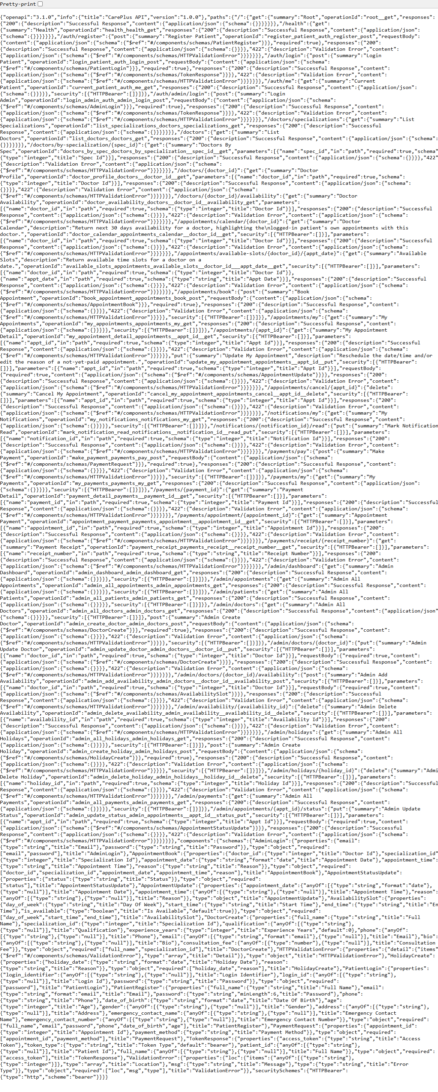

Figure C.5: FastAPI OpenAPI Schema

Appendix D – Installation and Setup Instructions
This appendix explains how to install and run the Healthcare Appointment System.
D.1 Required Software
The following software is required:
- Python
- MySQL
- Visual Studio Code
- Postman
- Git
- Web Browser
D.2 Database Setup
- Install and start MySQL.
- Create the healthcare appointment database.
- Execute the schema.sql file.
- Execute the sample_data.sql file if sample data is required.
- Verify that the required tables have been created.
D.3 Backend Setup
- Open the project in Visual Studio Code.
- Open the backend directory.
- Create a Python virtual environment if required.
- Activate the virtual environment.
- Install the packages listed in requirements.txt.
- Configure the database connection.
- Configure the .env file.
- Start the FastAPI backend.
D.4 Frontend Setup
- Open the frontend directory.
- Verify that the frontend files are connected to the correct backend API.
- Start the frontend using the method selected for the project.
- Open the application in a web browser.
D.5 Application Execution
The basic execution flow is:

Start MySQL
↓
Start FastAPI Backend
↓
Start Frontend
↓
Open Application
↓
Register / Login
↓
View Doctors
↓
Check Availability
↓
Book Appointment
↓
Receive Notification

Appendix E – User Manual / Guide
This appendix provides basic instructions for using the healthcare appointment scheduling system.
E.1 Patient Guide
Step 1: Registration
The patient creates an account by entering the required registration details.

Step 2: Login
The patient logs into the system using the registered credentials.

Step 3: View Doctors
The patient can view available doctors and their relevant information.

Step 4: Check Availability
The patient checks the doctor's available appointment dates and time slots.

Step 5: Book Appointment
The patient selects a suitable available slot and books an appointment.

Step 6: View Appointment
The patient can view the details and status of the booked appointment.
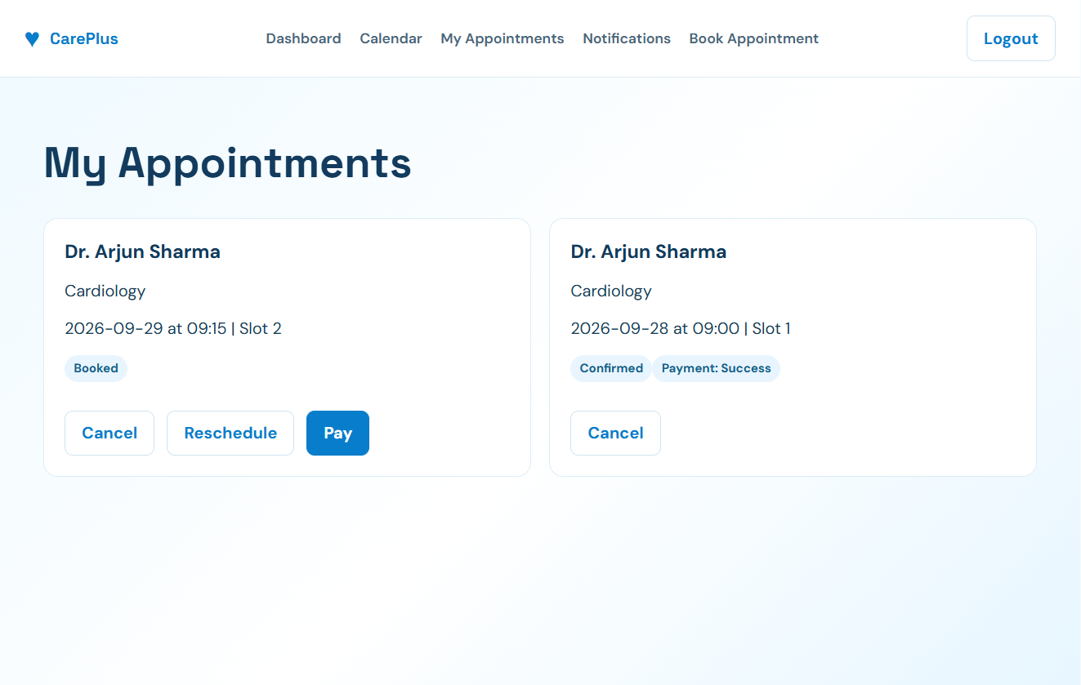

Step 7: Manage Appointment
The patient can update or cancel an appointment according to the functionality provided by the system.
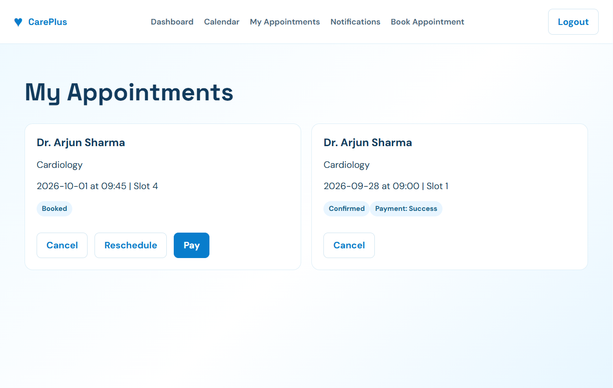
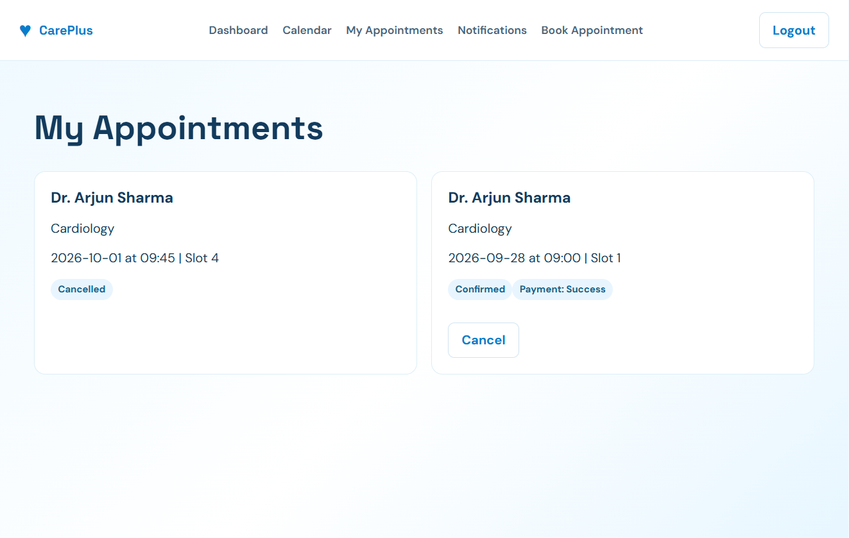

Step 8: Check Notifications
The patient can view notifications related to appointments.
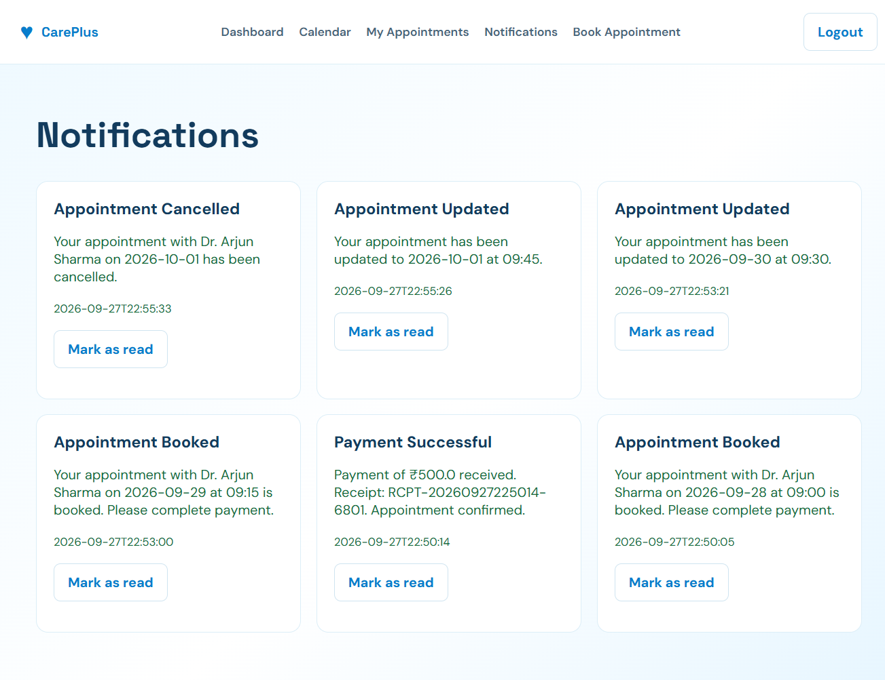

E.2 Doctor Guide
Step 1: Login
The doctor logs into the system using the appropriate credentials.
Step 2: Manage Availability
The doctor can manage available dates and appointment time slots.
Step 3: View Appointments
The doctor can view appointments associated with their schedule.
Step 4: Manage Appointment Information
The doctor can perform the appointment-related operations provided by the system.

E.3 Admin Guide
Step 1: Admin Login
The administrator logs into the administrative section.

Step 2: Manage Users
The administrator can manage the users supported by the system.
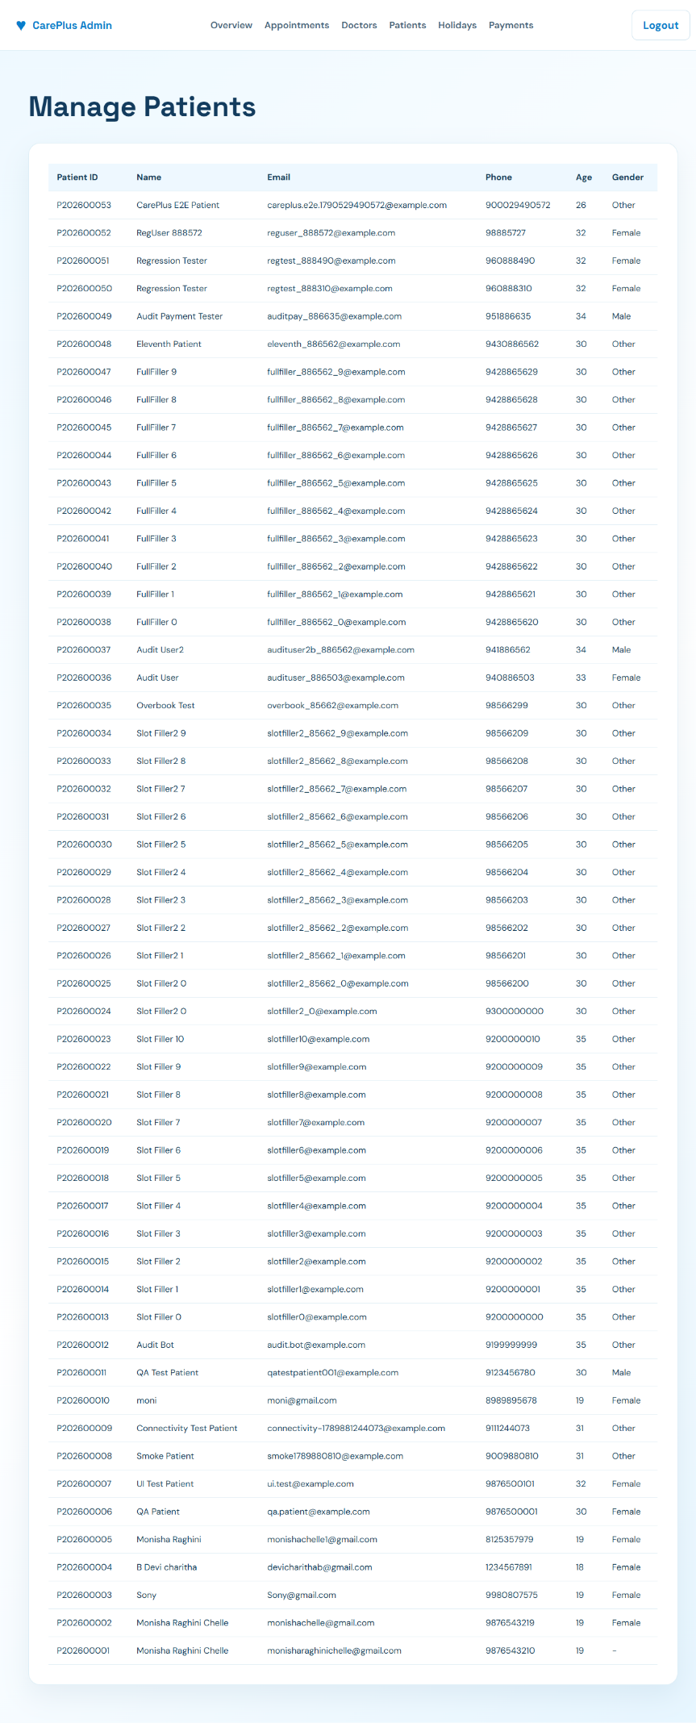

Step 3: Manage Doctors
The administrator can manage doctor-related information.
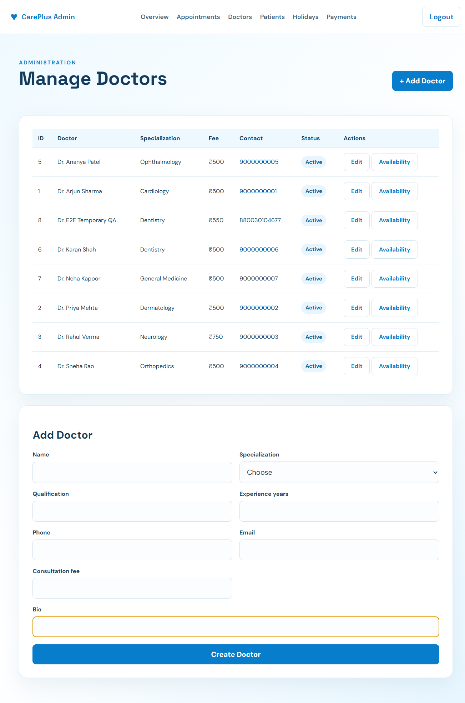

Step 4: Manage Appointments
The administrator can view and manage appointment information.
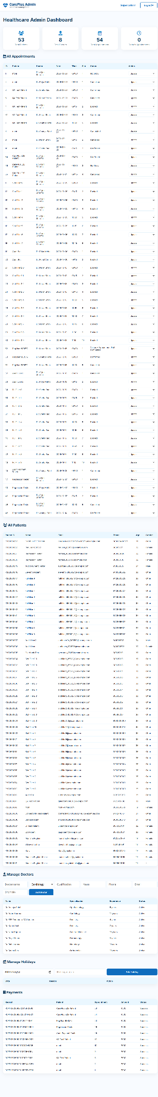

Appendix F – Geo-Tag Photos with Guide
This section contains the actual geo-tagged photographs required by the project guide or department.
Include the photographs provided or requested by your guide.
For each photograph, add a caption such as:
Figure F.1: Project Development/Review Session
Figure F.2: Project Review with Guide
Review -1

Geo Tag photos with guide

Review forms with guide signatures

