This is a Title This is a Title This is a Title
This is a Title This is a Title
This is a Title

Submitted by

CHAN TAI MAN
3036123456
B. Eng. (ABC Uni)

A dissertation submitted in partial fulfilment of the requirements for the degree of Master of Science in Engineering
(Electrical and Electronic Engineering)

At the

Department of Electrical and Computer Engineering
The University of Hong Kong

In
May 2026

ABSTRACT

The abstract should be suitable for direct inclusion in abstracting services as a self-contained article. The length of the abstract should not exceed 1 page. Do not include figure numbers, table numbers, references or displayed mathematical expressions. Provide the abstract word count.

Abstract Word Count: XXX

DECLARATION

I declare that this dissertation represents my own work, except where due acknowledgement is made, and that it has not been previously included in a thesis, dissertation or report submitted to this University or to any other institution for a degree, diploma or other qualifications

Signed_______________________________________________________

YOUR NAME

ACKNOWLEDGEMENT

I would like to express my sincere gratitude to all those who contributed to the completion of this thesis.

First and foremost, I would like to thank xxxxxxxxxxxxx

Finally, I am deeply grateful to my family for their constant love, patience, and belief in me. This thesis would not have been possible without their unwavering support.

Thank you to everyone who contributed directly or indirectly to this work.

[Your Name]
[Date]

Table of Content

Abstract

Declaration
Acknowledgements
Table of Contents
List of Tables
List of Figures

Chapter 1 Introduction
1.1 General Background 1 1.2 Motivation 5
1.3 Outline 6

Chapter 2 Literature Review
2.1 This is section 2.1 9
2.1.1 Naïve Bayes Classifier 10
2.1.2 Fisher’s Linear Discriminant 12
2.2 This is section 2.2 21
2.3 This is section 2.3 21

Chapter 3 Proposed Methodology
3.1 Pre-processing 23
3.2 Proposed Method 25

Chapter 4 Experimental Results
4.1 Experimental Settings 30
4.2 Comparison with state-of-the-art algorithms 40
4.3 Discussion 45

Chapter 5 Conclusion

Reference 50

List of Tables

Table |  | Page
2.1 | Title for Table 2.1 | 16
4.1 | Title for Table 4.1 | 27

List of Figures

Figure |  | Page
2.1 | Title for Figure 2.1 | 19
4.1 | Title for Figure 4.1 | 31

Chapter 1 Introduction

This document, saved in the “Word docx” format, is a guide to using the Manuscript Template. Before submitting your final paper, check that the format conforms to this guide. In particular, check the text to make ensure that the correct referencing style has been used and that the citations are in numerical order throughout the text. Your manuscript cannot be accepted for publication unless all formatting requirements are met.

1.1 This is Section 1.1
This document, saved in the “Word docx” format, is a guide to using the Manuscript Template. Before submitting your final paper, check that the format conforms to this guide. In particular, check the text to make ensure that the correct referencing style has been used and that the citations are in numerical order throughout the text. Your manuscript cannot be accepted for publication unless all formatting requirements are met.

Sub-section

This is an example of equation
 | 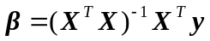 | (1.)
Provide equation numbers. Equation numbers should be named according to the chapters.
 | 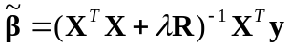 | (1.)
where is a constant called the regularization parameter and the matrix R depends on the application at hand and methods used. Typical methods includes ridge

1.2 Motivation and Contribution

This section is dedicated for motivation and contribution. You should elaborate about your contribution in this dissertation.

1.3 Outline

The thesis is organized as follows.

Chapter 2 Literature Review

A classifier 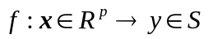 is a function or mapping which returns for a feature vector x the membership function y that belongs to a given set S. The membership function can either be a soft decision where  or a hard decision that S consists of discrete labels of different classes. For binary classifier with discrete output, 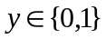.

Consider an input x=[x₁ x₂ …x_{j}....x_{p}]^{T} , where x_{j} is referred as a feature. The collection of n samples of x, x_{i}=[x_{i},₁ x_{i},₂ …x_{i},_{j}....x_{i},_{p}]^{T} i=1,…,n, forms an input or design matrix 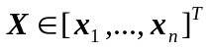. The corresponding labels/classes or responses y_{i} are stacked in the response vector Y=[y₁ y₂…y_{j}…y_{n}]^{T} or classes of items. In this thesis, we focus mainly on two-class classification, where . In classification, all inputs X are labelled and are used to determined the classifier. Usually, the data set is divided in a training set {(x₁,y₁), (x₂,y₂),…(x_{m},y_{m})} , and a testing set, one for training the classifer and the other for evaluating its ability of generalization. It should be distinguished from unsupervised (semi-) clustering, where all (part of the) samples are unlabelled and the separation is carried out without previous knowledge on the relationship between the Y and X.
Table 2.1 shows an example of a table. Fig. 2.1 shows an example of a figure.

Table 2.1 Example of a Table
Initialization
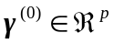 ;
t = 0; (loop = 0);
Recursion:
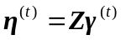
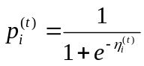
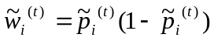, 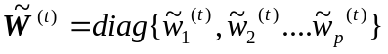

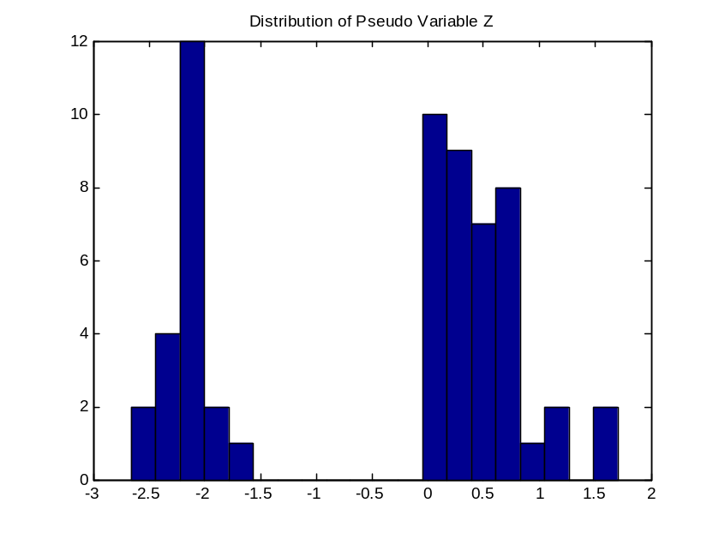

Fig 2.1. This is a figure.

Conclusion

This is my conclusion.

References

[1] Sven Serneels, Christophe Croux, Peter Filzmoser, Pierre J. Van Espen, “ Partial robust M-regression”, Chemometrics and Intelligent Laboratory Systems, Volume 79, Issues 1-2, Pages 55-64, ISSN 0169-7439, Oct 28 2005
[2] Fort G, Lambert-Lacroix S. ,“Classification using partial least squares with penalized logistic regression”, Bioinformatics (2005) 21:1104–1111, 2005

[3] S.C. Chan, “Partial Least Square”, internal technical report, Department of Electrical and Electronics Engineering, University of Hong Kong, 2009
[4] Ricardo A. Maronna, R. Douglas Martin, and Victor J. Yohai., Robust Statistics: Theory and Methods. 2006, Jon Wiley & Sons, Ltd ISBN: 0-470-01092-4
Computer Society, Washington, DC, 315-320, Dec 2004

