**Source Code :**

1. **The main flask code , named flasksqlcode.py**

from flask import Flask, render_template, request, redirect, url_for

from flask_mysqldb import MySQL

app = Flask(__name__)

app.secret_key = "deviapp"

app.config['MYSQL_HOST'] = 'localhost'

app.config['MYSQL_USER'] = 'root'

app.config['MYSQL_PASSWORD'] = 'root123'

app.config['MYSQL_DB'] = 'deviflasksql'

mysql = MySQL(app)

@app.route('/')

def func1():

return render_template('login.html')

@app.route('/login', methods=['POST'])

def login():

if request.method == 'POST' and 'uname' in request.form and 'pass' in request.form:

username = request.form['uname']

password = request.form['pass']

cursor = mysql.connection.cursor()

cursor.execute("SELECT * FROM usertable WHERE user_id=%s AND password_user=%s", (username, password))

data = cursor.fetchall()

if data:

return render_template('success.html',data=data)

else:

error="Invalid credentials,try again!"

return render_template('login.html',error=error)

if __name__ == '__main__':

app.run(debug=True)

1. **In the templates folder :**
2. **The login.html file (containing the login page HTML code)**

<!DOCTYPE html>

<html>

<head>

<style>

body {

font-family: Arial, Helvetica, sans-serif;

background-color: #f2f2f2;

text-align: center;

}

h1 {

background-color: #333;

color: #fff;

padding: 20px;

}

form {

max-width: 300px;

margin: 0 auto;

padding: 20px;

background-color: #fff;

border-radius: 5px;

box-shadow: 0px 0px 10px 0px #888888;

}

label {

display: block;

text-align: left;

margin-top: 10px;

}

input[type="text"],

input[type="password"] {

width: 100%;

padding: 10px;

margin-top: 5px;

margin-bottom: 10px;

border: 1px solid #ccc;

border-radius: 3px;

box-sizing: border-box;

}

input[type="submit"] {

background-color: #333;

color: #fff;

padding: 10px 20px;

border: none;

border-radius: 3px;

cursor: pointer;

}

input[type="submit"]:hover {

background-color: #555;

}

p {

color: red;

margin-top: 10px;

}

</style>

</head>

<body>

<h1>Login Details</h1>

{% if error %} ***<! The {% %} if for adding python lines in html >***

<p><strong>{{error}}</strong></p>

{% endif %}

<form method="post" action="/login">

<label for="uname">Username</label>

<input type="text" id="uname" name="uname">

<label for="pass">Password</label>

<input type="password" id="pass" name="pass">

<input type="submit" value="Submit">

</form>

</body>

</html>

1. **Success.html, the HTML file displaying the page after successful login**

<!DOCTYPE html>

<html>

<head>

<meta charset="UTF-8">

<title>Success</title>

<style>

body {

background-color: #f2f2f2;

color: #333;

font-family: Arial, Helvetica, sans-serif;

text-align: center;

}

h1 {

background-color: #333;

color: #fff;

padding: 20px;

text-align: center;

}

#intro {

font-size: 1.3em;

}

.colorful {

color: orange;

}

.container {

text-align: center;

padding: 20px;

}

.data-table {

width: 100%;

border-collapse: collapse;

margin: 20px 0;

}

.data-table tr {

background-color: #fff;

}

.data-table td {

padding: 10px;

border: 1px solid #ccc;

}

.data-table td:nth-child(2n) {

background-color: #f2f2f2;

}

</style>

</head>

<body>

<div class="container">

<h1>Hi there

{% for row in data %}

{{ row[0] }}

{% endfor %}

!!

</h1>

<p id="intro">Welcome to the home page...</p>

<p class="colorful">

<table class="data-table">

<tbody>

{% for row in data %}

<tr>

<td>Name: {{ row[2] }}</td>

</tr>

<tr>

<td>Roll number: {{ row[3] }}</td>

</tr>

<tr>

<td>Stream opting: {{ row[4] }}</td>

</tr>

{% endfor %}

</tbody>

</table>

</p>

</div>

</body>

</html>

1. **The SQL database creation on MySQL WorkBench**

CREATE DATABASE deviflasksql;

USE deviflasksql;

CREATE TABLE usertable(user_id varchar(30) NOT NULL,password_user varchar(30) NOT NULL,name_user varchar(30) NOT NULL,Rollno varchar(50) NOT NULL,streamuser varchar(30) NOT NULL);

INSERT INTO usertable(user_id,password_user,name_user,Rollno,streamuser) VALUES ('devik01','devi123','Devi Krishna','MITU19IMBI0015','Bioengineering'),( 'diyak06','diya456','Diya Krishna','MITU25EMBS0022','Commerce');

**Implementation :**

1. 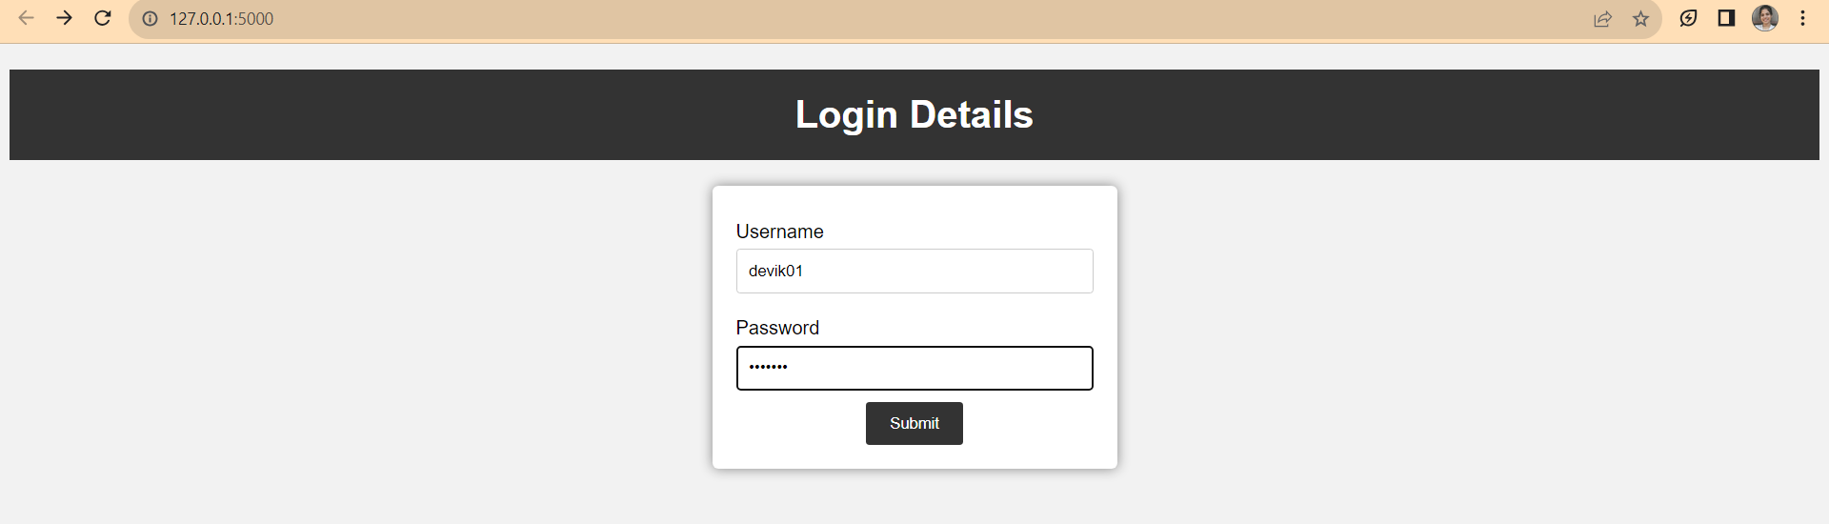The main login page displayed
2. 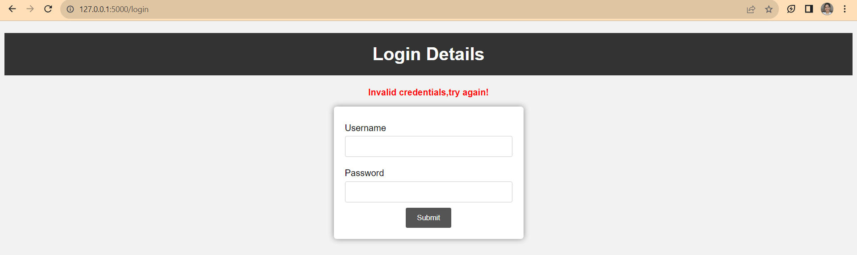If the credentials do not match with the database, error message displayed
3. 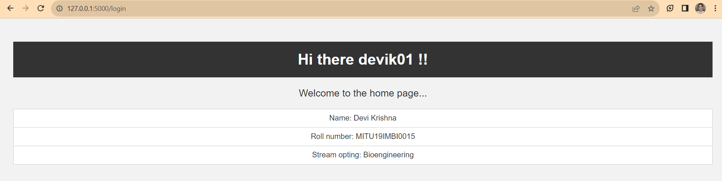If the credentials match with the database, the login is successful and database details are displayed in the second HTML page