Mini Project Report

Natural Language Processing

Complaint Classification Using Natural Language Processing

By

Nadaa Ahamed
Aashika Karthikesan
Devika Nair
123A1075
123A1076
123A1082



Department of Computer Engineering
SIES Graduate School of Technology Nerul, Navi Mumbai - 400 706
(AY 2026-27)

Contents

Abstract ii

CHAPTER 1: INTRODUCTION 1

1.1 Introduction 1

1.2 Motivation 1

1.3 Problem Statement and Objectives 1

1.4 Mini Project Contribution 2

CHAPTER 2: PROPOSED SYSTEM AND METHODOLOGY 3

2.1 Proposed System 3

2.2 Architecture / Framework / Block Diagram 3

2.3 Algorithm and Process Design 3

2.4 Hardware and Software 4

2.5 Methodology 4

CHAPTER 3: RESULTS AND DISCUSSIONS 5

3.1 Results 5

3.2 Code and Showcase Frontend 6

CHAPTER 4: CONCLUSION AND FUTURE SCOPE 7

4.1 Conclusion 7

4.2 Future Scope 7

References 8

Abstract
This mini-project develops ClearRoute, an educational complaint-classification prototype that analyzes a customer's written issue, suggests one of five support categories, and maps that category to a responsible team. The English pipeline uses cleaned complaint text, word-level TF-IDF features with unigrams and bigrams, and a Linear Support Vector Classifier selected after comparison with Multinomial Naive Bayes and Logistic Regression. A separate Marathi pipeline processes Devanagari complaints with character n-gram TF-IDF features and a class-weighted Linear SVM. The English dataset contains 636 curated examples and achieved 96.88% accuracy and a 0.966 macro F1 on one stratified 80/20 split. The Marathi dataset contains 75 examples and achieved 96.00% accuracy and a 0.960 macro F1 under stratified five-fold out-of-fold evaluation. To reduce unsafe automatic routing, empty, fragmentary, unsupported-script, and low-margin cases can be sent for clarification or human review. The prototype includes a minimal browser interface and a local Python HTTP server. Results are encouraging but preliminary: especially for Marathi, the small dataset and lack of an independent test set prevent claims of general performance.

CHAPTER 1
INTRODUCTION

1.1 Introduction
Customer support teams receive messages about payments, technical problems, delivery, product quality, and service experience. Manually reading and forwarding every message takes time and can create inconsistent routing. Text classification offers a way to organize incoming messages by learning patterns from labeled examples. This project builds a small supervised machine-learning system that predicts a complaint category and maps it to a suggested support destination.
The system is a decision-support prototype rather than an autonomous case-resolution tool. It does not investigate a complaint, issue a refund, or contact a department. Its purpose is to demonstrate the end-to-end path from text input through model prediction to a suggested next step.

1.2 Motivation
A useful classifier must do more than match a few obvious keywords. Similar terms can appear in different contexts, while a complaint may describe an issue without using an expected label word. This motivates the use of TF-IDF representations and supervised models trained on examples. The project also addresses a practical boundary case: random, incomplete, or ambiguous text should not be forced into a support category. Adding Marathi support explores how language-specific representations can extend the same workflow while making dataset limitations visible.

1.3 Problem Statement and Objectives

Problem Statement
Given a short English or supported Marathi customer message, classify it into Billing, Technical Support, Delivery, Product Quality, or Customer Service, and suggest the corresponding support team. When the text is too sparse, unsupported, or uncertain, the system should request clarification or recommend human review rather than presenting a confident category.

Objectives
• Prepare and inspect labeled English complaint data and a separate Marathi complaint corpus.
• Compare conventional supervised text-classification models on a fixed English split and evaluate the Marathi model with stratified cross-validation.
• Use language-appropriate TF-IDF features: word n-grams for English and character n-grams for Devanagari Marathi.
• Add input-quality and uncertainty checks so unsuitable complaints can be reviewed.
• Demonstrate prediction and routing through a minimal browser-based interface.

1.4 Mini Project Contribution
The contribution is an integrated, inspectable prototype: dataset preparation, English model comparison, a separate Marathi character-level classifier, a conservative clarification/manual-review path, and a local showcase interface. The implementation separates prediction from routing: a trained model predicts a category, while a fixed mapping supplies the suggested destination. Input checks are included to handle incomplete and unsupported messages, and results report evaluation limits rather than presenting small-sample scores as guarantees.
The project also makes the language boundary explicit. Devanagari input requires user confirmation as Marathi, mixed-script messages are held for review, and transliterated Marathi is outside the current training scope. These decisions make the prototype easier to demonstrate responsibly and identify concrete data and evaluation needs for future work.

CHAPTER 2
PROPOSED SYSTEM AND METHODOLOGY

2.1 Proposed System
The application accepts a complaint and first performs basic input and script checks. English text is passed to the English pipeline. Devanagari text can enter the Marathi pipeline after the user confirms that the input is Marathi; script alone cannot distinguish Marathi from Hindi. Mixed Latin and Devanagari text and unsupported inputs are directed to review. For supported text, the selected model returns a category prediction. The application maps the predicted category to its team and examines whether the message is suitable for automatic routing.
Input checks cover empty text, very short fragments, no vocabulary match, and low classification margin. For English, the margin is the difference between the highest and second-highest LinearSVC decision scores. It is a model score gap, not a calibrated probability. A fixed threshold of 0.30 is used as a conservative heuristic. Any prediction can still be wrong; human review remains important.

2.2 Architecture / Framework / Block Diagram
Figure 2.1. Complaint classification and routing workflow
Stage | Operation | Outcome
1. Input | Browser form receives complaint text and language confirmation. | Text or request for clarification
2. Validate | Check empty/fragmentary text, script, vocabulary coverage, and mixed-script cases. | Eligible text or manual review
3. Represent | English: word TF-IDF (1–2 grams). Marathi: character TF-IDF (2–5 grams). | Sparse numerical feature vector
4. Predict | Language-specific LinearSVC model selects one of five categories. | Predicted category and decision scores
5. Route / review | Map category to team; send uncertain or unsupported cases for review. | Suggested destination or review action

Figure 2.1 summarizes the system boundary. The local browser page communicates with a lightweight Python HTTP server, which loads the saved model artifacts. Classification and team routing happen locally in the project prototype; the demo does not connect to a real support-ticket platform.

2.3 Algorithm and Process Design
Dataset preparation. The English final dataset contains 636 labeled records across five categories. Counts are unequal and no oversampling is applied. The Marathi CSV contains 75 Devanagari records, with 15 examples in each category.
Preprocessing. English text is HTML-unescaped, tags and URL noise are handled, whitespace is normalized, and English stop words are removed while negation terms are retained. Marathi text is represented at the character level, which can capture subword patterns without requiring word segmentation.
Feature extraction. English TF-IDF uses word unigrams and bigrams with a 30,000-feature cap and sublinear term frequency. Marathi TF-IDF uses character n-grams of lengths 2 through 5 and a 50,000-feature cap.
Model selection. Three English candidates—Multinomial Naive Bayes, Logistic Regression, and LinearSVC—are evaluated with the same stratified split; the model with the highest macro F1 is selected. Marathi uses a separate class-weighted LinearSVC pipeline.
Prediction and review. The model predicts one of the five labels only for supported inputs. Empty, very short, unmatched, mixed-script, or low-margin messages are held for clarification/manual review as applicable.
Routing. A deterministic mapping connects Billing to Billing, Technical Support to Technical Support, Delivery to Delivery, Product Quality to Product Quality, and Customer Service to Customer Service.

2.4 Details of Hardware and Software
The project is designed to run locally. No dedicated GPU, cloud service, or physical device is required. The exact computer model and hardware configuration were not recorded, so they are not specified here.
Component | Use in project
Python 3 | Training scripts, preprocessing, model evaluation, and local web server.
pandas, NumPy | Tabular data handling and numerical operations.
scikit-learn | TF-IDF feature extraction, model training, stratified splitting, and evaluation.
joblib | Saving/loading trained model pipelines.
HTML, CSS, JavaScript | Minimal interactive showcase frontend.
Python standard library | HTTP server and local API; no separate frontend package required.

2.5 Methodology
The English experiment uses a stratified 80/20 train-test split with random state 42; all English candidates share this split, and macro F1 is used for selection so each class contributes equally despite unequal counts. The selected model is assessed on the held-out 128 examples. Marathi uses stratified five-fold out-of-fold predictions across all 75 examples because a separate hold-out would leave very few per class; the final artifact is fitted on all rows for the demo. The language pipelines remain separate. No transliteration data or Marathi source/provenance column is recorded, limiting reproducibility; Marathi results are exploratory.

CHAPTER 3
RESULTS AND DISCUSSIONS

3.1 Results
English model comparison on the same held-out split is summarized in Table 3.1. LinearSVC gave the highest macro F1 and was selected. The result indicates strong performance on this particular split; it does not establish performance on future customers or a different source distribution.
Table 3.1. English model comparison on 128 held-out examples
Model | Accuracy | Macro precision | Macro recall | Macro F1
Multinomial Naive Bayes | 0.852 | 0.919 | 0.818 | 0.853
Logistic Regression | 0.922 | 0.949 | 0.904 | 0.922
LinearSVC (selected) | 0.969 | 0.973 | 0.962 | 0.966

Figure 3.1. English LinearSVC confusion matrix; rows are true labels and columns are predictions
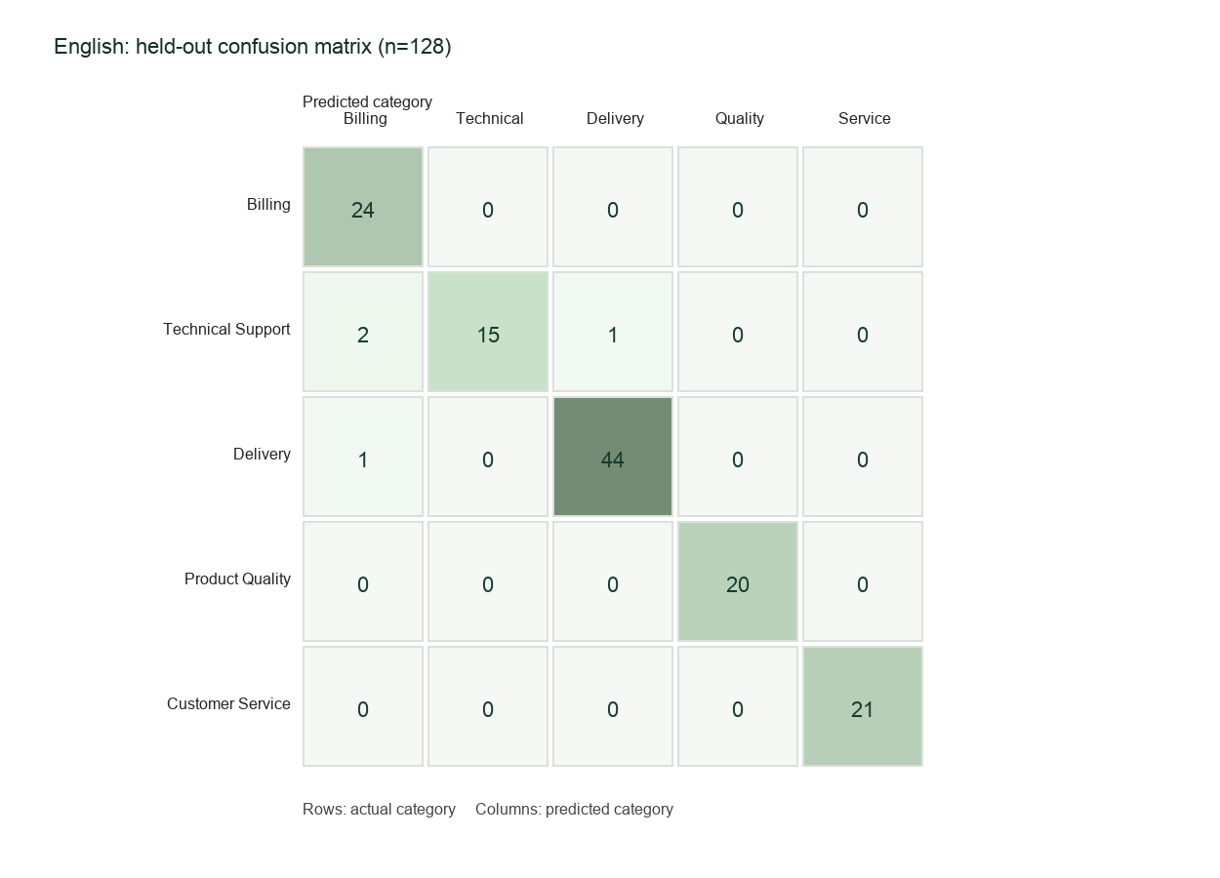
The held-out set contains 128 messages (24 Billing, 18 Technical Support, 45 Delivery, 20 Product Quality, 21 Customer Service). Four examples were misclassified. With the fixed 0.30 margin heuristic, six cases were flagged for review; two of the four category errors were among those flagged. The remaining automated subset contained 122 examples and had 98.36% accuracy. These review figures describe one held-out split, and the threshold has not been tuned or validated for deployment.
The Marathi five-fold out-of-fold evaluation produced 96.00% accuracy and 0.960 macro F1 across 75 examples. Table 3.2 and Figure 3.2 summarize this exploratory result. With the same fixed margin heuristic, 15 rows were flagged for review and two of the three classification errors were caught; 60 rows remained in the automated subset with 98.33% accuracy. Because all 75 examples are from a small corpus and there is no separate external test set, this result is not directly comparable to the English held-out score and should not be generalized.
Table 3.2. Marathi stratified five-fold out-of-fold result
Language/model | Examples | Accuracy | Macro F1 | Evaluation
Marathi character TF-IDF + class-weighted LinearSVC | 75 | 0.960 | 0.960 | 5-fold stratified out-of-fold

Figure 3.2. Marathi five-fold out-of-fold confusion matrix
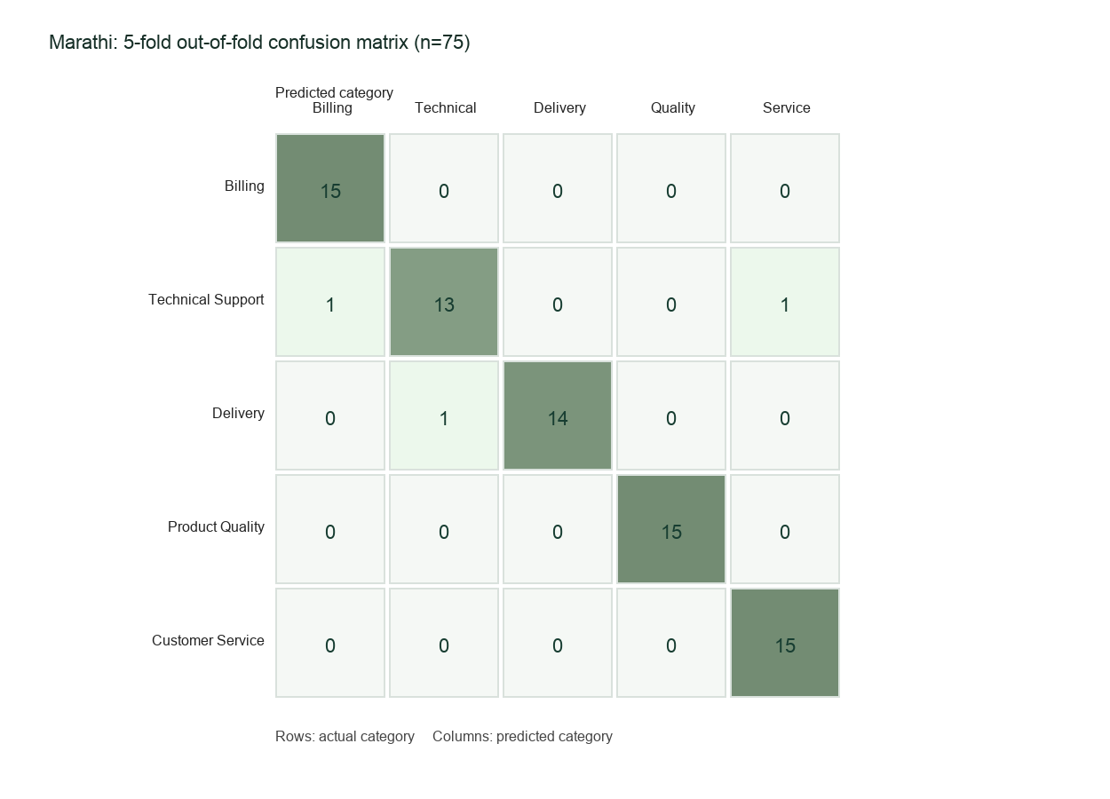
The interface explicitly asks the user to confirm Marathi when it detects Devanagari, since Hindi also uses Devanagari. It routes mixed Latin/Devanagari text to review because transliterated and mixed-script messages are not represented in the current Marathi training set. This is a deliberate limitation rather than an automatic language-identification claim.

3.2 Code and Showcase Frontend
The English pipeline is implemented in src/train.py, src/preprocessing.py, and src/test_model.py; Marathi training is in src/train_marathi.py. The local server (src/web_app.py) serves the showcase in web/index.html, web/styles.css, and web/app.js. Saved models and evaluation summaries are stored in models/ and outputs/. Run .venv/bin/python src/web_app.py from the project root and open http://127.0.0.1:8000. The educational demo suggests a destination or review.

CHAPTER 4
CONCLUSION AND FUTURE SCOPE

4.1 Conclusion
This project demonstrates a complete small-scale NLP workflow for complaint categorization: data preparation, feature extraction, model comparison, evaluation, uncertainty handling, category-to-team mapping, and a working local showcase frontend. The English LinearSVC achieved 96.88% accuracy on a single stratified held-out split, while the Marathi character n-gram model achieved 96.00% accuracy under five-fold out-of-fold evaluation. The scores are dataset-specific and not assurances of future accuracy.
The prototype also addresses incomplete or noisy submissions. Rather than forcing every message into a category, it supports clarification or human review for cases that fail input checks or appear uncertain. This reduces some routing risk but does not eliminate false classifications. Human review and broader evaluation remain necessary.

4.2 Future Scope
• Collect a larger, diverse, consented Marathi dataset with documented source, labeling guidance, and independent review.
• Create an external test set and evaluate by source and time to measure generalization and dataset shift.
• Add transliterated Marathi examples and evaluate code-mixed Marathi-English as a separately defined input type.
• Test Marathi/Hindi language identification or ask users to select a language when script is ambiguous.
• Calibrate and validate review thresholds on representative validation data; monitor false automatic routing and review workload.
• Add user feedback and error analysis while protecting customer privacy; integrate with a ticketing system only after reliability and governance checks.

References
[1] scikit-learn Developers, “TfidfVectorizer,” scikit-learn API Reference. https://scikit-learn.org/stable/modules/generated/sklearn.feature_extraction.text.TfidfVectorizer.html (accessed 9 Oct. 2026).
[2] scikit-learn Developers, “LinearSVC,” scikit-learn API Reference. https://scikit-learn.org/stable/modules/generated/sklearn.svm.LinearSVC.html (accessed 9 Oct. 2026).
[3] Ataur77, “ecommerce-customer-support,” Hugging Face Datasets. https://huggingface.co/datasets/Ataur77/ecommerce-customer-support (accessed 9 Oct. 2026).
[4] M. Othman, “mo-customer-support-tweets-945k,” Hugging Face Datasets. https://huggingface.co/datasets/MohammadOthman/mo-customer-support-tweets-945k (accessed 9 Oct. 2026).
[5] Complaint Classification Project, README and implementation files: data/final_clean_complaints.csv, data/marathi_complaints.csv, src/train.py, src/train_marathi.py, src/web_app.py, and outputs/model_comparison.json and outputs/marathi_model_comparison.json (accessed 9 Oct. 2026).

