
RAYAT SHIKASHAN SANSTHA’S
SADGURU GADAGE MAHARAJ COLLEGE, KARAD.
(An Empowered Autonomuos College)

A
Project report on
Hostel Website

Submitted to
SHIVAJI UNIVERSITY, KOLHAPUR
Through
DEPARTMENT OF COMPUTER APPLICATIONS

SADGURU GADAGE MAHARAJ COLLEGE, KARAD
In partial fulfilment of the degree

Bachelor of Computer Applications (BCA)
Part-III Semester-IV
By
Miss-Gaikwad Devika Lalaso
Miss-Chavan Dhanashri Shivaji
Under The Guidance of
Prof.s. S.S Jadhav
Year: 2025-26

RAYAT SHIKSHAN SANSTHA’S
SADGURU GADGE MAHARAJ COLLEGE, KARAD.



CERTIFICATE

This is certify that Miss.Gaikwad Devika Lalaso
and Miss.Chavan Dhanashri Shivaji have satisfactorily completed the Major project entitled as “Hostel Website” in the partial Fulfilment of BCA (Sem IV) during the academic year
2025-26.

Place: Karad Date:

Guide Examiner Head of Department

Dept. of Computer Applications
S.G.M. College, Karad

ACKNOWLEDGEMENT

We express our sincere thanks to Hon. Principal Dr. C. J. Khilare sir of S. G. M. College, Karad for providing us required university rule and regulation to complete this project work in time.
We are also thankful to Miss. N. S. Thorat (HOD of Computer Application Department) and our guide Miss. S.S. Jadhav Madam who encourage, advice and suggest us to successful complete our project. We are thankful to our librarian and their staff for providing us all library facilities time to time. We would like to thank to other teaching and non-teaching staff members of Computer Applications Department.
At last but not least, we are very much thankful to our parent and friends for cooperation to successfully complete this project in time.

Miss-Gaikwad Devika Lalaso
Miss-Chavan Dhanashri Shivaji

Place: Karad
Date :



DECLARATION

We hereby declare that, the industrial project entitled “Hostel Website” has not formed earlier the basic for the award of degree of this or any other University or examination body.
Further we declared that we have not violated any of the provisions under copyright act.

Place: Karad Date:

Name: Gaikwad Devika Lalaso
Exam Seat No.

Sign

Name: Chavan Dhanshri Shivaji

Exam Seat No.

Sign

INDEX

SR.NO | Name | Page No
1 | Introduction To Project  - About Project  - Proposed System  - Objectives  - Scope of System
2 | Requirement  - Requirement Analysis
3 | System Diagram  - DFD  - Entity Relationship diagram
4 | System Requirement  - Hardware  - Software  - Technology Used

5 | System Design  - Database Design  - Input Design
6 | Source Code
7 | Conclusion and Suggestion  - Conclusion and Suggestion  - Future enhancement  - Bibliography

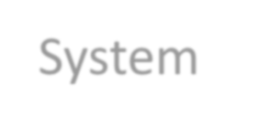

Introduction

To

System

Introduction To Project
○ About project:

Welcome to this well designed project “Hostel Website” this project related to the hostel. A hostel is a place where students or working individuals can stay, usually for a long period of time. Hostels provide affordable with basic facilities like beds, study areas and dining services.
- The main purpose of a hostel is to offer a safe, clean living environment for people who needlong-term housing. Hostels are commonly found near schools, colleges, and workplaces
- They help people time, especially those who come from different cities or rural areas.
- In this project, we aim to design and develop a hostel system that includes all the essential features needed for smooth management and comfortable living. The hostel will focus on safety, cleanliness for all residents.

○ Existing System:

- Manual Record Keeping
  - Most hostel information like student details, room allocation, payments, and complaints are stored in registers or files.
  - Staff must search through papers to find student information.
  - This process is slow and time-consuming.
- Offline Room Booking
  - Students or visitors must visit the hostel physically to check room availability.
  - Room booking is done manually by staff.
  - Sometimes double booking can happen due to lack of a proper system.
- Security Issues
  - Manual systems have low data security.
  - Anyone can access registers, and records can be changed or lost easily.
- Payment Handling Problems
  - Fee collection is mostly cash-based.
  - Managing payment records manually can cause calculation errors.
1

○ Proposed System

Introduction to proposed :
The proposed system is a web-based hostel Website developed to make hostel management easier and more efficient. It allows students to register and log in through the website and check room availability online. Students can book rooms according to their preference without visiting the hostel physically. All student details, room information, and booking records are stored securely in a database. room details, and bookings through the system. This system reduces manual work, saves time. It also allows users to access hostel information anytime and from anywhere through the internet.

Objectives:
  - To develop a web-based system for managing hostel information efficiently.
  - To provide online registration and login for students.
  - To allow students to check room availability and book rooms online.
  - To maintain student and room records in a database.
  - To help the admin manage hostel data easily.
  - To provide quick access to hostel information and facilities.
  - To improve the accuracy and security of hostel data.
  - To save time and effort for both students and hostel staff.
  - To make hostel management faster and more organized.

Scope of project
  - Student Registration and Login
Students can create an account and log in to access hostel services through the website.
  - Hostel Information Display
The website provides details about hostel facilities, rules, and available room types.
  - Room Availability Checking
Students can check whether rooms are available before booking.
2
  - Online Room Booking
The system allows students to book hostel rooms directly through the website.
  - Student and Room Database
All student details, room information, and booking records are stored in a database.
  - Admin Management System
The admin can manage rooms, student records, and bookings easily.
  - Reduced Paperwork
The system reduces manual record keeping and paperwork in hostel management.

3



Requirement

4
Requirement Analysis

The Requirement Analysis identifies the essential needs and expectations of students and hostel management and ensures the system is designed to improve efficiency, transparency, and convenience in hostel operations. It helps in understanding the important features required for the hostel website such as student registration, login, room availability checking, and online room booking.

5



System

diagrams

6
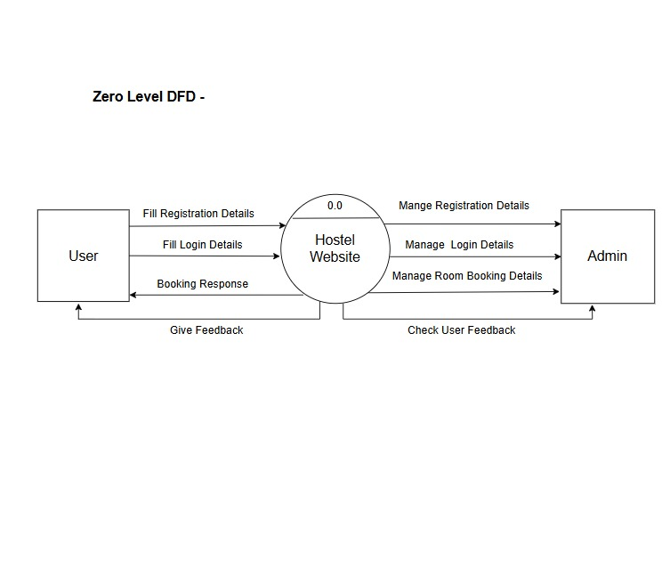
Data flow Diagram

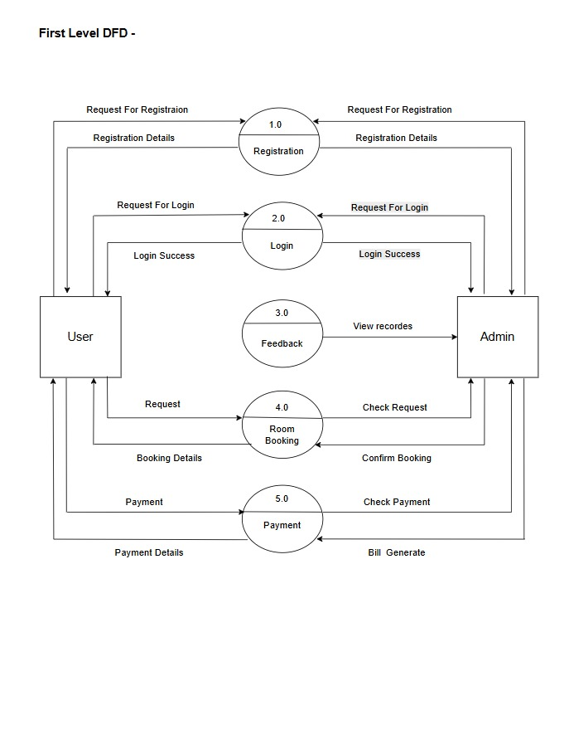
7
7
ERD

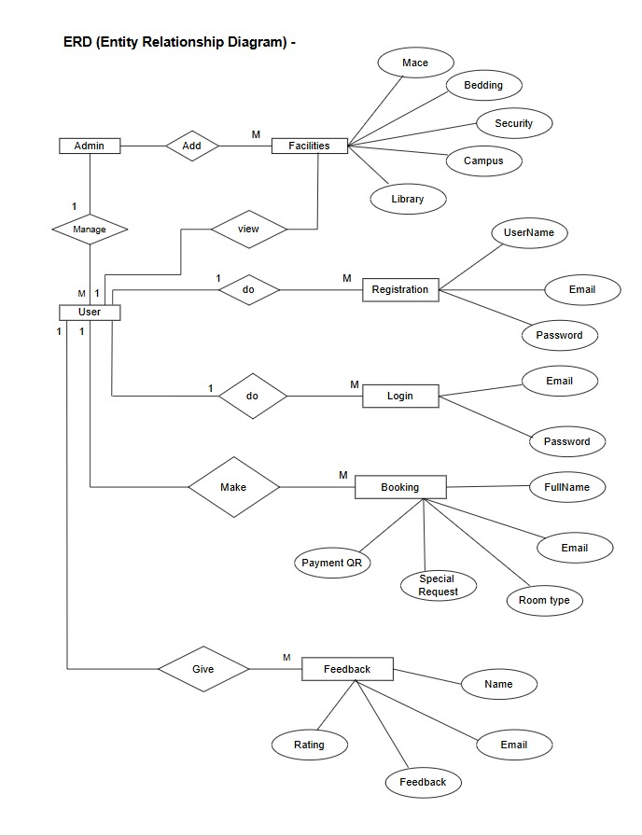

9



System

requirement

10
9

System requirement

- HARDWARE SPECIFICATION :

  - Processor : AMD Ryzen 5

  - RAM : 6 GB

  - Monitor : 15 inch Color Monitor

- SOFTWARE SPECIFICATION:

1)Operating System : Windows 11 pro
2)Developing Tool : VS Code
  - Front End : HTML, CSS, JavaScript
  - Back End : PHP
Database : MYSQL
- TECHNOLOGY USED:

HTML is a text-based language that uses special codes, known as tags, to annotate or "mark up" content. This markup tells a web browser how to display text, images, and other multimedia on a webpage.
HTML was created by Tim Berners-Lee.
He began development of the core components of the World Wide Web, including the initial specification for HTML, around 1990.
The first publicly available description of HTML, a document called "HTML Tags," was mentioned in late 1991.
The first formal specification, HTML 1.0, was developed in 1993.

- Need for HTML programming:

  - HTML is the fundamental backbone of every webpage, using tags to define the hierarchical organization of all content.

10
  - It explicitly identifies different types of content, such as headings (<h1>), paragraphs (<p>), lists (<ul>), and tables (<table>), giving meaning (semantics) to the data.
  - HTML enables internet navigation by creating hyperlinks (<a>) that connect pages within a site and to external resources, forming the basis of the World Wide Web.

  - It provides standard elements to embed images (<img>), videos (<video>), and audio (<audio>) directly into the web page.
  - Proper HTML usage, including semantic tags, ensures that content is understandable and navigable by assistive technologies (like screen readers), making the web accessible to all users.

  - It allows the creation of forms (<form>) and input fields (<input>) to collect data from users, which is essential for registration, logging in, and interaction.
  - Features of HTML Programming:
HTML (HyperText Markup Language) is the standard markup language for documents designed to be displayed in a web browser. It acts as the fundamental building block or skeleton of every webpage, defining the structure of the content through a system of elements represented by tags. These tags instruct the browser on how to display content—identifying text as headings, paragraphs, lists, or tables, and specifying where to place links and media. It's a static language, meaning it primarily organizes information rather than performing complex logic or calculations.
The language works by surrounding content with these tags (e.g., <h1>Content</h1>), which can also include attributes to provide additional information or modify element behavior (e.g., <img src="image.jpg">). HTML forms the foundation upon which CSS (Cascading Style Sheets) is applied for styling and presentation, and JavaScript is used to add dynamic behavior and interactivity, making the complete modern web experience possible.
- Hyperlinking and Navigation: The core function of HTML is to link documents together using the anchor tag (<a>), which establishes the interconnected network that forms the World Wide Web.
11
- Media Embedding: HTML offers native, built-in support for integrating various media formats, including images (<img>), audio (<audio>), and video (<video>), directly into a webpage without needing external plugins.
- Form Creation and Input: It allows developers to create complex interactive forms using elements like <form> and <input> with modern types (e.g., date, email, range), enabling user input and data collection.
- Client-Side Storage: Modern HTML (HTML5) introduced powerful client- side storage mechanisms like localStorage to enable web applications to store data directly in the user's browser, supporting offline capabilities and improving performance

12



System

Design

13

- _{Registration}

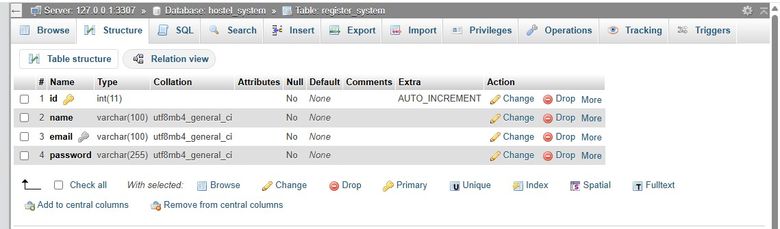

- Login:

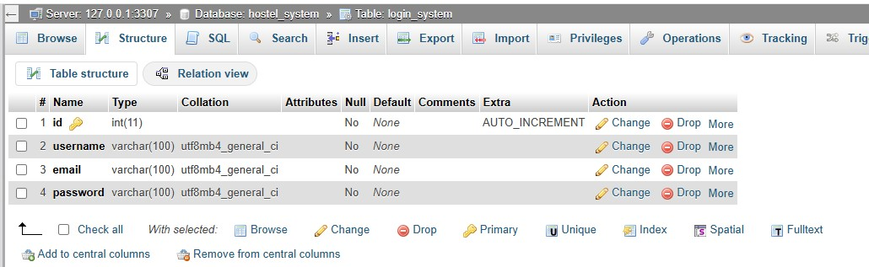

Booking:

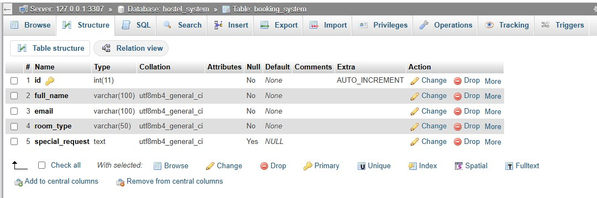

14
Feedback:
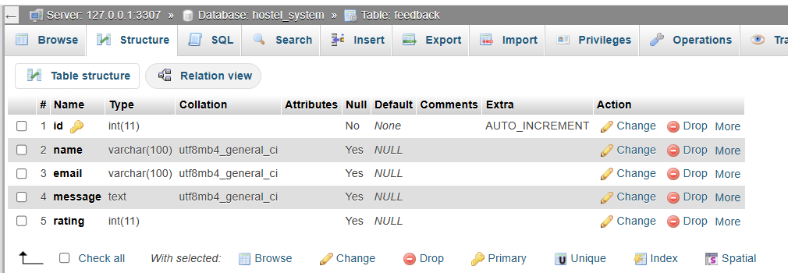

15


16

Input

design

Registration form:
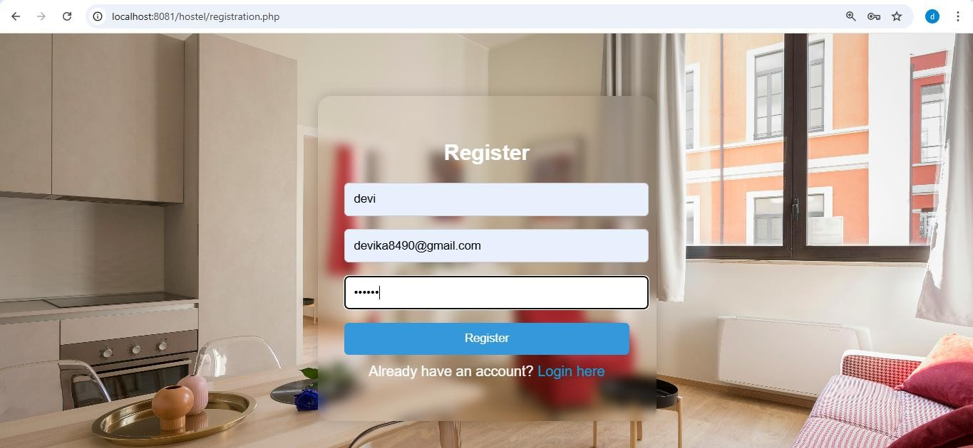
Login:
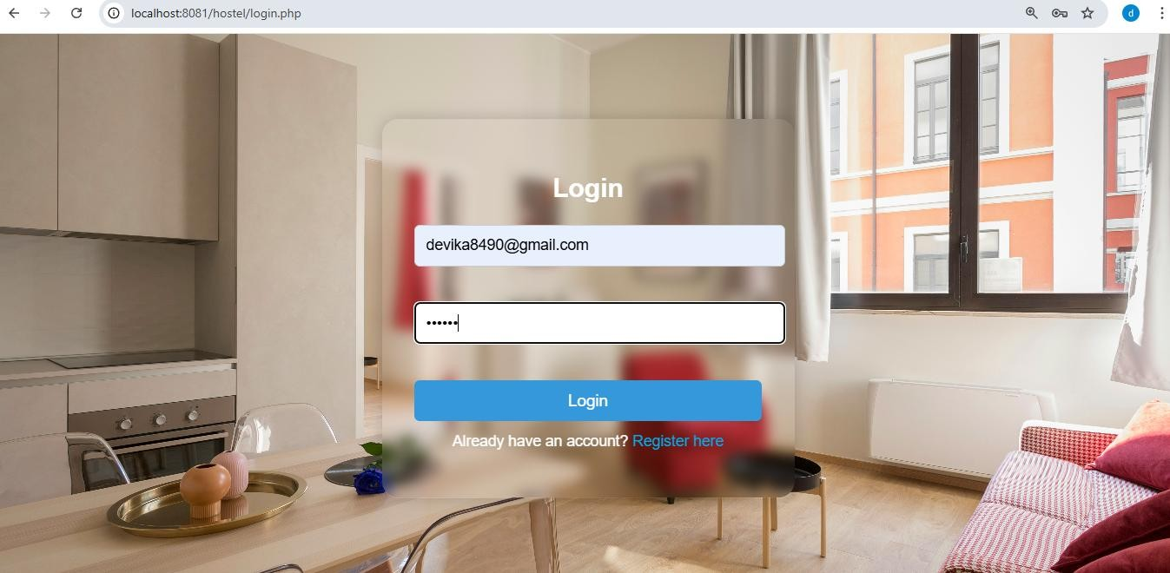

17
Home :

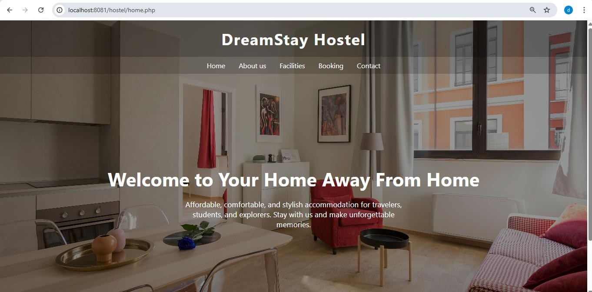

About us:
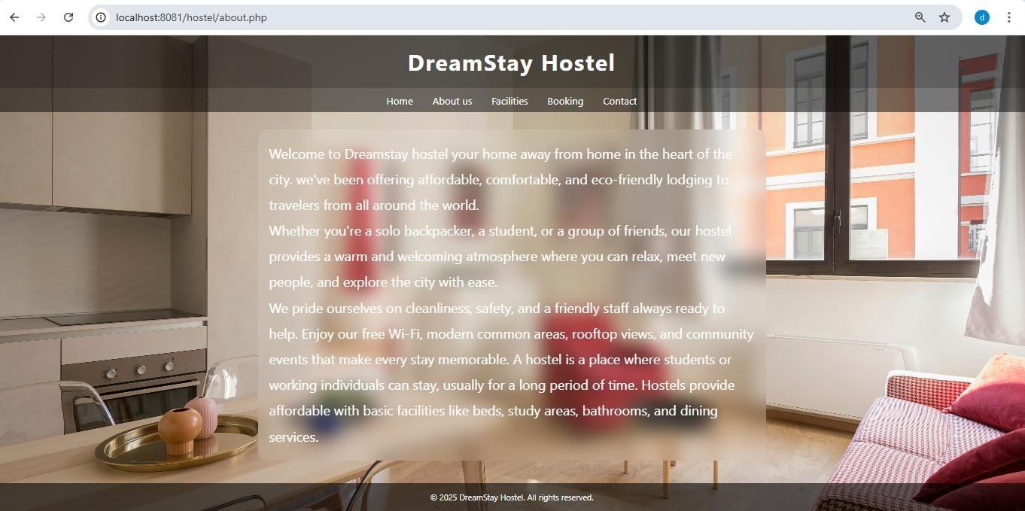

18

Contact us:

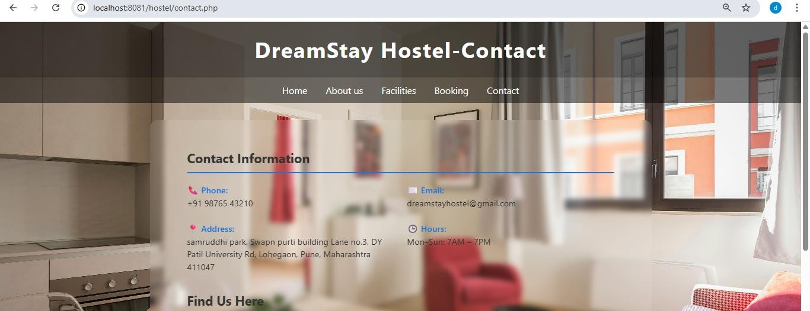

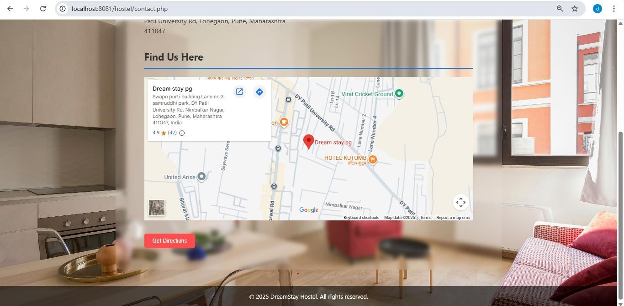

Facilities:
19
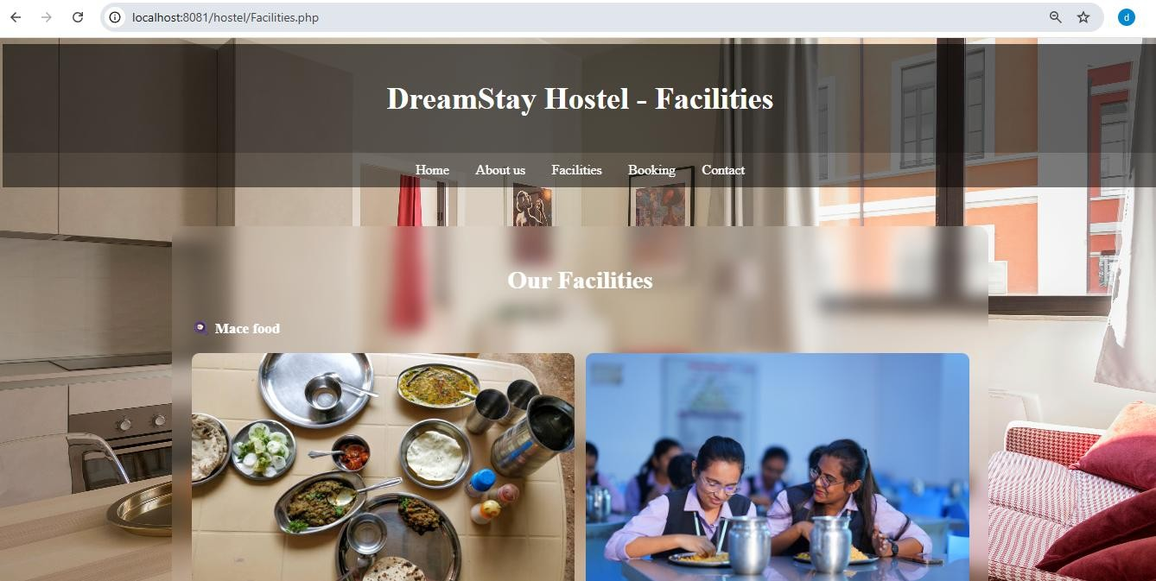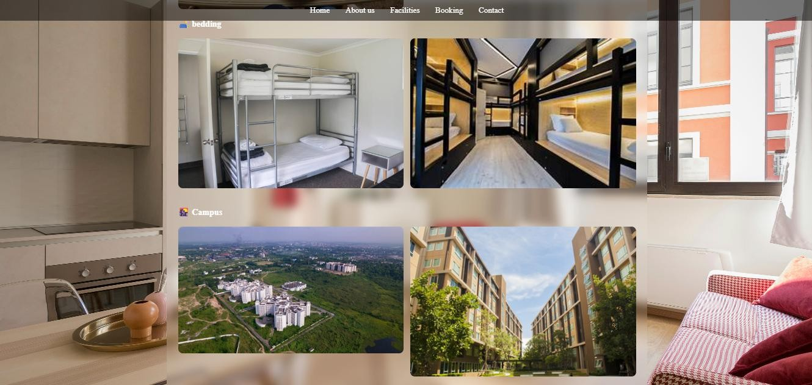
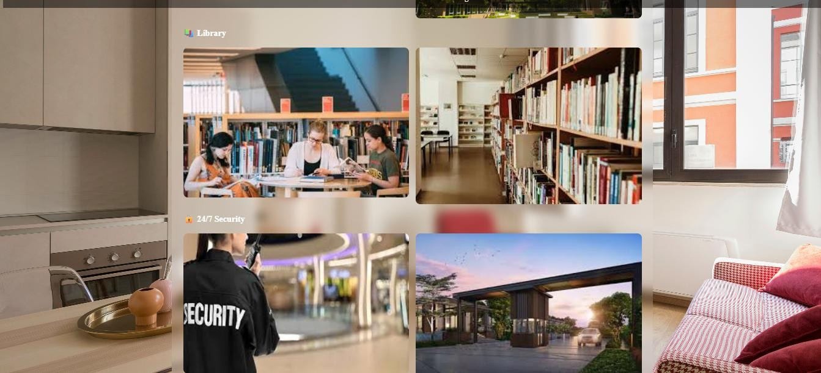
20
Booking form:
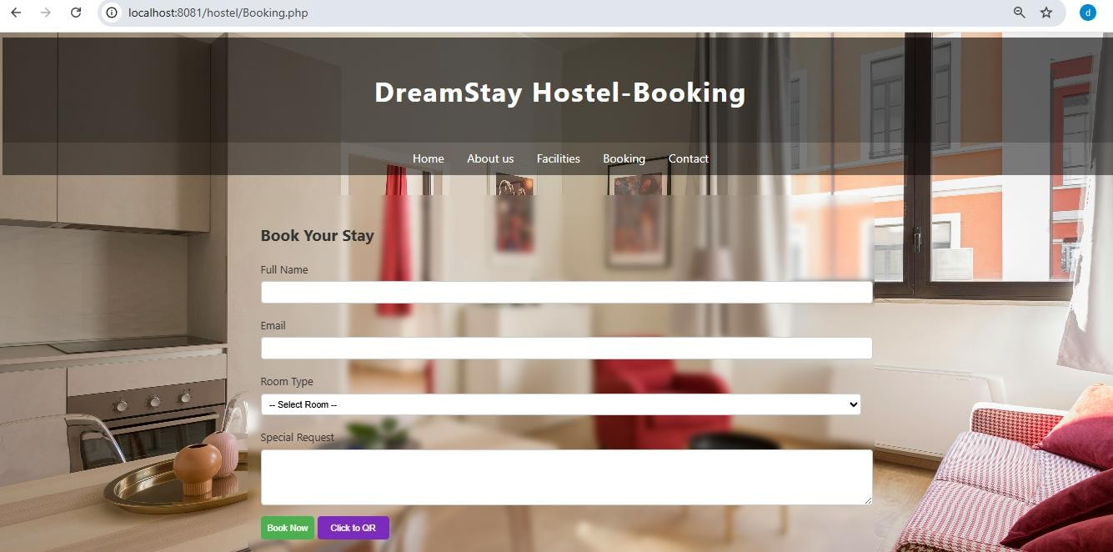
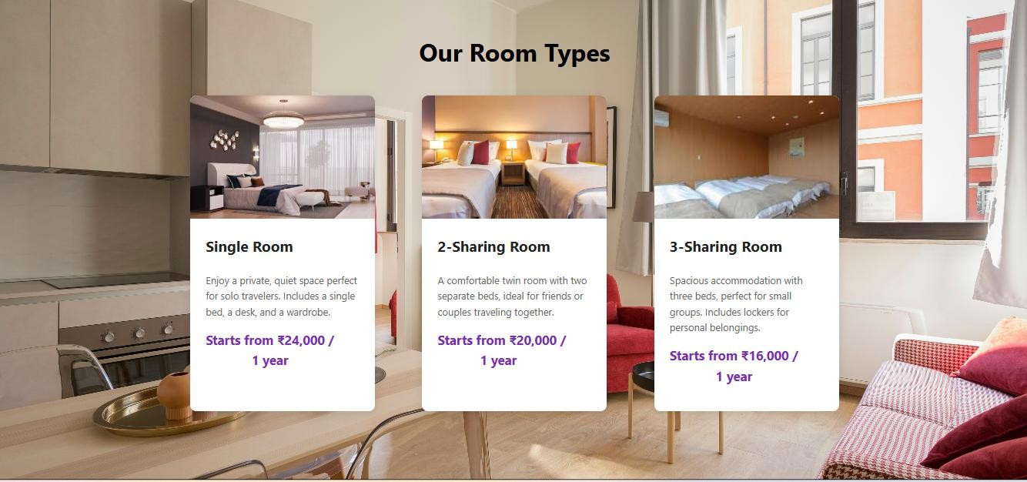
Feedback:
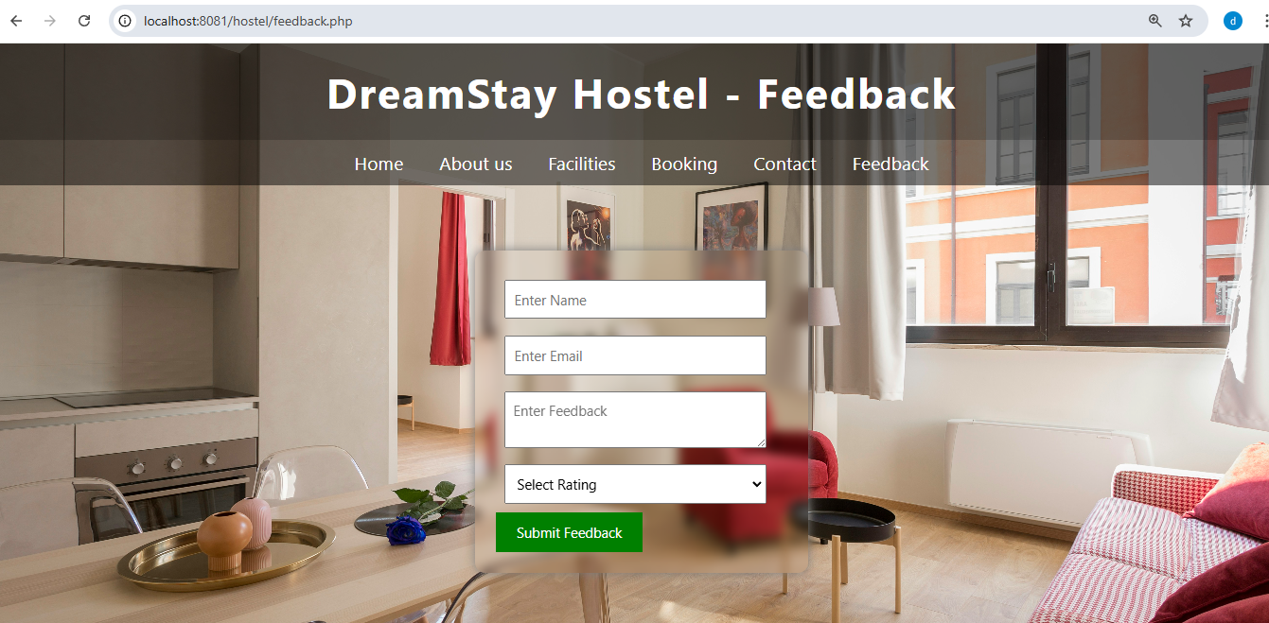
21


22

Source

code

1)Home.php:
<!DOCTYPE html>
<html lang="en">
<head>
<meta charset="UTF-8">
<meta name="viewport"
content="width=devicewidth, initial-scale=1">
<title>DreamStay
Hostel</title>
<style>
* { margin: 0; padding: 0; box-sizing: border-box; font-family: 'Segoe UI', Tahoma, Geneva, Verdana,
sans-serif;
}

body {
background:
url('https://images.unsplash. com/photo-1522708323590d24dbb6b0267') no-repeat
center center fixed; background-size: cover; color: white;
}
header {
background-color: rgba(0,
23
0, 0, 0.6); padding: 20px 0; text-align: center;
}

header h1 { font-size: 2.5em; color: #fff; letter-spacing: 2px;
}

nav { background-color: rgba(0,
0, 0, 0.5); padding: 10px; text-align: center;
}

nav a { color: #fff; text-decoration: none; margin: 0 15px; font-size: 1.1em; transition: color 0.3s;
}

nav a:hover { color: #00d9ff;
}
.hero { height: 90vh; display: flex; align-items: center; justify-content: center; background: rgba(0, 0, 0,
24
0.4); text-align: center; padding: 0 20px;
}

.hero h2 { font-size: 3em; margin-bottom: 20px;
}

.hero p { font-size: 1.2em; max-width: 600px; margin: 0 auto;
}

.section { background: rgba(255, 255,
255, 0.1); margin: 30px auto; padding: 20px; max-width: 900px; border-radius: 15px; backdrop-filter: blur(5px);
}
.section h3 { color: #00d9ff; margin-bottom: 10px;
}
25
.section p { line-height: 1.6;
}

footer { text-align: center; padding: 15px; background-color: rgba(0,
0, 0, 0.6); font-size: 0.9em; margin-top: 40px;
}
</style>
</head>
<body>

<header>
<h1>DreamStay
Hostel</h1>
</header>

<nav>
<a
href="home.php">Home</a
>
<a href="about.php">About us</a>
<a
href="Facilities.php">Facilit ies</a>
<a
26
href="Booking.php">Booki ng</a>
<a
href="contact.php">Contact
</a>

</nav>

<div class="hero">
<div>
<h2>Welcome to Your
Home Away From
Home</h2>
<p>Affordable,
comfortable, and stylish
accommodation for
travelers, students, and explorers. Stay with us and
make unforgettable
memories.</p>
</div>
</div>

<footer>
&copy; 2025 DreamStay
Hostel. All rights reserved.
</footer>

</body>
27
</html>

* { margin: 0; padding: 0; boxsizing: border-box; font-
family: Arial, sans-serif;
}

body { scroll-behavior: smooth; background:
#f9f9f9;
}

header { background: #800000; color: #fff; padding: 15px 40px; display: flex; alignitems: center; justify-content: space-between; flex-wrap:
wrap;
}
.logo-name { display: flex; align-items: center; gap: 10px;
}

header img { height:
70px; border-
radius: 50%;
}

28
.company-name { color: white; font-
weight: bold;
font-size: 1.2rem; line-height: 1.2;
}

nav ul { list-style: none; display: flex; flex-wrap: wrap;
}

nav ul li { margin:
0 15px;
}

nav ul li a {
text-decoration: none; color: white; font-
weight: bold;
transition: 0.3s;
}

nav ul li a:hover { color:
gold;
}

.hero,
.about,
29
.contact { display: flex; flex-direction: column; justify-content: center; align-items: center; text-align: center; padding: 40px 20px;
}

.hero img,
.about img { max-width: 600px; width: 100%; height: auto; borderradius: 10px; marginbottom: 20px;
}
.hero h1,
.about h2,
.contact h2 { color:
#800000; margin-
bottom: 15px;
}

.hero h1 { font-size:
2.5rem;
}

.about h2,
.contact h2 { font-size:
2rem;
}
30

.hero p,
.about p,
.contact p { maxwidth: 800px;
margin: auto; font-
size: 1.1rem;
color: #333; lineheight: 1.6;
}

footer { background: #222; color: #ddd; text-align: center;
padding: 15px;
margin-top: 40px;
}

@media(max-width:768px) { nav ul { flex-direction: column; gap: 10px;
margin-top: 10px;
}

header { flex-direction: column; align-items:
flex-start;
}
}
</style>
</head>
31

<body>
<?php include 'header.php'; ?>

<!-- Hero Section -->
<section id="hero" class="hero">
<img src="sayadri.jpg" alt="Sahyadri Sakhar Karkhana Factory">
<h1>Sahyadri Sahakari Sakhar Karkhana Ltd.</h1>
<span style="color:black;">
Sahyadri Sahakari Sakhar Karkhana Ltd. (SSSKL) is one of the most prominent
cooperative sugar factories in western Maharashtra, situated at Yashwantnagar in Taluka Karad, District Satara. It was established in 1969 and commenced crushing operations in the 1974-75 season with an initial capacity of about 1,250 tons of cane per day (TCD). Over the years, the factory has expanded its scale and infrastructure, becoming a model cooperative enterprise in the region. Today, its cane crushing capacity stands at 7,500 TCD, supported by modern milling machinery such as Fibrizors and ULKA mills, and a distillery unit of 45 kilolitres per day (KLPD). The factory is strategically located around 12–13 km from Karad town, close to Shirwade Railway Station, and within reach of the fertile Krishna river basin, which ensures consistent cane cultivation in its command area.
</span>
</section>
</body>

</html>

registration.html
<?php
$conn = new mysqli("localhost", "root", "", "hostel_system", 3307); if ($conn->connect_error) { die("Connection Failed: " . $conn->connect_error);
}
$error = "";
$success = "";
32

if ($_SERVER["REQUEST_METHOD"] == "POST") {

$name = trim($_POST['username'] ?? '');
$email = trim($_POST['email'] ?? '');
$password = trim($_POST['password'] ?? '');

if (!empty($name) && !empty($email) && !empty($password)) {

// Check if email already exists
$check = $conn->prepare("SELECT id FROM register_system WHERE email=?");
$check->bind_param("s", $email);
$check->execute();
$check->store_result();

if ($check->num_rows > 0) {
$error = "Email already exists!";
} else {

// Direct password store (no hashing)
$stmt = $conn->prepare("INSERT INTO register_system (name, email, password) VALUES (?, ?, ?)");
$stmt->bind_param("sss", $name, $email, $password);

if ($stmt->execute()) {
$success = "Registration Successful!";
} else {
$error = "Error while registering!";
}

$stmt->close();
33
}

$check->close();
} else {
$error = "All fields are required!";
}
}

$conn->close();
?>
<!DOCTYPE html>
<html lang="en">
<head>
<meta charset="UTF-8">
<title>Register</title>
<style>
body { font-family: Arial, sans-serif;
background: url('https://images.unsplash.com/photo-1522708323590-d24dbb6b0267') no-
repeat center center fixed; background-size: cover; color: white; display: flex; justify-content: center; align-items: center; height: 100vh; margin: 0;
}
.register-container { padding: 30px; border-radius: 15px; width: 320px; box-shadow: 0 0 15px rgba(0,0,0,0.2); backdrop-filter: blur(6px);
34
} h2 { text-align: center; margin-bottom: 20px; } input { width: 100%; margin-bottom: 15px; padding: 10px; border-radius: 5px; border: 1px solid #ccc;
} button { width: 100%; padding: 10px; background: #3498db; color: white; border: none; border-radius: 5px; cursor: pointer;
} button:hover { background: #2980b9; }
.error { color: #ff4d4d; font-size: 14px; margin-bottom: 10px; } .success { color: #00ff88; font-size: 14px; margin-bottom: 10px; } p { text-align: center; margin-top: 10px; } a { color: #00acee; text-decoration: none; } a:hover { text-decoration: underline; }
</style>
</head>
<body>
<div class="register-container">
<h2>Register</h2>

<form method="POST" action="">
<div class="error"><?php echo $error; ?></div>
<div class="success"><?php echo $success; ?></div>

<input type="text" name="username" placeholder="Username" required>
<input type="email" name="email" placeholder="Email" required>
<input type="password" name="password" placeholder="Password" required>

<button type="submit">Register</button>

<p>Already have an account? <a href="login.php">Login here</a></p>
35
</form>
</div>
</body>
</html>
Booking.php
<?php
$conn = new mysqli("localhost", "root", "", "hostel_system", 3307);

if ($conn->connect_error) {
die("Connection Failed: " . $conn->connect_error);
}

if ($_SERVER["REQUEST_METHOD"] == "POST") {

$name = $_POST['name'] ?? '';
$email = $_POST['email'] ?? '';
$room = $_POST['room'] ?? '';
$message = $_POST['message'] ?? '';

if (!empty($name) && !empty($email) && !empty($room)) {

$stmt = $conn->prepare("INSERT INTO booking_system (full_name, email, room_type, special_request) VALUES (?, ?, ?, ?)");
$stmt->bind_param("ssss", $name, $email, $room, $message);
$stmt->execute();
$stmt->close();

echo "<script>alert('Booking Successful!');</script>";
} else {
echo "<script>alert('Please fill all required fields');</script>";
}
}

$conn->close();
?>
<!DOCTYPE html>
<html lang="en">
<head>
<meta charset="UTF-8">
<title>Hostel Booking Page</title>
<style>
body {
font-family: 'Segoe UI', Tahoma, Geneva, Verdana, sans-serif;
line-height: 1.6;
color: #333;
36
background: url('https://images.unsplash.com/photo-1522708323590-d24dbb6b0267') no-repeat center center fixed;
background-size: cover;

}

header {
background-color: rgba(0, 0, 0, 0.6);
padding: 20px 0;
text-align: center;
}

header h1 {
font-size: 2.5em;
color: #fff;
letter-spacing: 2px;
}

nav {
background-color: rgba(0, 0, 0, 0.5);
padding: 10px;
text-align: center;
}

nav a {
color: #fff;
text-decoration: none;
margin: 0 15px;
font-size: 1.1em;
transition: color 0.3s;
}

nav a:hover {
color: #00d9ff;
}
.section {
background: rgba(255, 255, 255, 0.1);
margin: 30px auto;
padding: 20px;
max-width: 900px;
border-radius: 15px;
backdrop-filter: blur(5px);
}
37

.form-box {
margin: 30px auto;
padding: 20px;
max-width: 900px;
border-radius: 15px;
backdrop-filter: blur(5px);
}

label {
display: block;
margin: 10px 0 5px;
}
input, select, textarea {
width: 100%;
padding: 8px;
margin-bottom: 10px;
border: 1px solid #ccc;
border-radius: 5px;
}
button {
background: #4CAF50;
color: white;
padding: 10px;
border: none;
border-radius: 5px;
cursor: pointer;
}
button:hover {
background: #45a049;
}
footer {
text-align: center;
padding: 15px;
background-color: rgba(0, 0, 0, 0.6);
font-size: 0.9em;
margin-top: 40px;
color: #fff;
}
.container {
max-width: 1100px;
margin: 0 auto;
padding: 20px;
}
.room-section {
padding: 50px 0;
38
text-align: center;
}
.room-section h2 {
font-size: 2.5em;
margin-bottom: 40px;
color:black;
}

/* Styling for the room cards */
.room-cards {
display: flex;
justify-content: space-around;
flex-wrap: wrap;
gap: 30px;
}
.room-card {
background-color: #fff;
border-radius: 10px;
box-shadow: 0 4px 15px rgba(0, 0, 0, 0.1);
overflow: hidden;
transition: transform 0.3s ease-in-out, box-shadow 0.3s ease-in-out;
width: 300px;
text-align: left;
}
.room-card:hover {
transform: translateY(-10px);
box-shadow: 0 8px 30px rgba(0, 0, 0, 0.2);
}
.room-card img {
width: 100%;
height: 200px;
object-fit: cover;
display: block;
}
.room-card-content {
padding: 25px;
}
.room-card-content h3 {
margin-top: 0;
font-size: 1.5em;
color: #222;
}
.room-card-content p {
font-size: 1em;
line-height: 1.6;
color: #666;
39
}
.price {
font-size: 1.3em;
font-weight: bold;
color: #7b2cbf;
margin: 15px 0;
}
.qr-box{
display:none;
text-align:center;
margin-top:20px;
}
.book-button {
display: inline-block;
background-color: #7b2cbf;
color: #fff;
text-decoration: none;
padding: 10px 20px;
border-radius: 5px;
transition: background-color 0.3s ease;
}
.book-button:hover {
background-color: #5a1f8c;
}

@media (max-width: 768px) {
.room-cards {
flex-direction: column;
align-items: center;
}
.room-card {
width: 90%;
}
}

</style>
</head>
<body>
<header>

<h1>DreamStay Hostel-Booking</h1>
</header>

<section>
40
<nav>
<a href="home.php">Home</a>
<a href="about.php">About us</a>
<a href="Facilities.php">Facilities</a>
<a href="Booking.php">Booking</a>
<a href="contact.php">Contact</a>

</nav>
</div>
</section>

<div class="form-box">
<h2>Book Your Stay</h2>
<form method="POST" action="">
<label>Full Name</label>
<input type="text" name="name" required>

<label>Email</label>
<input type="email" name="email" required>

<label>Room Type</label>
<select name="room" required>
<option value="">-- Select Room --</option>
<option value="single">Single Room</option>
<option value="double">Double Sharing</option>
<option value="triple">Triple Sharing</option>
</select>

<label>Special Request</label>
<textarea name="message" rows="4"></textarea>

<button type="submit">Book Now</button>
<button class="book-button" onclick="showQR('qr1')">Click to QR</button>

<div id="qr1" class="qr-box">
<img src="images\qr.jpeg" width="500">
</div>
</form>
</div>

<section class="room-section">
<div class="container">
<h2>Our Room Types</h2>
<div class="room-cards">

41
<div class="room-card">
<img src= "images/bed1.avif">
<div class="room-card-content">
<h3>Single Room</h3>
<p>Enjoy a private, quiet space perfect for solo travelers. Includes a single bed, a desk, and a wardrobe.</p>
<div class="price">Starts from ₹24,000 / <br>&nbsp &nbsp &nbsp &nbsp &nbsp &nbsp &nbsp1 year </div>

</div>
</div>

<div class="room-card">
<img src="images/bed2.webp">
<div class="room-card-content">
<h3>2-Sharing Room</h3>
<p>A comfortable twin room with two separate beds, ideal for friends or couples traveling together.</p>
<div class="price">Starts from ₹20,000 /<br>&nbsp&nbsp&nbsp&nbsp &nbsp &nbsp &nbsp &nbsp1 year </div>

</div>
</div>
<div class="room-card">
<img src="images/bed3.jpg">
<div class="room-card-content">
<h3>3-Sharing Room</h3>
<p>Spacious accommodation with three beds, perfect for small groups. Includes lockers for personal belongings.</p>
<div class="price">Starts from ₹16,000 / <br>&nbsp &nbsp &nbsp &nbsp &nbsp &nbsp &nbsp1 year </div>

</div>
</div>

</div>
</div>

</section>
<script>
function showQR(id){
var qr = document.getElementById(id);

if(qr.style.display === "none" || qr.style.display === ""){
qr.style.display = "block";
42
} else {
qr.style.display = "none";
}
}
</script>

<footer>
&copy; 2025 DreamStay Hostel. All rights reserved.
</footer>

</body>
</html>

db.php

<?php

$conn = mysqli_connect("localhost","root","","hostel_system",3307);

if(!$conn){ die("Connection failed");
} ?>

43



Conclusion

and

suggestion

44

Conclusion
The Hostel Website is developed to simplify and modernize the process of managing hostel activities. The system helps students and administrators handle important tasks
such as room booking, registration, login, and hostel information in an organized way. By using this website, manual work is reduced and data can be stored and managed efficiently.
The website improves communication between hostel management and students. It provides easy access to information about available rooms, facilities, and booking details. This system also saves time, reduces paperwork, and minimizes errors that may occur in manual record keeping.
Overall, the Hostel Management Website makes hostel management more efficient, transparent, and user-friendly. It provides a reliable platform for managing hostel operations and enhances the overall experience for both students and administrators.
Future Enhancement:

- The system can be made more digital friendly.
- Payment records management
- Proper booking form

45



BIbilography

46

○ WEBSITE:

- www.hostelworld.com – For reference on hostel facilities and booking system.
- www.wikipedia.org – For general information about hostels and their management.
- www.w3schools.com – For learning HTML, CSS, and website design techniques.
- https://www.canva.com-Canva. Design Resources for Web Layouts and Icons.
- https://www.w3schools.com/css-W3Schools. CSS Tutorial.
○ Books:

• HTML and CSS :Design and Build Websites- Kamal Acharya
47

