**Prediction of Cardiovascular Attacks (CVA’s) using Machine Learning**

By Devika Jagarlamudi

**Description of the chosen community/population**

My proposed solution would be using Machine Learning algorithms to forecast cardiovascular attacks (CVAs) among individuals diagnosed with diabetes in the Sikh community in Amritsar state of Punjab in India known for its cultural and religious significance to the Sikh community. The Sikh population in Amritsar is significant, and diabetes and cardiovascular diseases are prevalent health concerns in this community. So, I want to include both male and female participants aged between 44 - 75 years. According to the 2015 Census of India the population of Amritsar district was estimated to be around approximately 2.5 million with greater proportion being Sikhs (Singh et al., 2016).

By focusing just on the Sikh community in Amritsar I would want My proposed solution to aim in addressing the cardiovascular health needs and risk factors of this population and developing a machine learning model would help to predict cardiovascular attacks among individuals with diabetes in this community which could help in early intervention and targeted preventive strategies.

**Background information on the health problem**

Cardiovascular Attacks (CVAs) are a major leading cause of mortality worldwide with an estimated number of 17.9 million deaths each year where it represents 31% of all global deaths (World Health Organization, 2017). India has seen a very high burden of both diabetes and CVAs according to the International Diabetes Federation (IDF) where in 2021the individuals Ire approximately 77 million in India who Ire living with diabetes making it the second-highest country in terms of diabetes prevalence (International Diabetes Federation, 2019).

In Amritsar population the Sikh population ais always seen to have unhealthy diets and lifestyles that mainly contribute to the high incidence of diabetes which increases the risk of cardiovascular attacks where Uncontrolled diabetes would gradually damage the blood vessels which then leads to the accumulation of plaque, formation of blood clots, and blockage of arteries, obstructing the blood flow to the heart.  The Sikh community in Amritsar, like many other states in India which has been highly  affected by these health issues where a study conducted in the Sikh population of Punjab found that the prevalence of diabetes was 6.6% in urban areas and 3.1% in rural areas Furthermore it was reported that the prevalence of CVAs in the Sikh population of Amritsar was 11.4%, with a higher prevalence among males (13.3%) compared to females (9.5%). Additionally, the insulin resistance prevalent in type 2 diabetes also seen to exacerbate the complications where it significantly increases the chances of attacks due to elevated blood sugar levels, arterial hardening, and other factors like hypertension and obesity. Effective management of diabetes can alleviate the risk of heart attacks which is a 1% reduction in blood sugar levels correlates with a 14% decrease in attack risk in type 2 diabetes, while intensive glucose control reduces cardiovascular attack risk by 42% in type 1 diabetes (Singh et al., 2016).

**Description of the existing technology solutions available**

* **Automatic External Defibrillators (AEDs)**

In the event of sudden cardiac arrest, readily available Automatic External Defibrillators are the first and most important responder. An AED (Automatic External Defibrillators) auto-diagnoses the electrical activity of the heart and can choose the suitable shock to bring back a normal heartbeat. If it is required, then the device delivers electrical current between the chest and the heart. As small as a briefcase and simple to operate, AEDs possess voice leads and visual signals to lead even untrained people through the process. These are frequently encountered in public spaces, such as schools, gyms, and airports.

* **Wearable ECG Monitors**

The Wearable ECG monitors are high-tech devices built into smartwatches, fitness trackers, and other items, enabling continuous tracking of the heart's electrical activity. These devices can recognize and gauge irregularities including atrial fibrillation as a risk factor for heart attacks or strokes. The data collected could be sent to the healthcare providers in real-time which would make the necessary medical intervention devices interactive which leads to users' engagement, and self-management of heart health.

* **Intravascular Ultrasound (IVUS)**

Intervascular Ultrasound (IVUS) is the technique of catheter with the ability to see the innards of blood vessels from inside. This is a comprehensive examination. Through this procedure, a small ultrasonic probe is inserted into the artery and a 0-degree view of the wall is provided by the high frequency sound waves. It is crucial in this regard in evaluating the quantity and character of plaque build-up and it provides guidance for the choice of stents and various other treatments. IVUS is incomparable for estimating the atherosclerosis degree in coronary arteries and performing complex interventions.

* **Coronary Stents**

Coronary stents are lifesaving devices that are prominently used during the procedures in which coronary artery surgery is done, for example, angioplasty. A stent, which is a tiny wire mesh tube, is inserted into the coronary vessels after a blockage or narrowing to keep them open. The stent is launched to the necessary spot on a balloon catheter, once there, the balloon is inflated, and the stent expands and then locks in place to let the blood flow more easily. Drug-eluting stents, which are pre-treated to release medicine that helps to prevent the artery from closing again, are in wide use.

**Telemedicine and Mobile Health Apps**

The development of telemedicine platforms and mobile health apps is a considerable progress in patient care, and these advances can be seen in the management of chronic conditions like heart disease. These technologies enable patients to receive treatment on remote bases that eliminate the end for frequent hospital visits. Health apps may be used to record usual vital signs like heart rate, blood pressure, and oxygen levels, which means a lot to people with heart disease. Doctors can check up on their patients in real time and adapt treatment plans as needed, based on available data. Together, they improve the capacity to prevent, diagnose and treat cardiovascular diseases more efficiently, saving patient lives and improving their quality of life.

**Description of the proposed technology solution**

Predicting heart problems in people with diabetes can really help saving many lives. This is vital since cardiac events account for a huge portion of deaths, specifically in the diabetic population. I can take precautions to prevent heart problems by knowing who is more subjected to have them. It is necessary to act now since, as people become old, there will be more chances for the older people to develop diabetes and cardiac issues. I can start helping people in maintaining their health before experiencing heart attacks by developing a prediction tool now. For Businesses and Doctors this model can be super helpful.

**Role of Machine Learning in predicting the Cardiovascular Attacks (CVA’s)**

The primary goal of this project is to use Machine Learning, employing Jupiter Notebook, to predict Cardiovascular Attacks (CVAs) in people with Diabetes aged between 45 to 75 in Amritsar population. My target is to build a model in such a way that it gives output, that is person having chances to get attack or not, based on the given input. Build the model through Machine Learning, a set of training data is required. This gathered data will be used by Machine Learning method to train the model.

Model

Given Input 1

Given Input 2

Given Input 3

Output 1

Output 2

Output 3

 Machine Learning is like having a super-smart assistant that can alert doctors early if someone might be in danger or in the line of disease occurrence.  The Key components of My proposed solution will include:

* **Data collection**

I collected the datasets from the community-driven platform which is Kaggle. Extracted the data and transported it to excel file in order to understand the complete data. The data I have used consists of various attributes related to individual health and lifestyle. –Below is the table which includes attributes, their description and the datatype which I have used for model training.

<https://www.kaggle.com/datasets/prosperchuks/health-dataset?select=diabetes_data.csv>

These attributes offer useful information about individuals health conditions, lifestyle habits and demographic characteristics.

* **Data preprocessing**

I did some careful preparation with the data to make sure it is good for studying further. Initial steps include loading the dataset, displaying its columns, shape, Description, unique values. Then I made sure there Aren’t any duplicates or missing values that could mess things up. As I have taken the encoded data, no outliers Ire detected. In My data, age groups are segmented under specific levels that is.

* Level 1: 18-24 years old
* Level 2: 25-29 years old
* Level 3: 30-34 years old
* Level 4: 35-39 years old
* Level 5: 40-44 years old
* Level 6: 45-49 years old
* Level 7: 50-54 years old
* Level 8: 55-59 years old
* Level 9: 60-64 years old
* Level 10: 65-69 years old
* Level 11: 70-74 years old
* Level 12: 75-79 years old
* Level 13: 80 years or older

Since I have targeted the population between 45 to 75 age, 45 to 75 age range Ire then filtered away from the data in order to better fit the target age group and the demographic that the predictive model is meant to expect. To make sure My model works Ill, I split the data into two parts: one for training the model and the other for testing it. By doing this, I can check how Ill the model predicts without bias. With these steps, I have prepared the data nicely for teaching the machine learning.

* **Exploratory Data Analysis**  
  I investigated how My datasets important variables Ire distributed. Conducted correlation analysis.

This graph provides a visual comparison of prevalence of Diabetes and Stroke within the dataset.

**Before filtering age**

**After filtering age**

* **Model Training**

After the data was prepared, I trained My model using a method called Logistic Regression. This model helps us to make predictions when I am dealing with the binary outcomes like whether someone will have a cardiovascular attack or not. Using My training set of data, I built and trained the model.

* **Model Evaluation**

Once trained, I made predictions regarding the test data using the training model and evaluated the model’s performance. Checked how Ill it did by looking at its accuracy, which was around 93.20%. Additionally, I generated other evaluation measures, such as Mean Squared Error (MSE), and created a Confusion matrix to show the models performance. Overall, the model demonstrated reasonable accuracy.

* **Prediction​**

Once all the inputs Ire collected, I converted them into data frame and used the trained model to make predictions. The prediction outcome is then displayed to the user, indicating whether the individual have chances to get stroke or not, based on the provided information.

**Why should I solve this problem?**

**Identify High-Risk Individuals**

* Based on the machine learning predictions, I will now know which individuals are at elevated risk and will identify elevated risk of having a cardiovascular attack (CVA).
* These high-risk individuals will be My focus for preventive actions.

**Explain the Risk**

* I will then clearly explain to each high-risk individual and their doctor what factors are contributing to their increased risk of CVA.
* By understanding this they can better understand the need for making changes for prevention.

**Personalized Prevention Plan**

* For every high-risk individual I will then create a personalized prevention plan based on their specific risk factors.
* This plan may also include lifestyle changes such as diet, exercise, quitting smoking, medications, and regular check-ups with their doctor.

**Community Education**

* I will collaborate with community leaders and organizations to educate the entire Sikh community in Amritsar about the importance of CVA prevention.
* This can also include awareness campaigns, group education sessions, and promoting healthy habits.

**Train Healthcare Providers**

* I will train doctors, nurses, and other healthcare providers on how to use and understand the machine learning predictions and how to implement it.
* This will then better help them in identifying high-risk patients and provide appropriate preventive care.

**Continuous Monitoring**

* I will continuously monitor the health of high-risk individuals and track the effectiveness of their prevention plans.
* If needed, I can adjust or modify the plans based on their progress and any changes in their risk factors.

**Update the Model**

* As I gather increased data over time, I will then be able to update the machine learning model to ensure it remains accurate and relevant.
* This will help us continue to identify high-risk individuals and provide the best preventive care.

**Figures or visual diagrams that illustrate my technology solution.**

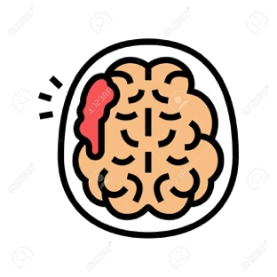



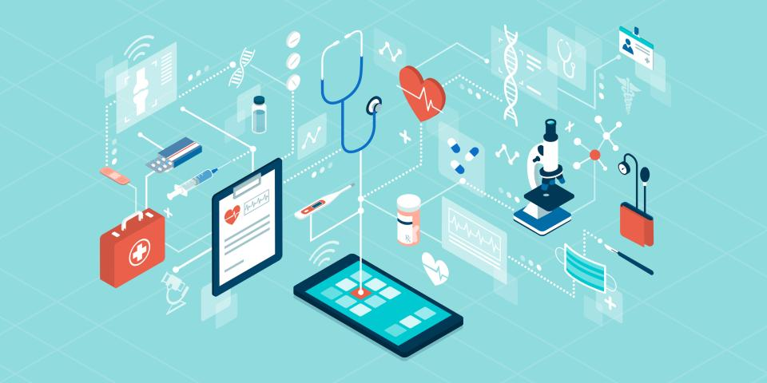

 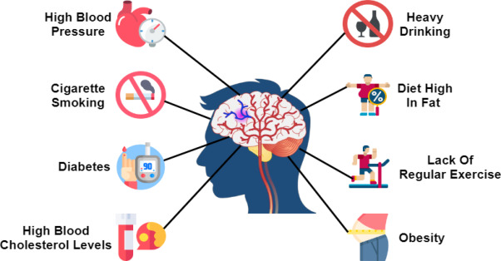

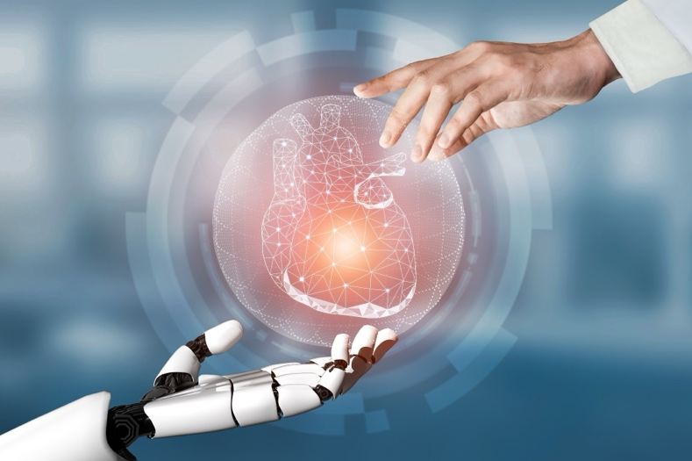

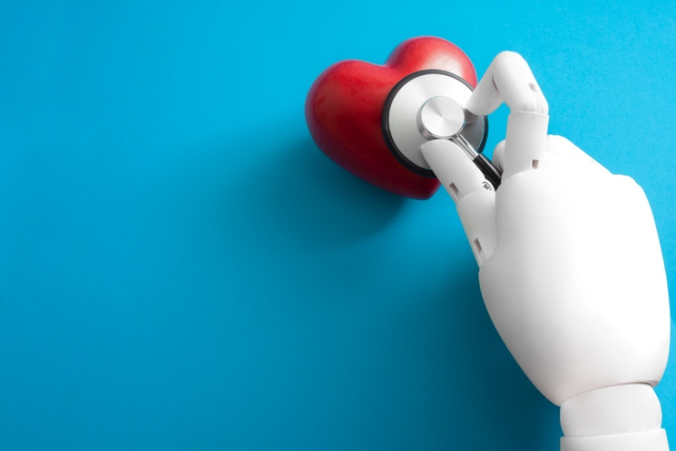

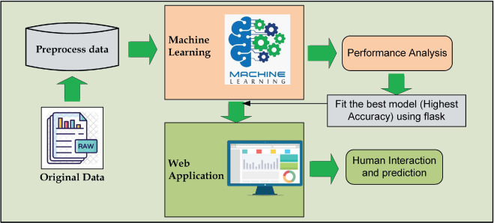

**Conclusion**

In this study, I focused on creating a code that can predict stroke in people suffering with diabetes. I did not develop an application; I just wrote a code that shows how this prediction works. I worked together to do some exploratory data analysis to understand the dataset and highlight the key features related to CVAs. The prediction model was built using Logistic Regression, and it can predict stroke outcomes with certain level of accuracy. My project function as an illustration on how important it is to use technology-Machine Learning to address immediate health problems. Healthcare professionals can detect the issue in the initial stages and take certain preventive measures to reduce the risk of stroke in diabetes people by accurately predicting CVAs. My work provides the base for future investigations in the field of predictive healthcare analysis. Make the solution useful for future I can add more information to this data and make it easier to use. Overall, my project is a step forward in using Machine learning to improve the healthcare. It helps doctors make better decisions and helps to stay updated regarding their health conditions. It is important for us to remember that machine Learning can only offer useful information and predictions, but it should not be the only factor that should be considered while taking decisions regarding My health. In the end, maintaining a comprehensive approach to healthcare that includes regular checkups, lifestyle adjustments, and following medical advice remains important for assuring general Illbeing.

International Diabetes Federation. (2019). *International Diabetes Federation - Home*. Idf.org. <https://idf.org/>

Singh, A., Shenoy, S., & Sandhu, J. S. (2016). Prevalence of Type 2 Diabetes Mellitus among Urban Sikh Population of Amritsar. Indian jMynal of community medicine: official publication of Indian Association of Preventive & Social Medicine, 41(4), 263–267. <https://doi.org/10.4103/0970-0218.193338>