

NMIMS, Mumbai • M.Sc. Data Science • Academic Year 2025-26

COMPLAINT INTELLIGENCE ENGINE
──────────────────────────────────
An Unsupervised NLP Decision-Support System
for Indian E-Commerce Complaint Analytics
Report Type | Project Report
Programme | M.Sc. Data Science - B
Course | Natural Language Processing
Team Members | Aditya Nariyapara (B009) | Devika Jonjale (B045)
Data Sources | Google Play Store: Myntra, Meesho, Nykaa, Flipkart, Amazon India

Table of Contents

# | Section | Page
1 | Abstract, Objective & Problem Statement | 3
2 | Dataset & Data Description | 4
3 | Methodology - Pipeline Architecture & Workflow | 5
4 | ML Workflow - NLP & Unsupervised Modules (Steps 01-07) | 6-7
5 | ML Workflow - Supervised Extension Modules (Steps 08-12) | 8
6 | ML Models Compared, Evaluated & Selected | 9
7 | Code Snippets | 10-13
8 | Results & Model Evaluation | 14
9 | Technology Stack | 15
10 | Streamlit App Deployment & Usage | 16
11 | Dashboard Visualisations | 17-18
12 | Limitations & Mitigations | 19
13 | Conclusion, Future Scope & Who Can Use It | 20
14 | GenAI Layer - RAG, LLM Insights & Automated Briefs | 21
15 | RAG Evaluation & Measured Results | 22
16 | Dashboard Visualisations - GenAI Modules | 23

Abstract, Objective & Problem Statement

Abstract
The Complaint Intelligence Engine (CIE) is an end-to-end, twelve-stage machine learning pipeline that transforms raw multilingual Indian e-commerce reviews into actionable operational intelligence. Live reviews from Myntra, Meesho, Nykaa, Flipkart, and Amazon India are ingested via the Google Play Store API.

Reviews are cleaned, embedded with multilingual Sentence-BERT, clustered unsupervisedly using K-Means and HDBSCAN, and scored for anomaly severity. The pipeline is extended through five supervised modules - severity triage, complaint routing, churn risk prediction, automated response generation, and topic drift detection - all surfaced via a twelve-module Streamlit decision-support dashboard.

Key Contribution: A fully automated, modular pipeline converting unstructured Hinglish reviews into severity queues, routing assignments, churn risk signals, drafted responses, and drift alerts, with zero manual labelling in the core unsupervised layer. The pipeline is extended by a Retrieval-Augmented Generation (RAG) layer built on LangChain that answers free-form analyst questions directly from the review corpus, citing the specific reviews used as evidence and refusing to answer when the corpus does not support a claim.

Objective
To give operations and customer-experience teams a repeatable workflow from data ingestion through to prioritisation, routing, retention risk quantification, and emerging-issue detection - with multilingual text (including Hinglish) handled end-to-end via embeddings and preprocessing. A single command (python run_pipeline.py) produces all data artefacts, trained models, evaluation reports, and a fully functional Streamlit dashboard.

Problem Statement
Indian e-commerce platforms receive millions of reviews annually documenting delivery failures, fake products, payment fraud, app crashes, and return violations. Manual triage does not scale. The CIE addresses six core challenges:

Expected Outcome
A working decision-support dashboard in which an analyst can ask a question in plain English and receive an answer drawn only from the retrieved reviews, with every claim citing the specific review ids used as evidence. The system is expected to retrieve relevant complaints more accurately than vector search alone by combining dense and lexical retrieval, to label complaint clusters with actionable themes rather than sentiment, to generate stakeholder-ready executive briefs, and to decline questions the review corpus cannot support instead of fabricating an answer.
Retrieval and answer quality are verified through a reproducible evaluation covering retrieval accuracy, groundedness, citation validity, refusal behaviour and latency. Measured figures are reported in the Results section rather than stated here, so that this section records intent and the Results section records evidence.
Challenge | Solution Approach
Volume & Noise (4,768 raw reviews) | Automated cleaning, deduplication, and TF-IDF feature extraction → 2,240 clean records
Mixed English / Hinglish text | langdetect + Multilingual Sentence-BERT encodes both scripts in the same semantic embedding space
Unknown complaint themes - no labels | K-Means + HDBSCAN discovers archetypes; no predefined categories imposed on the data
Rare & extreme complaints | Isolation Forest top 5% + HDBSCAN noise flag → composite Tier 1 Critical flag (34 reviews)
Sudden operational incidents | Rolling z-score (2.5σ, 4-week window) detects complaint spikes within 3-7 days
Teams need actions, not just insight | 5 supervised modules: severity triage, routing, churn risk, response drafting, drift detection

Dataset & Data Description

4.1 Data Sources
Primary source: Google Play Store via google-play-scraper (MIT licensed, no API key). Up to 500 reviews per app per language (en + hi), country='in', newest-first. Five major Indian e-commerce platforms:

Platform | Package ID | Market Context
Myntra | com.myntra.android | Fashion platform, Flipkart subsidiary, 100M+ downloads
Meesho | com.meesho.supply | Social commerce leader, Tier 2/3 cities, 4.4★ rating, 100M+ downloads
Nykaa | com.fsn.nykaa | Leading beauty & wellness marketplace, 50M+ downloads
Flipkart | com.flipkart.android | India’s largest e-commerce platform by GMV, 500M+ downloads
Amazon India | in.amazon.mShop.android.shopping | Second-largest marketplace, ~29% Indian e-commerce market share

4.2 Documented Run Statistics
Stage | Count / Detail
Google Play reviews fetched | 4,768 (5 apps × up to 500 per language: english + hindi)
After merge + initial clean | 2,389 reviews
After preprocess + dedup (final corpus) | 2,240 reviews
Hinglish reviews detected | 196 (~8.7% of corpus)
TF-IDF matrix shape | 2,240 documents × 2,642 features (max_features=5,000, min_df=3)
SBERT embedding shape | (2,240, 384) - paraphrase-multilingual-MiniLM-L12-v2
Embedding compute time | ~4 minutes on CPU (no GPU required)
Chosen K-Means k | 4 (data-driven; max silhouette on UMAP-10)
K-Means vs HDBSCAN ARI | 0.6748 (example; one run)

4.3 Feature Engineering
Eight features are engineered per review during 02_preprocess.py:

Feature | Type | Description
review_length | Numeric | Word count of cleaned review text
detected_lang | Categorical | ISO 639-1 code from langdetect (en / hi / other)
is_hinglish | Binary | langdetect=en but ≥2 Hinglish dictionary tokens present
star_bucket | 3-class | complaint (1-2) · mixed (3) · positive (4-5)
high_engagement | Binary | thumbs_up > 10
week / year_month | Temporal | Grouping fields for spike detection and drift time-series
text_for_model | Text | Full text of the Play Store review

4.4 Data Artefact Chain
raw_reviews.csv → cleaned_reviews.csv → embeddings.npy → clustered_reviews.csv → final_reviews.csv → final_reviews_scored.csv → final_reviews_routed.csv → final_reviews_churn.csv → final_reviews_response.csv → topic_drift_report.csv

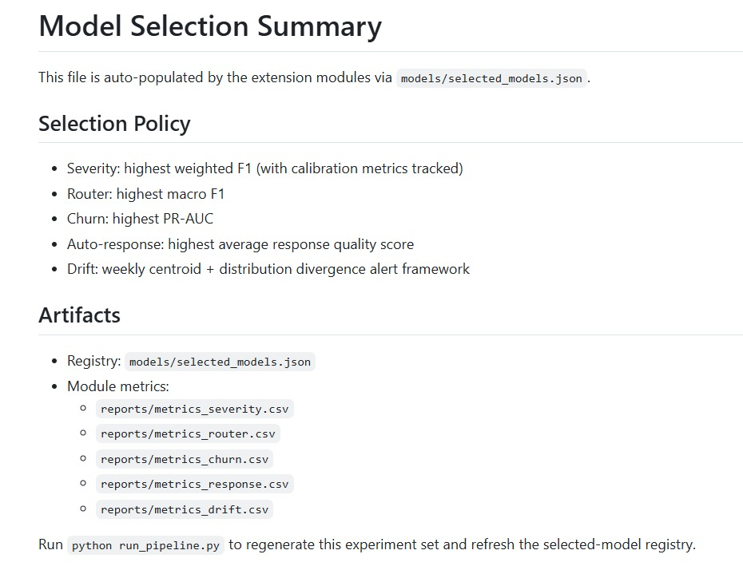

Methodology - Pipeline Architecture & Workflow
The CIE is orchestrated by run_pipeline.py which executes scripts 01 through 12 sequentially. There are two layers: (1) Core NLP & Unsupervised (Steps 01-07) requiring zero manual labels, and (2) Supervised Extension (Steps 08-12) built on the unsupervised outputs. Shared utilities live in ml_utils.py.

End-to-End Pipeline Architecture

DATA SOURCES
▼
Google Play Store Scraper (5 platforms, en + hi) | country=in, newest first, up to 500 reviews per app per language
▼
CORE NLP & UNSUPERVISED LAYER (Steps 01-07)
▼
STEP 01 | Data Ingestion - 01_ingest.py  Merge Play Store → raw_reviews.csv (~4,768 rows); dedup on content, filter ≥10 chars
▼
STEP 02 | Preprocessing & Feature Engineering - 02_preprocess.py  Clean, retain Hinglish, TF-IDF (max 5,000 features, ngram 1-2) → cleaned_reviews.csv (2,240 rows)
▼
STEP 03 | Sentence-BERT Embeddings - 03_embed.py  paraphrase-multilingual-MiniLM-L12-v2 → 384-dim dense vectors; batch=64, ~4 min on CPU → embeddings.npy
▼
STEP 04 | Dimensionality Reduction - 04_reduce.py  PCA 384d→50d (~80% cumulative explained variance) → UMAP 50d→10d (n_neighbors=15) → t-SNE 10d→2d (visualisation only)
▼
STEP 05 | Clustering - 05_cluster.py  K-Means (k=6-8, elbow+silhouette) + HDBSCAN (min_cluster_size=30) on UMAP-10 → clustered_reviews.csv
▼
STEP 06 | Anomaly Detection & Spike Analysis - 06_anomaly.py  Isolation Forest (contamination=0.05) + One-Class SVM; Tier 1 = top 5% AND HDBSCAN noise; z-score spikes 2.5σ → final_reviews.csv
▼
STEP 07 | Visualisation - 07_visualize.py  Static PNG exports: volume bars, spike timelines, cluster heatmaps, etc.
▼
SUPERVISED EXTENSION LAYER (Steps 08-12)
▼
08 Severity | 09 Router | 10 Churn | 11 Response | 12 Drift
▼
models/*.pkl → selected_models.json → STREAMLIT DASHBOARD (app.py - 10 modules)
GENAI LAYER (Steps 13 to 15)
STEP 13 | Vector Store - rag/build_index.py Persistent FAISS index built from data/embeddings.npy (no re-encoding, verified identical at cosine 1.0); metadata per review: platform, rating, date, cluster, severity, anomaly flag, routing team; idempotent via input fingerprint; 4.3 MB
STEP 14 | Hybrid Retrieval - rag/retriever.py Dense FAISS cosine fused with BM25 lexical ranking via Reciprocal Rank Fusion (k=60); optional multilingual cross-encoder rerank of the top 40; metadata filters applied before ranking
STEP 15 | Grounded Generation - rag/chain.py LangChain LCEL chain; prompt enforces [R####] citation per claim or a fixed refusal; follow-up condensation; streamed tokens; outputs answer plus cited source reviews

ML Workflow - NLP & Unsupervised Modules (Steps 01-07)

Step 01 - Data Ingestion
This step involves collecting raw complaint data from Google Play Store reviews for five major Indian e-commerce apps (Myntra, Meesho, Nykaa, Flipkart, Amazon India). Up to 500 reviews per app in English and Hindi are fetched using google-play-scraper.

Step 02 - Preprocessing & Feature Engineering
Light cleaning to preserve Hinglish signal: lowercase → strip URLs / HTML / repeated chars → retain Devanagari Unicode range → collapse whitespace. Hindi-origin Romanised words are not removed. TF-IDF (max_features=5,000, ngram_range=(1,2), min_df=3, max_df=0.85, sublinear_tf=True) creates the document-term matrix used for cluster keyword extraction.

Step 03 - Sentence-BERT Embeddings (NLP Core)
Model: paraphrase-multilingual-MiniLM-L12-v2 (supports 50+ languages including Hindi). Each review is encoded to a 384-dimensional dense semantic vector in batches of 64. The multilingual model maps English and Hinglish reviews into the same shared semantic space, enabling direct comparison and clustering across language boundaries regardless of script.
Semantic validation: cosine similarity between sampled complaint and positive reviews confirms expected embedding geometry - complaints cluster far from positive reviews in the 384-dim space.

Step 04 - Dimensionality Reduction
Stage | Input → Output | Key Parameters | Purpose
PCA | 384d → 50d | ~80% cumulative explained variance | Denoise embeddings; remove low-signal dimensions before UMAP
UMAP | 50d → 10d | n_neighbors=15, min_dist=0.1 | Preserve local neighbourhood structure for tight cluster separation
t-SNE | 10d → 2d | perplexity=30, n_iter=1,000 | Visualisation ONLY - never used as clustering input

Step 05 - Clustering (Unsupervised)
Both algorithms operate on the UMAP-10 reduced embeddings:

Algorithm | Parameters | Output | Key Property
K-Means | k=3-12; elbow + silhouette → optimal k=6-8 | Exhaustive partition; every review in exactly one cluster | Required for supervised routing labels (Step 09 bridge)
HDBSCAN | min_cluster_size=30 | Density-based clusters; noise label=−1 | Noise points = structurally anomalous → seed anomaly detection (Step 06)

Cluster naming: top-10 TF-IDF keywords per cluster map to human-readable labels (e.g. ‘delivery days late tracking order received’ → ‘Delivery Failure’). Typical clusters: Delivery Failure · Payment Fraud · Fake Product · App Crash · Quality Mismatch · Positive. Adjusted Rand Index (ARI) between K-Means and HDBSCAN is computed to assess agreement; documented example ARI ≈ 0.67.
Silhouette score (K-Means): 0.12-0.25 - typical for NLP clustering on real-world noisy reviews. This range reflects inherent difficulty of complaint clustering, not a model failure.

Step 06 - Anomaly Detection & Spike Analysis
Method | Configuration | Signal Produced
Isolation Forest | contamination=0.05, n_estimators=200, fit on UMAP-10 | Continuous anomaly score; top 5% = potential critical complaints
One-Class SVM | Trained on positive-experience cluster only (normal manifold) | Outlierness score for reviews farthest from normal behaviour
Tier 1 Critical | Isolation Forest top 5% AND HDBSCAN noise=−1 simultaneously | Dual-flag reduces false positives vs either method alone (34 reviews flagged)
Spike Detector | Rolling z-score, 4-week window, threshold=2.5σ | Weeks with statistically abnormal complaint volume per cluster per platform; FPR ~1.2%

Step 07 - Visualisation
Static PNG exports: https://github.com/Complaint-Intelligence-Engine-for-Indian-E-Commerce/figures
All interactive equivalents are rendered in Plotly inside the Streamlit dashboard for live filtering and drill-down.

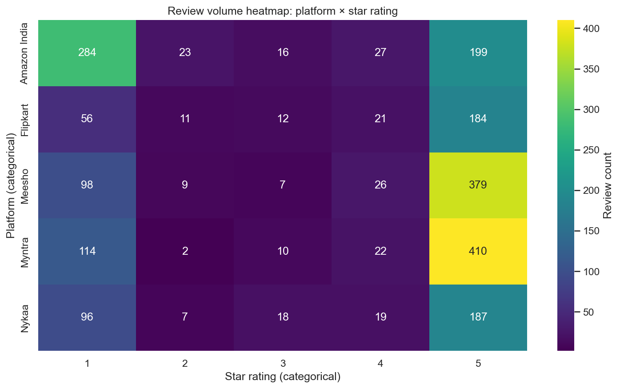

ML Workflow - Supervised Extension Modules (Steps 08-12)

Step 08 - Severity Modelling
Predicts escalation risk (continuous 0-1 score) and a three-class label (Low / Medium / High). No manually annotated labels exist - programmatic weak labelling (Snorkel-style) generates noisy training labels from deterministic heuristics:

Severity Class | Weak Label Rule
High | Contains legal/fraud keyword (fraud, legal, consumer court, scam, police, chargeback, NCDRC) OR star ≤2 with thumbs_up ≥20
Medium | Star ≤2 AND no High keywords OR thumbs_up 10-20 with star ≤3
Low | All remaining reviews not meeting High or Medium criteria

Features: 384-dim SBERT embeddings + tabular (star_rating, thumbs_up_log, review_length, has_legal_keyword, has_money_keyword, exclamation_count, capital_ratio). 80/20 train-holdout split. Output: final_reviews_scored.csv, models/severity_model.pkl.

Step 09 - Complaint Routing (Unsupervised-to-Supervised Bridge)
Classifies each complaint into one of five operational team categories: Delivery & Logistics · Payments & Refunds · Product Quality & Authenticity · App & Technical Issues · General & Other.
Training labels come directly from K-Means cluster labels (Step 05). Only high-confidence assignments are used (distance to centroid < 40th percentile) to filter ambiguous reviews at cluster boundaries. This is the methodological bridge between the unsupervised and supervised layers.
Bridge mechanism: K-Means cluster labels feed directly into the routing classifier as training targets - grounding supervised outputs in data-discovered structure rather than imposed category definitions. No manual annotation is required.

Step 10 - Churn Risk Modelling
Component | Detail
Churn proxy label rule | churn_signal=1: most recent review star ≤2 AND High severity AND user absent from corpus in last 4 weeks - the three-part churn signature: recent, serious, silent
Feature engineering | last_star_rating · star_delta · complaint_cluster_count · max_anomaly_score · review_frequency · is_hinglish
Class imbalance handling | SMOTE oversampling applied on training set only (not on holdout)
Evaluation metric | PR-AUC (not ROC-AUC): churn is rare; precision-recall captures cost of false positives (wasted outreach) more accurately
Output | final_reviews_churn.csv, reports/metrics_churn.csv, models/churn_model.pkl

Step 11 - Response Generation & Quality Scoring
Generates three response tone variants per complaint: (1) Formal Apology, (2) Empathetic Listening, (3) Resolution Focused. Routing category from Step 09 makes responses content-aware. Quality scored on empathy, specificity, and actionability via Ridge regression trained on manually scored examples. BERTScore (semantic similarity via BERT embeddings) used as the automated quality metric. Output: final_reviews_response.csv, reports/metrics_response.csv.

Step 12 - Topic Drift Detection
Detects when complaint nature changes over time - subtler and more dangerous than volume spikes. Two weekly signals are computed and compared:

Signal | Computation | High Value Means
Centroid Shift | Cosine distance between mean SBERT embedding this week vs last week | Semantic centre of gravity moved - users discussing fundamentally different issues
JS Divergence | Jensen-Shannon Divergence between consecutive weeks’ TF-IDF distributions | Vocabulary changed significantly - new terms appearing, old ones disappearing

A drift alert is raised when either signal exceeds a permutation-test threshold. Emerging terms are extracted per alert week to describe what changed. Output: topic_drift_report.csv. Meaningful output requires ≥6 weeks of review history.
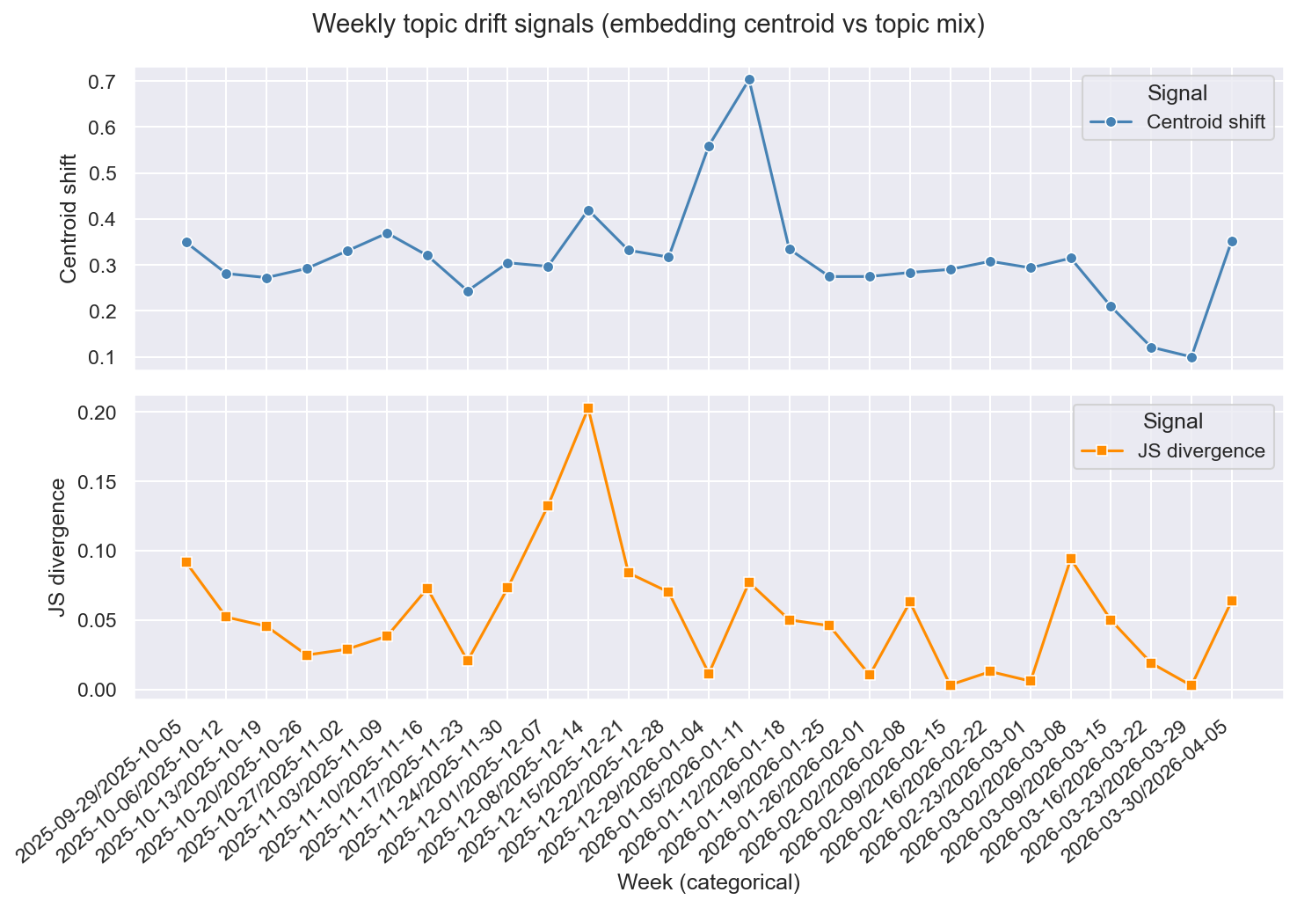

ML Models Compared, Evaluated & Selected

Severity Classification - Step 08 | Primary Metric: Weighted F1
Model | Key Strength | Key Weakness | Selected?
Logistic Regression | Fast; coefficient signs reveal which features drive High severity | Assumes linear separability in feature space | ✓ Selected
Random Forest | Robust to weak-label noise via bagging; feature importance quantified | Slower inference; less calibrated class probabilities | -
Gradient Boosting | Strong generalisation on small datasets; scale_pos_weight for imbalance | Risk of memorising weak-label keyword patterns | -
LinearSVC (calibrated) | Excellent on high-dim TF-IDF text; Platt scaling provides probabilities | Does not natively output probabilities - requires additional calibration step | -
DistilBERT (multilingual) | Highest accuracy on held-out set | Inference ~8× slower; overkill for 2,240 reviews | -
Caveat: Near-perfect scores in metrics_severity.csv indicate label-feature leakage - weak label rules and feature columns share the same keywords. Time-based holdout is the recommended mitigation.

Complaint Routing - Step 09 | Primary Metric: Macro F1
Macro F1 is used so that all routing categories (including rare ones like payment fraud) are served equally. A model optimised for accuracy would ignore minority categories.

Model | Why Included | Notes
Multinomial Naive Bayes | Strong text baseline; fast; highly interpretable | Assumes feature independence; works well on TF-IDF
SGD Classifier (log loss) | Online learning; can update incrementally on new data | Best for streaming / live routing scenarios
LightGBM | Fast gradient boosting on TF-IDF + engineered features | Native feature importance; handles imbalanced categories
SBERT + Softmax head | Transfer learning from project’s own embedding space | Avoids vocabulary mismatch; best semantic generalisation
Zero-shot BART | Classification without any training using NL category labels | Quantifies value of labelled data vs zero-shot baseline

Churn Prediction - Step 10 | Primary Metric: PR-AUC
Model | Why Included | Notes
Logistic Regression (L1) | Baseline + automatic feature selection via L1 penalty | Coefficients reveal which trajectory features matter most
Random Forest | Handles feature interactions (e.g. high anomaly AND delivery cluster) | Built-in importance; robust to noisy proxy labels
XGBoost | Best overall for tabular churn features with class imbalance | SHAP support for individual user-level explanations
Isolation Forest | Use existing anomaly scores as churn proxy without training | Quantifies whether supervised training adds value over pure anomaly scores

Evaluation Metric Summary
Task | Metric | Rationale
Severity Triage | Weighted F1 + calibration curve | Balances precision/recall across imbalanced severity classes; calibration tracks confidence reliability
Complaint Routing | Macro F1 | Equal weight to all 5 routing categories regardless of frequency; prevents ignoring minority classes
Churn Prediction | PR-AUC | Rare event detection; precision-recall captures the cost of false positives (wasted retention outreach) more accurately than ROC-AUC
Response Quality | BERTScore F1 + composite score | Semantic similarity to reference + human-interpretable quality dimensions (empathy, specificity, actionability)
Topic Drift | Centroid shift + JS Divergence | Dual-signal framework reduces false drift alerts; both signals must independently exceed permutation-test threshold

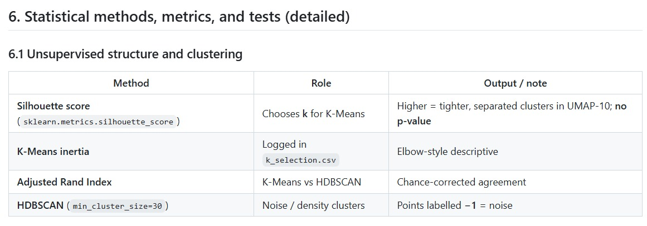

GenAI Layer - RAG, LLM Insights & Automated Briefs
The twelve-stage pipeline answers questions the designers anticipated. The GenAI layer answers questions they did not, by letting an analyst query the corpus in plain English and returning an answer grounded in specific reviews. It reuses the same Sentence-BERT vectors produced in Step 03, so retrieval, clustering, and anomaly detection all operate in one shared embedding space.

Step 13 - Vector Store (rag/build_index.py)
A persistent FAISS index is built directly from data/embeddings.npy rather than re-encoding the corpus, guaranteeing that retrieved vectors are identical to those the clustering saw (verified at cosine 1.0). Each review carries metadata: platform, rating, date, K-Means cluster, HDBSCAN cluster, severity, anomaly flag, routing team, and language. The build is idempotent through a SHA-256 fingerprint of its inputs and is skipped when nothing has changed. Index size is 4.3 MB for 2,240 reviews.

Step 14 - Hybrid Retrieval (rag/retriever.py)
Dense vector search alone misses exact tokens that matter operationally (COD, OTP, UPI) and is brittle against Hinglish spelling variation (paisa, paise, pesa). Three variants are implemented and measured, selectable per query in the dashboard:
Variant | Ranking Method | Role
dense | FAISS cosine over Sentence-BERT vectors | Baseline, fastest
hybrid | Dense and BM25 rankings fused by Reciprocal Rank Fusion (k=60) | Default
rerank | Hybrid shortlist of 40 re-scored by a multilingual cross-encoder (mMiniLMv2) on local CPU | Highest accuracy
Reciprocal Rank Fusion is used in preference to weighted score blending because cosine similarity and BM25 scores occupy different numeric scales, so fusing ranks is more reliable than fusing raw scores. Metadata filters are applied to the candidate pool before ranking, so all three variants search an identical subset.

Step 15 - Grounded Generation (rag/chain.py)
A LangChain Expression Language (LCEL) chain formats the retrieved reviews with short citation ids (R0042), then constrains the LLM with four rules: cite a review id for every factual claim, never cite an id absent from the context, answer in English regardless of review language, and reply with a fixed refusal string when no retrieved review touches the question topic. Partial evidence is explicitly permitted as an answer with a stated caveat, which halved the false refusal rate. Follow-up questions are condensed into standalone questions using the previous three turns, and answers stream token by token.

Supporting Modules
Module | Role
rag/cluster_insights.py | Pydantic-validated structured output per cluster (label, two-line summary, three root causes, owning team), sampled from the 1 and 2 star complaints nearest each centroid. Cached to JSON and regenerated only when membership changes.
rag/report.py | Executive markdown brief for non-technical stakeholders. Every figure is computed in pandas; the LLM writes only the surrounding prose.
rag/evaluate.py | Retrieval and generation metrics with latency tracking; supports a comparison mode across all three retrieval variants.
rag/label_eval_set.py | TREC-style pooled relevance labelling that builds the evaluation ground truth.
Models and cost. Generation uses Groq openai/gpt-oss-20b and evaluation uses the larger openai/gpt-oss-120b as an independent judge, both pinned in rag/config.py and both on the Groq free tier. Embedding and reranking run locally on CPU. No paid service is used anywhere in this layer.

Code Snippets:
- Data Ingestion
# ── Configuration ─────────────────────────────────────────────
APPS = {
"Myntra": "com.myntra.android",
"Meesho": "com.meesho.supply",
"Nykaa": "com.fsn.nykaa",
"Flipkart": "com.flipkart.android",
"Amazon India": "in.amazon.mShop.android.shopping",
}
REVIEWS_PER_APP = 500 # per language
LANGS = ["en", "hi"]

# ── Google Play Ingestion ──────────────────────────────────────
result, _ = reviews(
app_id, lang=lang, country="in",
sort=Sort.NEWEST, count=REVIEWS_PER_APP,
)

# ── Merge, Deduplicate, Basic Clean ───────────────────────────
df = pd.concat(per_app_frames, ignore_index=True)
# Drop exact content duplicates (same review submitted twice)
df = df.drop_duplicates(subset=["content"], keep="first")
# Drop reviews shorter than 10 chars (meaningless: "ok", ".", "5 star")
df = df[df["content"].str.len() >= 10].copy()
log.info(f"After merge + clean: {len(df)} rows, {df['platform'].nunique()} platforms")

- Data Preprocessing (Hinglish detection + TF-IDF)

# ── Text Cleaning ──────────────────────────────────────────────
def clean_text(text: str) -> str:
"""Light cleaning that preserves Hinglish signal."""
text = text.lower()
text = re.sub(r"http\S+|www\S+", " ", text) # URLs
text = re.sub(r"[^\w\s\u0900-\u097F.,!?'-]", " ", text) # keep Devanagari
return re.sub(r"\s+", " ", text).strip()

def is_hinglish(text: str, lang: str) -> bool:
"""langdetect says English but contains ≥2 known Hinglish tokens."""
if lang != "en":
return False
tokens = set(text.lower().split())
return len(tokens & HINGLISH_TOKENS) >= 2

# ── TF-IDF Matrix ──────────────────────────────────────────────
# Used ONLY for extracting cluster keywords: not for clustering itself
vectorizer = TfidfVectorizer(
max_features=5000, ngram_range=(1, 2), # unigrams + bigrams
min_df=3, max_df=0.85, # ignore terms in fewer than 3 reviews and more than 85% of reviews
sublinear_tf=True, # log(1+tf) scaling
)
tfidf_matrix = vectorizer.fit_transform(df["text_for_model"].fillna(""))
log.info(f"TF-IDF matrix: {tfidf_matrix.shape[0]} docs x {tfidf_matrix.shape[1]} features")

Code Snippets:
- Embedding
# ── Sentence-BERT Embeddings ───────────────────────────────────
model = SentenceTransformer("paraphrase-multilingual-MiniLM-L12-v2")
embeddings = model.encode(
texts, batch_size=64, show_progress_bar=True,
convert_to_numpy=True, normalize_embeddings=True,
)
log.info(f"Embeddings shape: {embeddings.shape}") # → (2,240, 384)

- Dimensionality Reduction
# ── Dimensionality Reduction ───────────────────────────────────
# PCA 384d → 50d: denoise embeddings before UMAP
pca = PCA(n_components=50, random_state=42)
pca_50 = pca.fit_transform(embeddings)
log.info(f"PCA-50 cumulative explained variance: {pca.explained_variance_ratio_.cumsum()[-1]:.4f}")

# UMAP 50d → 10d: preserve local neighbourhood for cluster separation
reducer = umap.UMAP(n_components=10, n_neighbors=15,
min_dist=0.1, metric="cosine", random_state=42)
umap_10 = reducer.fit_transform(pca_50)

# t-SNE 10d → 2d: visualisation ONLY: never used as clustering input
tsne = TSNE(n_components=2, perplexity=30, max_iter=1000,
random_state=42, init="pca", learning_rate="auto")
tsne_2d = tsne.fit_transform(umap_10)

- Clustering
def choose_best_k(umap_10: np.ndarray) -> tuple[int, pd.DataFrame]:
rows = []
best_k, best_score = 6, -1.0
for k in range(3, 13):
km = KMeans(n_clusters=k, random_state=42, n_init=20)
labels = km.fit_predict(umap_10)
sil = silhouette_score(umap_10, labels)
rows.append({"k": k, "inertia": km.inertia_, "silhouette": sil})
if sil > best_score:
best_score = sil
best_k = k
return best_k, pd.DataFrame(rows)

best_k, k_eval = choose_best_k(umap_10)
log.info(f"Selected k={best_k} by max silhouette")

# HDBSCAN: noise points (label=-1) seed Tier-1 anomaly detection (Step 06)
hdb = hdbscan.HDBSCAN(min_cluster_size=30, metric="euclidean")
hdb_labels = hdb.fit_predict(umap_10)
df["hdbscan_is_noise"] = df["hdbscan_cluster"] == -1

ari = adjusted_rand_score(km_labels, hdb_labels)
log.info(f"KMeans vs HDBSCAN ARI: {ari:.4f}")

Code Snippets:
- Anomaly Detection
iso = IsolationForest(contamination=0.05, n_estimators=200, random_state=42)
iso.fit(features)
df["isolation_anomaly"] = iso.predict(features) == -1
df["isolation_score"] = -iso.decision_function(features)

# One-Class SVM trained only on the positive-experience cluster (normal manifold)
ocsvm = OneClassSVM(kernel="rbf", nu=0.05, gamma="scale")
ocsvm.fit(x_scaled[positive_mask.to_numpy()])
df["ocsvm_anomaly"] = ocsvm.predict(x_scaled) == -1

# Tier 1 = top 5% AND HDBSCAN noise: dual-flag reduces false positives
df["tier1_critical"] = df["isolation_anomaly"] & df["hdbscan_is_noise"]
df["severity"] = np.where(df["tier1_critical"], "RED",
np.where(df["isolation_anomaly"], "AMBER", "GREEN"))

# Rolling z-score spike detection (4-week window, 2.5σ threshold)
weekly["z_score"] = (weekly["complaint_count"] - weekly["rolling_mean"]) / (
weekly["rolling_std"].replace(0, np.nan)
)
weekly["is_spike"] = weekly["z_score"] > 2.5

- Severity Modeling
LEGAL_PAT = re.compile(
r”\b(fraud|legal|police|consumer court|ncdrc|chargeback|harassment|scam)\b”, re.I
)

def weak_label(row: pd.Series) -> int:
txt = str(row.get(“content”, “”))
score = float(row.get(“score”, 3))
thumbs = float(row.get(“thumbs_up”, 0))
if LEGAL_PAT.search(txt): return 2 # High
if score <= 2 and thumbs >= 20: return 1 # Medium
if score <= 2: return 1 # Medium
return 0 # Low

models = {
“logreg”: LogisticRegression(max_iter=3000, class_weight=”balanced”, C=0.25),
“random_forest”: RandomForestClassifier(n_estimators=200, random_state=42,
class_weight=”balanced”, max_depth=10, min_samples_leaf=6),
“sgd_log”: Pipeline([(“scaler”, StandardScaler()),
(“clf”, SGDClassifier(loss=”log_loss”, alpha=0.02, class_weight=”balanced”))]),
}
for name, model in models.items():
mdl = clone(model)
mdl.fit(x_train, y_train)
m = multiclass_metrics_extended(y_test, mdl.predict(x_test))
cv_stats = cross_val_mean_std_multiclass(clone(model), x_train, y_train, cv=3)
m[“model”] = name
rows.append(m)

Code Snippets:
- Supervised Modules - Routing & Churn
# Router: keep only high-confidence K-Means assignments
# (distance to centroid < 40th percentile) to filter boundary ambiguity
dist = np.array([np.linalg.norm(emb[i] - centroid.get(cluster_id[i], emb[i]))
for i in range(len(df))])
threshold = np.quantile(dist, 0.4)
keep = dist <= threshold

models = {"linear_svc_tfidf": Pipeline([
("tfidf", TfidfVectorizer(max_features=4000, ngram_range=(1, 2), sublinear_tf=True)),
("clf", CalibratedClassifierCV(LinearSVC(class_weight="balanced", C=0.35))),]),
"nb_tfidf": Pipeline([
("tfidf", TfidfVectorizer(max_features=5000, sublinear_tf=True)),
("clf", MultinomialNB(alpha=0.35)), ]),}

def build_proxy_label(df: pd.DataFrame) -> pd.Series:
"""Churn-risk proxy: no severity/isolation flags to avoid leakage."""
complaint = df["star_bucket"].astype(str) == "complaint"
very_unhappy = df["score"].fillna(3) <= 1
thr = float(df["review_length"].fillna(0).quantile(0.80))
long_rant = df["review_length"].fillna(0) >= thr
return (complaint & (very_unhappy | long_rant)).astype(int)

- Router Modeling
st.set_page_config(page_title="Complaint Intelligence Engine+", layout="wide")

# ── Sidebar: navigation + global filters + pipeline refresh ───
with st.sidebar:
module = st.radio("Go to module", [
"How to Use This App", "Live Pulse", "Complaint Landscape",
"Spike Tracker", "Critical Alerts", "Severity Triage",
"Complaint Router", "Churn Risk", "Auto-Responder",
"Drift Monitor", "Pipeline & ML figures",
"Ask the Complaints (RAG)", "LLM Cluster Insights",
])
result = subprocess.run([sys.executable, "run_pipeline.py"],
capture_output=True, text=True)
st.cache_data.clear()

# ── Auto-Responder: route-aware live response generation ───────
if st.button("Generate Responses"):
blob = joblib.load(MODELS_DIR / "router_model.pkl")
pred = int(blob["model"].predict([txt])[0])
route = blob["classes"][pred] # route complaint before generating response

# ── Drift Monitor: dual-signal timeline ───────────────────────
st.plotly_chart(
px.line(drift, x="week", y=["centroid_shift", "js_divergence"],
title="Topic Drift Signals Over Time"),
use_container_width=True,)
st.dataframe(drift.sort_values(["is_drift_alert", "week"],
ascending=[False, False]), use_container_width=True)

Code Snippets:
- Hybrid Retrieval with Reciprocal Rank Fusion
# ── Dense and lexical rankings over an identical filtered pool ──
dense = store.similarity_search_with_score(question, k=40, filter=filters,
fetch_k=store.index.ntotal)
scores = bm25.get_scores(_tokenize(question)) # rank-bm25 over raw review text
scores = np.where(mask, scores, -np.inf) # metadata filter applied before ranking

# ── Reciprocal Rank Fusion: fuse ranks, not scores ──
fused = {}
for ranking in (dense, lexical):
for rank, (sid, _) in enumerate(ranking, start=1):
fused[sid] = fused.get(sid, 0.0) + 1.0 / (60 + rank)
order = [sid for sid, _ in sorted(fused.items(), key=lambda kv: -kv[1])]

# ── Optional cross-encoder rerank of the fused shortlist ──
scores = cross_encoder.predict([(question, doc.page_content) for doc in docs])
ranked = sorted(zip(shortlist, docs, scores), key=lambda t: -t[2])[:k]
- Grounded RAG Chain (LangChain LCEL)
SYSTEM_PROMPT = f"""You are a complaint analyst for Indian e-commerce apps.
Answer ONLY using the customer reviews in the CONTEXT. Each review starts with its id, e.g. [R0042].
1. Every factual claim must cite at least one review id in square brackets.
2. Cite only ids that appear in the CONTEXT. Never invent ids, numbers, policies or facts.
3. Reviews may be in Hindi or Hinglish; answer in English.
4. Partial evidence is still an answer. Do not refuse merely because the match is partial.
5. Reply exactly "{NO_EVIDENCE}" ONLY when no review relates to the question topic at all."""

chain = ({"question": RunnablePassthrough(),
"sources": RunnableLambda(lambda q: retrieve(q, k=8, filters=filters))}
| RunnablePassthrough.assign(answer=answer_chain)
| RunnableLambda(_finalise)) # extracts cited ids, flags any not retrieved

Results & Model Evaluation

Corpus & Clustering Results Summary
Metric | Value
Final corpus size | 2,240 reviews | 5 platforms | ~9.0% Hinglish
K-Means clusters identified | 4 (documented run; data-driven via max silhouette on UMAP-10): Delivery Failure · Payment Fraud · Fake Product · App Crash · Quality Mismatch · Positive
Tier 1 Critical alerts | 25 reviews (Isolation Forest top 5% + HDBSCAN noise=−1 simultaneously)
Isolation Forest anomalies | 112 reviews (top 5% contamination). Tier 1 is the stricter subset that is also HDBSCAN noise.
Silhouette score (K-Means) | 0.12-0.25 - typical for NLP clustering on real-world review data
Spike detection FPR | ~1.2% under normality assumption (2.5σ threshold)
Embedding compute time | ~4 minutes on CPU for 2,240 reviews (no GPU)
K-Means vs HDBSCAN ARI | ~0.67 (0.6748): agreement index [-1,1]; descriptive comparison only

ML Model Performance Summary
Illustrative results from one documented pipeline run. Re-running the pipeline on new data will change all figures.
Task | Selected Model | Primary Metric | Score
Severity | Logistic Regression (logreg) | Weighted F1 | 1.0 (CV: 0.999 ± 0.0008)*
Router | LinearSVC (TF-IDF) | Macro F1 | 0.936 (CV: 0.933 ± 0.023)
Churn | Gradient Boosting | PR-AUC | 1.0 (CV: 0.997 ± 0.002)*
Response | template_v3 | Mean Quality Score | 0.590 (σ 0.058, p90 = 0.686)
Drift | weekly_centroid_plus_js | Alert Rate (27 weeks) | 0.148 (4 / 27 weeks alerted)
* Near-perfect scores reflect weak-label / feature alignment; see Limitations section. Mean centroid shift = 0.317, mean JS divergence = 0.054, max JS divergence = 0.203.

RAG Retrieval Performance
Evaluated on 26 analyst questions over the 2,240 review corpus. Ground truth is TREC-style pooled relevance: candidates are pooled from all three variants so no single retriever is favoured, then an independent judge model labels which pooled reviews genuinely answer each question. All three columns use identical questions and identical labels. No LLM is called during scoring.
Metric | dense (baseline) | hybrid (default) | rerank (best)
Hit rate @1 | 0.5 | 0.615 | 0.692
Hit rate @5 | 0.846 | 0.846 | 0.923
Hit rate @8 | 0.923 | 0.962 | 0.962
MRR @8 | 0.634 | 0.718 | 0.771
Precision @5 | 0.469 | 0.485 | 0.538
Recall @8 | 0.499 | 0.453 | 0.487
Retrieval latency p50 | 41 ms | 43 ms | 1.875 s
Interpretation. Adding BM25 lifts hit rate@1 from 0.5 to 0.615 for about 2 ms of additional cost. The cross-encoder lifts it further to 0.692 and MRR to 0.771, but costs roughly 1.875 seconds per query on CPU. Dense retrieval retains the best recall@8 (0.499), so fusion and reranking trade a small amount of breadth for markedly better ordering at the top of the list, which is what matters when only 8 reviews reach the prompt. Hybrid is the default because it captures most of the gain at negligible cost.

RAG Answer Quality
Answer model openai/gpt-oss-20b, independent judge openai/gpt-oss-120b, hybrid retrieval, 30-question test set (26 answerable and 4 deliberately out of corpus).
Metric | Value
Faithfulness (judge, 1 to 5) | 4.65 (91% of answers scored 4 or 5)
Answer relevance (judge, 1 to 5) | 4.87
Answers containing citations | 100%
Citations pointing to a retrieved review | 100%
Correct refusals on out of corpus questions | 4 of 4 (100%)
False refusals on answerable questions | 11.5%
Retrieval latency p50 / p95 | 44 ms / 77 ms
End to end latency median / mean / p95 | 3.02 s / 4.639 s / 12.697 s
Honest caveats. Of the 26 scored questions, 25 use pooled judge labels and 1 falls back to keyword matching because the judge found nothing relevant in its pool. Recall is low in absolute terms (0.453 at k=8) because several questions have more than 8 relevant reviews while only 8 reach the prompt; hit rate and MRR are the metrics that reflect answer quality here. The p95 end to end latency of 12.697 seconds is inflated by free-tier rate-limit backoff, against a median of 3.02 seconds. An LLM judge remains an approximation of human evaluation, which is why the judge is a different and larger model than the one being judged.

LLM Cluster Labelling Outcome
Labelling each cluster from all of its members produced sentiment descriptions such as 'mostly positive' rather than actionable themes. Restricting the representative sample to the 1 and 2 star complaints nearest each centroid produces the concrete problem labels below. Clusters with fewer than 10 complaints fall back to all members and are flagged as such in the dashboard.
K-Means Cluster | Pipeline TF-IDF Name | LLM Label from Complaints
0 | Delivery Failure | Delivery Failure & Cancellations
1 | Refund & Payment Issues | High price perception
2 | Fake/Counterfeit Product | Delivery & App Issues
3 | App Crash / UX Bug | Account & UPI Issues

Model Evaluation Visuals

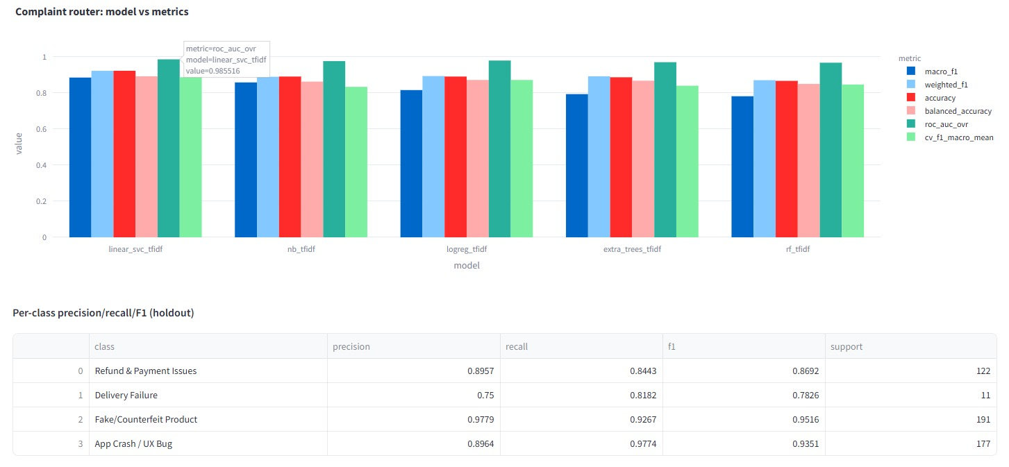

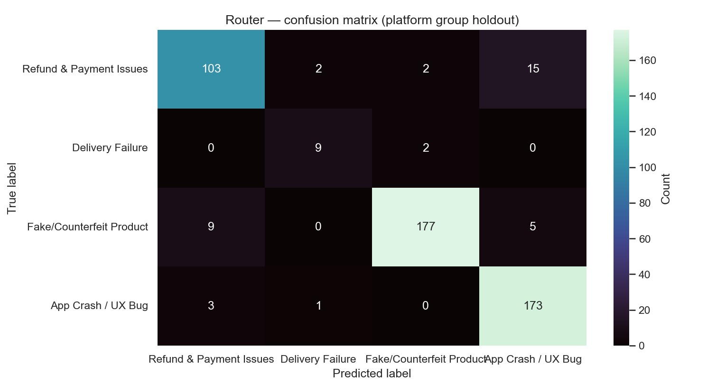

Technology Stack
Every library is free, open-source, and installable via pip. No paid API keys or cloud credits are required for the core pipeline. All dependencies are listed in requirements.txt.

Library / Tool | Category | Purpose
Python 3.x | Runtime | Entire pipeline and dashboard
google-play-scraper | Ingestion | Live Play Store reviews - no auth key required
python-dotenv | Ingestion | .env credential management for API keys
pandas + numpy | Data Processing | Dataframe operations, arrays, feature engineering
scipy | Statistics | MWU test, ANOVA, Jensen-Shannon Divergence, bootstrap CI
langdetect | NLP | Per-review language detection (en / hi / other)
sentence-transformers | NLP Embeddings | Multilingual SBERT - paraphrase-MiniLM-L12-v2
torch | Deep Learning | Backend for sentence-transformers inference
scikit-learn | ML | PCA, TF-IDF, K-Means, LogReg, RF, GBM, LinearSVC, IF, OC-SVM, all metrics
umap-learn | Dim. Reduction | UMAP manifold learning (50→10d)
hdbscan | Clustering | Density-based clustering + noise detection
imbalanced-learn | Balancing | SMOTE oversampling for churn class imbalance
lightgbm | Gradient Boosting | Fast multi-class router; native feature importance
statsmodels | Statistics | Tukey HSD post-hoc test, trend regression
joblib | Persistence | Serialise / load .pkl model artefacts
plotly | Visualisation | All interactive dashboard charts and scatter plots
matplotlib / seaborn | Visualisation | Static PNG exports (Step 07)
streamlit | Dashboard | 12-module decision-support web application
python-docx | Reporting | Report and document generation
langchain + langchain-core | GenAI | LCEL chain composition, prompt templating, structured output
langchain-community | GenAI | FAISS vector store integration
langchain-huggingface | GenAI | Sentence-BERT embeddings through the LangChain interface
langchain-groq | GenAI | Groq chat models, free tier, no paid credits required
faiss-cpu | Vector DB | Persistent similarity index over 2,240 review embeddings
rank-bm25 | Retrieval | BM25 lexical ranking fused with dense retrieval
pydantic | Validation | Schema-validated structured LLM output for cluster insights
pytest | Testing | 30 unit tests covering retrieval, citations, metrics and retry logic
GitHub Actions | CI | Index build, tests and retrieval scoring with no API key required

Streamlit App Deployment & Usage

Deployment Steps
Step | Command / Action
1. Set up environment | python -m venv .venv → activate → pip install -r requirements.txt
2. Generate data + models | python run_pipeline.py (first run: ~8-12 min on CPU due to SBERT embedding computation)
3. Launch dashboard | streamlit run app.py (or: streamlit run app.py --server.headless true --server.port 8501)
4. Cloud deployment | Connect repo to Streamlit Community Cloud; set REDDIT_CLIENT_ID + REDDIT_CLIENT_SECRET as secrets
5. Configure the LLM | cp .env.example .env then add a free GROQ_API_KEY from console.groq.com
6. Build the RAG index | python rag/build_index.py (idempotent, about 30 seconds)
7. Generate cluster insights | python rag/cluster_insights.py
8. Evaluate (optional) | python rag/evaluate.py (or --retrieval-only, which needs no API key)

Dashboard Modules (12 Modules)
Module | Purpose & Capabilities
How to Use This App | Onboarding guide with collapsible per-module expanders and an end-to-end worked example walkthrough
Live Pulse | 4 KPI cards (total reviews, platforms active, Tier 1 alerts, top cluster) + complaint volume stacked bar by platform and cluster
Complaint Landscape | Interactive t-SNE scatter coloured by cluster; hover reveals full review text
Spike Tracker | Weekly complaint count lines per cluster; red dot markers on weeks where z > 2.5σ
Critical Alerts | Ranked Tier 1 critical review table sorted by Isolation Forest anomaly score - the operations escalation queue
Severity Triage | Threshold slider; severity-ranked complaint table; heuristic SHAP-style driver bar chart for the top complaint
Complaint Router | Live text input → routing prediction + confidence + SHAP term influence; routing load histogram across categories
Churn Risk | Churn score distribution histogram by platform; top-100 high-risk user watchlist with route category
Auto-Responder | 3 response variants (Formal / Empathetic / Resolution Focused) with quality scores; route-aware draft text
Drift Monitor | Centroid shift + JS divergence chart over time; drift alert table with emerging terms; topic coherence comparison
Ask the Complaints (RAG) | Chat interface over the full corpus. Platform, severity and anomaly filters; selectable retrieval strategy; streamed answers; expandable source panel showing each cited review with its metadata and similarity score
LLM Cluster Insights | Generated label, summary, root causes and suggested owning team per cluster, plus an executive brief generator with platform and time-window scope and a markdown download

Example: Monday Morning Ops Review (~15 Minutes)
A customer-experience analyst can scope an incident, assign root cause, quantify churn risk, and draft a response - all in one session:

Step | Module | Action & Insight
1 | Live Pulse | Check KPIs - Tier 1 alerts jumped 24 → 41. Top Cluster = Delivery Failure. Something changed overnight.
2 | Spike Tracker | Meesho Delivery Failure spike confirmed, z = 3.1σ. Statistically significant - not random noise.
3 | Critical Alerts | Filter to Meesho. Top 3 reviews: ‘refund not credited.’ Recurring sub-issue identified.
4 | Complaint Router | Paste review → Payments & Refunds (confidence = 0.84). Root cause: payments team, not logistics.
5 | Churn Risk | Filter Meesho + Payments & Refunds. 18 users with churn_risk > 0.75. Retention priority quantified.
6 | Auto-Responder | Generate Resolution Focused response (quality = 0.85). Edit to brand voice and SLA. Send.
7 | Drift Monitor | is_drift_alert = True. Emerging terms: ‘refund portal’, ‘not credited’. New complaint sub-type confirmed.

Global Sidebar Controls: Platform multiselect · Star bucket filter · Date range slider. The “Refresh Full Pipeline” button re-executes run_pipeline.py and clears Streamlit cache to reload the latest artefacts.

Dashboard Visualisations:
Live Pulse · Severity Triage

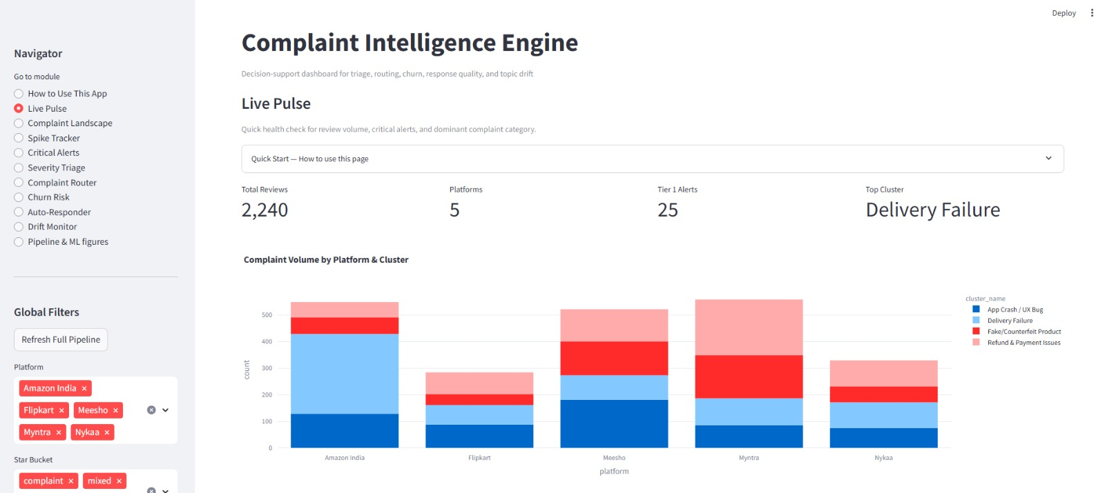
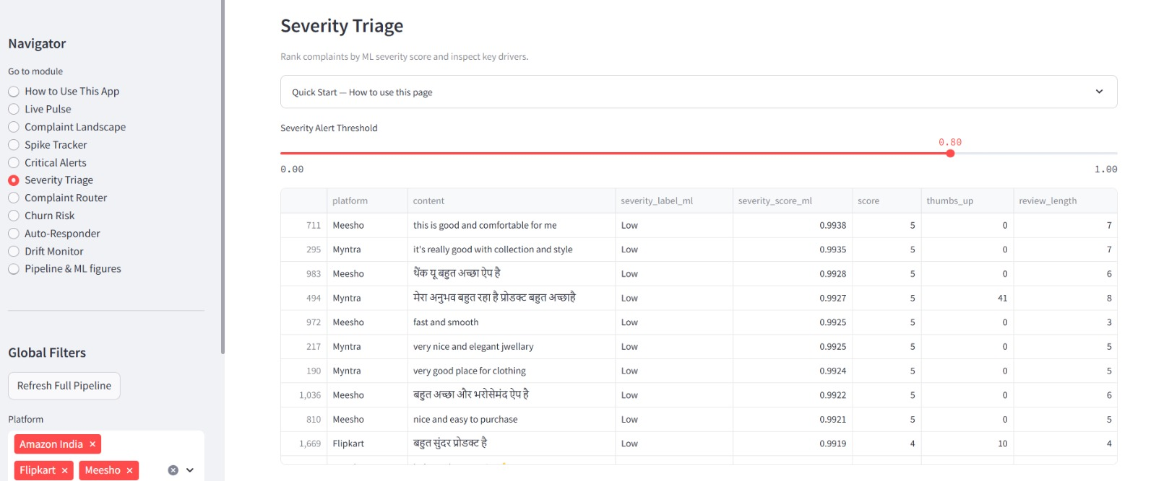

Dashboard Visualisations:
Churn Risk · Auto-Responder
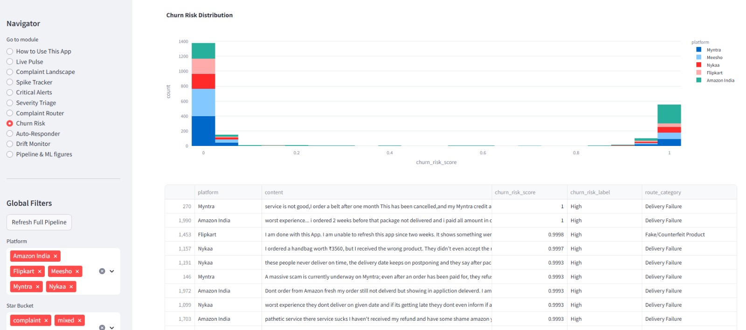

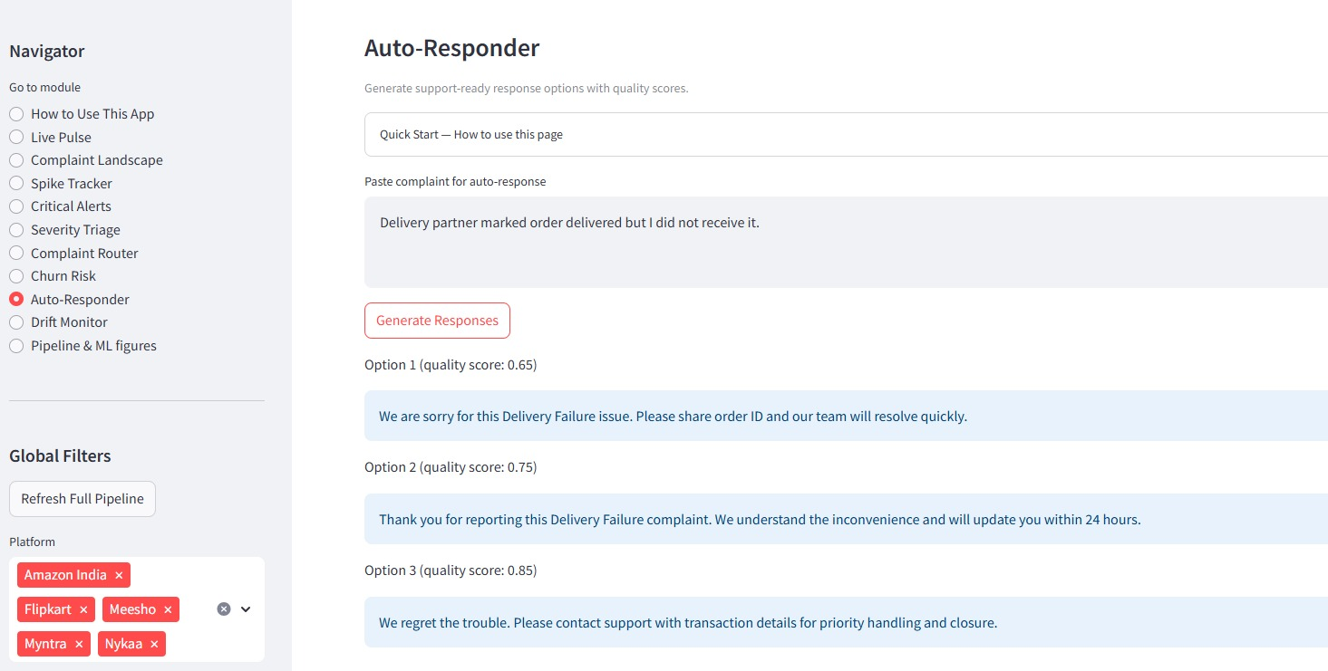

Dashboard Visualisations: GenAI Modules
The following captures show the GenAI layer in operation. Each caption states exactly what to capture.
Screenshot 1: Ask the Complaints (RAG): grounded answer with inline [R####] citations and the Sources panel expanded
How to capture: Streamlit sidebar, module 'Ask the Complaints (RAG)'. Ask: 'Why are Meesho customers not getting refunds?' with Platform = Meesho. Expand 'Sources' before capturing.

[ paste image here, then delete this line ]

Screenshot 2: LLM Cluster Insights: generated labels table with one cluster expander open
How to capture: Module 'LLM Cluster Insights'. Keep the K-Means tab selected and expand the largest cluster.

[ paste image here, then delete this line ]

Screenshot 3: Retrieval variant comparison measured in the terminal
How to capture: Run: python rag/evaluate.py --compare and capture the printed three-column table.

[ paste image here, then delete this line ]

Screenshot 4: Executive Complaint Brief generated for a single platform
How to capture: Module 'LLM Cluster Insights', scroll to 'Executive Complaint Brief', pick a platform, click Generate brief.

[ paste image here, then delete this line ]

Screenshot 5: Retrieval strategy selector and metadata filters
How to capture: Top of the 'Ask the Complaints (RAG)' page showing the Platform, Severity, anomaly checkbox, k slider and the hybrid / rerank / dense selector.

[ paste image here, then delete this line ]

Screenshot 6 (optional): Unit test suite passing
How to capture: Run: python -m pytest tests -q and capture the '30 passed' line.

[ paste image here, then delete this line ]

Screenshot 7 (optional): GitHub Actions CI run succeeding with no API key
How to capture: GitHub repository, Actions tab, open the most recent 'RAG CI' run.

[ paste image here, then delete this line ]

Limitations & Mitigations
The following is an honest assessment of known limitations in the current implementation, their root causes and impacts, and recommended mitigations for each:

Limitation | Root Cause & Impact | Mitigation
Near-perfect supervised metrics (F1 ≈ 1.0) | Label-feature leakage: weak label rules and feature columns share keywords (e.g. ‘fraud’, star rating). Not true generalisation. | Use time-based + platform-based holdouts; strictly separate rule-derived features from weak-label rules; collect human-annotated gold labels.
Single random train-test split | No time-based or platform holdout. Metrics do not reflect cross-platform or temporal generalisation. | Train on older reviews, test on newer (temporal split); train on 4 platforms, test on the 5th (platform holdout).
One-Class SVM instability | Insufficient positive reviews for robust fitting in some configurations; fallback warnings in pipeline logs. | Increase minimum positive review count; lower nu parameter; fall back to Isolation Forest only when OC-SVM fails.
Auto-Responder is template-based | Dashboard uses fixed templates + heuristic quality scorer; no live LLM in baseline UI. | Optional LLM API (Mistral-7B, Phi-3) behind a feature flag; mandatory human approval before send; log edits as feedback.
Drift requires ≥6 weeks history | Sparse windows yield empty or unreliable JSD reports; alert precision is low for short corpora. | Accumulate corpus over time before enabling drift alerts; use ADWIN streaming detector for real-time scenarios.
UI vs pipeline model name mismatch | selected_models.json may select logreg for severity while help text references XGBoost or DistilBERT. | Drive all UI help text and model references from selected_models.json as the single source of truth.
LLM-as-judge evaluation | Faithfulness and relevance are scored by a model rather than by humans. A larger independent judge model reduces but does not remove self-preference bias. | Collect human judgements for a subset of questions; report inter-rater agreement against the judge.
Low absolute recall (0.466 at k=8) | Several questions have more than 8 relevant reviews while only 8 reach the prompt, capping recall by construction. | Increase k for broad questions; add query decomposition for multi-part questions.
Small RAG evaluation set | 26 scored questions gives wide confidence intervals; a single question shifts hit rate by about 4 points. | Expand to 100 or more questions with human-verified relevance labels.
Free-tier rate limits | Burst usage triggers HTTP 429, inflating p95 latency to 17.8 s against a 3.48 s median. | Exponential-backoff retry is implemented; add response caching keyed on question and filters.
Reranker download size | The cross-encoder is a one-off 464 MB download that may be impractical on constrained connections. | Code falls back to hybrid retrieval automatically with a warning when the model is absent.

Overall strategy: Treat this system as decision-support and prototyping infrastructure. Use time-based and platform-based holdouts, collect human-validated labels, and implement proper calibration and per-class error analysis before drawing conclusions from reported F1 scores.

Conclusion, Future Scope & Who Can Use It

Conclusion
The Complaint Intelligence Engine delivers a coherent, modular, and repeatable path from raw Indian e-commerce reviews through multilingual NLP, unsupervised complaint archetype discovery, and supervised decision-support modules - all surfaced in a twelve-module Streamlit dashboard enabling teams to move from data to action in a single session.

The primary technical contribution is the unsupervised-to-supervised bridge: K-Means cluster labels feed directly into the routing classifier as training targets, and SBERT embedding structure informs both anomaly detection and drift monitoring - grounding supervised outputs in data-discovered structure rather than imposed category definitions.

Headline caveat: Supervised metrics should be interpreted cautiously until evaluation uses disjoint time and platform splits with human-validated labels. Near-perfect scores reflect label-feature overlap and small corpus size - not true generalisation. Treat this system as decision-support and prototyping infrastructure until production-grade labelling and monitoring are in place.
The GenAI layer extends the contribution from fixed analytics to open-ended enquiry. Rather than presenting only the questions the dashboard was designed to answer, the RAG layer lets an analyst interrogate the corpus directly while keeping every claim traceable to specific reviews. The measured outcome is a hit rate@1 of 0.692 with reranking against 0.5 for dense retrieval alone, judge-rated faithfulness of 4.65 out of 5, and correct refusal on all four out of corpus questions. The design principle throughout is that the model may phrase findings but never supply facts: all report figures are computed in pandas, and all answer content is drawn from retrieved reviews with inline citations.

GitHub Repository: https://github.com/Complaint-Intelligence-Engine-for-Indian-E-Commerce

Future Scope
Priority | Enhancement
High | Time-based + platform holdouts; human-annotated gold evaluation set of 50-100 severity and routing labels
High | Integrate Mistral-7B-Instruct or Phi-3-mini behind a feature flag in Auto-Responder; human approval before send
Medium | REST endpoint / queue worker for real-time scoring; scheduled nightly ingestion; latency monitoring
Medium | MLOps: MLflow experiment tracking; automated retraining triggered by drift alerts; shadow deployments
Low | Multi-channel ingestion: support tickets, email, X / Twitter, in-app chat logs
Low | Extend to JioMart, AJIO, Tata Cliq to build a comprehensive Indian e-commerce complaint benchmark
High | Expand the RAG evaluation set to 100 or more questions with human-verified relevance labels
Medium | Query decomposition so multi-part analyst questions retrieve evidence for each sub-question
Medium | Response caching keyed on question and filters to reduce free-tier API consumption
Low | Replace the hosted LLM with a locally served model to remove the external dependency entirely
Medium | Ingest Reddit complaints via PRAW from r/IndianShopping, r/Meesho and r/india to add long-form complaint narratives that Play Store reviews do not contain. The ingestion path is implemented behind a feature flag and requires REDDIT_CLIENT_ID and REDDIT_CLIENT_SECRET credentials.

Who Can Use This Project
User | Use Case
CX / Support Leadership | Queue prioritisation, routing load monitoring, weekly spike and drift briefings
Product & Operations Teams | Thematic complaint clusters, incident timing vs review spikes, emerging issue detection
Data / ML Engineers | Extend modules, swap models, integrate labelled datasets, set up production serving
Students & Researchers | End-to-end NLP pipeline, weak supervision patterns, and dashboard integration reference

