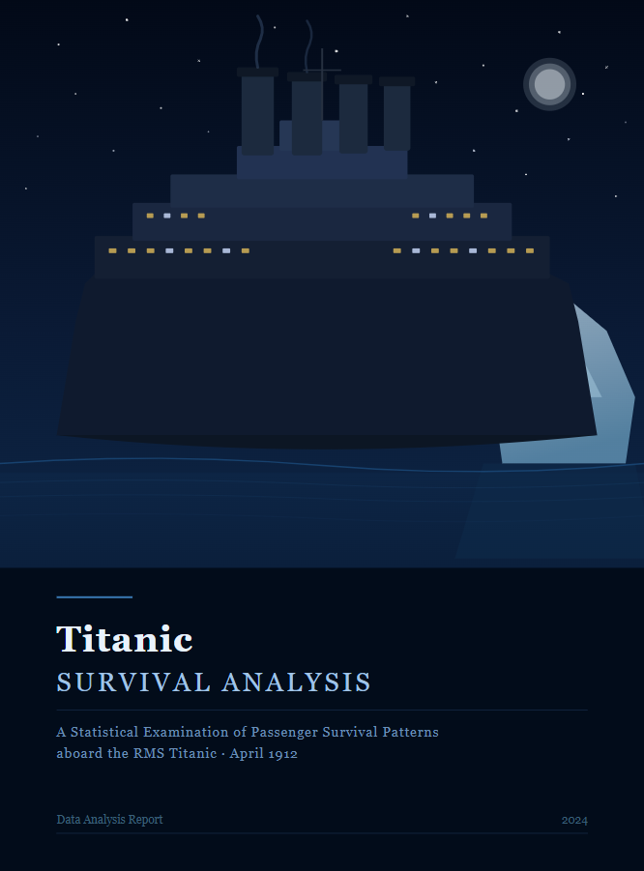
INDEX
Introduction | 3
Data Description | 3
Analysis | 3
Findings(Insights) | 6
Conclusion | 6
Recommendations | 7
Final Note | 7

Introduction
The objective of this report is to analyze the Titanic dataset to understand the factors that influenced passenger survival. The goal is to identify patterns and relationships between variables such as class, gender, age, and survival outcome.

Data Description
The dataset was obtained from the Titanic dataset (CSV/Excel format). It includes the following columns:
- Passenger ID
- Name
- Age
- Gender (Sex)
- Passenger Class (Pclass)
- Fare
- Embarked (Port)
- Survival (0 = No, 1 = Yes)
Data cleaning was performed to ensure accuracy and consistency before analysis.

Analysis

Data Cleaning
- Handled missing values (Age, Embarked)
- Filled missing Age values using average/median
- Replaced missing Embarked values with most frequent value
- Removed duplicate records
- Converted categorical data into proper format
- Ensured consistency across all columns

Data Analysis (Excel / SQL / Power BI)
- Analyzed survival rate overall
- Compared survival by gender
- Compared survival by passenger class
- Studied age distribution vs survival
- Examined fare vs survival relationship

Visualization
- Bar Chart: Survival by Gender
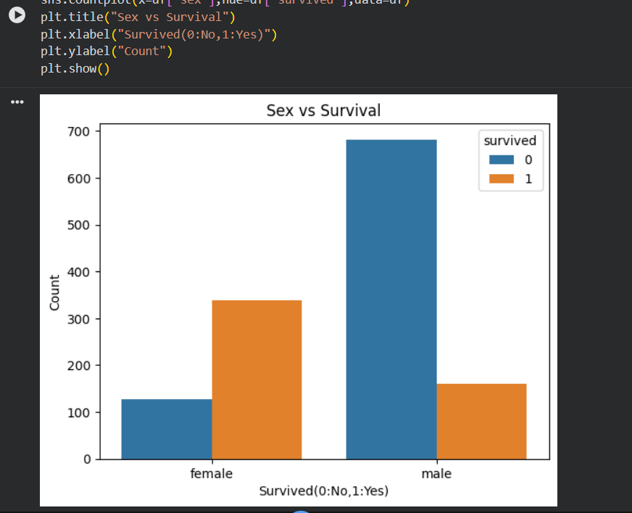
- Bar Chart: Survival by Class
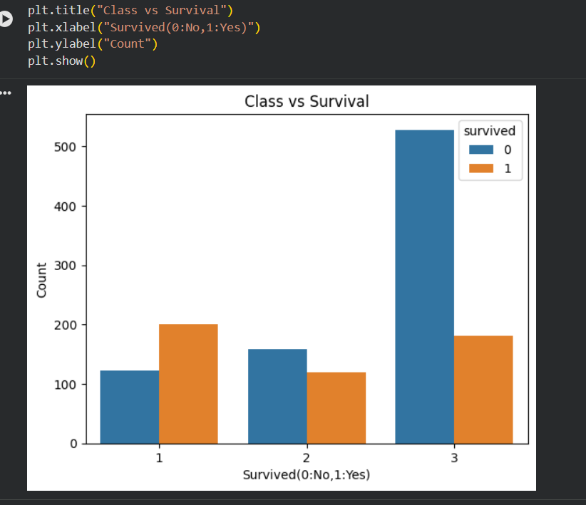
- Histogram/Column Chart: Age Distribution
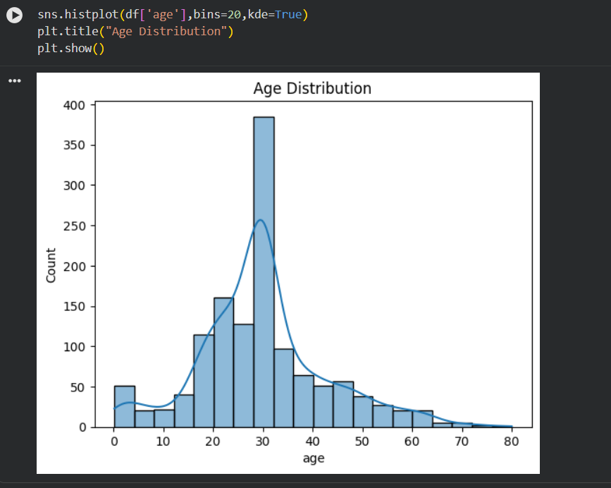
- Scatter Plot: Fare vs Survival
- Dashboard: Combined analysis view
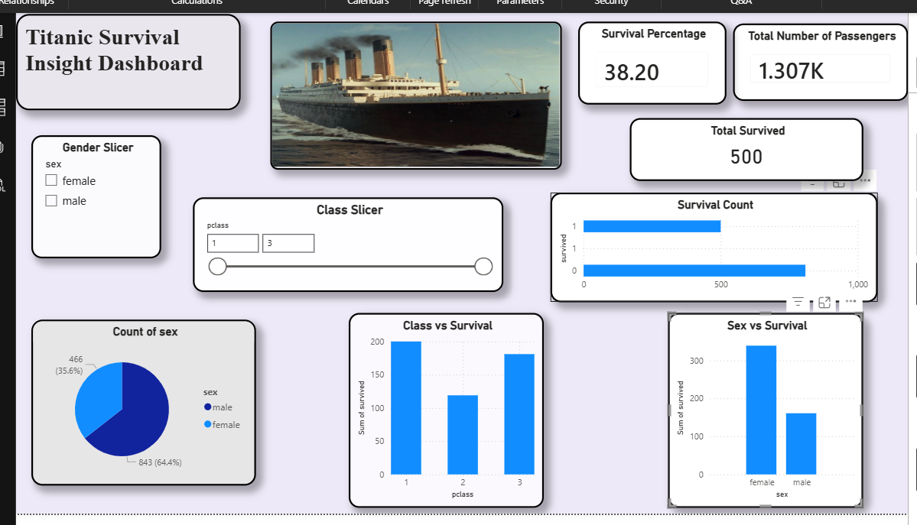

Findings (Insights)
- Females had a significantly higher survival rate than males
- Passengers in 1st class had higher survival chances
- Lower-class passengers had lower survival rates
- Younger passengers had slightly better survival chances
- Higher fare passengers were more likely to survive

Conclusion
The analysis shows that survival was strongly influenced by gender, passenger class, and fare. Social and economic factors played a major role in determining survival chances during the disaster.

Recommendations
- Prioritize vulnerable groups in emergency situations
- Ensure equal safety measures across all classes
- Improve emergency response planning and accessibility
- Use data analysis to enhance safety strategies in transport systems

Final Note
This project demonstrates how data analysis can uncover meaningful insights from historical data and help understand real-world scenarios using statistical and visualization techniques.

