
INDEX
Introduction | 3
Data Description | 3
Analysis | 3
Findings(Insights) | 5
Conclusion | 6
Recommendations | 6

Introduction
The objective of this report is to analyze Netflix content data to understand trends in movies and TV shows, audience preferences, and content distribution. The goal is to extract insights that can help improve content strategy and decision-making.

Data Description
The dataset was obtained from a Netflix titles dataset (CSV/Excel format). It includes information such as:
- Title
- Type (Movie/TV Show)
- Genre
- Country
- Release Year
- Rating
- Duration
Data cleaning was performed in Excel to ensure accuracy and consistency before analysis.

Analysis

Data Cleaning
- Removed missing and null values where necessary
- Standardized text fields (Genre, Country, Type)
- Converted date formats into a consistent structure
- Removed duplicate records
- Ensured consistency across all columns

Data Analysis (Excel / SQL / Power BI)
- Compared Movies vs TV Shows distribution
- Analyzed content trend over years
- Studied genre distribution
- Examined ratings distribution
- Identified top content categories

Visualization
- Bar Chart: Movies vs TV Shows
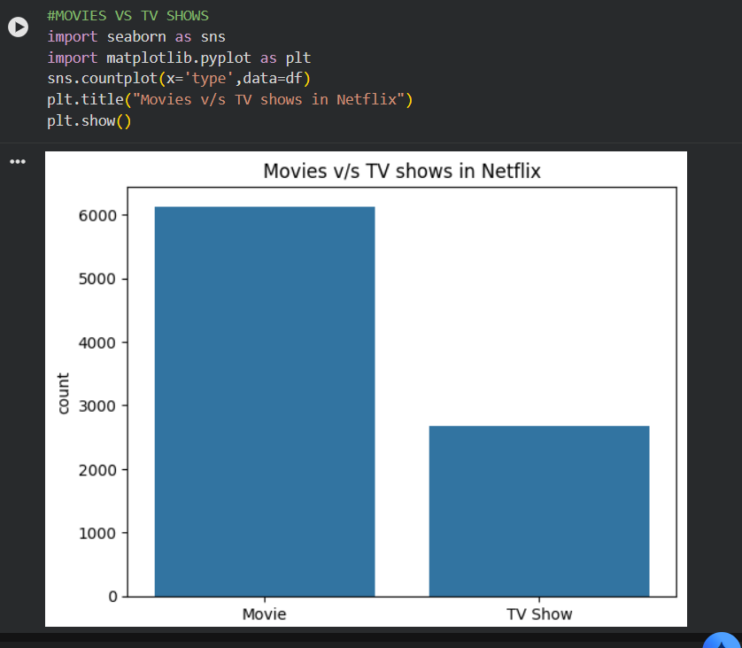
- Line Chart: Content added over years (trend)
- Pie/Bar Chart: Genre distribution
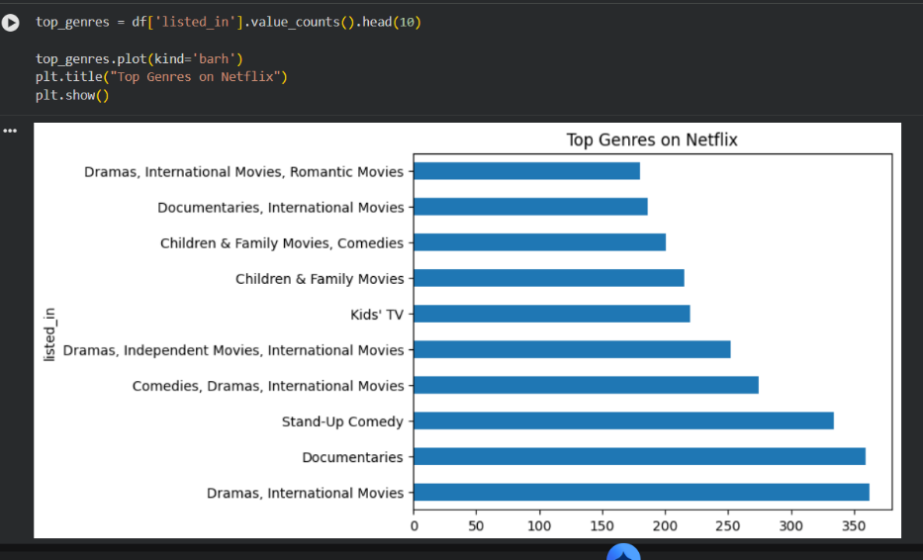
- Column Chart: Ratings distribution
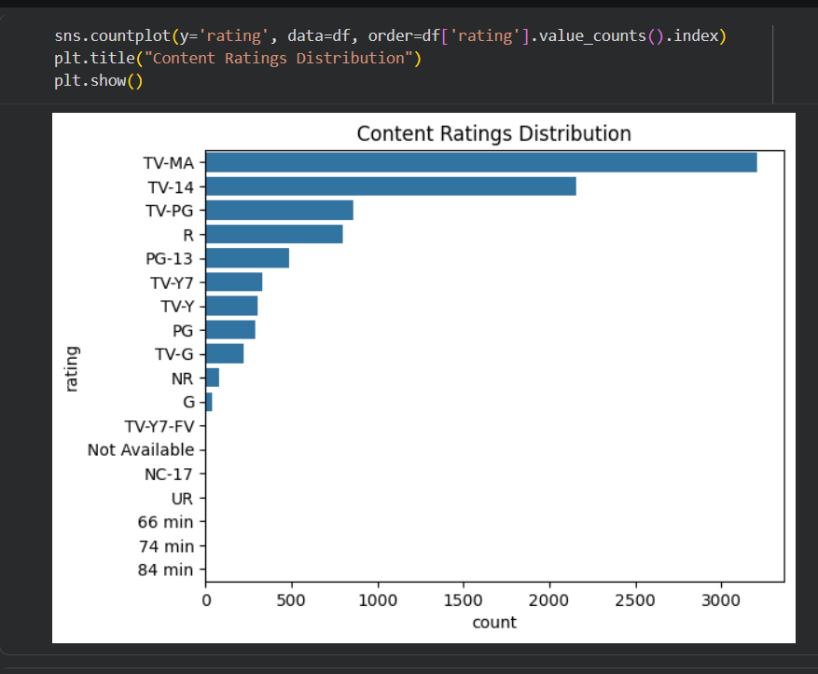
- Dashboard: Combined view of all insights
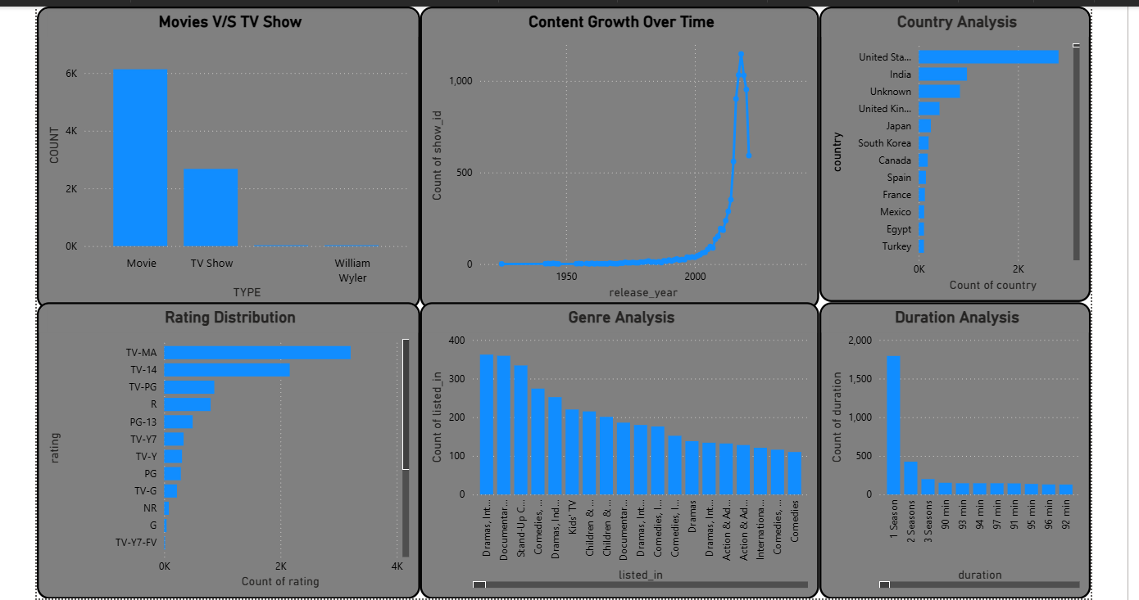

Findings (Insights)
- Movies are more in number compared to TV Shows
- Netflix content has significantly increased in recent years
- Certain genres (like Drama/Comedy) dominate the platform
- Most content falls under specific rating categories (e.g., TV-MA, PG)
- Content production is concentrated in a few countries

Conclusion
The Netflix dataset analysis reveals strong growth in content over time and highlights dominant genres and categories. The insights help in understanding audience preferences and platform trends.

Recommendations
- Invest more in high-demand genres
- Increase production of TV Shows to balance content
- Focus on regional content expansion
- Target content based on popular ratings categories
- Leverage trends to release content during peak demand periods

Final Note
This project demonstrates how data analysis and visualization can be used to understand content performance and support strategic decisions in the entertainment industry.

