ContractIQ
Sprint 3 – Database Design
Contract Obligation Tracking & Compliance Management Platform

1. Objective
This sprint defines the database structure required for ContractIQ before additional backend features are implemented. It identifies the core tables, columns, keys, relationships and purpose of each table.

2. Database Schema

users
Central identity table for authentication, roles, departments and account status.
Column | Data Type | Key / Constraint | Purpose
id | BIGINT | PK | User identifier
name | VARCHAR(100) |  | Full name
email | VARCHAR(255) | UNIQUE | Login/contact email
hashed_password | VARCHAR(255) |  | Password hash
department | VARCHAR(100) |  | Department
role | VARCHAR(50) |  | Application role
is_active | BOOLEAN |  | Account status
created_at | TIMESTAMP |  | Creation time
updated_at | TIMESTAMP |  | Last update

contracts
Central business entity storing contract parties, ownership, lifecycle dates, status and value.
Column | Data Type | Key / Constraint | Purpose
id | BIGINT | PK | Contract identifier
contract_number | VARCHAR(100) | UNIQUE | Business contract number
title | VARCHAR(255) |  | Contract title
party_name | VARCHAR(255) |  | External party
owner_id | BIGINT | FK → users.id | Internal owner
status | VARCHAR(50) |  | Lifecycle status
start_date | DATE |  | Start date
end_date | DATE |  | Expiry date
value | DECIMAL(15,2) |  | Contract value
created_at | TIMESTAMP |  | Creation time
updated_at | TIMESTAMP |  | Last update

contract_versions
Preserves historical contract document versions and who created each version.
Column | Data Type | Key / Constraint | Purpose
id | BIGINT | PK | Version identifier
contract_id | BIGINT | FK → contracts.id | Parent contract
version_number | INT |  | Version number
document_path | VARCHAR(500) |  | Document location
change_summary | TEXT |  | Changes
created_by | BIGINT | FK → users.id | Creator
created_at | TIMESTAMP |  | Creation time

obligations
Tracks contractual duties, responsible users, deadlines, priorities and completion.
Column | Data Type | Key / Constraint | Purpose
id | BIGINT | PK | Obligation identifier
contract_id | BIGINT | FK → contracts.id | Parent contract
assigned_to | BIGINT | FK → users.id | Responsible user
description | TEXT |  | Obligation details
due_date | DATE |  | Due date
status | VARCHAR(50) |  | Progress status
priority | VARCHAR(20) |  | Priority
completed_at | TIMESTAMP |  | Completion time
created_at | TIMESTAMP |  | Creation time

renewals
Tracks renewal requests, proposed dates, outcomes and notes.
Column | Data Type | Key / Constraint | Purpose
id | BIGINT | PK | Renewal identifier
contract_id | BIGINT | FK → contracts.id | Contract
requested_by | BIGINT | FK → users.id | Requester
renewal_date | DATE |  | Proposed renewal date
new_end_date | DATE |  | New expiry
status | VARCHAR(50) |  | Renewal status
notes | TEXT |  | Notes
created_at | TIMESTAMP |  | Creation time

notifications
Stores alerts for users, including deadlines, overdue items and renewals.
Column | Data Type | Key / Constraint | Purpose
id | BIGINT | PK | Notification identifier
user_id | BIGINT | FK → users.id | Recipient
contract_id | BIGINT | FK → contracts.id | Related contract, optional
obligation_id | BIGINT | FK → obligations.id | Related obligation, optional
type | VARCHAR(50) |  | Notification type
title | VARCHAR(255) |  | Title
message | TEXT |  | Content
is_read | BOOLEAN |  | Read status
created_at | TIMESTAMP |  | Creation time

reports
Stores generated report metadata, filters and file locations.
Column | Data Type | Key / Constraint | Purpose
id | BIGINT | PK | Report identifier
generated_by | BIGINT | FK → users.id | Generator
report_type | VARCHAR(100) |  | Report type
title | VARCHAR(255) |  | Title
parameters | JSONB |  | Report filters
file_path | VARCHAR(500) |  | File location
created_at | TIMESTAMP |  | Generation time

audit_logs
Records important actions for accountability, including affected entity and old/new values.
Column | Data Type | Key / Constraint | Purpose
id | BIGINT | PK | Audit identifier
user_id | BIGINT | FK → users.id | Actor
entity_type | VARCHAR(100) |  | Affected entity
entity_id | BIGINT |  | Affected record
action | VARCHAR(50) |  | Action
old_values | JSONB |  | Previous values
new_values | JSONB |  | New values
ip_address | VARCHAR(45) |  | IP address
created_at | TIMESTAMP |  | Audit time

activities
Stores the operational timeline of comments, reviews, assignments and other activities.
Column | Data Type | Key / Constraint | Purpose
id | BIGINT | PK | Activity identifier
user_id | BIGINT | FK → users.id | Actor
contract_id | BIGINT | FK → contracts.id | Related contract, optional
obligation_id | BIGINT | FK → obligations.id | Related obligation, optional
activity_type | VARCHAR(100) |  | Activity type
description | TEXT |  | Details
created_at | TIMESTAMP |  | Activity time

3. Table Relationships
Parent | Child | Relationship | Foreign Key
users | contracts | 1:N | contracts.owner_id → users.id
contracts | contract_versions | 1:N | contract_versions.contract_id → contracts.id
users | contract_versions | 1:N | contract_versions.created_by → users.id
contracts | obligations | 1:N | obligations.contract_id → contracts.id
users | obligations | 1:N | obligations.assigned_to → users.id
contracts | renewals | 1:N | renewals.contract_id → contracts.id
users | renewals | 1:N | renewals.requested_by → users.id
users | notifications | 1:N | notifications.user_id → users.id
contracts | notifications | 1:N optional | notifications.contract_id → contracts.id
obligations | notifications | 1:N optional | notifications.obligation_id → obligations.id
users | reports | 1:N | reports.generated_by → users.id
users | audit_logs | 1:N | audit_logs.user_id → users.id
users | activities | 1:N | activities.user_id → users.id
contracts | activities | 1:N optional | activities.contract_id → contracts.id
obligations | activities | 1:N optional | activities.obligation_id → obligations.id

4. Entity Relationship Diagram
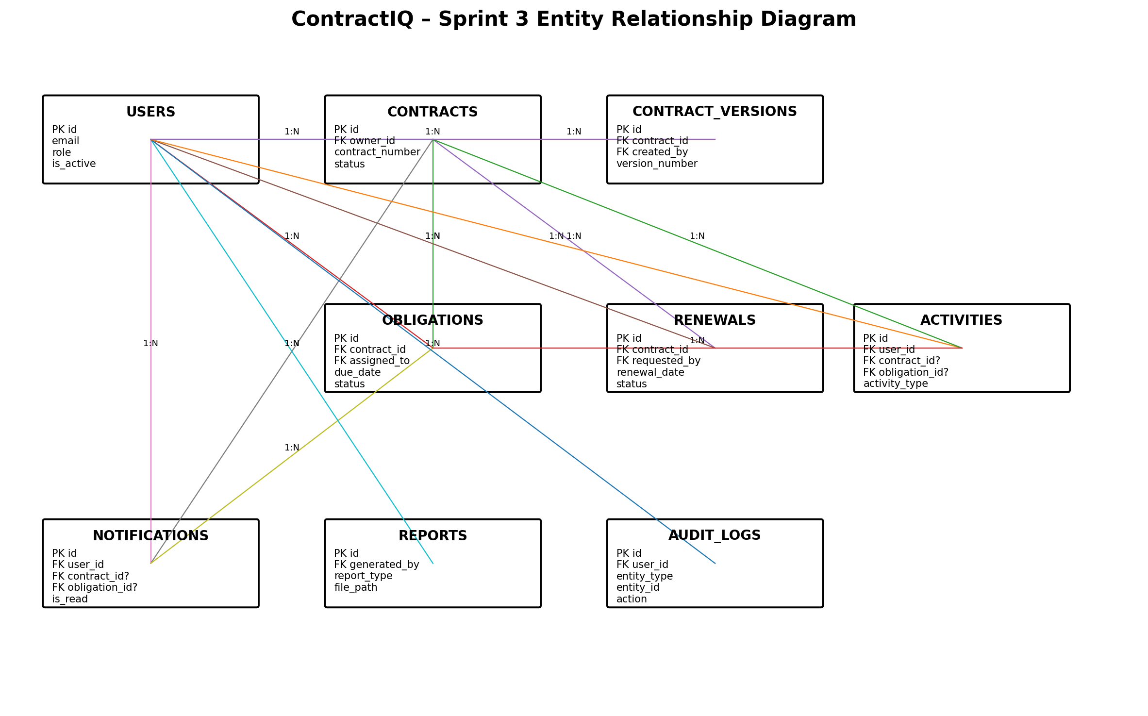

5. How the Tables Work Together
Users provide identity, role and ownership information. Contracts are the central business records. Contract versions preserve document history, while obligations store duties, deadlines and responsible users. Renewals manage contract extensions.
Notifications alert users about deadlines and renewals. Reports store generated-report metadata. Activities provide an operational timeline, while audit logs provide an accountability trail of important actions. The design mainly uses one-to-many relationships and can be extended with junction tables if future requirements introduce many-to-many ownership or assignment.

6. Design Conventions
- Lowercase snake_case naming.
- BIGINT surrogate primary keys named id.
- Explicit foreign keys using *_id naming.
- TIMESTAMP fields for lifecycle tracking.
- JSONB for flexible report and audit metadata.
- VARCHAR status/type fields so application-level enums can evolve.

