ELECTRICITY PRICING IN TEXAS:
SEASONAL TRENDS, INFLUENCING FACTORS, AND STRATEGIC INSIGHTS

EXECUTIVE SUMMARY
This study examines Texas's energy price swings between 2019 and 2021, emphasizing the main determinants of price patterns, such as weather, load, and generation. We discovered trends and connections using Tableau data visualization, which provide useful information for companies and regulators to maximize electricity use.
Important findings show notable hourly and seasonal pricing fluctuations. The relationship between settlement point prices and temperature across areas demonstrates how strong price spikes occur throughout the summer months, especially during peak hours (afternoons), as a result of higher temperatures and increased demand. Regional differences are also highlighted in the analysis; the most volatile prices are found in LZ_WEST and LZ_SOUTH.

According to generation data, coal, wind, and gas-fired power account for more over 80% of total generation, making them the main energy sources. However, relying on these sources during severe weather causes price spikes and generation shortages, particularly during winter storms and heat waves.
The biggest deficits in March and August indicate inefficiencies in balancing supply and demand, according to a breakdown of energy shortfalls by month. These results highlight how urgently better forecasts, diversified energy portfolios, and enhanced load management techniques are needed.
Adopting sophisticated demand-response systems, investing in renewable energy integration, and avoiding peak-hour electricity usage are all recommendations for organizations looking to minimize price volatility and optimize energy expenses. Grid resilience and renewable capacity expansion should be policymakers' top priorities in order to stabilize pricing amid severe weather conditions.
BUSINESS QUESTIONS
- How do settlement point prices differ by area and what seasonal patterns are there? ~ Graph 1: Trend Line of Price Points
- Which are the main sources of electricity production, and what is the extent of each source's contribution? ~ Graph 2: Top Contributors of Electricity
- How has the production of electricity from various fuels evolved over time, and which sources are becoming more or less popular? ~ Graph 3: Trend of Electricity Generated from Various Fuels
- How do weather factors (such temperature) and electricity costs relate to one another and does this differ by location? ~ Graph 4: How Weather Impacts Price
- How do meteorological factors, including temperature, affect the amount of electricity generated over time? ~ Graph 5: Weather Impact on Electricity Generation
- What are the months with the most electrical shortages, and how do these shortages relate to changes in prices? ~ Graph 6: Electricity Shortage Over Months
- Show the weather details and price point for the chosen day and hour ~ Graph 7: Weather Data and Price for All Regions

INTRODUCTION
Texas's energy market is distinguished by dynamic electricity pricing, which is determined by consumer demand as opposed to set government rates. This makes controlling energy expenses extremely difficult for both households and businesses, especially during times of high demand or unfavorable weather.
Significant patterns were seen in electricity costs in the year 2020, with summertime seasonal peaks and severe volatility during severe weather conditions like heat waves or storms. Temperature, energy demand (load), generation capacity, and the contribution of different energy sources such as coal, wind, and gas-CC all have an impact on these variations.
DATA PREPARATION ISSUES AND TRANSFORMATION OVERVIEW

Data cleaning began with identifying and removing null and duplicate values. Next, I performed the necessary pivots and joined the data. The most challenging part was handling the large data volume. Processing data from 2019 to 2021 in Tableau Prep was slow, especially when removing null values from the weather data. To address this, I created a calculated field to identify and remove null values across all weather variables simultaneously. Another significant challenge was transforming the weather data. After extensive consideration, I determined that grouping weather variables by regions instead of cities aligned best with the business questions. I then implemented this transformation and used pivot mechanisms as needed.

ANALYSES: KEY INSIGHTS FROM DATA VISUALIZATIONS
- Seasonal Variations in Power Costs: Summer (June to August) and winter extremes—especially during weather events like storms or heatwaves—see the biggest rises in electricity rates, which show notable seasonal trends. There are noticeable regional differences, with LZ_WEST and LZ_SOUTH exhibiting higher levels of price volatility than other locations.
- Price and Temperature Association: High temperatures and settlement point prices are found to be strongly positively correlated, particularly in areas like LZ_NORTH and LZ_WEST. Temperature has a greater effect on prices during peak hours (afternoons), suggesting that there is a greater need for cooling.
- Sources of Generation and Price Stability: Although wind and gas-CC are the main sources of energy generating, reliance on them during severe weather events results in price rises because of generation shortages. Wind and other renewable energy sources help maintain stability in good weather but are erratic in bad weather.
- In close accord with temperature trends, electricity generation rises drastically from June to August during the summer and falls during the winter. Higher energy demand for cooling is indicated by the fact that the highest electricity generation occurs during the hottest months of July and August. Although the decline in energy generation during the winter months points to a possible risk of underproduction during really cold weather, it also shows a decrease in demand.

SUGGESTIONS FOR EXPANDING THE WORK:
- Transforming load and electricity generation data by region allows us to better understand price increases and predict future load requirements, enabling efficient electricity generation planning for the upcoming months.
- Analyzing weather patterns and their impact on power generation by region can aid in planning electricity production. For instance, if a region is predicted to generate less electricity in a given month, the shortfall can be compensated by other regions with proper foresight.
SUPPORTING ANALYTICS
- DESCRIPTIVE ANALYTICS:
a. Graph 1: Trend Line of Price Points
The trends in electricity prices by month and region are summarized in this graph.
It provides insight into "what happened" by displaying trends in historical data, like geographical variations and seasonal price swings.
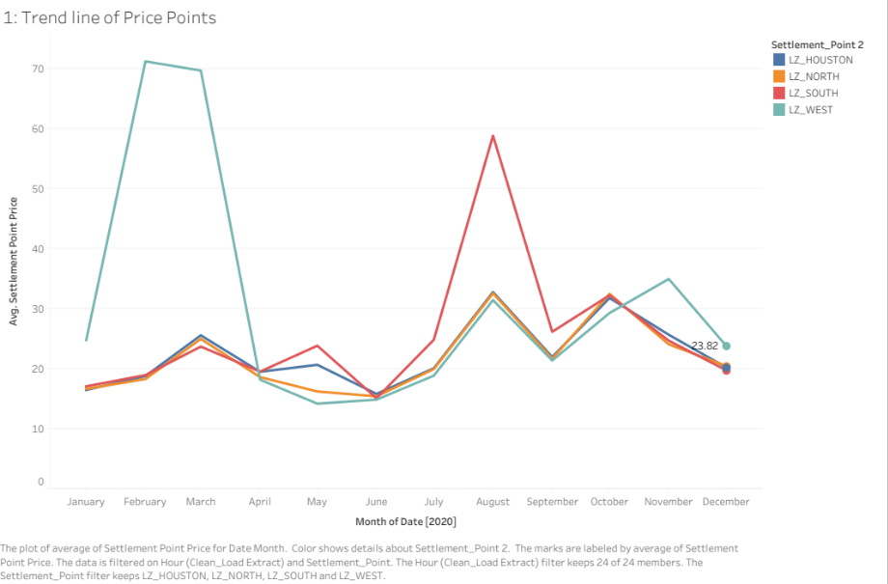
b. Graph 2: Top Contributors of Electricity
This graph shows the relative contributions of each fuel type to the creation of electricity.
In order to determine the most important and less important sources of energy generation, it offers a snapshot of historical data.

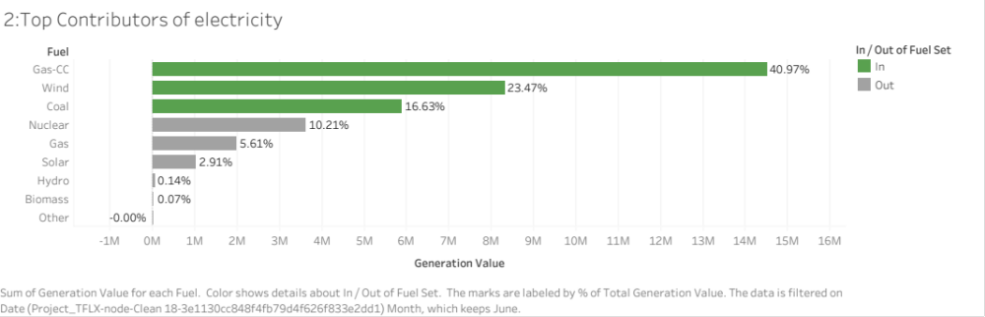

c. Graph 6: Electricity Shortage Over Months [Extra Credits]
This graph illustrates monthly electricity shortages, showing the severity of shortfalls throughout the course of the year. In order to determine when shortages happened most frequently, it compiles historical data.
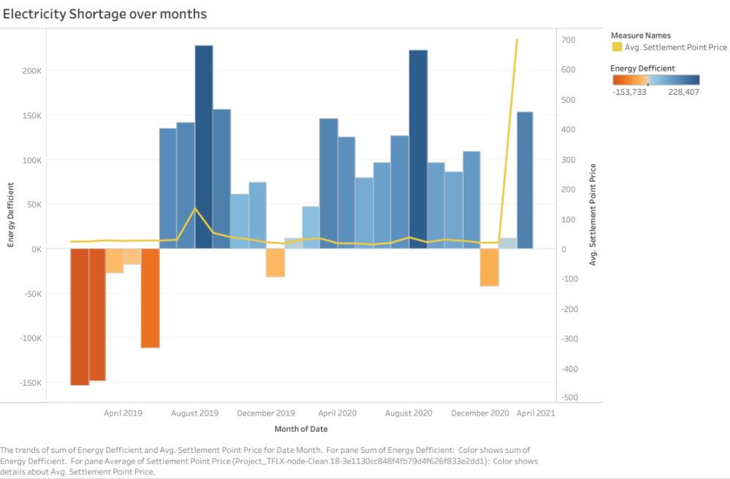

  - DIAGNOSTIC ANALYTICS
a. Graph 4: How Weather Impacts Price
This graph investigates the regional correlation between power prices and weather/temperature.
By establishing a connection between temperature variations and price surges, it helps determine the "why" of these events.

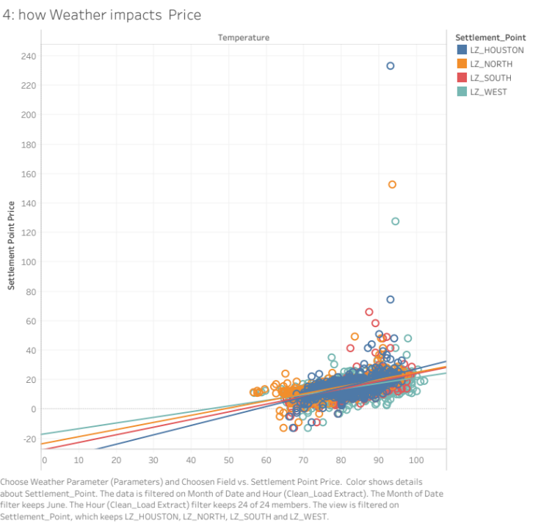
b. Graph 5: Weather impact on Electricity Generation [Extra Credits]
This graph illustrates how weather and temperature affects the amount of electricity generated over time. It finds causes of generation variations, including temperature-dependent demand, by examining trends.

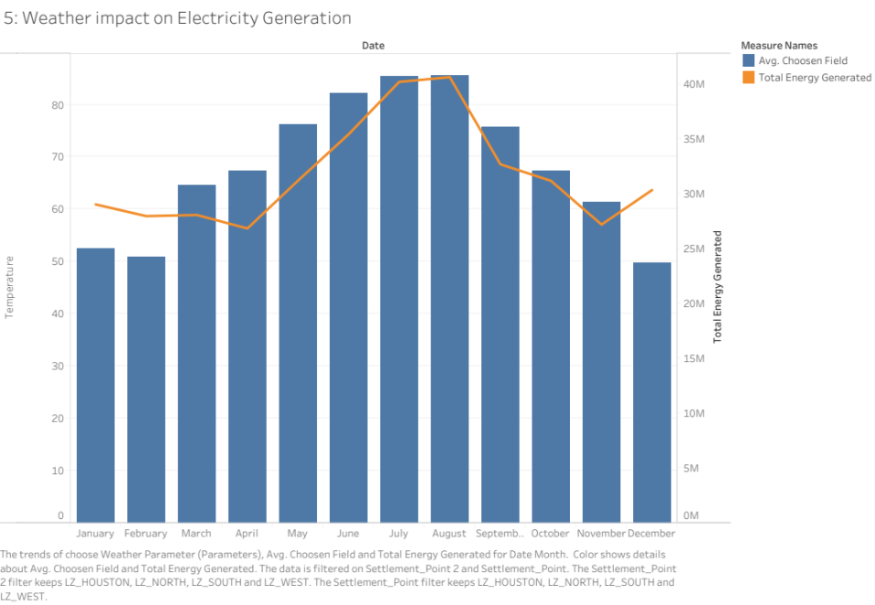

  - PREDICTIVE ANALYTICS
a. Graph 3: Trend of Electricity Generated from Various Fuels
This graph displays the historical evolution of electricity generation from various fuels and projects future developments. By forecasting changes in energy production, it helps interested parties to prepare for upcoming adjustments.
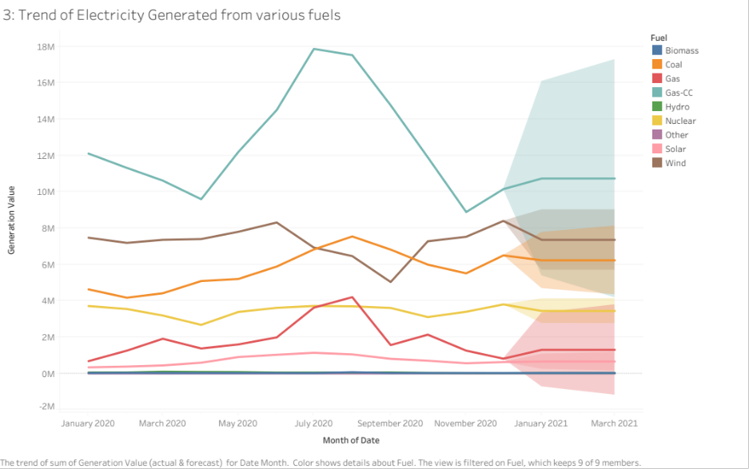
b. Graph 7: Weather Data and Price for All Regions [Extra Credit]
This graph forecasts the potential effects of regional factors like humidity or wind speed on electricity prices by combining meteorological and pricing data.
Using local weather forecasts, it assists in predicting future pricing trends.

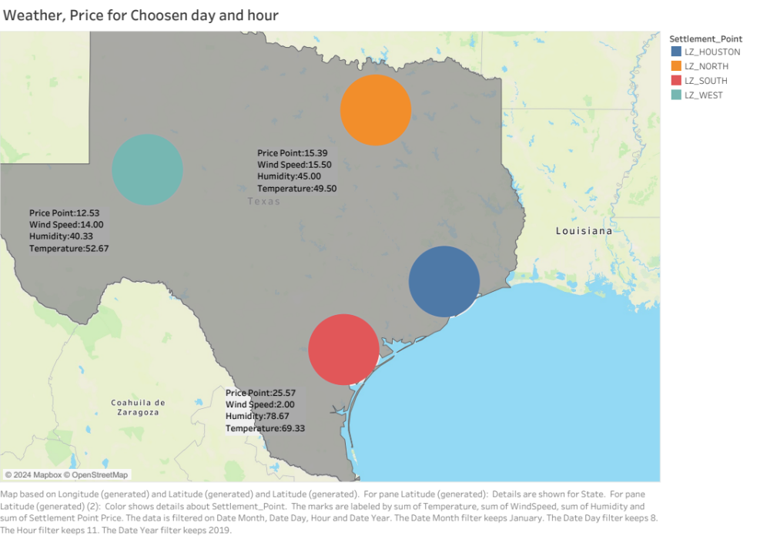
  - PRESCRIPTIVE ANALYTICS
Prescriptive provides actionable strategies to improve future outcomes. Hence Graph 3, Graph 6 and graph 7 also comes under prescriptive analytics.
RECOMMENDATIONS
- Boost the Production of Renewable Energy to Reduce Seasonal Price Increases and Shortages:
Justification: It is evident from Graph 3 (Trend of Electricity Generated from Various Fuels) that although renewable energy sources like wind and solar are growing, their contributions are still lower than those of non-renewables like coal and gas-fired power plants.
In high-demand months like summer (July–August) and winter (December–February), which correspond with price spikes seen in Graph 1 (Trend Line of Price Points), Graph 6 (Electricity Shortage Over Months) displays notable shortages.
To counteract peak demands, it is advised to increase investments in renewable energy infrastructure, particularly in areas with significant wind or solar potential.
To lessen dependency on fossil fuels and maintain electricity pricing at times of heavy demand, concentrate on long-term plans for expanding renewable energy sources.

- To control demand and maximize supply, use weather-based dynamic pricing models.
Justification:
Temperature has a significant impact on energy costs and generation, as shown in Graphs 4 (How Weather Impacts Price) and 5 (Weather Impact on energy Generation).
While colder months with high heating demands have similar impacts, hot temperatures increase demand and drive-up prices. This is further supported by Graph 7, which displays the impact of regional weather characteristics on prices (Weather Data and Price for All Regions). The introduction of dynamic pricing models that adapt to current demand projections and weather forecasts is advised. Encourage energy-efficient behaviors or provide discounts during off-peak hours to encourage customers to use less during extreme weather.

DASHBOARD
https://public.tableau.com/app/profile/maddi.pranav.reddy6957/viz/Project_Group3/Dashboard1?publish=yes
STORY
https://public.tableau.com/app/profile/maddi.pranav.reddy6957/viz/Project_Group3/Story1?publish=yes
EXTRA CREDIT

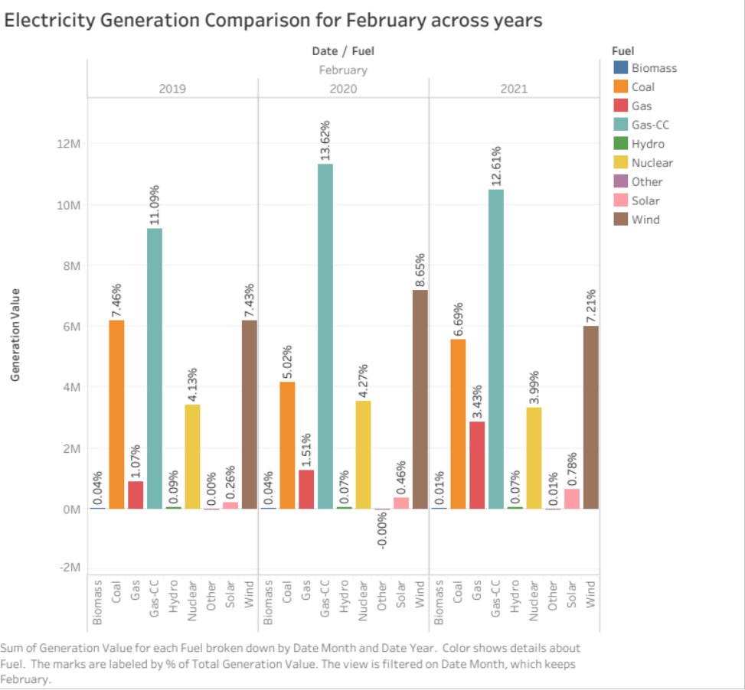

PARAMETERS TO IMPROVE INTERACTIVITIES
Choose Weather Parameter: This parameter was designed to allow users to select specific weather-related measures, such as temperature, humidity, or precipitation, enabling a focused analysis of how weather impacts various factors. By providing this selection flexibility, users can tailor the visualization or analysis to highlight the influence of different weather conditions.

Select Fuel Type: This parameter enables the user to choose a particular type of fuel and compare its generation against other fuel types. This allows to highlight the selected fuel type give insights about it

Top N: This parameter allows users to define and highlight the top N fuel types based on their contribution. By spotlighting the most impactful fuel types, this parameter helps users identify key contributors.

