DoorstepDelight: Web Solution for SweetSpot's Fast Delivery

**CHAPTER 1: PROJECT OVERVIEW**

**Introduction**

SweetSpot is a modern, full-stack e-commerce platform designed to redefine the online cake ordering experience. The project's core mission is to empower customers with a seamless, creative, and convenient way to get the perfect cake, whether it's a ready-made selection or a fully custom creation. This solution is built not only for the end-user's delight but also for operational excellence, providing a powerful and efficient management system for the SweetSpot team.

The platform's standout features include a unique Dual-Mode Ordering system, which elegantly combines pre-designed cakes with a revolutionary 'Design**-**Your-Own-Cake' Studio. This allows customers to bring their creative visions to life with real-time pricing and timelines. The user experience is further enhanced by a Celebration-Ready Cart that intelligently suggests add-on decorations, ensuring every order is a complete celebration.

This documentation provides a comprehensive overview of the SweetSpot project, detailing the architecture, key functionalities, and implementation strategies that combine creative freedom with business efficiency. It serves as a guide to understanding how we've built a solution that makes every moment sweeter, from the first click to the final bite.

**Problem Statement**

The existing market for online bakery products lacks a single, integrated platform that effectively caters to both the demand for quick, ready-made cakes and the complex process of ordering custom-designed creations.

Customers face a disjointed experience, often involving manual communication, unclear pricing, and a lack of intuitive tools to visualize and order a personalized cake. This leads to frustration, time-consuming back-and-forth, and uncertainty.

Simultaneously, bakery businesses struggle with managing this dual-model system across multiple branches. They face operational inefficiencies, fragmented order tracking, and a lack of centralized data to streamline inventory, production, and delivery logistics.

The objective is to solve this by creating an elegant, dual-mode e-commerce platform that provides a seamless, transparent, and feature-rich experience for customers while offering a robust, centralized management system for the business.

**Objective**

The primary objective of the SweetSpot project is to develop a comprehensive e-commerce platform that sets a new standard for both the customer ordering experience and internal operational efficiency. By creating a unified solution, the project aims to solve the inherent challenges of managing both ready-made and custom cake orders, providing a seamless, delightful, and transparent journey for the customer while simultaneously offering powerful management tools for the business.

**Key Features**

* **Customer-Centric Features:**
  + **Dual-Mode Ordering:** A single platform to browse, select, and order both pre-designed and fully custom cakes with ease.
  + **'Design-Your-Own-Cake' Studio:** An intuitive digital tool for customers to visualize their cake designs, get instant pricing, and select specific details.
  + **Celebration-Ready Cart:** An intelligent cart that simplifies the ordering process by suggesting essential add-ons like candles and toppers.
  + **Personalized User Hub:** A user profile with a detailed 'My Orders' section for tracking, and a 'Wishlist' to save favorite items for future purchases.
* **Business-Centric Features:**
  + **Centralized Admin Dashboard:** A single-pane-of-glass view for real-time sales statistics, inventory management, and order tracking across all branches.
  + **Streamlined Order Management:** Tools for branch-level admins to efficiently manage custom orders, production schedules, and delivery logistics.
* **Technical Objectives:**
  + **Scalable and Secure Architecture:** A robust platform built to handle high volumes of traffic and ensure the integrity of user data.
  + **Reliable Payment Integration:** A secure gateway to support various payment options for a safe and frictionless transaction experience.

**CHAPTER 2: SYSTEM ARCHITECTURE**

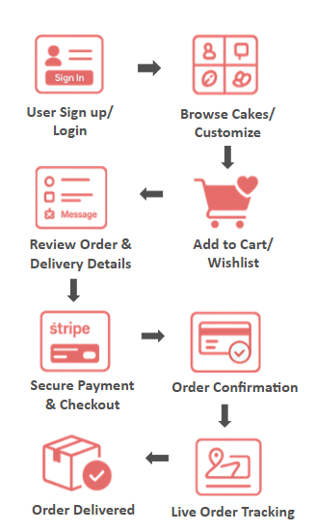

The above diagram illustrates the end-to-end customer ordering workflow for the SweetSpot Doorstep Delight platform. It represents a structured, sequential process that ensures a seamless and transparent user experience from initial login to final delivery.

The workflow begins with User Sign Up/Login, where customers securely access the platform via Firebase Authentication. Following authentication, users can Browse Cakes/Customize, either selecting from a curated list of pre-designed cakes or creating unique designs through the ‘Design-Your-Own-Cake’ Studio.

Once selections are made, customers Add to Cart/Wishlist, enabling them to store preferred items and proceed at their convenience. The next stage, Review Order & Delivery Details, allows users to verify product specifications, customization details, and shipping information before purchase.

The Secure Payment & Checkout stage integrates payment gateways such as Stripe, ensuring encrypted and reliable transactions. Successful payment triggers Order Confirmation, notifying the customer and initiating the order processing workflow.

Customers can then monitor progress via Live Order Tracking, which provides real-time updates across preparation, dispatch, and delivery stages. The workflow concludes with Order Delivered, marking the completion of the transaction.

This architecture emphasizes usability, personalization, and operational efficiency, ensuring that each stage contributes to a streamlined and user-focused e-commerce experience.

**CHAPTER 3: TECHNOLOGY STACK**

The SweetSpot platform is built using a modern and robust technology stack designed for performance, scalability, and an exceptional user experience. The choice of technologies was made to ensure a seamless integration of front-end responsiveness, back-end efficiency, and secure data management.

**Front-End Development**

* **ReactJS:** The core of the user interface is built with ReactJS, a powerful JavaScript library for building dynamic and interactive single-page applications. This allows for a modular component-based architecture, enhancing code reusability and maintainability.
* **Tailwind CSS:** For styling, we utilize Tailwind CSS, a utility-first CSS framework. Tailwind enables rapid and responsive UI development with a flexible class-based system, ensuring a polished and consistent design across all devices.
* **Framer Motion:** To create a dynamic and engaging user experience, animations are implemented using Framer Motion. This library provides a simple yet powerful API for adding smooth and performant animations to React components.
* **Vite:** The project is bundled and developed using Vite, a next-generation front-end tooling system. Vite offers an incredibly fast development server with hot module replacement (HMR), significantly improving the development workflow and build times.

**Back-End & Data Management**

* **Firebase Authentication:** For all user management and secure login functionality, we use Firebase Authentication. This provides a robust, easy-to-implement, and scalable solution for handling user sign-up, login, and session management.
* **Mock Data (JavaScript):** In the initial stages of development and for demonstration purposes, all product and application data is managed using JavaScript objects. This approach allows for rapid prototyping and feature development without the overhead of a full back-end database.
* **Leaflet:** The mapping functionality, used for displaying bakery locations and managing delivery zones, is implemented with Leaflet. This is a lightweight and mobile-friendly JavaScript library for interactive maps, ensuring a smooth and responsive map experience.

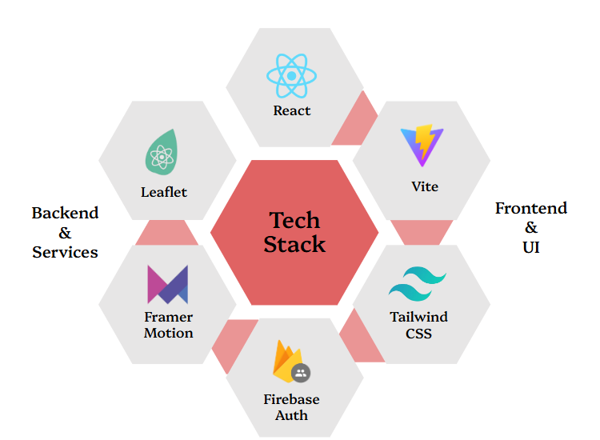

**CHAPTER 4: PROJECT MODULES**

**Project Modules:**

1. **Customer Modules:**

Below is the overview of the customer module:

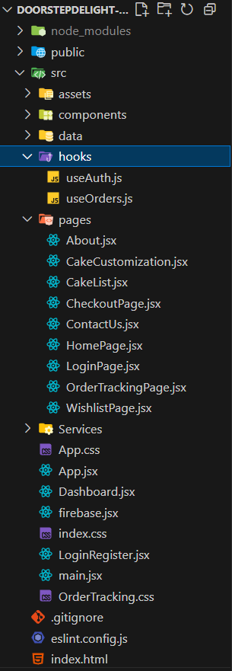

This image showcases the front-end file structure for the customer module, highlighting its organized and modular design.

* The pages directory contains all the main user-facing views, such as the Homepage, CheckoutPage, and WishlistPage.
* A component-based architecture is used, separating the UI into reusable components.
* The project utilizes custom hooks for managing state related to user authentication and orders.
* A data folder holds mock data, aligning with the project's tech stack.
* Firebase.jsx contains code to connect to firebase authentication, hence allowing users to use google to sign in.

**CHAPTER 5: CUSTOMER INTEGRATION**

**Sweet spot Uniqueness:**

SweetSpot focuses on four key features that truly set us apart from any other app or website.

1. **Dual-Mode Ordering:** We seamlessly offer both ready-made and custom cakes in one place. Whether you need a detailed design for next month or a beautiful cake in a few hours, we have you covered.
2. **The 'Design-Your-Own-Cake' Studio:** Our unique digital studio lets customers bring their creative visions to life with instant pricing and timelines, all from home.
3. **Celebration-Ready Cart:** We don't just deliver a cake; we deliver an entire celebration. Our cart smartly suggests decoration items like candles , saving you time and effort.

**5.1 Home Page – Glimpse at Sweetspot**

The homepage of Sweetspot is designed to capture the user’s attention while creating a positive and memorable impression of the brand. Unlike most cake delivery platforms, where the homepage primarily functions as a purchase section accompanied by company information, Sweetspot adopts a distinctive approach. While providing an aesthetically pleasing introduction to the brand and its objectives, the homepage also showcases cakes in an attractive manner that sparks curiosity and encourages further exploration. This design strategy fosters a warm and engaging brand image, establishing a stronger emotional connection with users.

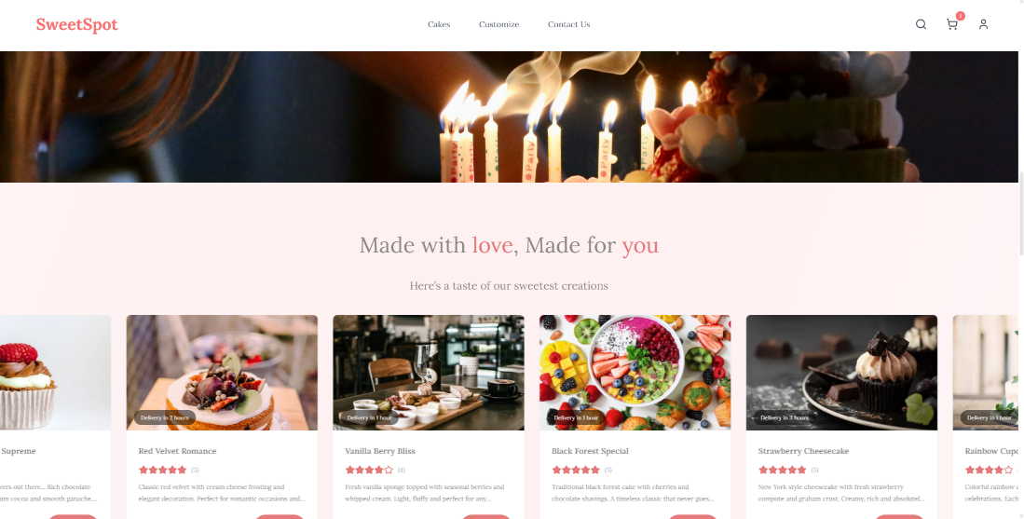

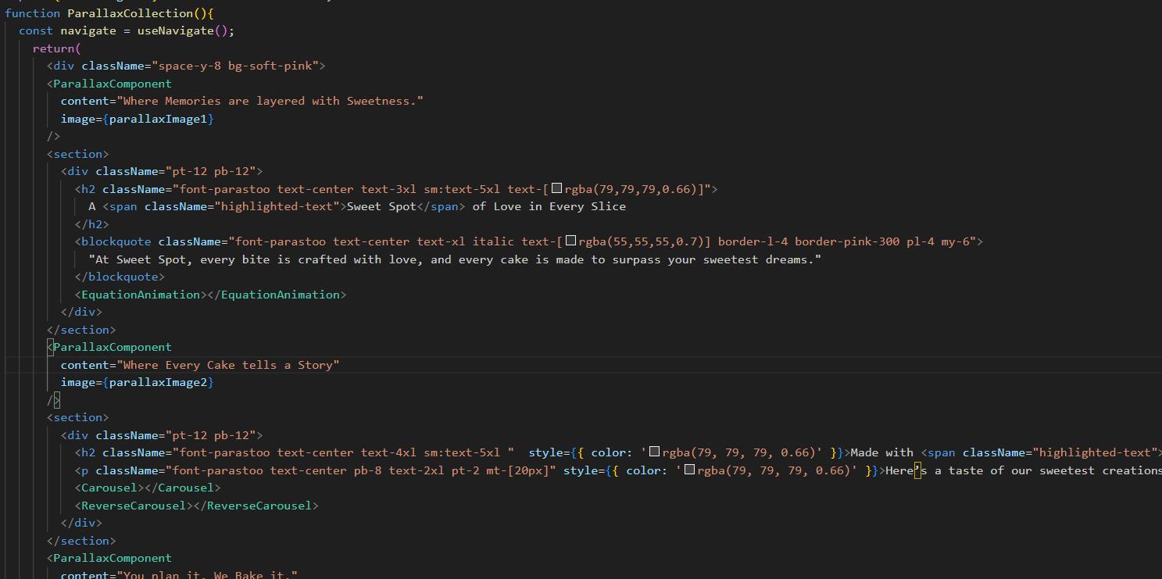

**5.2 CakeList – SweetSpot Selection Hub**

The Cake List page in SweetSpot serves as the central browsing and selection hub for customers.  
It displays a curated list of cakes with quick access to details like weight options,egg/eggless preferences, and customization availability.  
Users can apply multiple filters (price, flavor, health category, weight, egg preference) to quickly find their desired product.  
When a customer clicks on a cake’s Details button, they are shown available weight variants and egg preferences.  
Clicking the Add to Cart button instantly adds the selected cake to the shopping cart, with a confirmation pop-up for better UX.

Once an item is added, the Add to Cart button changes into a quantity selector with minus (-) and plus (+) buttons, allowing the user to directly adjust the number of cakes without leaving the page.  
The cart icon in the navbar gives quick access to the Cart Page, where all selected cakes are displayed with their details, quantities, and total price.

**5.2.1 Page Structure & Components**

The Cake List page is designed for intuitive navigation, modularity, and responsiveness.

**5.2.1.1 Cake Display Grid / List**

* Shows cake thumbnails, names, prices, and quick-view actions.
* Supports both grid and list layouts for user preference.
* Includes a View Details button for accessing full product info.

**5.2.1.2 Cake Details Modal / Section**

* Opens when the user clicks on Details.
* Displays:
  + Weight options (e.g., 0.5 kg, 1 kg, 2 kg)
  + Egg / Eggless preference toggle
  + Brief product description
  + Pricing updates dynamically based on selected weight and preference.
* Contains Add to Cart button.

**5.2.1.3 Add to Cart & Quantity Selector**

* Initial state: Add to Cart button.
* After adding: Button changes into a quantity selector with (-) decrease and (+) increase buttons.
* Quantity changes instantly reflect in the cart’s total.
* Prevents quantities below 1.

**5.2.1.4 Cart Icon & Cart View**

* A cart icon is present in the navbar on every page.
* Clicking the icon opens the Cart Page/Drawer, showing:
  + All cakes added to the cart.
  + Selected weight and egg preference for each item.
  + Individual and total prices.
  + Quantity selectors for quick updates.
  + Checkout button to proceed with the order.

**5.2.1.5 Filter Sidebar / Toolbar**

* Filter options include:
  + Price Range (slider or fixed ranges)
  + Flavors (e.g., Chocolate, Vanilla, Red Velvet)
  + Healthy / Unhealthy category
  + Weight
  + Egg / Eggless preference
* Dynamic filtering updates results instantly without page reload.

**5.2.2 Implementation Approach**

* Modular component-based design for maintainability.
* Responsive layout adapts to desktop, tablet, and mobile screens.
* Filters implemented using dynamic state updates (React hooks / API queries).
* Add-to-cart triggers both cart state update and pop-up notification.
* Quantity selector updates the cart instantly without a full reload.

**5.2.3 User Flow**

1. User lands on the Cake List Page after login or browsing.
2. Applies filters to refine cake options.
3. Selects a cake and clicks View Details.
4. Chooses weight and egg preference from the details modal.
5. Clicks Add to Cart → item is added, pop-up confirmation is shown, and button changes to quantity selector.
6. Adjusts quantity using (-) and (+) without leaving the page.
7. Clicks on Cart Icon in navbar to view all added cakes.
8. Reviews, updates, or removes items in the cart before checkout.

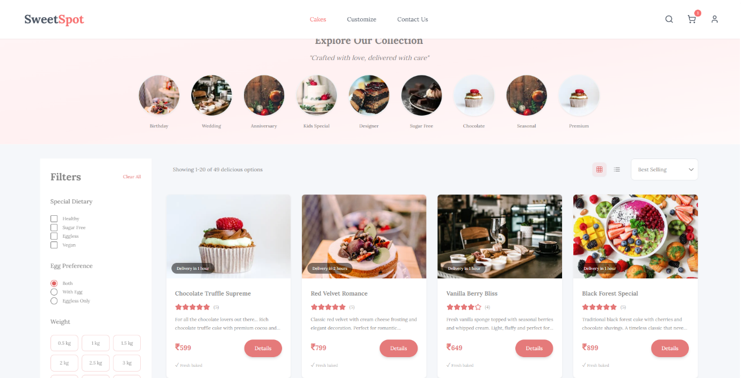

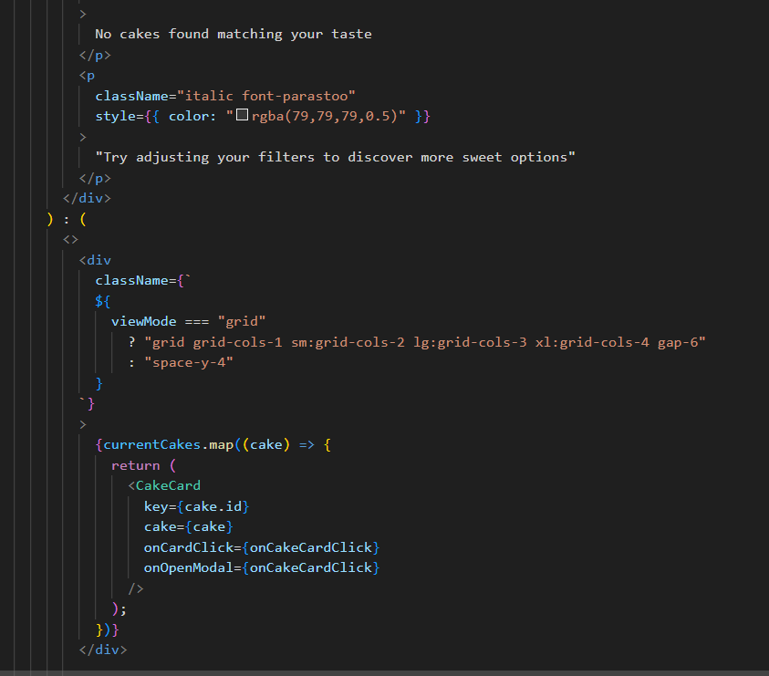

**5.3 CheckOut – SweetSpot Secure Checkout**

The Checkout Page in SweetSpot provides a seamless, step-by-step process for finalizing an order.

It is divided into three main stages: Decoration Selection, Order Review, and Payment.

This structured flow ensures customers can personalize their celebrations, verify their orders, and complete their purchases with ease.

**5.3.1 Page Structure & Components**

**5.3.1.1 Decoration Items Selection**

* Displays a curated collection of decoration items suitable for various events (candles, toppers, balloons, ribbons, etc.).
* Highlights affordable pricing compared to market rates, adding a unique value proposition to the platform.
* Allows users to select multiple items, with dynamic updates to the total cost.
* Includes an Add to Cart button for each decoration item.
* Proceed to Review button moves the user to the next stage.

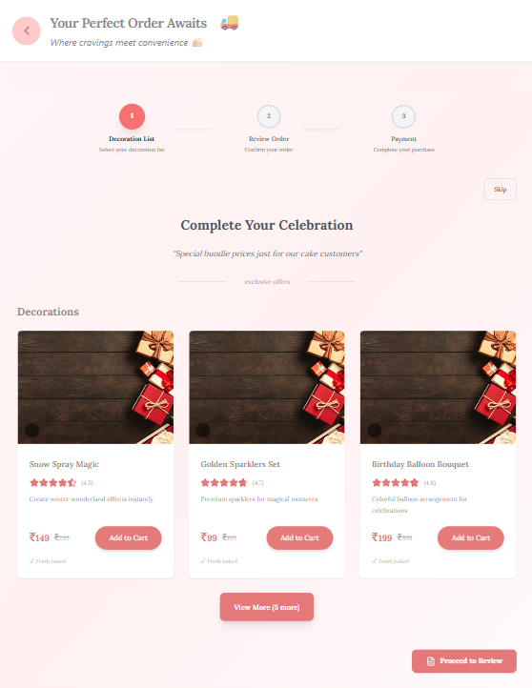

**5.3.1.2 Order Review**

* Shows a consolidated list of:
  + All cakes added to the cart with quantities, weights, and egg preferences.
  + All decoration items selected.
* Displays price breakdown including:
  + Subtotal
  + Taxes
  + Discounts (if applicable)
  + Final total amount
* Allows customers to remove or adjust items before proceeding.
* **Proceed to Payment** button moves the user to the final stage.

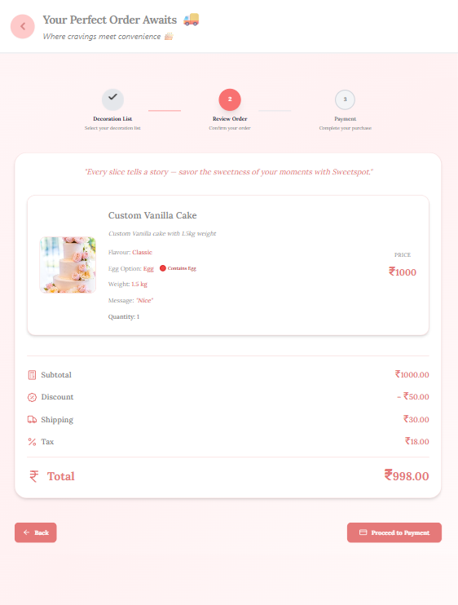

**5.3.1.3 Payment & Address**

* **Shipping Address** section: Displays saved addresses with an option to add or edit.
* **Billing Address** section: Option to use the same as shipping or enter a different address.
* **Payment Methods**:
  + Credit/Debit Card
  + UPI
  + Cash on Delivery (COD)
* After selecting the payment method and confirming payment, a confirmation pop-up appears stating: *“Your order has been successfully placed!”*.

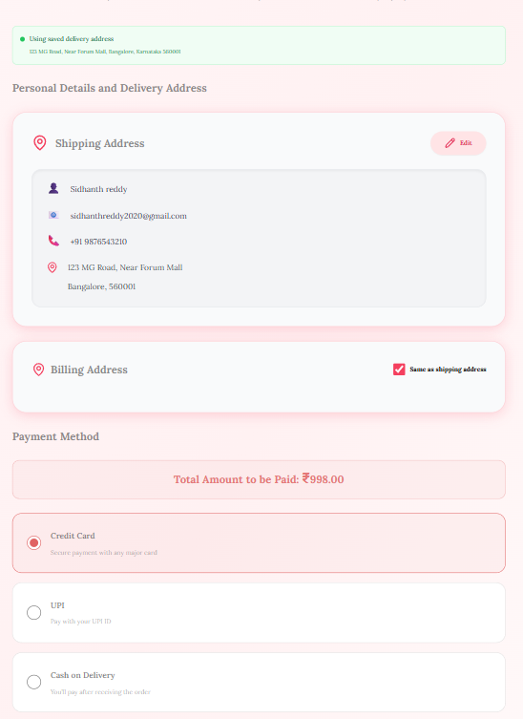

**5.3.2 Implementation Approach**

* Implemented as a multi-step checkout flow with progress indicators for each stage.
* Data persistence between stages to prevent loss of selected items.
* Real-time updates for totals when items are added or removed.
* Responsive design ensures compatibility across desktop, tablet, and mobile devices.

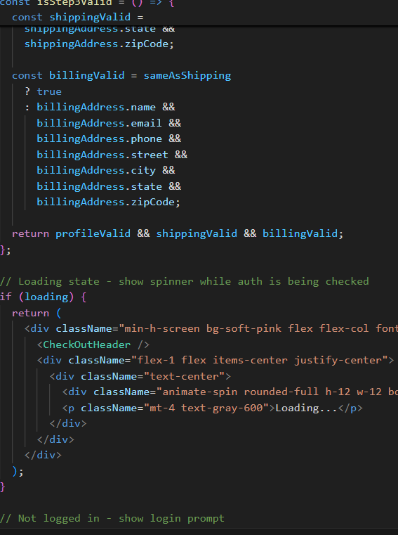

**5.3.3 User Flow**

1. User navigates to the Checkout Page from the cart.
2. In Decoration Items Selection, user selects desired event decorations.
3. Clicks Proceed to Review to view all cakes and decorations in a detailed summary with pricing.
4. Reviews order, makes adjustments if necessary, then clicks Proceed to Payment.
5. Enters/Confirms shipping and billing addresses.
6. Selects a payment method and completes the transaction.
7. Receives a confirmation pop-up confirming the order placement.

**5.4 Order Tracking – SweetSpot Real-Time Order Updates**

The Order Tracking page in SweetSpot Doorstep Delight lets customers monitor real-time order status from preparation to delivery.

It displays detailed order info, including items, quantities, prices, and delivery address.

A progress tracker shows key stages like preparation, dispatch, and delivery.

It provides estimated delivery times, live status updates, and optional map-based tracking.

The responsive, interactive design boosts transparency, trust, and customer satisfaction.

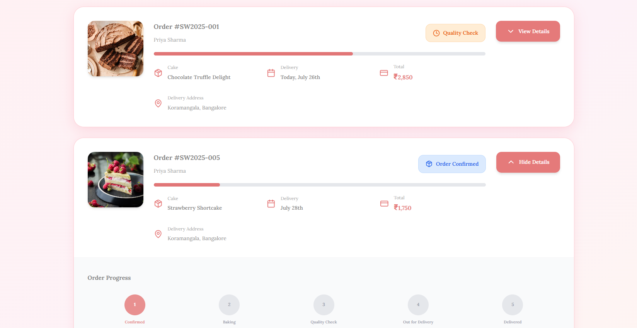

**5.4.1. Page Structure & Components**

The page is structured into **functional sections** for modularity and maintainability.

**5.4.1.1 Order Information Card**

* Shows Order ID, placed date and time, item list, customer name, and contact details.
* Displays the delivery address.
* Uses a card-style layout for quick readability.

**5.4.1.2 Tracking Progress Indicator**

* A step-based progress indicator that visually communicates the order’s current stage.
* Common stages:
  + Order Placed
  + Preparing
  + Out for Delivery
  + Delivered
* Active stage is highlighted.
* Past stages are marked as completed, future stages remain inactive until reached.

**5.4.1.3 Real-Time Status Updates**

* Shows **current stage description** (e.g., “Your cake is on the way!”).
* Displays **expected delivery time**.

**5.4.1.4 Order Timeline / History**

* Chronological list of status changes (timestamps + event descriptions).
* Each event includes:
* Status (e.g., “Baker has started preparing your order”)
* Time of update
* Visual marker for timeline clarity.

**5.4.2. Implementation Approach**

* The implementation is structured to be modular, maintainable, and responsive.

**5.4.3. User Flow**

* User logs in and navigates to Order Tracking page named as “My Orders”.
* Page loads order details via API/mock service.
* Progress tracker and timeline display real-time data.

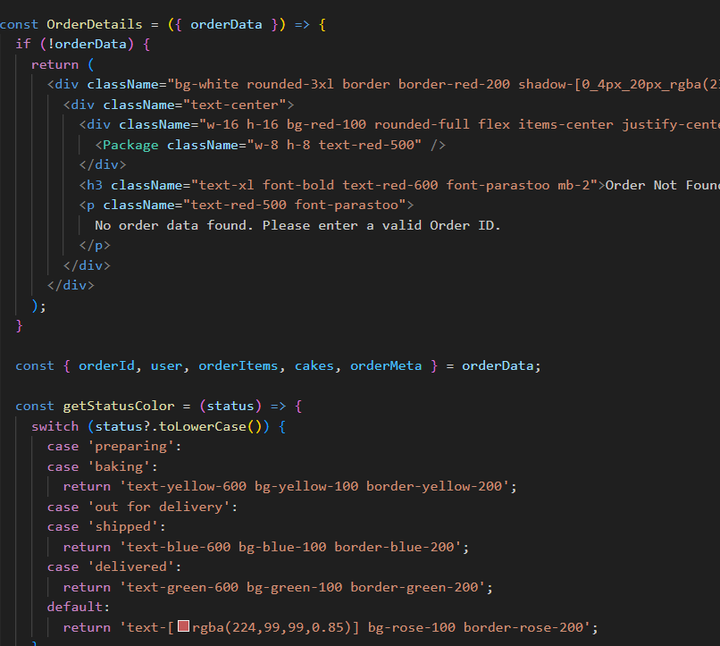

**5.5 Cake Customization – SweetSpot Creations**

The Cake Customization page in SweetSpot allows customers to design cakes according to their personal tastes and event needs.  
 It integrates a structured customization form with a visually rich gallery, creating an engaging and intuitive ordering experience.

**5.5.1.1 Introduction & Branding**

* Headline: “Make your own cake at SweetSpot” in brand typography and colors.
* Short description explains the concept of creating cakes for special occasions, with a link to view artisanal creations.

**5.5.1.2 Customization Form**

* Flavor Selection: Dropdown with multiple flavor options.
* Weight Selection: Buttons for 0.5kg, 1kg, 1.5kg, 2kg, 2.5kg, 3kg.
* Budget Range: Dropdown to set a preferred spending limit.
* Preferred Delivery Date: Calendar date picker.
* Image Upload: Drag-and-drop or select file (supports .jpg, .png, .gif, .pdf, .jpeg, .bmp up to 2MB).
* Extra Instructions: Text field for messages or personalization notes.

**5.5.1.3 Cake Gallery Preview**

* Grid layout on the right showing cakes, cookies, and desserts for inspiration.
* Includes product photography that aligns with SweetSpot’s branding and aesthetics.

**5.5.1.4 Submit Section**

* Submit Button: Adds the customized cake to the cart.
* Note confirming that customization will be saved for checkout.
* Links to Terms of Service and Privacy Policy.

**5.5.2 Implementation Approach**

* Single-page responsive layout for both form and gallery.
* Optimized grid for desktop and stacked layout for mobile.
* File upload validation for size and type.
* Data persistence ensures selections remain saved until checkout.

**5.5.3 User Flow**

* User navigates to the Cake Customization page.
* Reads introduction to understand the feature.
* Selects flavor, weight, budget, and delivery date.
* Optionally uploads a design reference and adds extra notes.
* Browses the inspiration gallery for ideas.
* Submits the customization, adding it to the cart.
* Proceeds to checkout to finalize the order.

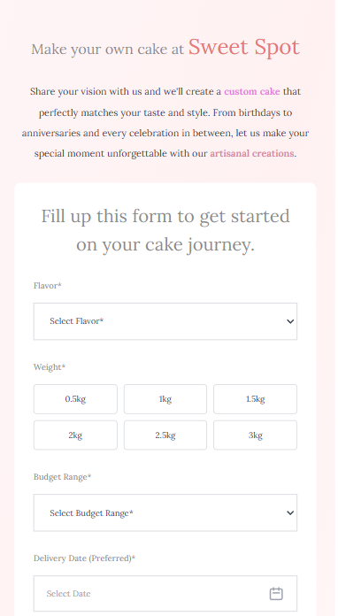 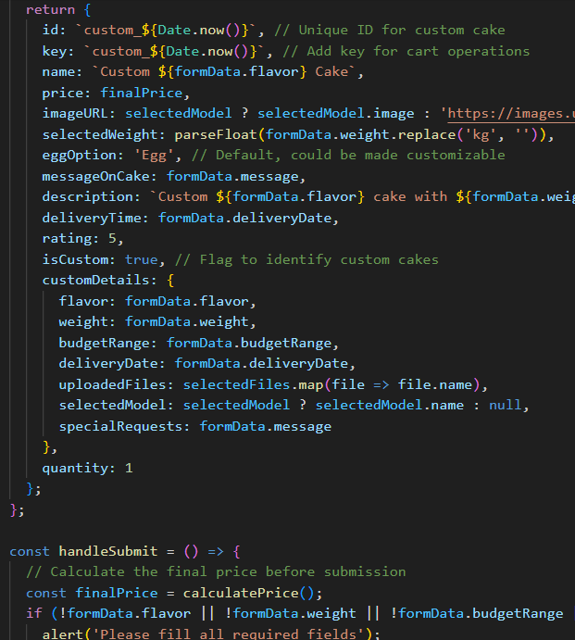

**5.6 Contact Us– SweetSpot Customer Connect**

The Contact Us page in SweetSpot serves as the primary channel for users to communicate directly with the brand.  
 It provides clear contact information, an interactive form, and integrated map support, ensuring users can reach out for queries, feedback, or assistance with ease.

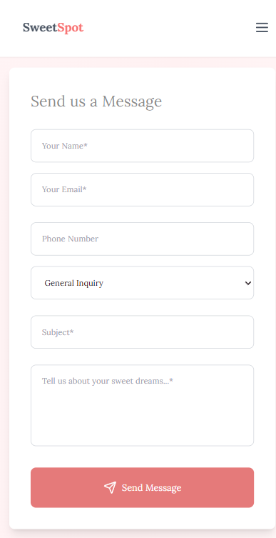 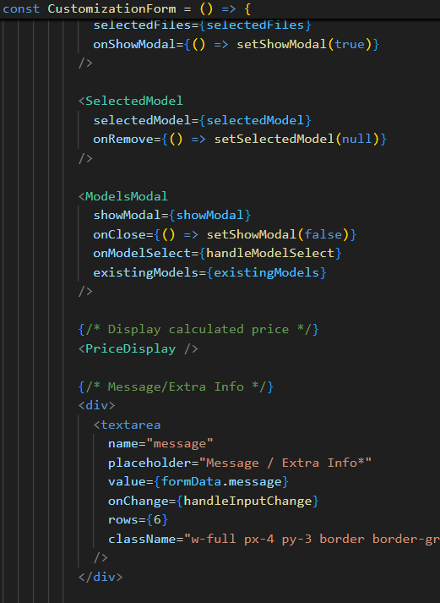

**5.6.1.1 Introduction & Branding**

Headline: “Get in Touch with SweetSpot” in brand typography and colors.

Short Description: Briefly invites users to connect for inquiries, feedback, or support regarding products and services.

Branding Elements: Background visuals and design motifs consistent with SweetSpot’s aesthetic identity.

**5.6.1.2 Contact Information Section**

Phone & Email: Clearly displayed customer support number and email address.

Business Hours: Operating times listed for quick reference.

Physical Address: Store or office location provided for in-person visits.

**5.6.1.3 Contact Form**

* Name Field: For identifying the sender.
* Email Field: To respond to inquiries.
* Subject Dropdown: Categorizes message type (e.g., Order Support, Feedback, General Inquiry).
* Message Box: For detailed inquiries or comments.
* Send Button: Submits the form and triggers a confirmation message.

**5.6.1.4 Map Integration**

* Embedded interactive map pinpointing SweetSpot’s physical location.
* Zoom and navigation controls for convenience.

**5.6.2 Implementation Approach**

* Single-page layout optimized for quick access to both contact info and form.
* Responsive design ensuring usability on desktop and mobile devices.
* Form validation to ensure complete and accurate submissions.
* Map integration using external mapping APIs for location display.

**5.6.3 User Flow**

* User navigates to the Contact Us page.
* Reads headline and brief description.
* Locates phone, email, and address for direct contact.
* Fills out the form with relevant details.
* Optionally checks map for location guidance.
* Submits form and receives confirmation message.

**5.7 Footer– SweetSpot Site Essentials**

The Footer in *SweetSpot Doorstep Delight* is a reusable UI component that appears consistently across all pages of the application. It serves as a closing section that reinforces brand presence while offering users easy access to essential links, contact information, and social media channels. Designed with a fully responsive layout, it ensures accessibility and usability across devices.

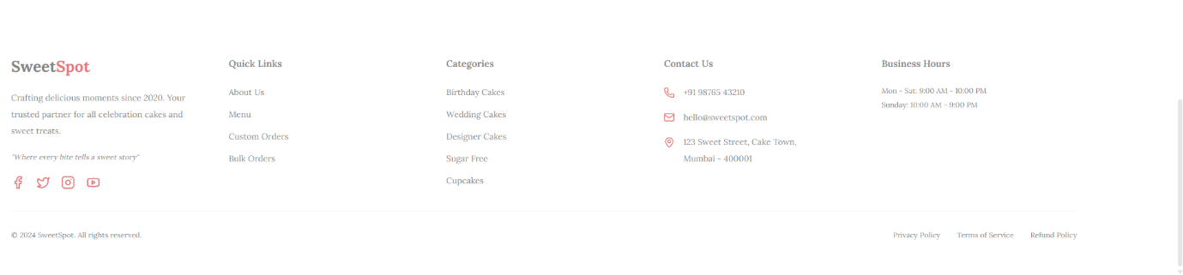

**5.7.1.** **Page Structure & Components**

The Footer is divided into functional sections for clarity and maintainability:

**5.7.1.1 Company Info**

* Displays the *SweetSpot* brand name with styled typography.
* Includes a short tagline and description.
* Features a brand quote: *"Where every bite tells a sweet story"*.
* Provides social media icons (Facebook, Twitter, Instagram, YouTube) with hover effects for user engagement.

**5.7.1.2 Quick Links**

* Navigation links such as:
  + About Us
  + Our Story
  + Menu
  + Custom Orders
  + Bulk Orders
* All links use internal navigation for seamless transitions.

**5.7.1.3 Categories**

* Direct links to product categories:
  + Birthday Cakes
  + Wedding Cakes
  + Designer Cakes
  + Sugar Free
  + Cupcakes

**5.7.1.4 Contact Us**

* Displays phone number with icon.
* Email address with mail icon.
* Physical store address in a multi-line format with a map pin icon.

**5.7.1.5 Business Hours**

* Shows opening and closing times for weekdays and weekends.

**5.7.1.6 Bottom Section**

* Copyright notice.
* Links to Privacy Policy, Terms of Service, and Refund Policy.

**5.7.2. Navigation Handling**

* Uses useNavigate from *react-router-dom* for internal navigation.
* Automatically scrolls to the top (window.scrollTo(0,0)) after navigation.

**5.7.3. Styling**

* Implemented using *Tailwind CSS* for consistent, responsive design.
* Uses a grid layout (grid-cols-2 on mobile, grid-cols-5 on large screens).
* Incorporates icons from *lucide-react*.
* Styled with RGBA color tones matching the brand palette.

**5.7.4. Responsiveness**

* Mobile-first design approach.
* Collapses into a 2-column layout on small screens.
* Expands into a 5-column grid on large displays.
* Maintains touch-friendly spacing for mobile devices.

**CHAPTER 6: FIREBASE AUTHENTICATION**

The Login Page in SweetSpot Doorstep Delight is a dedicated interface that enables users to securely sign in using their Google account via Firebase Authentication. It ensures a fast, secure, and modern authentication process while integrating seamlessly with the application’s user interface. The page is fully responsive, ensuring an optimized experience across both desktop and mobile devices.

**6.2 Purpose**

* Allow users to log in using their Google account.
* Manage and store authentication state securely via Firebase.
* Redirect authenticated users to the main application dashboard.
* Maintain a minimalistic and user-friendly login interface.
* Ensure session persistence for returning users.

**6.3 Page Structure & Components**

**6.3.1 Header Section**

* Displays application name and logo.
* Maintains consistent branding across the website.

**6.3.2 Login Card**

* Contains a **“Sign in with Google”** button.
* Displays a short message explaining the purpose of login.
* Styled in a card-based layout for focus and clarity.

**6.3.3 Google Login Integration**

* Login button triggers Firebase’s Google Authentication Provider.
* Upon success, user details such as **name, email, and profile picture** are fetched.

**6.3.4 Authentication Status Handling**

* Redirects users to the main dashboard after successful login.
* Displays an error message if authentication fails.

**6.3.5 Footer**

* Shows copyright.
* Maintains design consistency with the rest of the application.

**6.4 Data Handling**

**6.4.1 Data Sources**

* Firebase Authentication API for Google sign-in and profile data.
* User details stored in Firebase Authentication system.

**6.4.2 State Management**

* React state hooks (or vanilla JS) manage login status.
* Session persistence maintained via local storage or Firebase persistence.

**6.5 Implementation Approach**

**6.5.1 Initialization**

* Firebase SDK initialized with project credentials.
* GoogleAuthProvider configured for authentication.

**6.5.2 Login Flow**

1. User clicks **“Sign in with Google”** button.
2. Firebase popup prompts Google login.
3. Upon success, Firebase returns user credentials.
4. User details stored in state/session.
5. User redirected to dashboard.

**6.5.3 Error Handling**

* Displays error toast/message on authentication failure.
* Provides a retry option.

**6.6 User Flow**

1. User navigates to Login Page.
2. Clicks **“Sign in with Google”**.
3. Completes authentication in Firebase popup.
4. Redirected to the application’s main page.

**6.7 Dependencies**

* Firebase JavaScript SDK (Authentication module).
* React (or vanilla JavaScript depending on implementation).
* CSS / TailwindCSS for styling.

**Code Snippets and Output:**

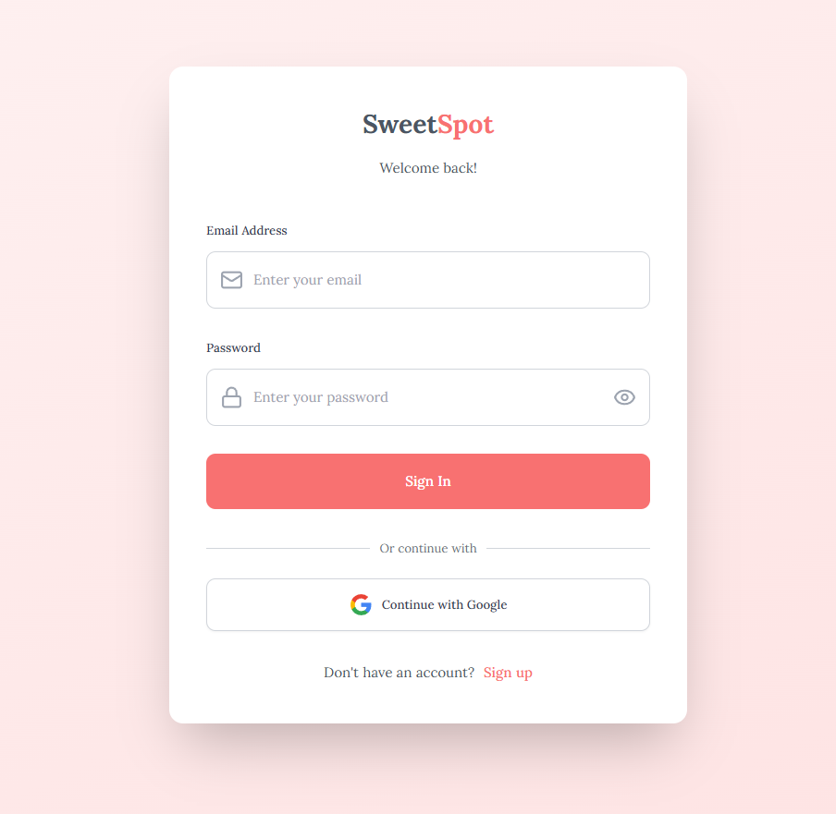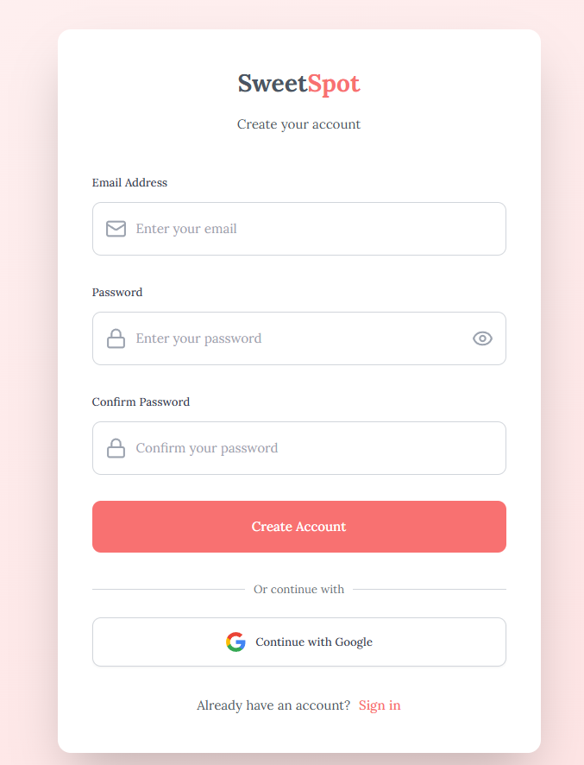

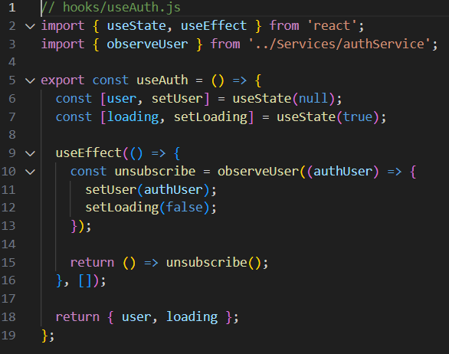

**CHAPTER 7: MOCK DATA LOGIC**

Since the SweetSpot Doorstep Delight project is a frontend-only implementation, actual backend services or databases were not integrated during the current phase.

Instead, mock data is used to simulate real-world API responses, enabling the frontend to demonstrate all functionalities without requiring a live backend connection.

**7.1 Purpose of Mock Data**

Mock data files act as temporary data sources that:

* Provide pre-defined datasets for cakes, decorations, menu items, addresses, and orders.
* Allow the application to retrieve and display information without depending on a server.
* Enable testing of filtering, searching, ordering, and checkout workflows.
* Maintain consistent test data for UI development and debugging.
* Allows easier integration with backend as data is retrieved from JS or JSON files.

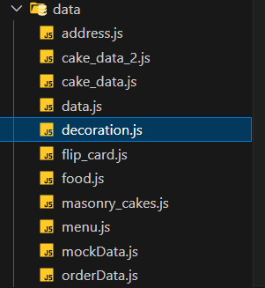

**7.2 Data Storage Structure**

Mock data is stored as **JavaScript files** in the data directory, each containing structured arrays or objects.  
Example files include:

* **address.js** – Stores customer address details for checkout and delivery simulation.
* **cake_data.js / cake_data_2.js** – Contains lists of available cakes, including attributes like name, price, flavor, weight, and egg/eggless type.
* **decoration.js** – Lists available decoration items for event customization, with prices and descriptions.
* **flip_card.js** – Stores data for interactive flip-card components used in the UI.
* **food.js** – Holds information on other available food items (if applicable).
* **masonry_cakes.js** – Provides a dataset for cakes displayed in a masonry-style gallery layout.
* **menu.js** – Contains navigation menu data for dynamic rendering.
* **mockData.js** – Acts as a central file or example dataset for testing purposes.
* **orderData.js** – Stores mock order information for simulating order tracking and history.

**7.3 Data Retrieval**

The application retrieves mock data by importing these JavaScript files directly into React components. 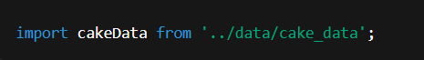

For example:

This allows components to:

* Map over datasets to render product listings.
* Apply filters (e.g., by price, flavor, or dietary preference).
* Pass selected items to the cart and checkout components.

**7.4 Advantages in Development**

* Offline Development: Enables frontend work without relying on a backend connection.
* Faster Iterations: Changes in data structure can be made instantly in the JS files.
* Predictable Results: Test cases and UI states can be reproduced consistently.
* Ease of Integration: Mock structure is designed to closely resemble future API responses for smoother backend integration.

**CHAPTER 8: TESTING STRATEGY**

Since SweetSpot Doorstep Delight is a frontend-focused project, the testing approach primarily emphasizes UI/UX validation, responsiveness, and functionality verification across different devices and screen sizes.  
Our goal is to ensure that the application delivers a seamless and consistent experience, whether accessed from a desktop browser or a mobile device.

**8.1 Objectives of Testing**

The testing phase ensures that:

* All UI components display correctly on different screen sizes.
* Functionalities such as product listing, filtering, adding to cart, checkout, and order tracking work as intended.
* User experience remains smooth, intuitive, and bug-free regardless of device type.
* Visual elements such as images, fonts, and layouts adapt properly to both desktop and mobile views.

**8.2.1 Desktop View Testing**

* Verified layout consistency across major browsers (Chrome, Firefox, Edge).
* Tested navigation menu interactions, hover states, and page transitions.
* Ensured cake list filters function correctly with mouse interactions.
* Checked cart updates in real time when items are added/removed.
* Validated checkout flow including decoration selection, review page, and payment section.
* Confirmed order tracking progress bar updates dynamically.

**8.2.2 Mobile View Testing**

* Used browser device emulation tools (e.g., Chrome DevTools) to test screen sizes from 320px (mobile) to 768px (tablet).
* Verified that the hamburger menu and other responsive elements work smoothly.
* Checked touch interactions for add to cart, increment/decrement buttons, and filter menus.
* Tested the scroll behavior to ensure sticky elements like the navbar function correctly.
* Ensured text and images resize proportionally without overlap or cropping.
* Simulated mobile checkout flow for smooth accessibility with smaller keyboards and screen real estate.

**8.3 Tools & Methods Used**

* **Chrome DevTools** – For device emulation and responsive layout testing.
* **Firefox Responsive Design Mode** – For cross-browser responsive validation.
* **Manual Testing on Real Devices** – Android and iOS devices for real-world touch interaction checks.
* **Cross-browser Testing** – Ensured the UI renders correctly across Chrome, Firefox, and Edge.

**8.4 Test Scenarios Covered**

| **Test Case ID** | **Description** | **Device** | **Expected Results** |
| --- | --- | --- | --- |
| TC01 | Add cake to cart from the cake list | Desktop/Mobile | Cake is added, button changes to quantity controls |
| TC02 | Apply filter by flavor | Desktop/Mobile | Only cakes with selected flavors are displayed |
| TC03 | Complete checkout with decorations | Desktop/Mobile | Order summary updates with decoration items |
| TC04 | Navigate to order tracking | Desktop/Mobile | |  | | --- |  | Displays correct stages with real-time status | | --- | |
| TC05 | Resize screen during checkout | Desktop | Layout adjusts without breaking |

**8.5 Outcome**

Testing confirmed that the SweetSpot Doorstep Delight application is fully functional on both desktop and mobile platforms, with a consistent and user-friendly interface. All major workflows, including product browsing, customization, ordering, and tracking, operate without critical bugs.

**CHAPTER 9: CONCLUSION**

The *SweetSpot* platform successfully bridges the gap between individuals seeking the perfect venue and businesses aiming to showcase their spaces effectively. By integrating an intuitive search interface, interactive mapping, and detailed venue listings, SweetSpot ensures a seamless experience for both venue seekers and providers. Its advanced filtering, location-based recommendations, and user-friendly booking process significantly enhance accessibility and decision-making for users.

Through this project, we have demonstrated how technology can simplify and personalize venue discovery, eliminating the inefficiencies of traditional search methods. SweetSpot not only serves as a robust platform for finding event spaces but also fosters stronger connections between communities and businesses. With its scalable architecture and future-ready design, SweetSpot has the potential to expand its reach, integrate advanced analytics, and incorporate emerging technologies such as AI-driven recommendations, ultimately redefining the venue booking experience.

**CHAPTER 10: FUTURE SCOPE**

SweetSpot Doorstep Delight is set to evolve into an intelligent, customer-focused platform with several new features. These include AI Cake Customization, allowing real-time design previews and personalized suggestions, and an AI Chatbot Assistance for 24/7 support. The platform will integrate a live backend for real-time inventory and order processing, replacing mock data. Advanced Filtering and Recommendations will use AI to suggest products based on dietary needs and trends, while Upgraded Order Tracking will offer live GPS delivery and secure in-app chat with delivery partners. Finally, Expanded Payment and Checkout Options will add more payment gateways, digital wallets, and loyalty points. These innovations will transform the platform into a seamless, real-time e-commerce solution.

**AI Cake Customization**

Customers can design cakes in real-time with instant visual previews. The AI provides personalized suggestions based on past purchases and preferences.

**AI Chatbot Assistance**

A 24/7 chatbot will offer support, guide customization, recommend products, and track orders in a conversational way.

**Database and API Integration**

This will replace mock data with a live backend, enabling real-time inventory updates, order processing, and dynamic content.

**Advanced Filtering and Recommendations**

AI will suggest flavors, designs, and decorations tailored to dietary needs, seasonal trends, and popular demand.

**Upgraded Order Tracking**

This includes live GPS delivery status, secure in-app chat with delivery partners, and push notifications for every update.

**Expanded Payment and Checkout Options**

More payment gateways, digital wallet support, loyalty points, and precise delivery scheduling will be added for greater convenience.

**CHAPTER 11: TEAM & CONTRIBUTION**

**Intern Role:**

| **Intern Name** | **Role** | **Responsibility** |
| --- | --- | --- |
| P. Sidhanth | Frontend Developer,  UI/UX Designer | Developed the Home Page module and handled overall integration of all SweetSpot components. |
| Devi | Frontend Developer | Created the Cake Customization page with interactive design elements. |
| N. Pawan Kumar Sai | UI/UX Designer, Frontend Developer, | Implemented the Add to Cart functionality and designed the Decoration Items selection page. |
| Madhurya | Frontend Developer | Built the Order Confirmation interface with a responsive layout. |
| Vishali | Frontend Developer | Designed and implemented the About Us page. |
| D Trivikram | Frontend Developer | Added the Map Integration feature and contributed to parts of the Order Tracking page. |
| Padmini | Frontend Developer | Developed the full Order Tracking page functionality. |
| K Asha | Frontend Developer | Created the Cake List page with filtering options. |
| Vishal | Frontend Developer | Built the Profile page layout and functionality. |
| Yuvaraj | Frontend Developer | Developed the Wishlist page. |
| Sravya | Frontend Developer | Designed the Payment page. |
| Yamini | Frontend Developer | Implemented the Cart Summary page. |
| Srija Sarojini | Frontend Developer | Implemented the Contact Us Page |
| Mokshith | FireBase Authentication | Developed the login page and integrated the Google Firebase Authentication |
| Ruthwik | FireBase Authentication | Developed the login page and integrated the Google Firebase Authentication |

**CHAPTER 12: REFERENCES**

The following external sources and competitor websites were referenced for design inspiration, feature benchmarking, and understanding industry best practices:

1. **IGP – Cakes**[**https://www.igp.com/cakes**](https://www.igp.com/cakes?adgroupid=1274334784933549&device=c&keyword=cakes%20&loc_interest_ms=&loc_physical_ms=158279&feeditemid=&adposition=&msclkid=729ecf87236315f4da4fa71ac33f7fed&utm_source=bing&utm_medium=cpc&utm_campaign=DSA-Feedbased_India_21&utm_term=cakes%20&utm_content=Feed%20based)
2. **SweetSpot Cakes**[**https://www.swtspotcakes.com/**](https://www.swtspotcakes.com/)
3. **Bakingo – Online Cakes**[**https://www.bakingo.com/**](https://www.bakingo.com/)
4. **Theobroma – Cakes Collection**[**https://theobroma.in/collections/cakes**](https://theobroma.in/collections/cakes)
5. **Monginis – Cakes**[**https://www.monginis.net/**](https://www.monginis.net/)