Reading images in Python
Python supports very powerful tools when comes to image processing. Let’s see how to process the images using different libraries like OpenCV, Matplotlib, PIL etc.
- Using OpenCV : OpenCV (Open Source Computer Vision) is a computer vision library that contains various functions to perform operations on pictures or videos. It was originally developed by Intel but was later maintained by Willow Garage and is now maintained by Itseez. This library is cross-platform that is it is available on multiple programming languages such as Python, C++ etc.
filter_none
brightness_4
# Python program to read image using OpenCV

# importing OpenCV(cv2) module
import cv2

# Save image in set directory
# Read RGB image
img = cv2.imread('g4g.png')

# Output img with window name as 'image'
cv2.imshow('image', img)

# Maintain output window utill
# user presses a key
cv2.waitKey(0)

# Destroying present windows on screen
cv2.destroyAllWindows()
Output :
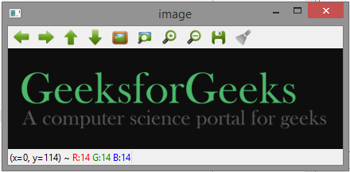
- Using MatplotLib : Matplotlib is an amazing visualization library in Python for 2D plots of arrays. Matplotlib is a multi-platform data visualization library built on NumPy arrays and designed to work with the broader SciPy stack. It was introduced by John Hunter in the year 2002. Matplotlib comes with a wide variety of plots. Plots helps to understand trends, patterns, and to make correlations. They’re typically instruments for reasoning about quantitative information.
filter_none
brightness_4
# Python program to read
# image using matplotlib

# importing matplotlib modules
import matplotlib.image as mpimg
import matplotlib.pyplot as plt

# Read Images
img = mpimg.imread('g4g.png')

# Output Images
plt.imshow(img)
Output :

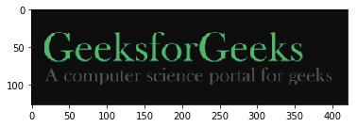

- Using PIL : PIL is the Python Imaging Library which provides the python interpreter with image editing capabilities. It was developed by Fredrik Lundh and several other contributors. Pillow is the friendly PIL fork and an easy to use library developed by Alex Clark and other contributors.
filter_none
brightness_4
# Python program to read
# image using PIL module

# importing PIL
from PIL import Image

# Read image
img = Image.open('g4g.png')

# Output Images
img.show()

# prints format of image
print(img.format)

# prints mode of image
print(img.mode)
Output :

PNG
RGBA

# Python3 program to process
# images using skikit-image
import os

# importing io from skimage
import skimage
from skimage import io

# way to load car image from file
file = os.path.join(skimage.data_dir, 'cc.jpg')

cars = io.imread(file)

# way to show the input image
io.imshow(cars)
io.show()
Output :
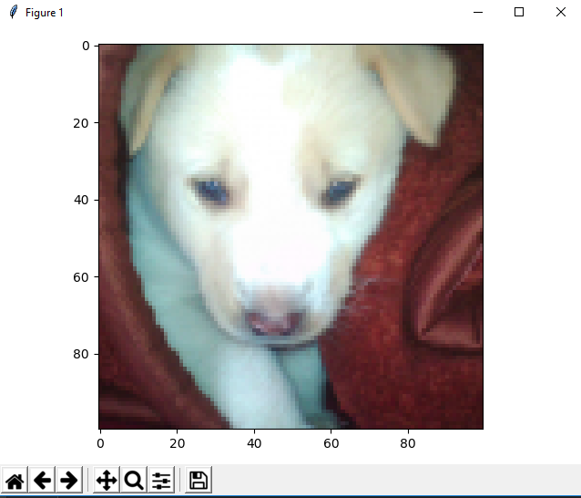

Image ROI

ROI is again obtained using Numpy indexing. Here I am selecting the ball and copying it to another region in the image:
>>> ball = img[280:340, 330:390]
>>> img[273:333, 100:160] = ball
Check the results below:
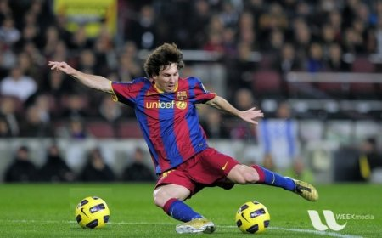

Accessing and Modifying pixel values
Let’s load a color image first:
>>> import cv2
>>> import numpy as np

>>> img = cv2.imread('messi5.jpg')
You can access a pixel value by its row and column coordinates. For BGR image, it returns an array of Blue, Green, Red values. For grayscale image, just corresponding intensity is returned.
>>> px = img[100,100]
>>> print px
[157 166 200]

# accessing only blue pixel
>>> blue = img[100,100,0]
>>> print blue
157
You can modify the pixel values the same way.
>>> img[100,100] = [255,255,255]
>>> print img[100,100]
[255 255 255]
>>> print img.shape
(342, 548, 3)
>>> print img.size
562248
>>> print img.dtype
uint8
convert BGR image to HSV
import cv2
import numpy as np

cap = cv2.VideoCapture(0)

while(1):

# Take each frame
_, frame = cap.read()

# Convert BGR to HSV
hsv = cv2.cvtColor(frame, cv2.COLOR_BGR2HSV)

# define range of blue color in HSV
lower_blue = np.array([110,50,50])
upper_blue = np.array([130,255,255])

# Threshold the HSV image to get only blue colors
mask = cv2.inRange(hsv, lower_blue, upper_blue)

# Bitwise-AND mask and original image
res = cv2.bitwise_and(frame,frame, mask= mask)

cv2.imshow('frame',frame)
cv2.imshow('mask',mask)
cv2.imshow('res',res)
k = cv2.waitKey(5) & 0xFF
if k == 27:
break

cv2.destroyAllWindows()
Below image shows tracking of the blue object:
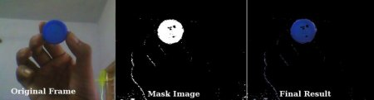

RGB to grayscale
Y = 0.2125 R + 0.7154 G + 0.0721 B

These weights are used by CRT phosphors as they better represent human perception of red, green and blue than equal weights
import numpy as np
import matplotlib.pyplot as plt

from skimage import data
from skimage.color import rgb2gray

original = data.astronaut()
grayscale = rgb2gray(original)

fig, axes = plt.subplots(1, 2, figsize=(8, 4))
ax = axes.ravel()

ax[0].imshow(original)
ax[0].set_title("Original")
ax[1].imshow(grayscale, cmap=plt.cm.gray)
ax[1].set_title("Grayscale")

fig.tight_layout()
plt.show()

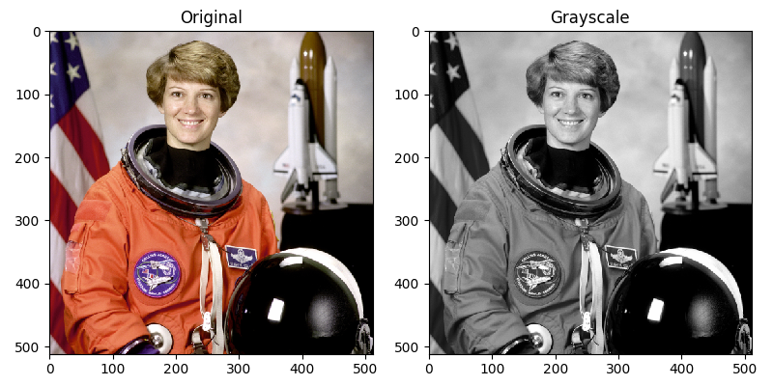

grayscale image to binary image

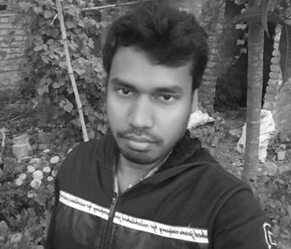

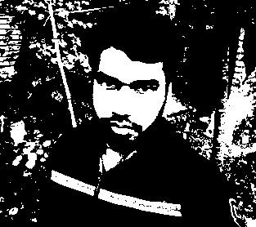

bw_img = cv2.threshold(img,127,255,cv2.THRESH_BINARY)

