# Python program to read image using OpenCV

# importing OpenCV(cv2) module
import cv2

# Save image in set directory
# Read RGB image
path = '/home/kmit/Downloads/images/TCGA-CS-4938-01Z-00-DX1_20x_17248_8864_256x256.png'
img = cv2.imread(path, -1)

# Output img with window name as 'image'
cv2.imshow('image', img)

# Maintain output window utill
# user presses a key
cv2.waitKey(0)

# Destroying present windows on screen
cv2.destroyAllWindows()

# Python program to read
# image using matplotlib

# importing matplotlib modules
import matplotlib.image as mpimg
import matplotlib.pyplot as plt

# Read Images
img = mpimg.imread('/home/kmit/Downloads/images/TCGA-CS-4938-01Z-00-DX1_20x_17248_8864_256x256.png')

# Output Images
plt.imshow(img)

<matplotlib.image.AxesImage at 0x7f4000abe6d8>
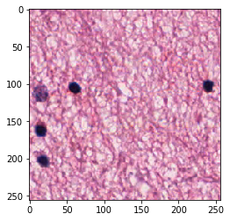
# Python program to read
# image using PIL module

# importing PIL
from PIL import Image

# Read image
img = Image.open('/home/kmit/Downloads/images/TCGA-CS-4938-01Z-00-DX1_20x_17248_8864_256x256.png')

# Output Images
img.show()

# prints format of image
print(img.format)

# prints mode of image
print(img.mode)

Python3 program to process
# images using skikit-image
import os

# importing io from skimage
import skimage
from skimage import io

# way to load car image from file
file = os.path.join(skimage.data_dir, '/home/kmit/Downloads/images/TCGA-CS-4938-01Z-00-DX1_20x_17248_8864_256x256.png')

img2 = io.imread(file)

# way to show the input image
io.imshow(img2)
io.show()

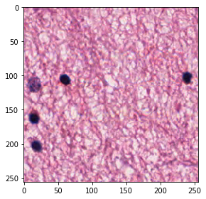
import cv2
import numpy as np

channel_initials = list('BGR')

image = cv2.imread('/home/kmit/Downloads/images/TCGA-CS-4938-01Z-00-DX1_20x_17248_8864_256x256.png')

for channel_index in range(3):
channel = np.zeros(shape=image.shape, dtype=np.uint8)
channel[:,:,channel_index] = image[:,:,channel_index]
cv2.imshow(f'{channel_initials[channel_index]}-RGB', channel)
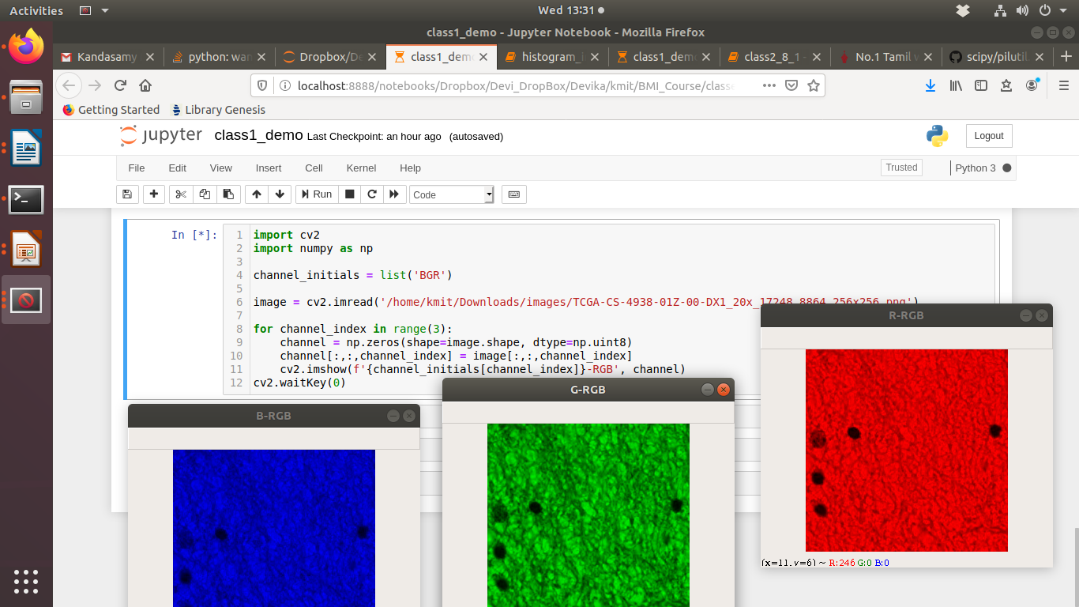
cv2.waitKey(0)

import matplotlib.pyplot as plt
path = '/home/kmit/Downloads/images/ball.jpeg'
image = cv2.imread(path, -1)
%matplotlib inline

# Show RGB channel separately in gray scale

fig, axes = plt.subplots(1, 3)

# image[:, :, 0] is R channel.
axes[0].set_title('R channel')
axes[0].imshow(image[:, :, 0], cmap='gray')
# image[:, :, 1] is G channel.
axes[1].set_title('G channel')
axes[1].imshow(image[:, :, 1], cmap='gray')
# image[:, :, 2] is B channel.
axes[2].set_title('B channel')
axes[2].imshow(image[:, :, 2], cmap='gray')

