Applying Mode Filter Using Python And Pillow

Overview:
- The mode filter replaces each pixel of a Digital image with the mode value of its neighborhood pixel window.
- The class ImageFilter.ModeFilter implements the mode filter.
- As per Pillow's implementation, to consider a pixel value as mode, the value should at least occur twice in the neighborhood. Else the original pixel value is retained in the image.
- The Python example applies the mode filter 7x times to a digital image.
- Similar to the median filter the mode filter as well is an edge preserving filter.
# import the required PIL Modules
from PIL import Image
from PIL import ImageFilter

# Load an image
imageObject = Image.open("./nightsky.jpg");

# Show the original image
imageObject.show();

# Apply mode filter multiple times
modeFilterApplied = imageObject.filter(ImageFilter.ModeFilter);
for i in range (0, 6):
modeFilterApplied = modeFilterApplied.filter(ImageFilter.ModeFilter);

# Show the image with mode filter applied
modeFilterApplied.show();

Mean Filter
Common Names: Mean filtering, Smoothing, Averaging, Box filtering
easy to implement method of smoothing images
The idea of mean filtering is simply to replace each pixel value in an image with the mean (`average') value of its neighbors, including itself. This has the effect of eliminating pixel values which are unrepresentative of their surroundings.
Mean filtering is usually thought of as a convolution filter.
Often a 3×3 square kernel is used, as shown in Figure 1, although larger kernels (e.g. 5×5 squares) can be used for more severe smoothing.
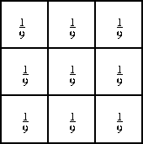

Figure 1 3×3 averaging kernel often used in mean filtering
As for one-dimensional signals, images also can be filtered with various low-pass filters (LPF), high-pass filters (HPF), etc. A LPF helps in removing noise, or blurring the image. A HPF filters helps in finding edges in an image.

Non-Linear Filtering of Images (Image Processing)
Linear filters have the property that their output is a linear combination of their input.
Filters that do not satisfy this property are non-linear.

Linear filtering is filtering in which the value of an output pixel is a linear combination of the values of the pixels in the input pixel's neighborhood.

Linear filtering of an image is accomplished through an operation called convolution. Convolution is a neighborhood operation in which each output pixel is the weighted sum of neighboring input pixels.
The matrix of weights is called the convolution kernel, also known as the filter.
Median filtering is a nonlinear method used to remove noise from images. It is widely used as it is very effective at removing noise while preserving edges. It is particularly effective at removing 'salt and pepper' type noise.
A Gaussian filter is a linear filter. ... The Median filter is a non-linear filter that is most commonly used as a simple way to reduce noise in an image. It's claim to fame (over Gaussian for noise reduction) is that it removes noise while keeping edges relatively sharp.
Laplacian filters are derivative filters used to find areas of rapid change (edges) in images. Since derivative filters are very sensitive to noise, it is common to smooth the image (e.g., using a Gaussian filter) before applying the Laplacian.

A blurring filter where you move over the image with a box filter (all the same values in the window) is an example of a linear filter. A non-linear filter is one that cannot be done with convolution or Fourier multiplication. A sliding median filter is a simple example of a non-linear filter.

Linear filters have the property that their output is a linear combination of their input. Filters that do not satisfy this property are non-linear. Nonlinear filters are not employed in image processing as frequently as linear filters, because in many cases they are based on heuristics closely tied to the particular application.The general idea in non-linear image filtering is that instead of using the spatial mask in a convolution process, the mask is used to obtain the neighboring pixel values, and then ordering mechanisms produce the output pixel.That is, as the mask is shifted about the image, the order of the pixels in the windowed section of the image is rearranged, and the output pixel is generated from these rearranged input pixels. Figure 4-13 illustrates this procedure, for three types of non-linear filters.
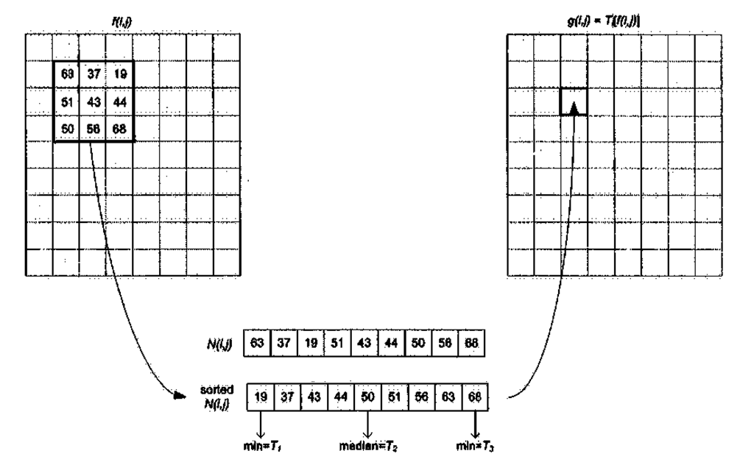
Figure 4-13. Examples of non-linear filters. g(i,j) = 50 for T2 and is referred to as a median filter, and is one of the more common non-linear filters used in image processing. Tt and T} correspond to the minimum and maximum intensity in the 3×3 neighborhood surrounding f(ij). Minimum filters form the basis of image erosion, and maximum filtering the basis of image dilation.
Subjective assessment of image quality is prevalent in medical imaging (less so in image compression systems), where it is imperative that highly trained clinicians determine whether or not there is a perceived gain or loss in diagnostic information. Practically speaking, relying on human observers to score the performance of image enhancement algorithms is not a viable strategy; first because it is not economical, and secondly the subjective nature precludes incorporation into mathematical models.

Thus an objective measurement, some means of quantifying image fidelity(accuracy), is required. The first metric that comes to mind is to consider the difference between the filtered pixels and the original pixels. If the original MxN image is f(i,j) and the filtered MxN image is g(i,j), the delta image d(i,j) is
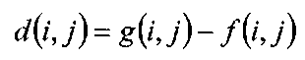
The total delta between the original / and processed g is then simply the sum:
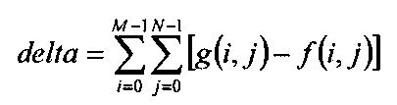
This sum could conceivably be used as a fidelity criterion – however the most commonly used criterion is the mean squared error (MSE’), which is the average of the squared delta measurement:
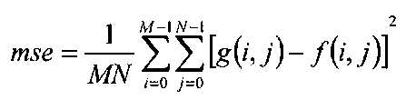
The root mean square error (RMS) is the square root of the MSE:
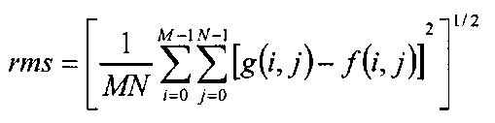
Related to these is the signal-to-noise ratio (SNR), roughly defined as SNR = signal/noise

class PIL.ImageFilter.ModeFilter(size=3)
Create a mode filter. Picks the most frequent pixel value in a box with the given size. Pixel values that occur only once or twice are ignored; if no pixel value occurs more than twice, the original pixel value is preserved.
Parameters: | size – The kernel size, in pixels.

class PIL.ImageFilter.RankFilter(size, rank)
Create a rank filter. The rank filter sorts all pixels in a window of the given size, and returns the rank’th value.
Parameters: | - size – The kernel size, in pixels.  - rank – What pixel value to pick. Use 0 for a min filter, size * size / 2 for a median filter, size * size - 1 for a max filter, etc.

Convolution:
equation of convolution
The input signal is decomposed into simple additive components, and the system response of the input signal results in by adding the output of these components passed through the system.

In general, a signal can be decomposed as a weighted sum of basis signals. For example, in Fourier Series, any periodic signal (even rectangular pulse signal) can be represented by a sum of sine and cosine functions. But here, we use impulse (delta) functions for the basis signals, instead of sine and cosine.
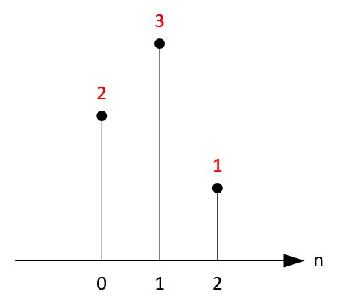

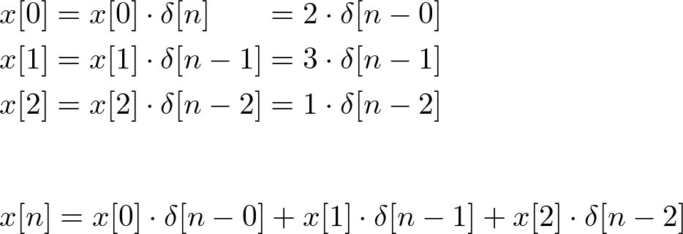
In general, a signal can be written as sum of scaled and shifted delta functions;
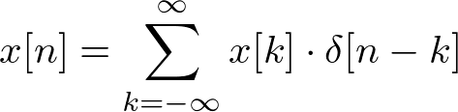

the input signal is 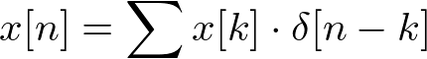, then the output will be 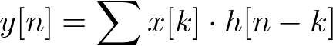. Note one condition; convolution works on the linear and time invariant system.
To summarize, a signal is decomposed into a set of impulses and the output signal can be computed by adding the scaled and shifted impulse responses.

Input: x[n]
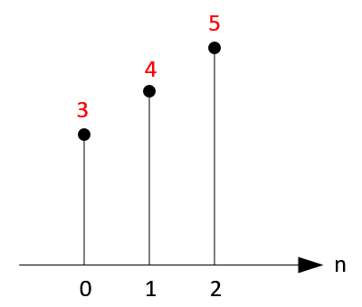

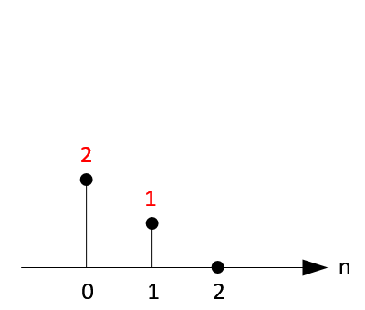
ImpulseResponse: h[n]

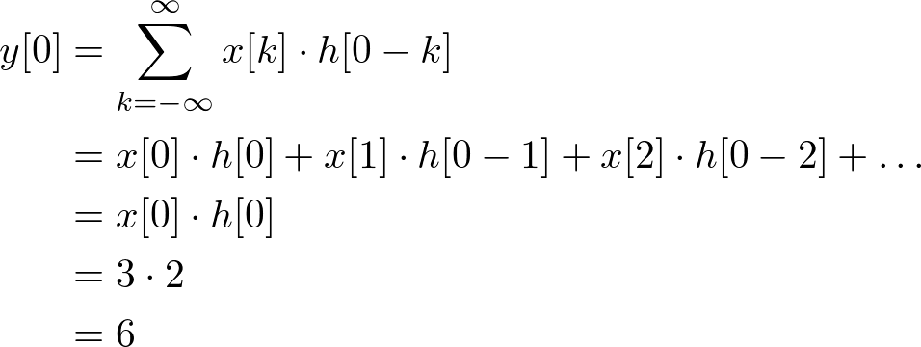

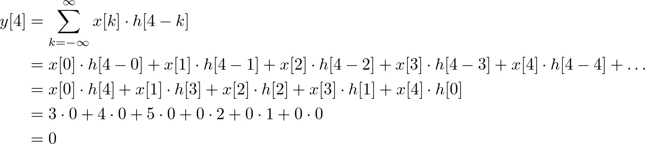

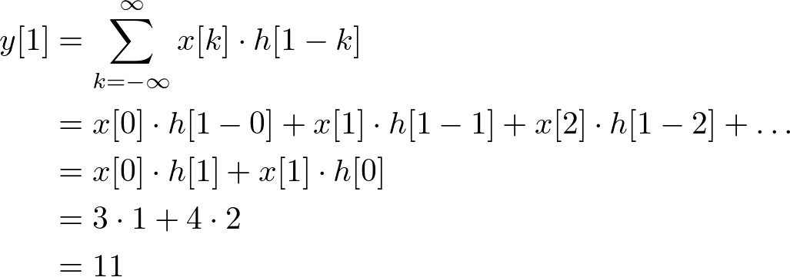
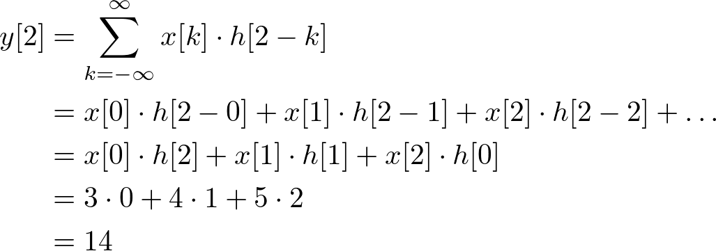
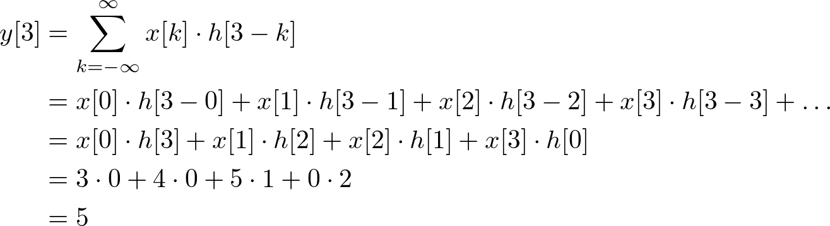

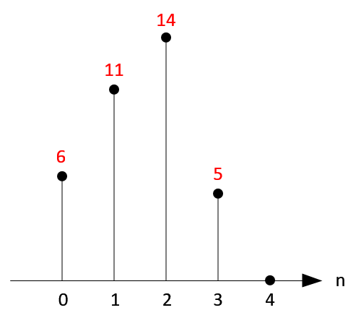

an equation for any sample of the output;
where i is the index of any sample point and k is the number of samples in impulse response.
For instance, if an impulse response has 4 samples, the sample of output signal at index 9 is;
y[9] = x[9]·h[0] + x[8]·h[1] + x[7]·h[2] + x[6]·h[3]

Convolution in 2D
2D convolution is just extension of previous 1D convolution by convolving both horizontal and vertical directions in 2 dimensional spatial domain. Convolution is frequently used for image processing, such as smoothing, sharpening, and edge detection of images.
The impulse (delta) function is also in 2D space, so δ[m, n] has 1 where m and n is zero and zeros at m,n ≠ 0. The impulse response in 2D is usually called "kernel" or "filter" in image processing.

Delta function (Impulse function) in 2D space

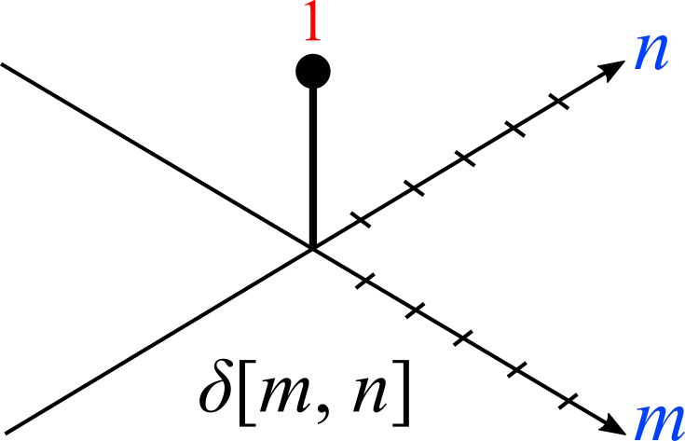
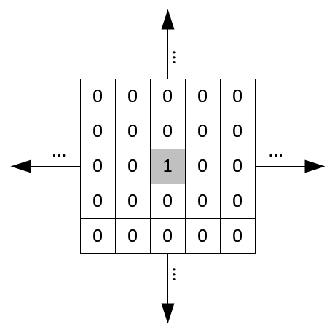

The second image is 2D matrix representation of impulse function. The shaded center point is the origin where m=n=0.

And, the output of linear and time invariant system can be written by convolution of input signal x[m, n], and impulse response, h[m, n];
Notice that the kernel (impulse response) in 2D is center originated in most cases, which means the center point of a kernel is h[0, 0]. For example, if the kernel size is 5, then the array index of 5 elements will be -2, -1, 0, 1, and 2. The origin is located at the middle of kernel.
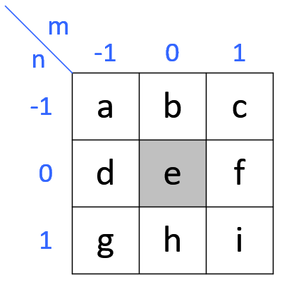

Gaussian smoothing

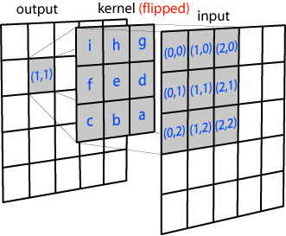

convolution can be done by multiplying each input pixel with the entire kernel. However, if the kernel is symmetrical (which a Gaussian kernel is) you can also multiply each axis (x and y) independently, which will decrease the total number of multiplications. In proper mathematical terms, if a matrix is separable it can be decomposed into (M×1) and (1×N) matrices. For the Gaussian kernel above this means you can also use the following kernels:

Separable Convolution 2D
In convolution 2D with M×N kernel, it requires M×N multiplications for each sample. For example, if the kernel size is 3x3, then, 9 multiplications and accumulations are necessary for each sample. Thus, convolution 2D is very expensive to perform multiply and accumulate operation.
However, if the kernel is separable, then the computation can be reduced to M + N multiplications.
A matrix is separable if it can be decomposed into (M×1) and (1×N) matrices.
For example;
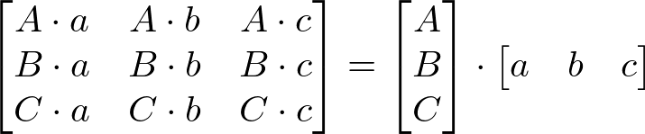
And, convolution with this separable kernel is equivalent to;

Gaussian smoothing filter is a well-known separable matrix. For example, 3x3 Gaussian filter is;

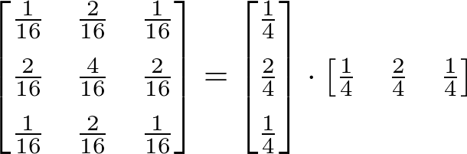
3x3 Gaussian Kernel

Gaussian kernel is separable;
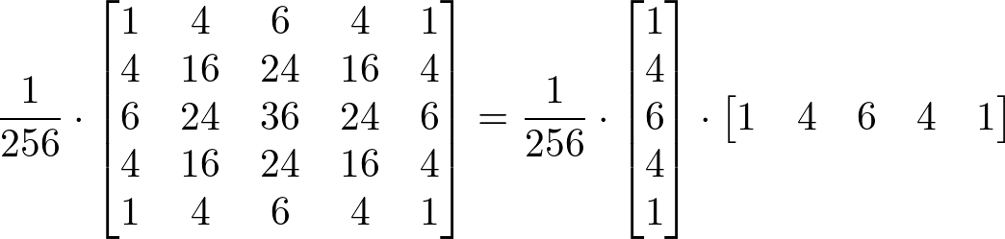
5x5 Separable Gaussian Kernel
Type gaussian kernal

You would now multiply each pixel in the input image with both kernels and add the resulting values to get the value for the output pixel.

Gaussian Smoothing
The Gaussian smoothing operator is a 2-D convolution operator that is used to `blur' images and remove detail and noise. In this sense it is similar to the mean filter, but it uses a different kernel that represents the shape of a Gaussian (`bell-shaped') hump.

The Gaussian distribution in 1-D has the form:
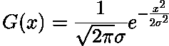
where is the standard deviation of the distribution. We have also assumed that the distribution has a mean of zero (i.e. it is centered on the line x=0). The distribution is illustrated in Figure 1.
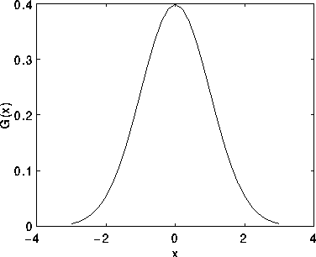

Figure 1 1-D Gaussian distribution with mean 0 and =1

In 2-D, an isotropic (i.e. circularly symmetric) Gaussian has the form:
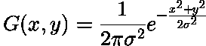
This distribution is shown in Figure 2.

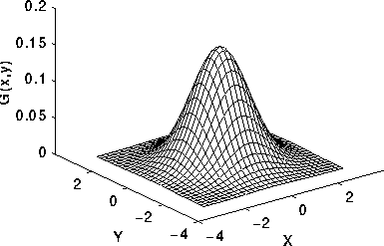
Figure 2 2-D Gaussian distribution with mean (0,0) and =1

The idea of Gaussian smoothing is to use this 2-D distribution as a `point-spread' function, and this is achieved by convolution. Since the image is stored as a collection of discrete pixels we need to produce a discrete approximation to the Gaussian function before we can perform the convolution. In theory, the Gaussian distribution is non-zero everywhere, which would require an infinitely large convolution kernel, but in practice it is effectively zero more than about three standard deviations from the mean, and so we can truncate the kernel at this point. Figure 3 shows a suitable integer-valued convolution kernel that approximates a Gaussian with a of 1.0. It is not obvious how to pick the values of the mask to approximate a Gaussian. One could use the value of the Gaussian at the centre of a pixel in the mask, but this is not accurate because the value of the Gaussian varies non-linearly across the pixel. We integrated the value of the Gaussian over the whole pixel (by summing the Gaussian at 0.001 increments). The integrals are not integers: we rescaled the array so that the corners had the value 1. Finally, the 273 is the sum of all the values in the mask.

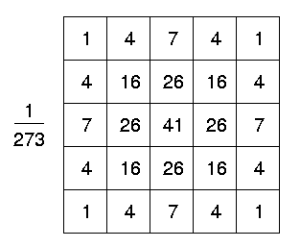

Once a suitable kernel has been calculated, then the Gaussian smoothing can be performed using standard convolution methods. The convolution can in fact be performed fairly quickly since the equation for the 2-D isotropic Gaussian shown above is separable into x and y components. Thus the 2-D convolution can be performed by first convolving with a 1-D Gaussian in the x direction, and then convolving with another 1-D Gaussian in the y direction.

A further way to compute a Gaussian smoothing with a large standard deviation is to convolve an image several times with a smaller Gaussian. While this is computationally complex, it can have applicability if the processing is carried out using a hardware pipeline.
The Gaussian filter not only has utility in engineering applications. It is also attracting attention from computational biologists because it has been attributed with some amount of biological plausibility, e.g. some cells in the visual pathways of the brain often have an approximately Gaussian response.

Guidelines for Use
The effect of Gaussian smoothing is to blur an image, in a similar fashion to the mean filter. The degree of smoothing is determined by the standard deviation of the Gaussian.

One of the principle justifications for using the Gaussian as a smoothing filter is due to its frequency response. Most convolution-based smoothing filters act as lowpass frequency filters. This means that their effect is to remove high spatial frequency components from an image.
Figure 5 shows the frequency responses of a 1-D mean filter with width 5 and also of a Gaussian filter with = 3.

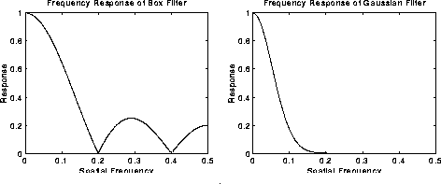

Both filters attenuate high frequencies more than low frequencies, but the mean filter exhibits oscillations in its frequency response. The Gaussian on the other hand shows no oscillations.

The Gaussian filter also turns out to be very similar to the optimal smoothing filter for edge detection

Salt and pepper noise is more challenging for a Gaussian filter.This type of noise is better reduced using median filtering

Increasing the standard deviation continues to reduce/blur the intensity of the noise, but also attenuates high frequency detail (e.g. edges) significantly,

Noise Generation
Noise arises as a result of variations in the detector sensitivity, environmental variations, the discrete nature of radiation, transmission or quantization errors, etc
Noise can generally be grouped into two classes:
- independent noise.
- noise which is dependent on the image data.
Image independent noise can often be described by an additive noise model, where the recorded image f(i,j) is the sum of the true image s(i,j) and the noise n(i,j):
The noise n(i,j) is often zero-mean and described by its variance . The impact of the noise on the image is often described by the signal to noise ratio (SNR), which is given by
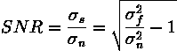
where and are the variances of the true image and the recorded image, respectively.

Detector Noise
One kind of noise which occurs in all recorded images to a certain extent is detector noise. This kind of noise is due to the discrete nature of radiation, i.e. the fact that each imaging system is recording an image by counting photons.This means that each pixel in the noisy image is the sum of the true pixel value and a random, Gaussian distributed noise value.

Figure 1 1-D Gaussian distribution with mean 0 and standard deviation 1
Salt and Pepper Noise
Another common form of noise is data drop-out noise (commonly referred to as intensity spikes, speckle or salt and pepper noise). Here, the noise is caused by errors in the data transmission. The corrupted pixels are either set to the maximum value (which looks like snow in the image) or have single bits flipped over. In some cases, single pixels are set alternatively to zero or to the maximum value, giving the image a `salt and pepper' like appearance. Unaffected pixels always remain unchanged. The noise is usually quantified by the percentage of pixels which are corrupted.

Gaussian noise can be reduced using a spatial filter. However, it must be kept in mind that when smoothing an image, we reduce not only the noise, but also the fine-scaled image details because they also correspond to blocked high frequencies. The most effective basic spatial filtering techniques for noise removal include: mean filtering, median filtering and Gaussian smoothing

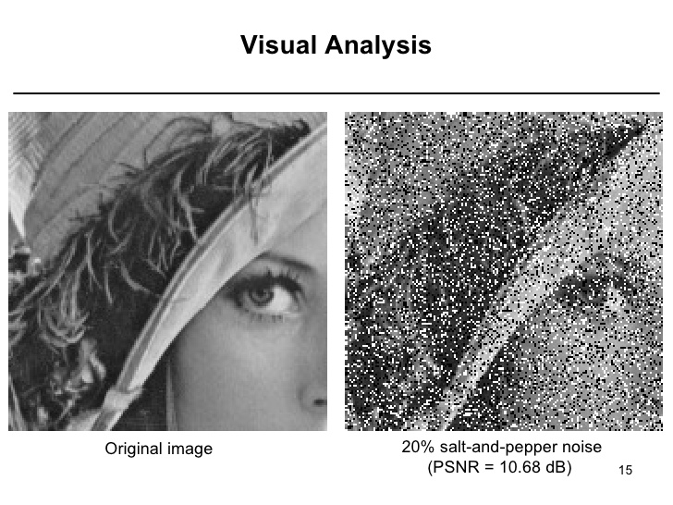

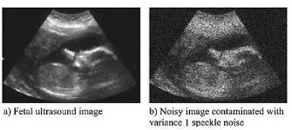

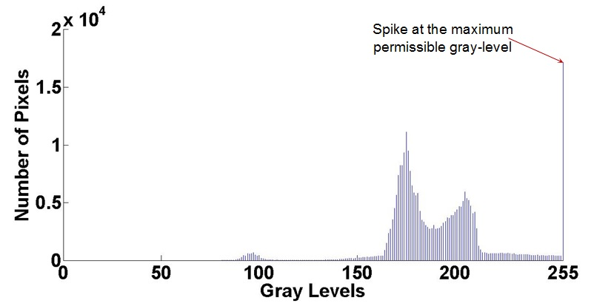

Point spread function

PSF is a system's impulse response
In functional terms it is the spatial domain version of the optical transfer function of the imaging system

Sharpening and unsharp masking
The objective of sharpening is to highlight detail in an image or to enhance detail that has been blurred. In this section, we discuss a few techniques along with a few examples demonstrating a couple of different ways to sharpen an image.

Unsharp masking (USM) is an image sharpening technique, often available in digital image processing software. The "unsharp" of the name derives from the fact that the technique uses a blurred, or "unsharp", negative image to create a mask of the original image.

TheAILearner—web link
In the previous blog, we discuss various first-order derivative filters. In this blog, we will discuss the Laplacian of Gaussian (LoG), a second-order derivative filter. So, let’s get started

Mathematically, the Laplacian is defined as
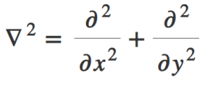
Unlike first-order filters that detect the edges based on local maxima or minima, Laplacian detects the edges at zero crossings i.e. where the value changes from negative to positive and vice-versa.
Let’s obtain kernels for Laplacian similar to how we obtained kernels using finite difference approximations for the first-order derivative.

Adding these two kernels together we obtain the Laplacian kernel as shown below
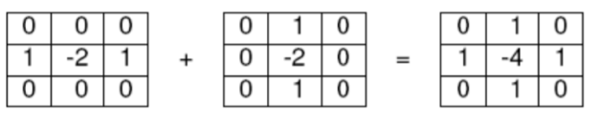
This is called a negative Laplacian because the central peak is negative. Other variants of Laplacian can be obtained by weighing the pixels in the diagonal directions also. Make sure that the sum of all kernel elements is zero so that the filter gives zero response in the homogeneous regions
Let’s now discuss some properties of the Laplacian
- Unlike first-order that requires two masks for finding edges, Laplacian uses 1 mask but the edge orientation information is lost in Laplacian.
- Laplacian gives better edge localization as compared to first-order.
- Unlike first-order, Laplacian is an isotropic filter i.e. it produces a uniform edge magnitude for all directions.
- Similar to first-order, Laplacian is also very sensitive to noise
To reduce the noise effect, image is first smoothed with a Gaussian filter and then we find the zero crossings using Laplacian. This two-step process is called the Laplacian of Gaussian (LoG) operation.
But this can also be performed in one step. Instead of first smoothing an image with a Gaussian kernel and then taking its Laplace, we can obtain the Laplacian of the Gaussian kernel and then convolve it with the image. This is shown below where f is the image and g is the Gaussian kernel.
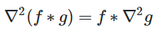
Now, let’s see how to obtain LoG kernel. Mathematically, LoG can be written as
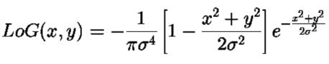
The LoG kernel weights can be sampled from the above equation for a given standard deviation, just as we did in Gaussian Blurring. Just convolve the kernel with the image to obtain the desired result, as easy as that.
Select the size of the Gaussian kernel carefully. If LoG is used with small Gaussian kernel, the result can be noisy. If you use a large Gaussian kernel, you may get poor edge localization.
Now, let’s see how to do this using OpenCV-Python

Steps for LoG:
- Apply LoG on the image. This can be done in two ways:
  - First, apply Gaussian and then Laplacian or
  - Convolve the image with LoG kernel directly
- Find the zero crossings in the image
- Threshold the zero crossings to extract only the strong edges.

Image Pyramids
Image pyramid refers to the way of representing an image at multiple resolutions. The idea behind this is that features that may go undetected at one resolution can be easily detected at some other resolution. For instance, if the region of interest is large in size, a low-resolution image or coarse view is sufficient. While for small objects, it’s beneficial to examine them at high resolution. Now, if both large and small objects are present in an image, analyzing the image at several resolutions can prove beneficial. This is the main concept behind image pyramids. The name “pyramid” because if you place the high-resolution image at the bottom and stack subsequent low-resolution images on top, the appearance resembles that of a pyramid.
Thus constructing an image pyramid is equivalent to performing repeated smoothing and subsampling (reducing the size to half) an image. This is illustrated in the image below

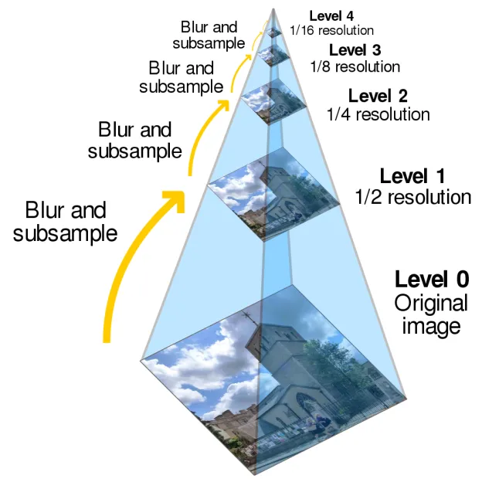
Why blurring? Because this reduces the aliasing or ringing effects that may arise if we downsample directly. Now depending upon the type of blurring applied the pyramid is named. For instance, if we apply a mean filter, the pyramid is known as the mean pyramid, Gaussian filter – Gaussian pyramid and if we don’t apply any filtering, this is known as subsampling pyramid, etc. For subsampling, we can use any interpolation algorithm such as the nearest neighbor, bilinear, bicubic, etc. In this blog, we will discuss only two kinds of image pyramids
- Gaussian Pyramid
- Laplacian Pyramid
Gaussian pyramid involves applying repeated Gaussian blurring and downsampling an image until some stopping criteria are met. For instance, one of the stopping criteria can be the minimum image size. OpenCV provides a builtin function to perform blurring and downsampling as shown below
aussian pyramid involves applying repeated Gaussian blurring and downsampling an image until some stopping criteria are met. For instance, one of the stopping criteria can be the minimum image size. OpenCV provides a builtin function to perform blurring and downsampling as shown below

cv2.pyrDown(src[, dstsize[, borderType]])
1 | cv2.pyrDown(src[, dstsize[, borderType]])
Here, src is the source image and rest are optional arguments which includes the output size (dstsize) and the border type. By default, the size of the output image is computed as Size((src.cols+1)/2, (src.rows+1)/2) i.e. the size is reduced to one-fourth at each step.

This function first convolves the input image with a 5×5 Gaussian kernel and then downsamples the image by rejecting even rows and columns. Below is an example of how to implement the above function.

