Reading Whole-slide Images using Large-image

[1]:
import large_image
INFO:girder:Created LRU Cache for 'tilesource' with 167 maximum size
[2]:
wsi_url = 'https://data.kitware.com/api/v1/file/5899dd6d8d777f07219fcb23/download'

wsi_path = 'TCGA-02-0010-01Z-00-DX4.07de2e55-a8fe-40ee-9e98-bcb78050b9f7.svs'

if not os.path.isfile(wsi_path):
!curl -OJ "$wsi_url"
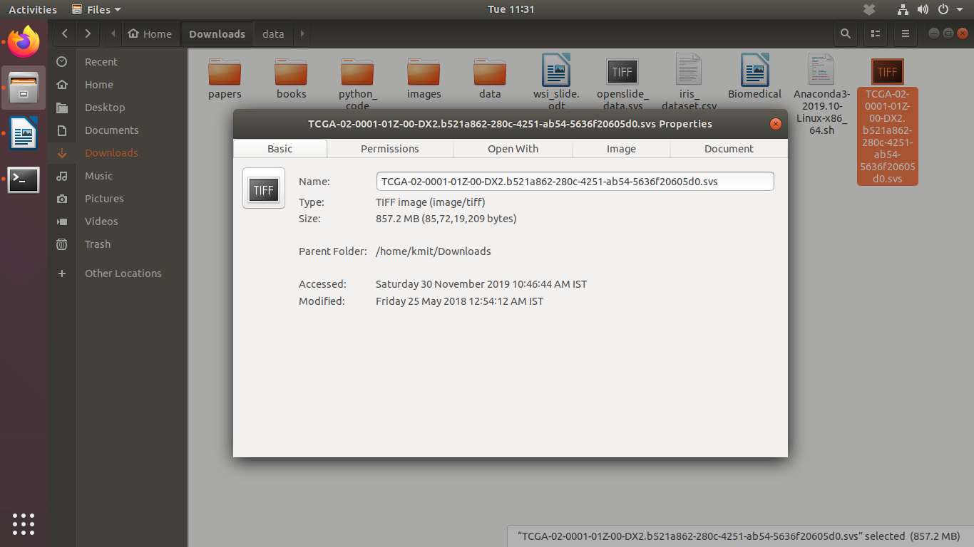

Loading a whole-slide image
[4]:
ts = large_image.getTileSource(wsi_path)
INFO:girder:Using memcached for large_image caching
Using memcached for large_image caching

[5]:
ts.getMetadata()
[5]:
{'levels': 9,
'magnification': 20.0,
'mm_x': 0.0005015,
'mm_y': 0.0005015,
'sizeX': 32001,
'sizeY': 38474,
'tileHeight': 240,
'tileWidth': 240}

getMagnificationForLevel()
The getMagnificationForLevel() function of the TileSource class returns a python dict containing the magnification and physical size of a pixel for a specified level in the image pyramid.
[7]:
# Get the magnification associated with Level 0
ts.getMagnificationForLevel(level=0)
[7]:
{'level': 0,
'magnification': 0.078125,
'mm_x': 0.128384,
'mm_y': 0.128384,
'scale': 256.0}
[8]:
# Get the magnification associated with all levels of the image pyramid
for i in range(ts.levels):
print('Level-{} : {}'.format(
i, ts.getMagnificationForLevel(level=i)))
Level-0 : {'magnification': 0.078125, 'scale': 256.0, 'level': 0, 'mm_y': 0.128384, 'mm_x': 0.128384}
Level-1 : {'magnification': 0.15625, 'scale': 128.0, 'level': 1, 'mm_y': 0.064192, 'mm_x': 0.064192}
Level-2 : {'magnification': 0.3125, 'scale': 64.0, 'level': 2, 'mm_y': 0.032096, 'mm_x': 0.032096}
Level-3 : {'magnification': 0.625, 'scale': 32.0, 'level': 3, 'mm_y': 0.016048, 'mm_x': 0.016048}
Level-4 : {'magnification': 1.25, 'scale': 16.0, 'level': 4, 'mm_y': 0.008024, 'mm_x': 0.008024}
Level-5 : {'magnification': 2.5, 'scale': 8.0, 'level': 5, 'mm_y': 0.004012, 'mm_x': 0.004012}
Level-6 : {'magnification': 5.0, 'scale': 4.0, 'level': 6, 'mm_y': 0.002006, 'mm_x': 0.002006}
Level-7 : {'magnification': 10.0, 'scale': 2.0, 'level': 7, 'mm_y': 0.001003, 'mm_x': 0.001003}
Level-8 : {'magnification': 20.0, 'level': 8, 'scale': 1.0, 'mm_y': 0.0005015, 'mm_x': 0.00050

[12]:

pos = 1000

tile_info = ts.getSingleTile(
tile_size=dict(width=1000, height=1000),
scale=dict(magnification=20),
tile_position=pos
)

plt.imshow(tile_info['tile'])
[12]:
<matplotlib.image.AxesImage at 0x7fab5b695250>
