Histopathology
Histopathology (compound of three Greek words: histos "tissue", pathos "suffering", and -logia "study of") refers to the microscopic examination of tissue in order to study the manifestations of disease.

Histopathology is the diagnosis and study of diseases of the tissues, and involves examining tissues and/or cells under a microscope.

Histopathologists are doctors who work closely with other clinical specialties. They can reach a diagnosis by examining a small piece of tissue from the skin, liver, kidney or other organ. This is called a biopsy.
They examine the tissue carefully under a microscope, looking for changes in cells that might explain what is causing a patient’s illness. Around 20 million histopathology slides are examined in the UK each year.

Cancer Diagnosis
Histopathologists provide a diagnostic service for cancer; they handle the cells and tissues removed from suspicious ‘lumps and bumps’, identify the nature of the abnormality and, if malignant, provide information to the clinician about the type of cancer, its grade and, for some cancers, its responsiveness to certain treatments.
Whole slide imaging (WSI), which refers to scanning of conventional glass slides in order to produce digital slides, is the most recent imaging modality being employed by pathology departments worldwide. WSI continues to gain traction among pathologists for diagnostic, educational, and research purposes

Whole slide imaging, also known as virtual microscopy, refers to scanning a complete microscope slide and creating a single high-resolution digital file. This is commonly achieved by capturing many small high-resolution image tiles or strips and then montaging them to create a full image of a histological section.
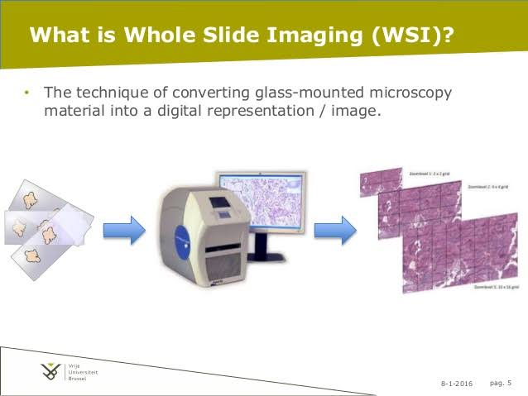

The DICOM Standard now provides support for WSI digital slides, by incorporating a way to handle tiled large images as multi-frame images and multiple images at varying resolutions

an .svs file is a pyramid of tiled images.

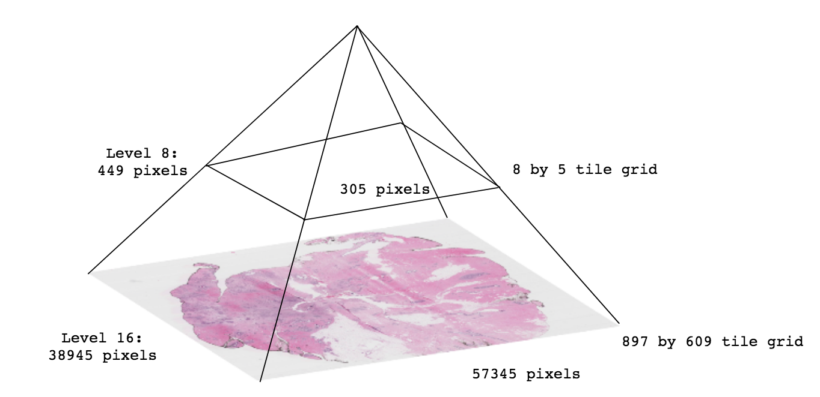

Most .svs images have between 15-20 levels, depending on the magnification of the image (typically 20x-40x) and the whole slide scanner

HistomicsTK

HistomicsTK is a Python and REST API for the analysis of Histopathology images in association with clinical and genomic data.

