EXPLORATORY ANALYSIS REPORT
Kochi Urban Mobility
Road traffic, weather and metro travel times
across 18 corridors in Kochi

Data period: 17–30 August 2026
Data sources: TomTom Routing API, Open-Meteo weather, Kochi Metro GTFS timetable
Author: Devika Vinod & Aravind S

1. Executive summary
This report explores two weeks of road travel-time data for 18 corridors in Kochi, together with hourly weather and the Kochi Metro timetable. The aim is to understand when and where traffic is worst, whether rain slows it down, and where the metro offers a faster alternative to the road.
Key findings
- Congestion lasts all day, not just at rush hour. Traffic flows at about 29 km/h at night but only about 21 km/h from 8 am to 8 pm. The worst period is 5–7 pm, at 19 km/h (33% slower than night). There is no distinct morning rush.
- The Kakkanad / Infopark side of the city is the slowest, and has no metro. Its corridors average about 22 km/h, and one end of each is 4.3–6.5 km from the nearest metro station.
- The metro wins on long trips along its line and loses where it detours. Aluva ↔ MG Road is 13–14 minutes faster by metro, and up to 21 minutes faster at 6 pm. Edappally or Palarivattom ↔ Vyttila is 6–10 minutes faster by road, because the metro loops through the city centre while the road uses the bypass.
- Rain showed no measurable effect on traffic speed in this data. Holidays mattered far more. Heavy rain first appeared to make traffic faster, but only because the wettest days coincided with Onam and a Sunday, when fewer people travelled. Compared fairly, rain changed speeds by about 1%. Too few hours of heavy daytime rain on working days were recorded to judge its effect.
- TomTom often chooses different roads for the same trip. Each corridor used between 5 and 31 distinct routes, so part of the variation in travel time comes from route changes rather than traffic alone.
What this means
- Transit planning: the biggest gap in public-transport coverage is Kakkanad / Infopark, the slowest area in the data. North-south trips along the metro line are already well served. Vyttila ↔ Edappally trips would benefit more from a direct bus along the bypass than from the metro.
- Data: fix the ingestion gap after 26 August, add a holiday flag, and collect several more weeks of data (including heavy rain on working days) before drawing conclusions about weather.

2. Data and method

2.1 Data sources
Table 1. Data sources used in this analysis
Source | What it provides | Coverage
TomTom Routing API | Travel time, traffic delay, route length and route geometry for each corridor, pulled roughly every hour | 17–30 Aug 2026; 4,727 readings
Open-Meteo | Hourly temperature and rainfall for Kochi | 17 Aug – 4 Sep 2026; 456 hours
Kochi Metro GTFS | Stations, timetable and line shape for the Aluva – Tripunithura metro | Timetable valid Aug 2024 – Dec 2025

2.2 The corridors
The analysis covers 18 one-way road corridors (9 routes, each measured in both directions), grouped by purpose:
Table 2. Corridor groups
Group | Purpose | Corridors
C1 Kakkanad IT Corridor | Commuter routes to Infopark and SmartCity | 6
C2 Kochi Metro Spine | Road trips along the Aluva – Tripunithura metro line, for road vs metro comparison | 6
C3 Key Junctions | Congestion hotspots between Edappally, Palarivattom and Vyttila | 4
C4 Water Metro Parallel Routes | Road trip between Vyttila and Kakkanad that the Water Metro could replace | 2

2.3 Data quality
The data is clean. There are no missing values, no duplicate readings and no impossible values (such as zero travel times, speeds above 120 km/h or negative rainfall), and every reading links correctly to its corridor, date, hour and weather. Only 7 of 4,734 expected readings are missing (0.15%).
Three points affect how the results should be read:
- Uneven collection. Because of problems in the data-ingestion job, traffic was recorded 22–33 times a day on 18–26 August but only 3–6 times a day on 27–30 August. Analyses that need whole days use 18–26 August.
- Onam holidays. 25 and 26 August 2026 were Onam public holidays (Uthradam and Thiruvonam), when traffic was much lighter than usual.
- One thin hour. 06:00 has only one set of readings, so values for that hour are unreliable.

2.4 How the results are measured
- Median, not average. Typical values use the median, so a few unusually bad jams don't distort the result.
- Speed and travel time, not TomTom’s delay figure. TomTom reports zero delay for 84% of readings, yet travel times on the same corridor still vary by 40–60%. Speed and travel time are therefore used as the measures of congestion.
- Speed vs normal. To compare conditions such as rain, each reading is compared with the usual speed for the same corridor at the same hour of day, so differences between routes and times of day cancel out.
- Ordinary working days. Where holidays or weekends would distort a comparison, only ordinary weekdays with full data (18–21 and 24 August) are used.

3. Traffic overview
A typical trip on these corridors takes 19 minutes at 24 km/h, which is slow city traffic. Trips are also unpredictable: the slowest 5% take 38 minutes or more, about twice the typical time, and on every corridor a bad-day trip takes 1.4–1.6 times as long as a typical one.
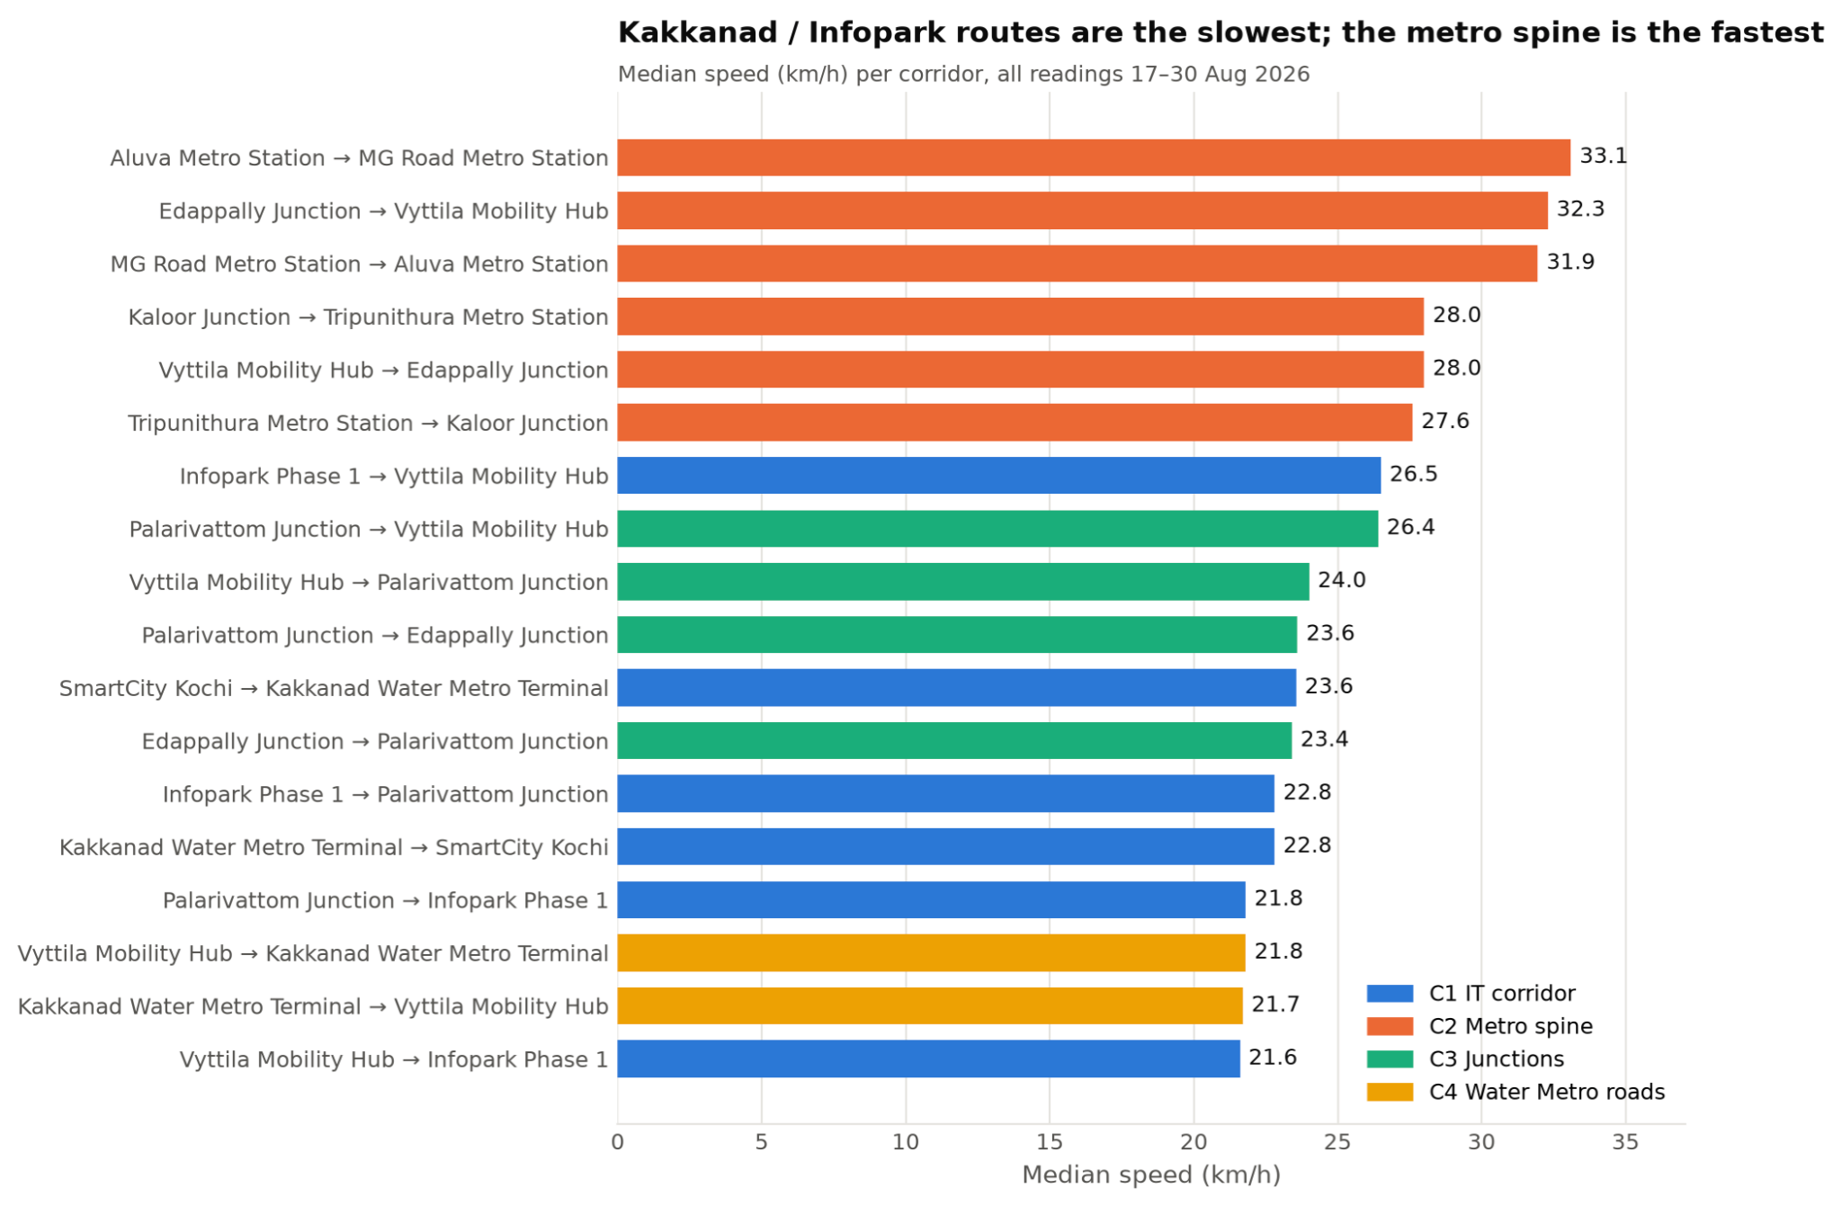
Figure 1. Median speed on each corridor. The six Metro Spine corridors (orange) are the fastest; the Kakkanad / Infopark corridors (blue and yellow) fill the bottom of the chart.
Table 3. Median speed by corridor group, slowest first
Corridor group | Median speed | Note
C4 Water Metro parallel roads | 21.8 km/h | Slowest group: Vyttila ↔ Kakkanad takes about 17 minutes for 6 km
C1 Kakkanad IT Corridor | 22.6 km/h | Routes to and from Infopark and SmartCity
C3 Key Junctions | 24.1 km/h
C2 Kochi Metro Spine | 30.2 km/h | Fastest group, on longer main roads
- The Kakkanad / Infopark side of the city (groups C1 and C4) is the slowest area, at about 22 km/h.
- Slowest corridor: Vyttila → Infopark Phase 1, at 21.6 km/h. Fastest: Aluva → MG Road, at 33.1 km/h.
- Least reliable: Infopark → Palarivattom. A bad-day trip takes 1.6 times the typical time.
- Some corridors are different lengths in each direction (Vyttila → Infopark is 8.7 km, the return 11.7 km), probably because of one-way roads, so corridors are compared by speed rather than minutes.

4. When is traffic worst?
Traffic speeds follow a clear daily pattern, but it is not the classic “two rush hours” shape. Speeds fall sharply from 8 am and stay low all day until about 9 pm.
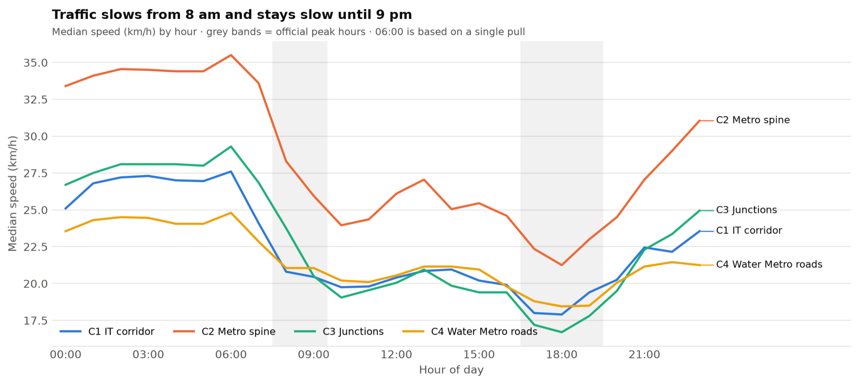
Figure 2. Median speed by hour of day for each corridor group. Grey bands mark the peak hours currently defined in the data model (8–9 am and 5–7 pm).

Table 4. Median speed by time of day, all corridors
Time of day | Median speed | Slower than night
Night (00–06) | 28.9 km/h | baseline
Early morning (07) | 27.0 km/h | 7%
Morning peak (08–09) | 22.1 km/h | 24%
Midday (10–16) | 21.1 km/h | 27%
Evening peak (17–19) | 19.3 km/h | 33%
Late evening (20–23) | 23.6 km/h | 18%
- Midday is as slow as the morning peak, so there is no distinct morning rush. The officially defined peak hours capture the evening peak but miss the congestion in between.
- The evening peak (5–7 pm) is the worst time of day, and 6 pm is the slowest single hour.
- The junctions (C3) and the metro spine (C2) slow down the most at the evening peak, by 38% and 35% compared with night. The Water Metro roads (C4) change least (22%) but are slow at every hour, which points to the route itself rather than rush-hour traffic.
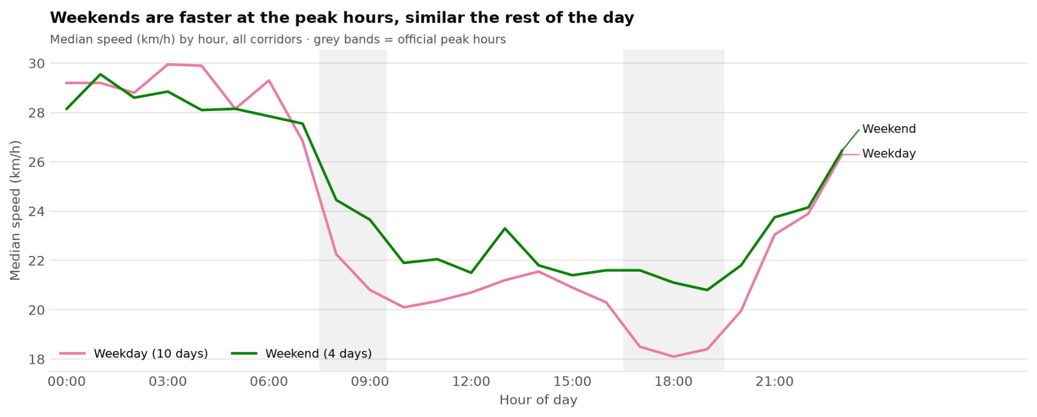
Figure 3. Median speed by hour, weekdays compared with weekends (all corridors).
Weekends are faster only at the peak hours: 2.8 km/h faster in the morning and 2.6 km/h in the evening, with little difference at other times. The peaks are therefore driven by commuting, while daytime congestion happens every day. (There were only 4 weekend days in the data.)
Implication: for planning purposes, “peak” in Kochi means roughly 8 am to 8 pm, worst between 5 and 7 pm, rather than two short rush hours.

5. Does rain slow traffic?
It rained in just over half of all hours in the traffic period, but most of it was light.
Table 5. Hours of rain during the traffic period (17–30 August); the heaviest hour had 11.4 mm
Rain intensity | Definition | Hours | Share
Dry | 0 mm per hour | 157 | 47%
Drizzle | up to 0.5 mm per hour | 108 | 32%
Light | 0.5–2.5 mm per hour | 55 | 16%
Moderate / heavy | over 2.5 mm per hour | 16 | 5%

5.1 A misleading first result
Comparing each reading with the normal speed for its corridor and hour, daytime traffic appeared to be faster in the rain: 1.7% below normal when dry, but 13.9% above normal in moderate or heavy rain. That is the opposite of what one would expect, so the results were checked day by day.
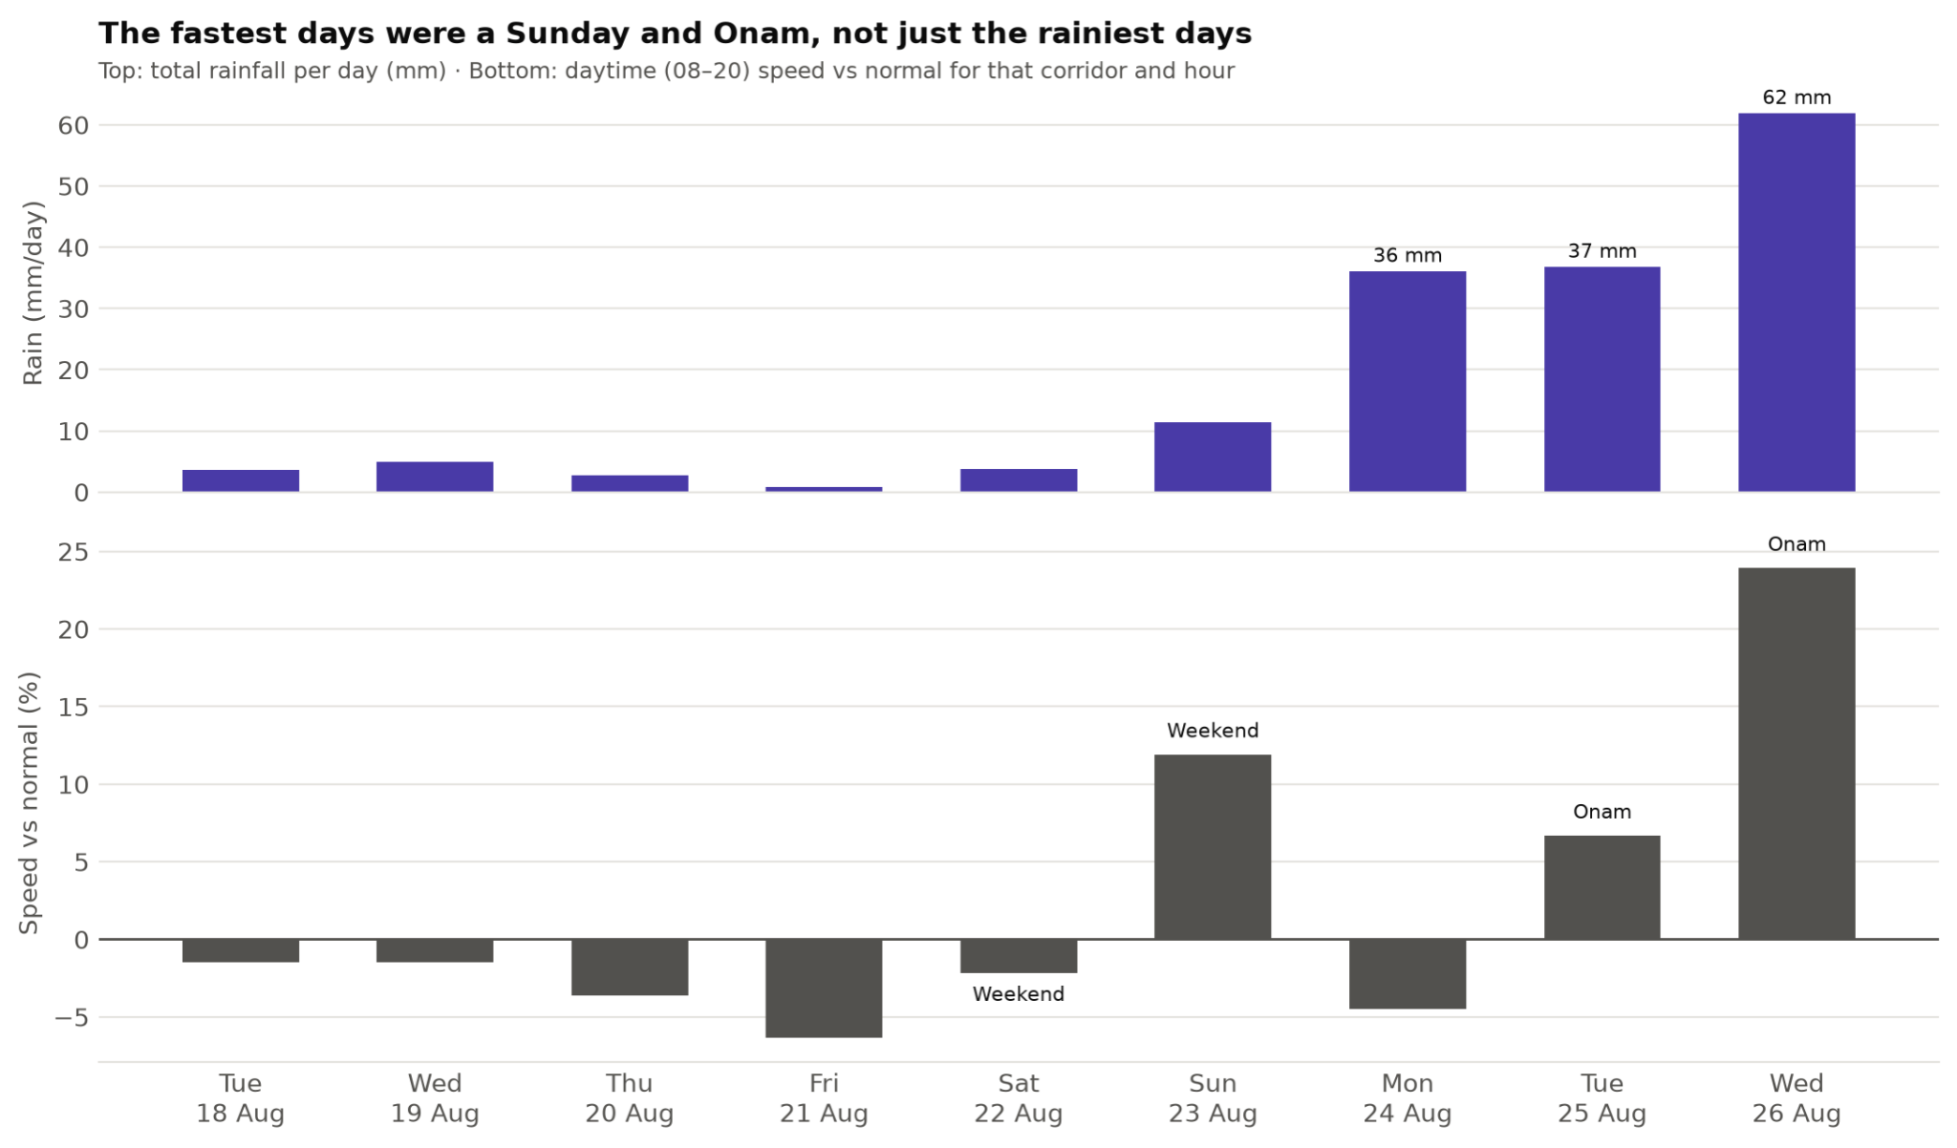
Figure 4. Total rainfall per day (top) and daytime speed compared with normal (bottom), for days with full data coverage.

Table 6. The wettest days, compared with normal daytime speed
Day | Rain (whole day) | Daytime speed vs normal | Note
Sun 23 Aug | 11 mm | +11.9% | Weekend
Mon 24 Aug | 36 mm | −4.5% | Working day: very wet, yet slightly slower
Tue 25 Aug | 37 mm | +6.7% | Onam holiday (Uthradam)
Wed 26 Aug | 62 mm | +23.9% | Onam holiday (Thiruvonam): fastest day in the data
The wettest days were also a Sunday and the two Onam holidays, when far fewer people were travelling. Traffic was fast because roads were quiet, not because it rained.

5.2 A fair comparison
To remove day-to-day differences such as holidays, rainy and dry hours were compared on the same day and the same corridor:
- All days: rain changed speeds by +1.6% (median), and rainy hours were slower in only 42% of comparisons. That is well within normal hour-to-hour variation.
- Ordinary working days only: every rain intensity was within ±1% of normal, and rainy hours were slower in exactly half of the comparisons.
Conclusion: in this data, drizzle and light rain make no measurable difference to traffic speed, and holidays have a much larger effect than weather. The effect of heavy rain remains unknown: there was only one daytime hour of moderate or heavy rain on a working day, too little to measure.

6. Road vs metro
The Kochi Metro timetable was used to estimate how long each corridor’s trip would take by metro: the average wait for the next train (half the time between trains) plus the time on the train. This was compared with the road travel time on ordinary working days. Walking to and from the stations is not included, so a metro advantage of less than about 5 minutes is likely to be cancelled out by the walk.

6.1 Which corridors have a metro alternative?
10 of the 18 corridors start and end within walking distance of a metro station: all of the Metro Spine (C2) and Key Junctions (C3) corridors. The other 8, all of C1 (Kakkanad IT Corridor) and C4 (Water Metro roads), have one end 4.3–6.5 km from the nearest station. These are also the slowest corridors in the data.

6.2 Travel time comparison
Table 7. Road vs metro, daytime (08–20) on ordinary working days. Positive values mean the metro is faster
Trip | Road, typical (min) | Road, worst hour (min) | Metro (min) | Metro saves, typical | Metro saves, worst hour | Result
MG Road → Aluva | 46.2 | 53.4 (18:00) | 32.3 | +14.0 | +21.1 | Metro faster
Aluva →  MG Road | 45.3 | 49.2 (10:00) | 32.7 | +12.6 | +16.5 | Metro faster
Edapally → Palarivattom | 11.2 | 11.9 (18:00) | 8.0 | +3.2 | +4.8 | About equal
Palarivattom → Edapally | 10.5 | 12.0 (20:00) | 7.9 | +2.6 | +4.1 | About equal
Tripunithura → JLN Stadium | 30.0 | 34.7 (11:00) | 31.0 | −1.0 | +3.6 | About equal
JLN Stadium → Tripunithura | 29.8 | 35.3 (18:00) | 31.1 | −1.3 | +4.6 | About equal
Vyttila → Edapally | 20.2 | 23.1 (18:00) | 26.5 | −6.3 | −3.4 | Road faster
Edapally → Vyttila | 18.4 | 22.8 (18:00) | 26.9 | −8.5 | −3.3 | Road faster
Vyttila → Palarivattom | 13.8 | 16.1 (18:00) | 22.4 | −8.6 | −6.4 | Road faster
Palarivattom → Vyttila | 12.8 | 16.0 (18:00) | 22.5 | −9.6 | −6.1 | Road faster

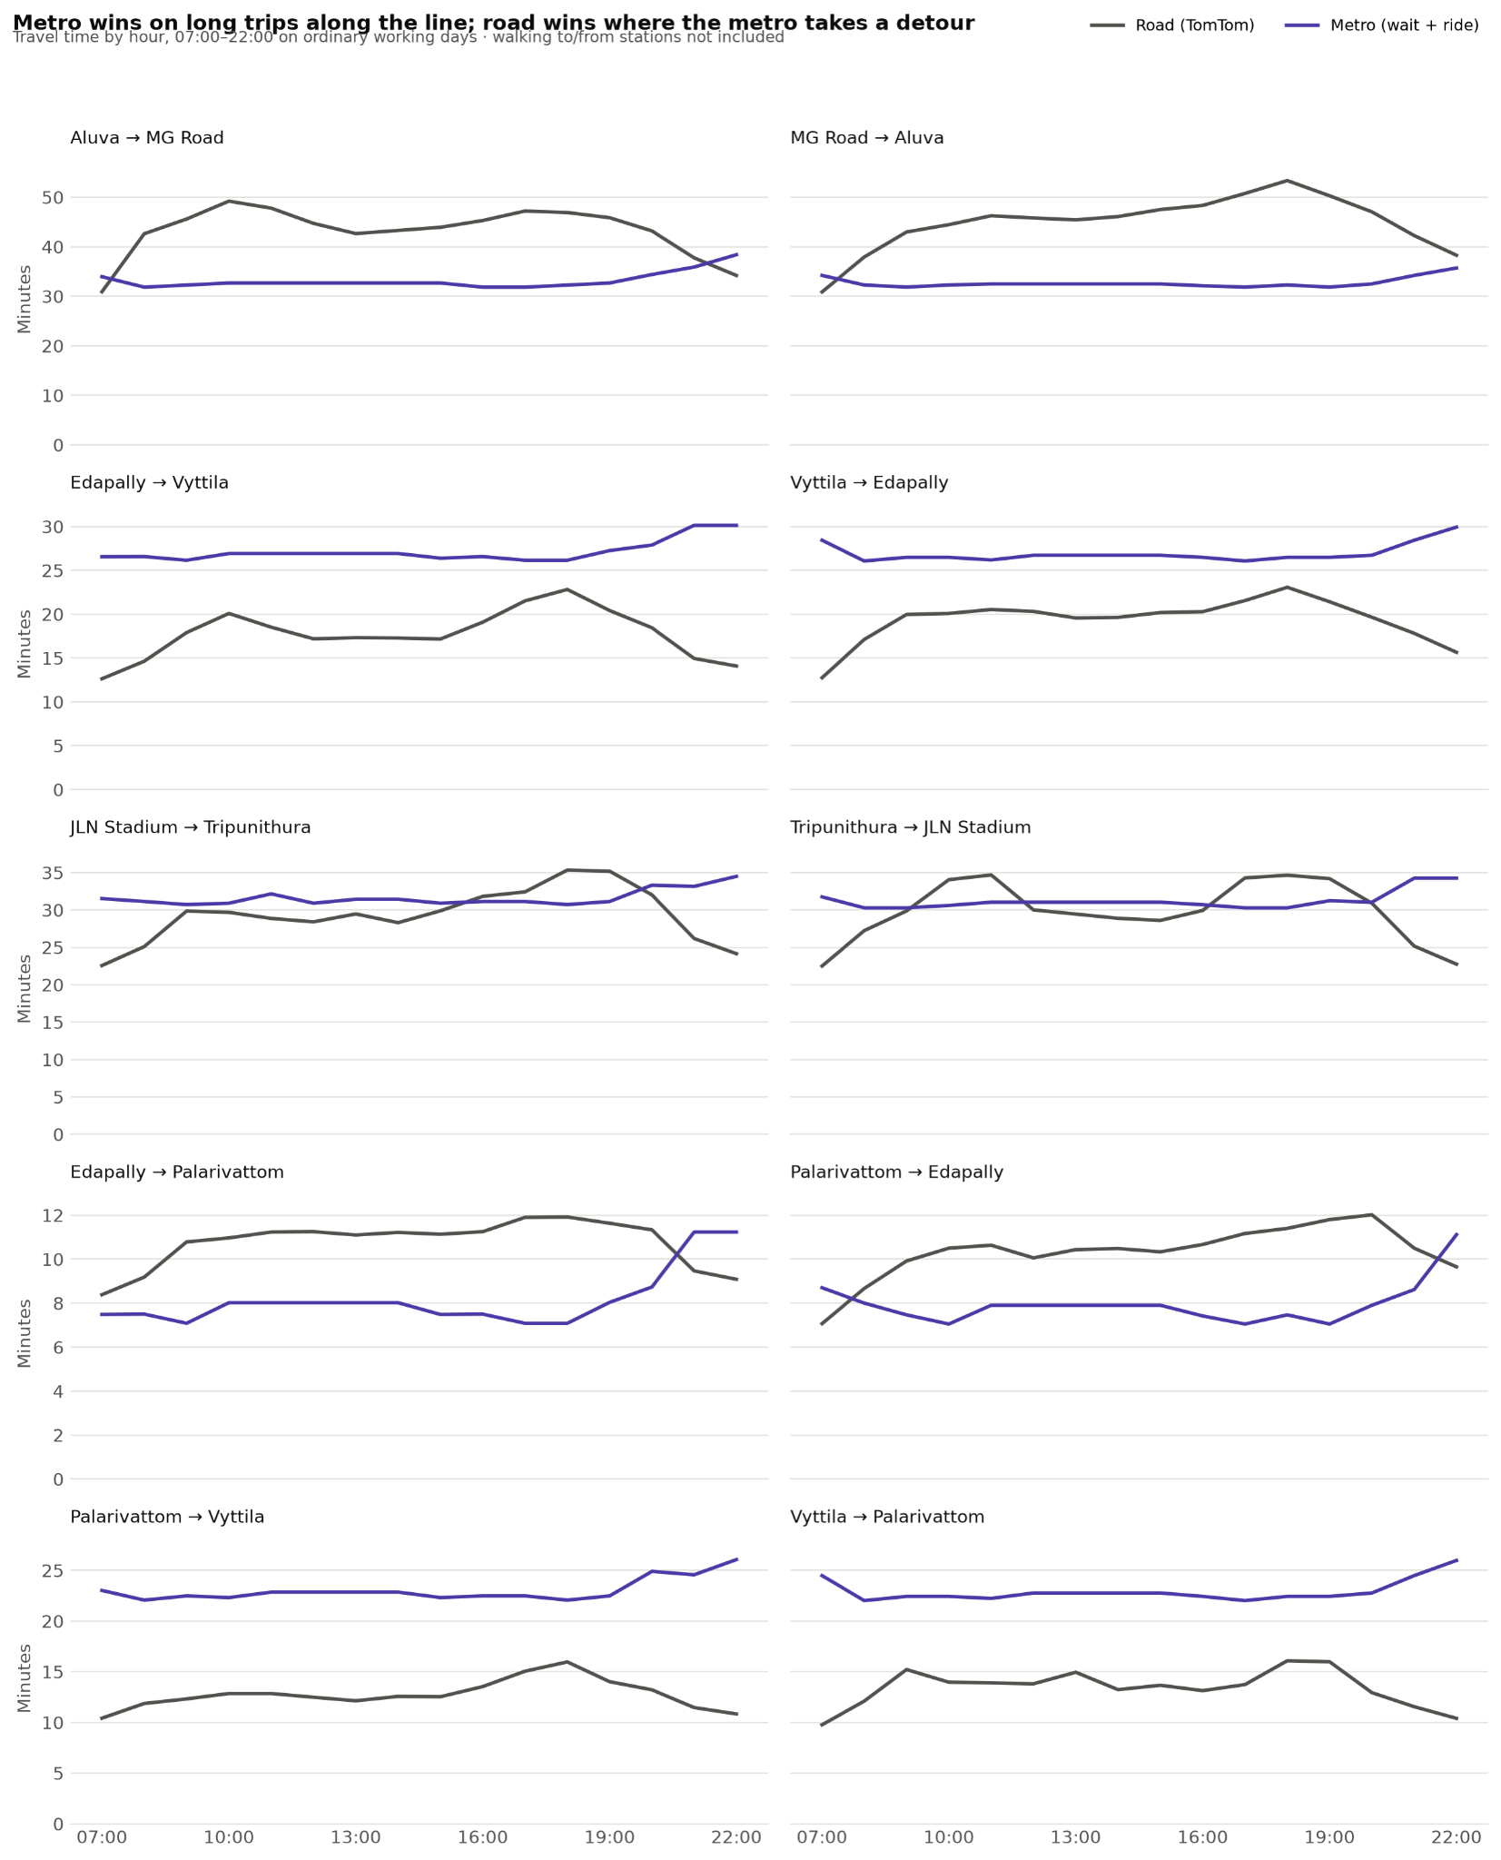
Figure 5. Travel time by hour, road compared with metro (wait + ride), for each corridor with a metro alternative. Walking to and from stations is not included.

- The metro is clearly faster for long north–south trips. Aluva ↔ MG Road is 13–14 minutes quicker on a typical trip and up to 21 minutes quicker at 6 pm, with short walks at both ends.
- The road is faster between Vyttila and Edappally or Palarivattom, by 6–10 minutes. The metro runs through the city centre (Kaloor, MG Road, Kadavanthra), while the road takes the direct bypass: Edappally → Vyttila is 11 stops by metro but only a 7.6 km drive.
- Kaloor ↔ Tripunithura is roughly even: the road wins at midday, the metro during the evening peak.
- The metro is predictable. Its journey time stays within about a minute from 8 am to 7 pm, while road times swing by 5–10 minutes. Trains run every 7–8.5 minutes in the daytime, but service thins after 8 pm, and by 10 pm the road is faster on every corridor.
Implication: the metro already serves long trips along its line well. The largest gap is Kakkanad / Infopark, the slowest area, which has no metro at all. Trips between Vyttila and Edappally would be better served by a direct bus along the bypass than by the metro.

7. Route map
The map shows the road route each corridor followed most often, drawn along the actual streets, with the Kochi Metro line (dashed) and its stations on top.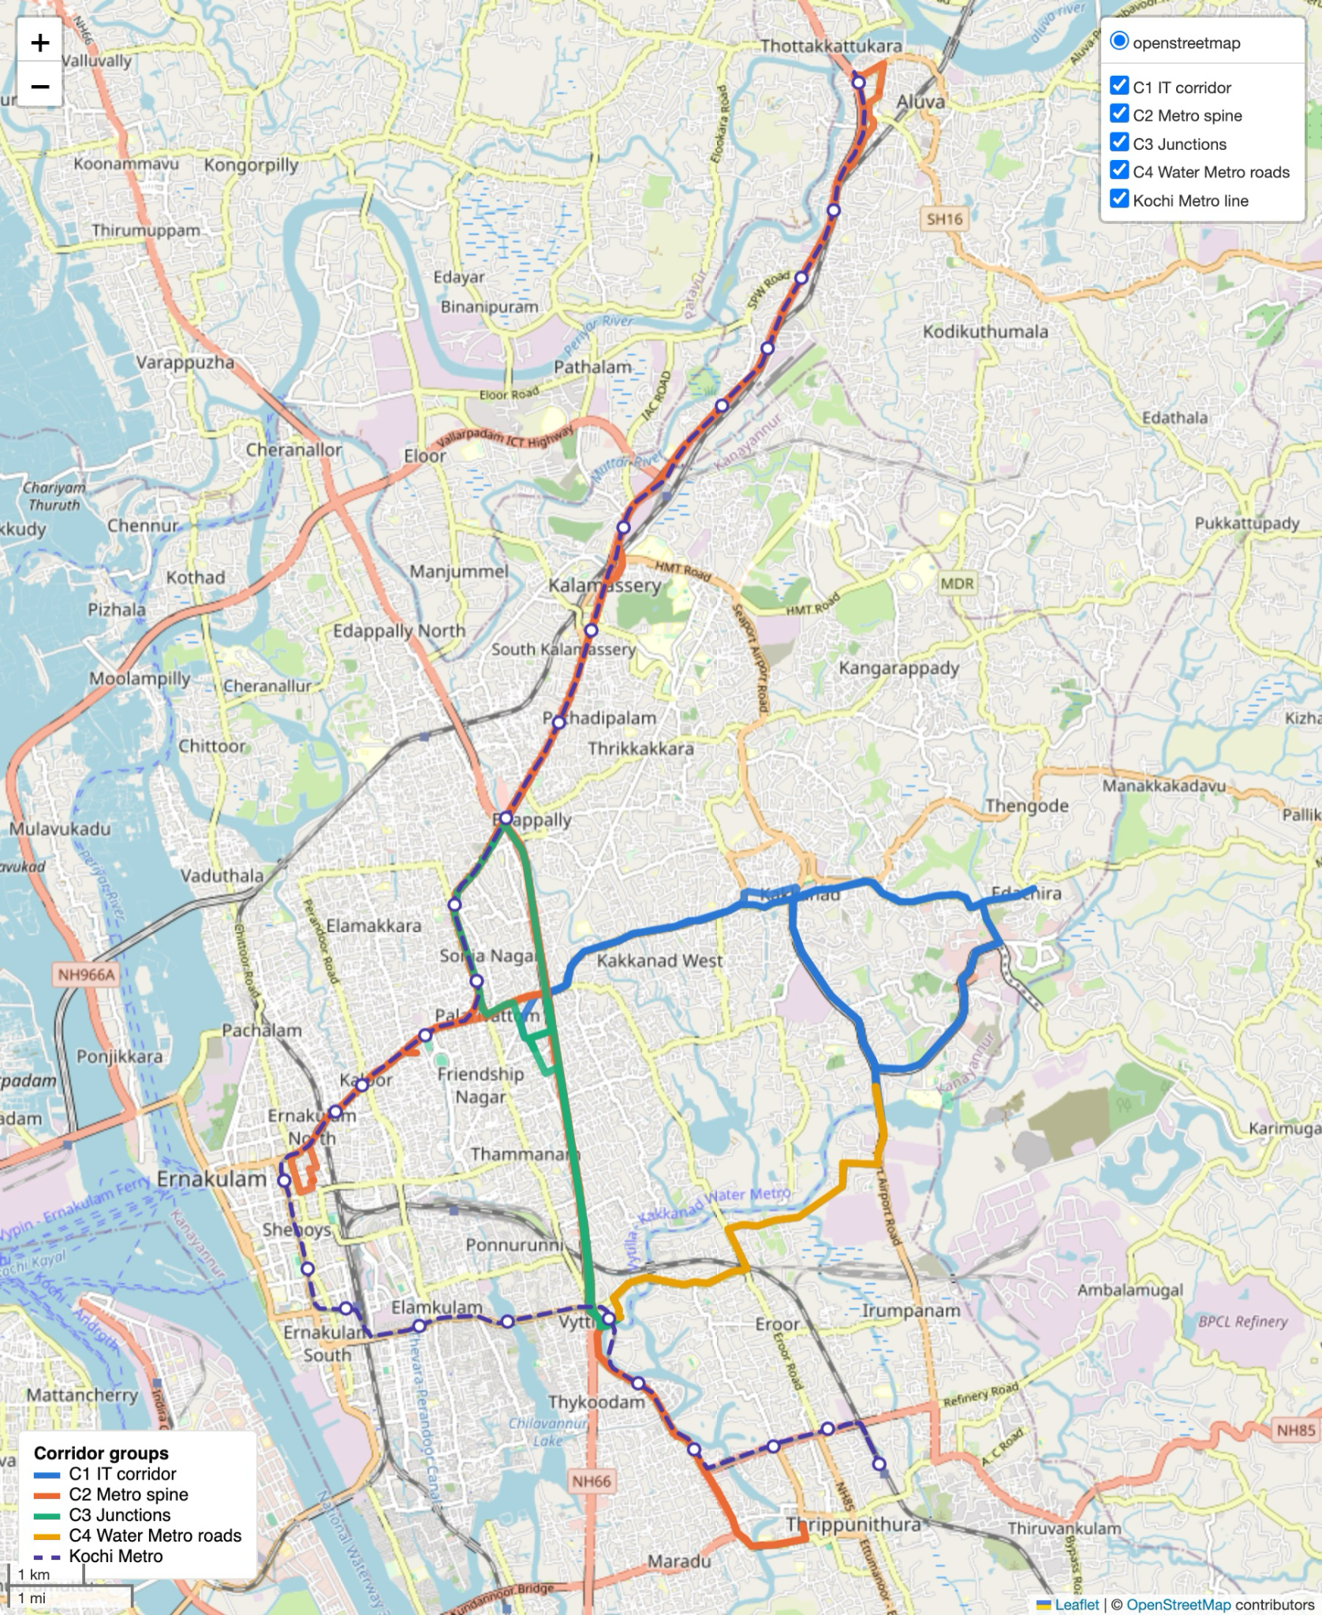
Figure 6. Road routes by corridor group and the Kochi Metro line. The green Edappally → Vyttila road route runs straight down the bypass, while the metro loops west through Ernakulam. Map data © OpenStreetMap contributors.

Routes change from trip to trip
TomTom does not always send a corridor’s trip along the same roads. Each corridor used between 5 and 31 distinct routes, and the most common route accounts for only 35–92% of readings. For MG Road → Aluva, the main route was used only 35% of the time, and route lengths ranged from 17 to 25 km. Some of the variation in travel time is therefore caused by route changes rather than by traffic alone.

8. Data issues and recommendations
Table 8. Data issues found during the analysis
# | Issue | Recommended action
1 | Traffic collection dropped to 3–6 readings a day from 27 August | Fix the ingestion job and keep collecting
2 | The date table has no holiday flag | Add an “is holiday” flag, starting with Onam (25–26 August)
3 | The defined peak hours (8–9 am, 5–7 pm) do not match the data | Redefine as daytime 8 am – 8 pm with an evening peak of 5–7 pm
4 | The metro timetable expired in December 2025 | Load the current Kochi Metro GTFS feed
5 | No Water Metro timetable | Obtain the Vyttila ↔ Kakkanad Water Metro schedule to evaluate the C4 corridors
6 | The Palarivattom and Tripunithura corridor end points are 1.1–1.3 km from their metro stations | Check the corridor coordinates
7 | Routes change between readings | Keep the route used with each reading so like can be compared with like
Recommended next analyses
- Revisit the rain question once several more weeks of data are available, including heavy daytime rain on ordinary working days.
- Reliability by corridor and hour: how much extra time a traveller must allow to arrive on time. This is where the metro’s predictability matters most.
- Water Metro vs road for Vyttila ↔ Kakkanad, once its timetable is available.
- Dashboard: publish these results in an interactive dashboard for ongoing monitoring.

Appendix A. Corridor statistics
Table 9. Statistics for every corridor, all readings 17–30 August 2026
Corridor | Route | Length (km) | Typical (min) | Worst 5% (min) | Speed (km/h) | Worst ÷ typical
C1_1_fwd | Palarivattom Junction → Infopark Phase 1 | 9.6 | 26.5 | 32.4 | 21.8 | 1.2
C1_1_rev | Infopark Phase 1 → Palarivattom Junction | 8.1 | 21.4 | 34.4 | 22.8 | 1.6
C1_2_fwd | Vyttila Mobility Hub → Infopark Phase 1 | 8.7 | 24.6 | 33.4 | 21.6 | 1.4
C1_2_rev | Infopark Phase 1 → Vyttila Mobility Hub | 11.7 | 25.2 | 30.3 | 26.5 | 1.2
C1_3_fwd | Kakkanad Water Metro Terminal → SmartCity Kochi | 6.2 | 16.4 | 22.3 | 22.8 | 1.4
C1_3_rev | SmartCity Kochi → Kakkanad Water Metro Terminal | 6.2 | 15.9 | 24.5 | 23.6 | 1.5
C2_4_fwd | Aluva Metro Station → MG Road Metro Station | 17.7 | 35.5 | 48.5 | 33.1 | 1.4
C2_4_rev | MG Road Metro Station → Aluva Metro Station | 17.3 | 36.7 | 51.5 | 32.0 | 1.4
C2_5_fwd | Edappally Junction → Vyttila Mobility Hub | 7.6 | 14.1 | 22.0 | 32.3 | 1.6
C2_5_rev | Vyttila Mobility Hub → Edappally Junction | 7.2 | 15.5 | 23.5 | 28.0 | 1.5
C2_6_fwd | Kaloor Junction → Tripunithura Metro Station | 11.3 | 24.1 | 34.3 | 28.0 | 1.4
C2_6_rev | Tripunithura Metro Station → Kaloor Junction | 11.0 | 23.9 | 35.1 | 27.6 | 1.5
C3_7_fwd | Edappally Junction → Palarivattom Junction | 3.5 | 8.9 | 11.9 | 23.4 | 1.3
C3_7_rev | Palarivattom Junction → Edappally Junction | 3.5 | 8.7 | 13.0 | 23.6 | 1.5
C3_8_fwd | Palarivattom Junction → Vyttila Mobility Hub | 5.4 | 11.0 | 15.4 | 26.4 | 1.4
C3_8_rev | Vyttila Mobility Hub → Palarivattom Junction | 4.2 | 10.6 | 15.7 | 24.0 | 1.5
C4_9_fwd | Vyttila Mobility Hub → Kakkanad Water Metro Terminal | 6.2 | 17.4 | 24.9 | 21.8 | 1.4
C4_9_rev | Kakkanad Water Metro Terminal → Vyttila Mobility Hub | 6.2 | 17.4 | 23.2 | 21.7 | 1.3

Appendix B. Glossary
Term | Meaning
Corridor | A fixed origin–destination road trip, measured in one direction
Reading | One TomTom travel-time measurement for one corridor at one moment
Median | The middle value: half of the readings are above it and half below
Worst 5% / 95th percentile | The travel time that only 5% of trips exceed
Worst ÷ typical | 95th-percentile travel time divided by median travel time. 1.0 means perfectly reliable; 1.5 means a bad trip takes 50% longer than usual
Speed vs normal | A reading’s speed divided by the median speed for the same corridor at the same hour of day. 1.10 means 10% faster than usual
Ordinary working days | Weekdays with full data coverage, excluding holidays: 18–21 and 24 August 2026
GTFS | General Transit Feed Specification, the standard format for public-transport timetables

