Hands on 1: Create a Spring Web Project using Maven

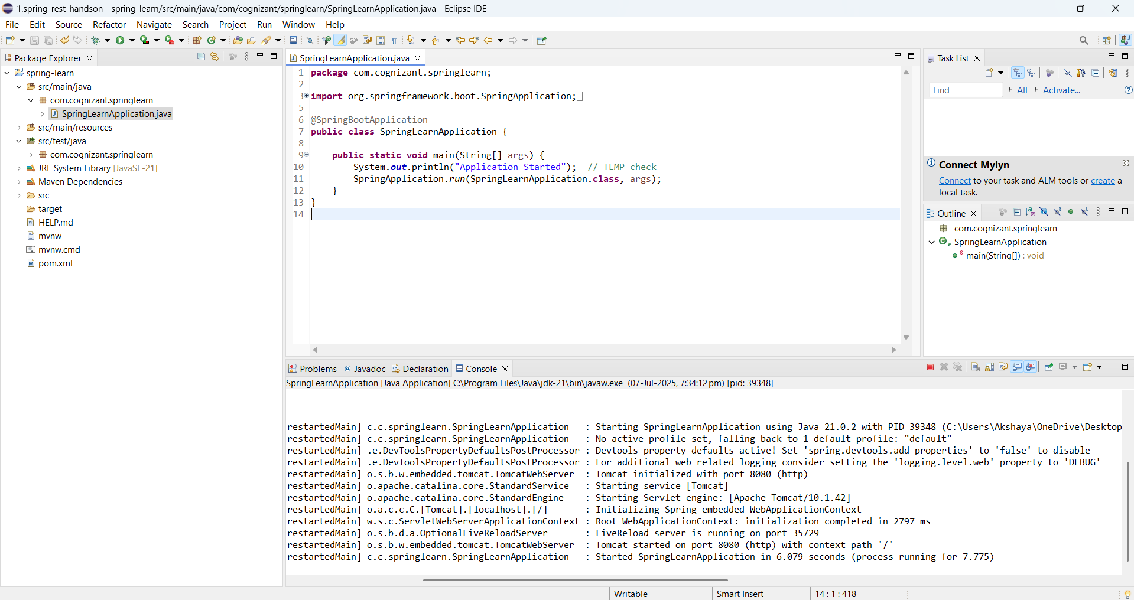Hands on 4
Spring Core – Load Country from Spring Configuration XML
