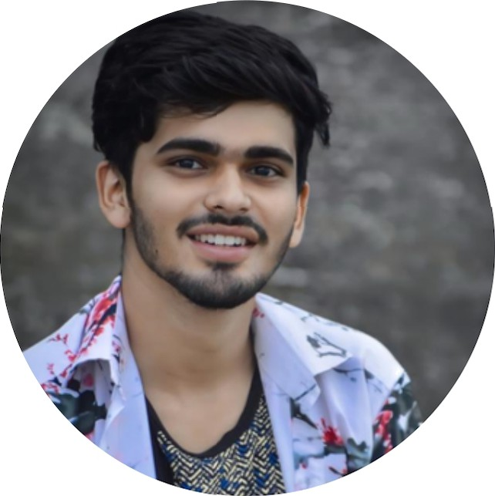



subhankardash455 5Äg DCil.COI

O Balasore,Odisha

SKILLS

- C

- JAVASCRIPT
- PYTHON
- css
- HTML

LANGUAGES
- Odia
- English
- Hindi

HOBBIES

Redding books
bypass dnticheats in games debugging in softwares

SUBHANKAR DASH
SOFTWARE ENGINEER

PROFILE

Looking for entry-level jobs in software domain where I can utilize my extensive knowledge about the area gained during my MCA degree.

EDUCATION

KALINGA INSTITUTE OF INDUSTRIAL TECHNOLOGY
,BHUBANESWAR
  - Master of computer application
  - Marks in second semester 8.oo CGPA
  - Continuing

SRIRAI'1 +3 SCIENCE RESIDENTIALCOLLEGE , BALASORE
  - Grddudted with 8.4g CGPA with distinction
  - Bachelor of science in physics honours
  - 2O2O-2023

UPENDRANATH COLLEGE ,S0R0

  - QUdlified 12th science with 72%marks
  - 2018-2020

GANDIBED HIGH SCHOOL , GANDIBED

  - Oualified 1Oth with 8y% mams
  - YOP 2018

PROJECT

bypass assult cube game for testing and making an esp for enmies in game and making amazon forntend using html and css

