Assignment

Usability Testing

Contents

Part A: Usability Test Plan 3

Selected Website and its Purpose: 3

Test Plan 3

Part B: Data Collection Procedure 5

Part 3 : Report on Findings 10

Discussion 10

Summary 10

Recommendations 14

Conclusion 15

References 17

# Part A: Usability Test Plan

## Selected Website and its Purpose:

The website selected is [Fitzroy Legal Service – Fitzroy Legal Service (fls.org.au)](https://fls.org.au/). Fitzroy Legal Services could be a community non-profit organization that gives legitimate data, exhortation and representation to casualties and defenseless individuals within the Fitzroy region and invites authoritative strategies and case. The rustic zones of Darebin and Yarra, as well as Melbourne's northern rural areas, are the seats of the pioneers. The point of the organization is to supply equity to society by giving free legitimate exhortation (Barendrecht 2011).

## Test Plan

For the purpose of Usability Testing, around 5 participants from various age groups 18-25, 26- 35, 36-45, 46- 55, 55+ will be hired and the following tasks will be given to them.

* **Task 1: Reading the contents of Website:** For this case, the participants will be given the task to read the website and their time will be noted.
* **Task 2: Applying for Membership:** The participants will be asked to apply for membership and their time will be noted.
* **Task 3: Donation:** The participants will be asked to click on donation icon and they will be instructed to donate.

**Approach that will be used in Usability Testing**

Approach of Thinking Aloud Test will be used. Within the "Thinking Aloud " test, candidates ought to utilize the system when considering out loud - meaning they as it were express their considerations whereas moving through the UI. Buyers talk out loud whereas performing different activities, which is considered portion of a well-known client assessment strategy known as the word-of-mouth prepare. As much as conceivable, clients ought to depict what they saw, felt, did, and felt. This approach may be a window into people's personality and permits us to get it their considerations about our objectives and expectations (Panagiotidi 2022). This device gives point of view that's difficult to induce with a basic understanding.

**Metrics**

* Completion of Scenario: All activities require participants to obtain or access certain information used during the study. An event is successful when the participant states that the activity goals have been met (whether successful or not), or when the participant requests and receives sufficient guidance to guarantee the event score is a critical error.
* Critical Error: This is deviation from the target situation when executed. Getting or something else unveiling untrue data due to the work of the members could be a basic botch. Members may or may not be aware that performance objectives are wrong or deficient. Satisfying the condition could be a common reason; help from other approval measures is the reason for the status evaluation as Basically Untrue. A deadly blunder can too be sent when an on-screen character starts (or endeavors to start) an action that will cause the expectation of the situation not to be fulfilled. In common, a lethal mistake could be an issue that's erroneously settled within the execution of an errand, or a mistake that produces off base comes about.

# Part B: Data Collection Procedure

For data collection questionnaire will be used. The implementation is shown below:

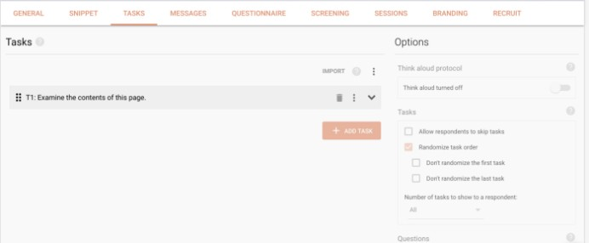For the Thinking aloud usability testing, an apparatus called Uxtweak has been introduced so that they can record the sound of the user's work. Uxtweak is utilized since it permits you to relegate assignments to respondents whereas recording everything they say (Joe et al. 2015). The gadget moreover has the advantage of not requiring a screen to see or move anything, making it simple for web guests to take an interest in FLS measurements.

The questions for the interview survey were prepared in Google Docs. This information has been added for users who cannot take the exam in person.

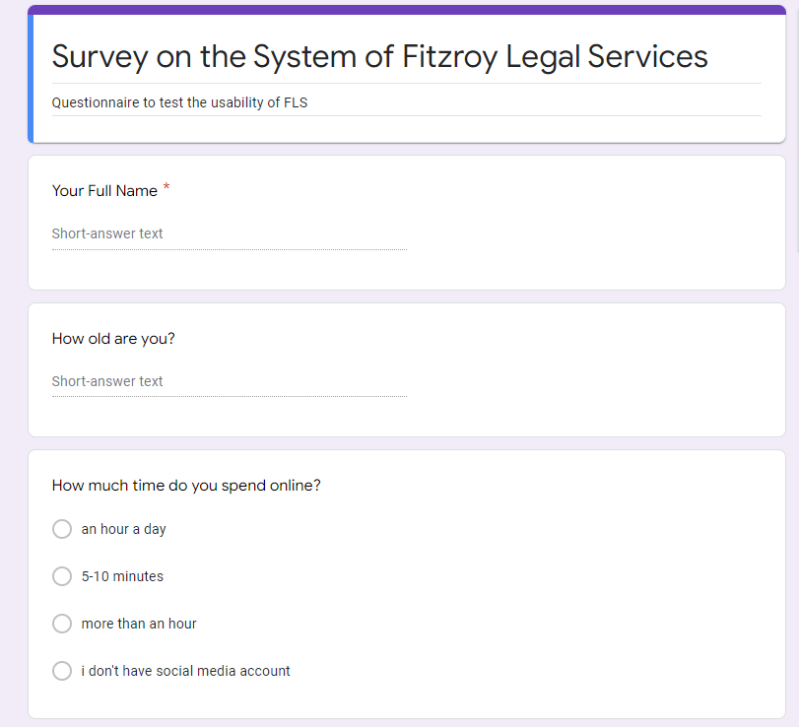

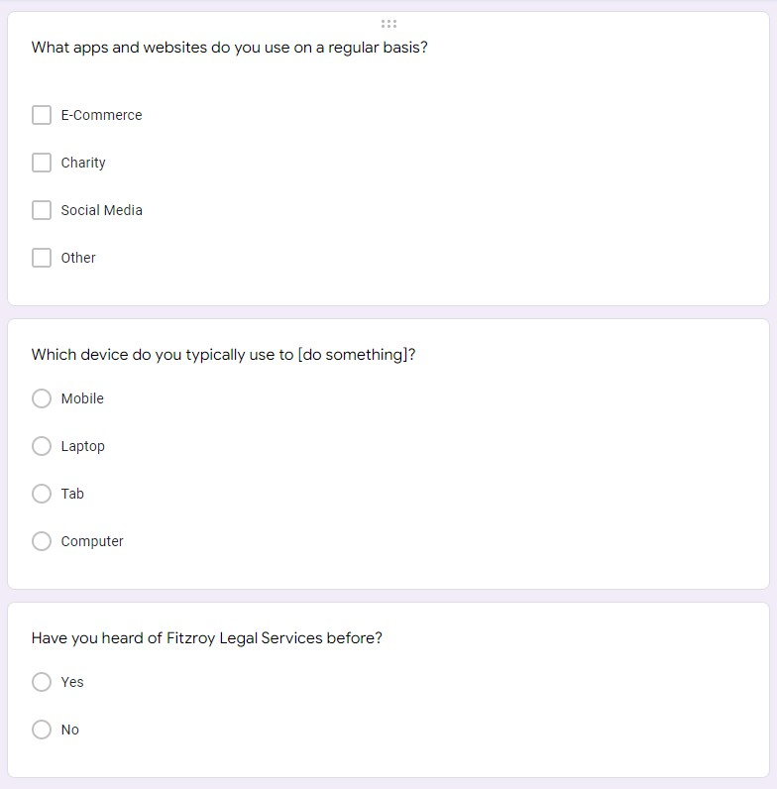

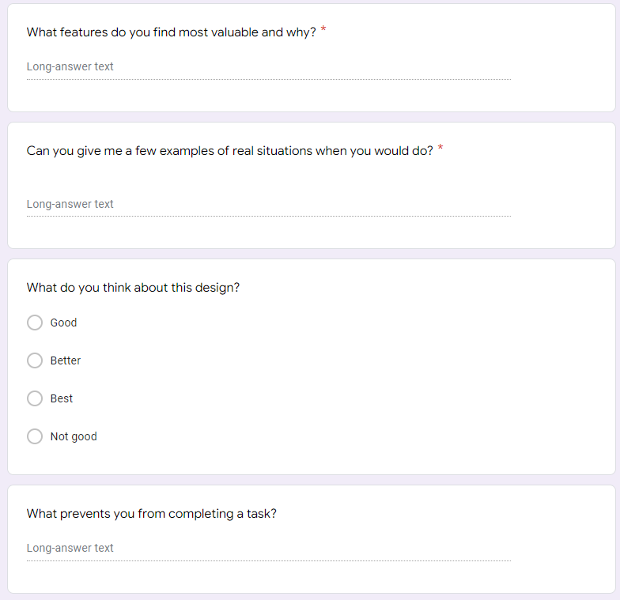

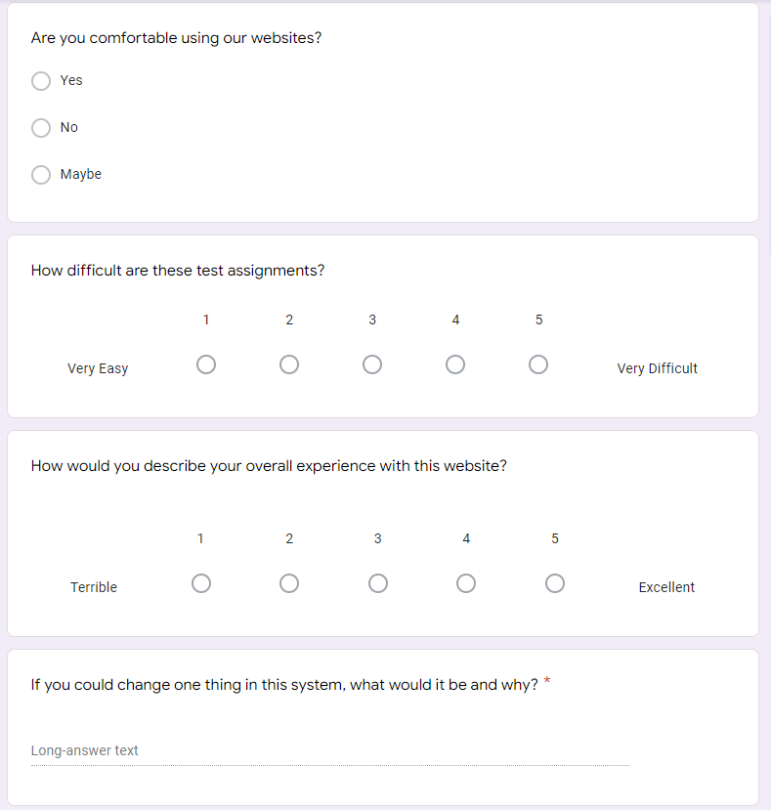

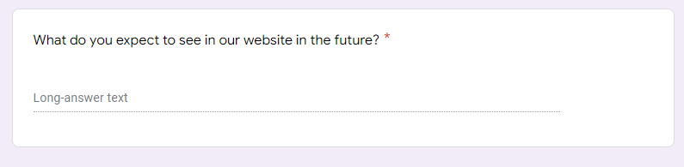

# Part 3 : Report on Findings

## Discussion

When I review the usability tests, I think the website is easy to use, understandable and easy to navigate. From the completion of the data flow, it can be concluded that its purpose is to provide a better experience to users. Participating users are also satisfied with their systems. I find the following features helpful and provide a better experience for customers using the Fitzroy website. These are:

• Most of the web pages are rich in content and readers can translate the content into their language.

• Website pages are well organized and online search functionality is efficient.

• Users of the self-talk test concluded that users were overall satisfied and satisfied with the functionality of the system.

• Since the site has features such as expanding the text they want, it provides convenience for users with vision problems.

• Likewise, there are fifteen language options for users who do not speak English on the site.

## Summary

After a few experimentation with Google Docs, Uxtweak and client see, it was chosen that the site ought to have more highlights. Convenience testing could be a way to determine on the off chance that the site or application is prepared by testing it with genuine clients within the venture (Valdellon 2022). The inquire about reason is to degree the in general client encounter by measuring how simple it is for the conclusion client to perform the assignments that clients of an application or website will meet. This test could be a way to decide how clients really associated together with your site and change over based on comes about (Vermeeren et al., 2010). It is vital that Fitzroy's site is simple to utilize and errands can be completed rapidly; something else, clients will take off your site and go to one of your competitors.

Based on the collected information and client encounter tests, it has been decided that clients visit the site for these reasons:

• It has 15 distinctive dialect capacities so that clients can alter and see web pages in their favorite languages.

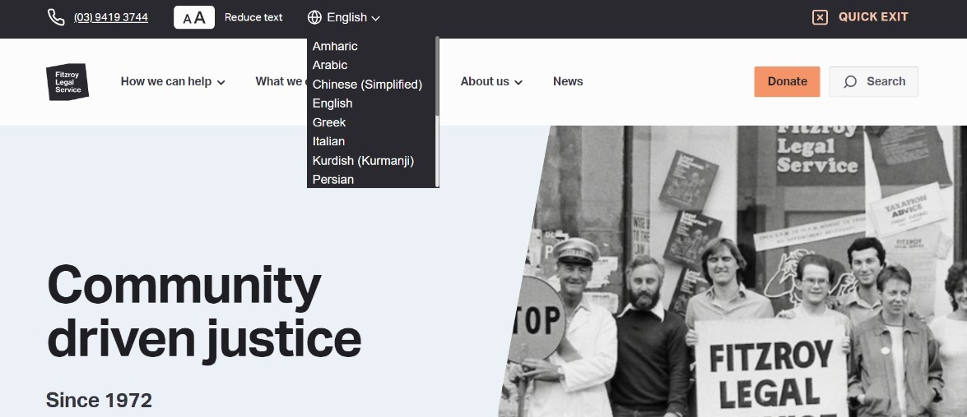

• There's a button to extend and decrease the content for way better client involvement. A few clients may not like small content. You'll choose to alter this option.

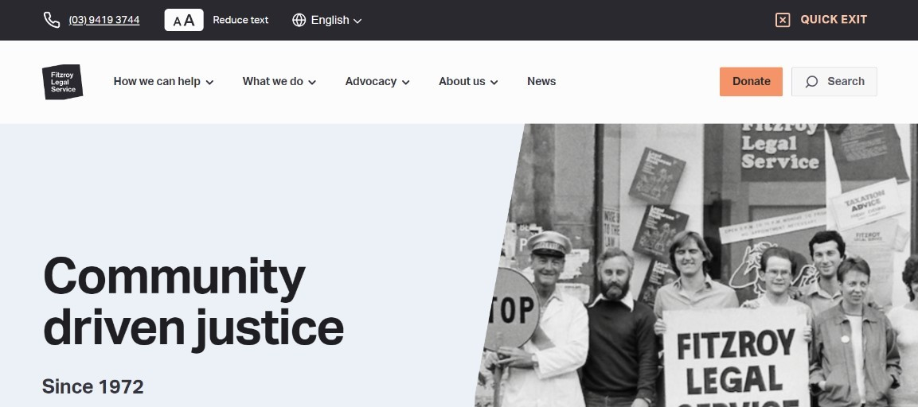

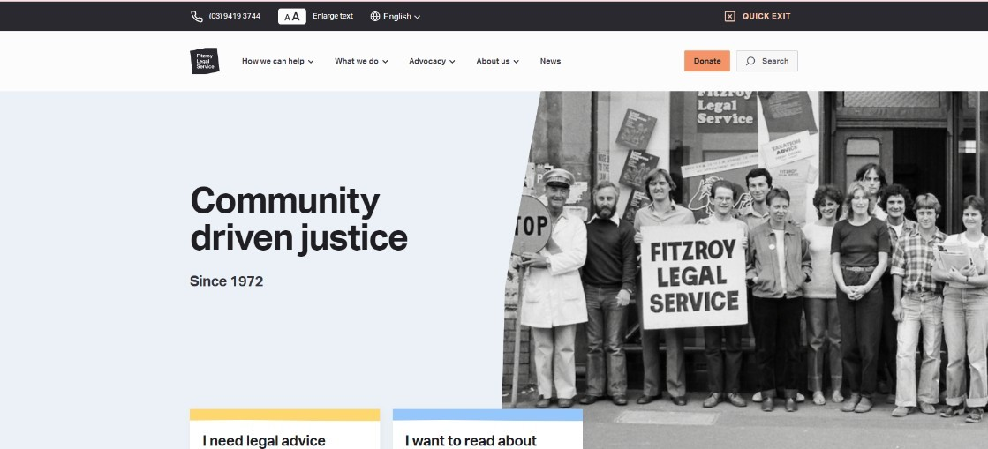• Have a look button that's clearly visible to the user's eye.

• Once you look and enter words within the look box, the catchphrases will be sifted and a list of results will be displayed.

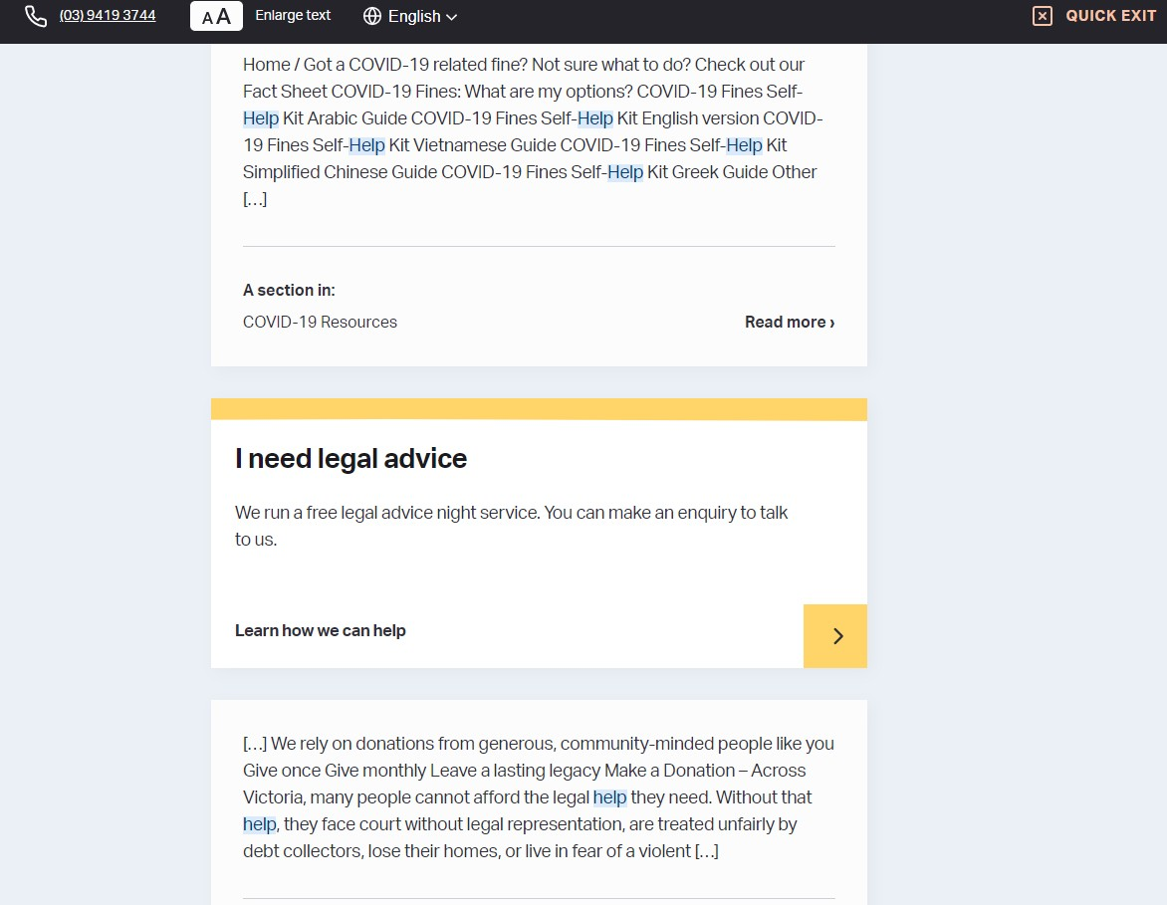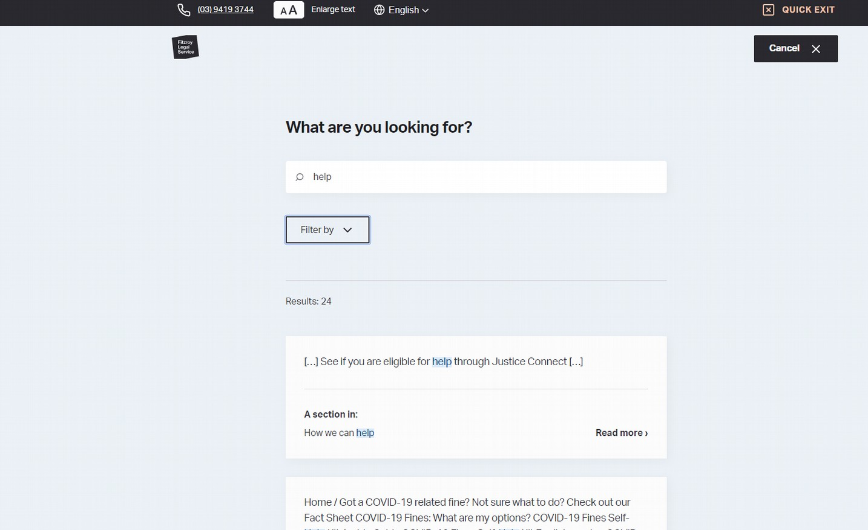

• Clients who are inquisitive about the administrations given by FLS and need to do anything they can to assist them do what they do will moreover select to give (Bernstein & Taylor 2013).

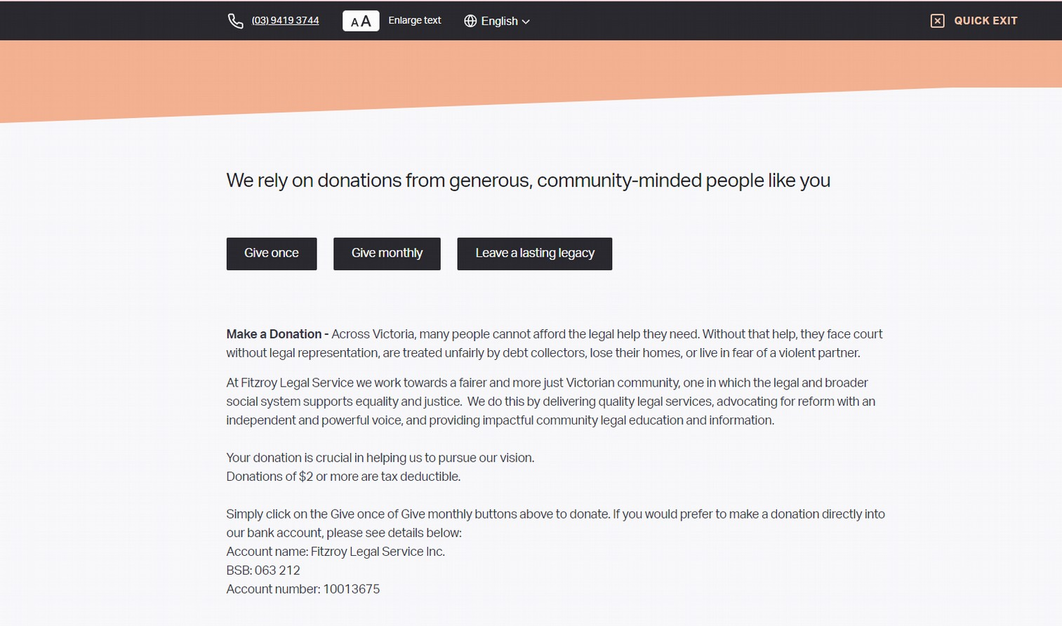

However, some users have had problems communicating and getting feedback on issues.

## Recommendations

Recommendation for Fitzroy Legal Services website to improve in the coming days would be the followings.

* Provide options for all languages ​​so that users around the world can understand and use their services (Gaibrois 2018).
* Provide a privacy policy page for users and visitors to their profiles to understand and follow their standards.
* Donation pages should be smooth and easy to navigate for users who want to donate without wasting time and money.
* The text here should be kept short so that users do not get bored even if they are not halfway through the page.
* They should focus on providing better user experience.
* Clients who need to go through numerous contact focuses to assist or enroll for an occasion are befuddled, which can lead to decreased deals. With co-planning, clients can be on the go.
* Programmed answers, upgrades and proposals ought to be actualized to disentangle errands and spare time for SLS staff (Damen & Wray 2020).
* When making a mailing list or looking for someone's contact data, all joins and joins ought to be put away in one put to spare time. In this way, in a CRM situation, all web-based demands, contracts and other errands are logged in genuine time.
* To guarantee precise data, cuts are suggested to avoid copy data from the information collection handle, to allow counting of commitments, individuals, visitors' accomplices, associates, media accomplices, and other pertinent groups.
* To reply rapidly and communicate with clients, FLS ought to utilize e-mail to communicate with all bunches at all times (Vdovin 2020). They can too plan gatherings and record them so you do not miss any of them. You'll print a postcard or phone number list with the press of a button.
* The framework ought to back more installment strategies to form gifts less demanding and more helpful for users.
* Page stacking speed ought to be quick and optimized so that clients can react convenient and from the page.

## Conclusion

Fitzroy Legal Services could be a non-profit community organization that gives lawful data, counsel and representation to casualties and helpless individuals within the Fitzroy area and invites authoritative methods and open prosecutions. It could be a non-profit legitimate admonitory location that points to supply lawful administrations and legitimate advice to the open and advance their rights and interface. The organization is committed to providing continuous legal advice to its clients. The foremost vital thing to keep in mind is that the point of the organization is to supply the most excellent offer assistance and back to individuals and at the same time make them aware of lawful issues. To begin with, briefly portray FLS's mission, objectives, and group of onlookers they are attempting to serve.

Fitzroy Legal Services may be a non-profit community organization that gives lawful data, exhortation and representation to casualties and helpless people within the Fitzroy zone and invites regulatory strategies and open arraignments. Moment, the appraisal and assessment of legitimacy is clarified. This inquire about looks at different sorts of convenience testing and a basic audit of ease of use testing. Subtle elements on the utilize of the legitimacy file are given underneath. Usually done to supply a step-by-step clarification of how the test was performed, counting the gear utilized and its authorization, test setup, environment, and performance. An overview incorporates convenience testing as well as client involvement and how they see the location to work. When I survey the ease-of-use tests, I discover the site to be user-friendly, instinctive and simple to explore. Looking at the total data stream of the framework, it can be concluded that its reason is to supply the finest client involvement to the clients. Discoveries are detailed together with the examination to help choice making. The thoughts from the assessment comes about are well created, displayed in a suitable, dependable, and proficient manner. Finally, proposals are made for changes to the Fitzroy Legal Services site.

# References

Barendrecht, M 2011, ‘Legal Aid, Accessible Courts or Legal Information? Three Access to Justice Strategies Compared’, *Global Jurist*, vol. 11, no. 1.

Bernstein, S & Taylor, SE 2013, *Close Relationships and Happiness*, Oxford University Press.

Damen, D & Wray, M 2020, *Supervision Levels Scale (SLS)*.

Gaibrois, C 2018, ‘“It crosses all the boundaries”: hybrid language use as empowering resource’, *European J. of International Management*, vol. 12, no. 1/2, p. 82.

Joe, J, Chaudhuri, S, Le, T, Thompson, H & Demiris, G 2015, ‘The use of think-aloud and instant data analysis in evaluation research: Exemplar and lessons learned’, *Journal of Biomedical Informatics*, vol. 56, pp. 284–291.

Panagiotidi, M 2022, *Think-aloud testing for usability: how to get more out of your data*.

Valdellon, L 2022, *Usability Testing: A Comprehensive 2022 Guide*.

Vdovin, A 2020, *The Advantages and Disadvantages of Email for Communications in a Company*.

Vermeeren, APOS, Law, EL-C, Roto, V, Obrist, M, Hoonhout, J & Väänänen-Vainio-Mattila, K 2010, ‘User experience evaluation methods’, in *Proceedings of the 6th Nordic Conference on Human-Computer Interaction Extending Boundaries - NordiCHI ’10*, ACM Press, New York, New York, USA, p. 521.