**Assignment 16.1**

**Problem Statement**

**Given a list of numbers - List[Int] (1, 2, 3, 4, 5, 6, 7, 8, 9, 10)**

- find the sum of all numbers

- find the total elements in the list

- calculate the average of the numbers in the list

- find the sum of all the even numbers in the list

- find the total number of elements in the list divisible by both 5 and 3

**BASE RDD**



**1) find the sum of all numbers**

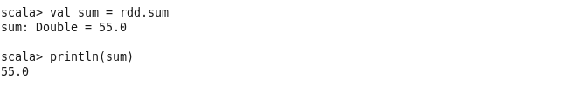

**2) find the total elements in the list**

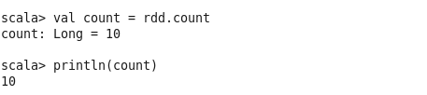

**3) Calculate the average of the numbers in the list**

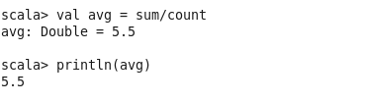

**4) Find the sum of all the even numbers in the list**

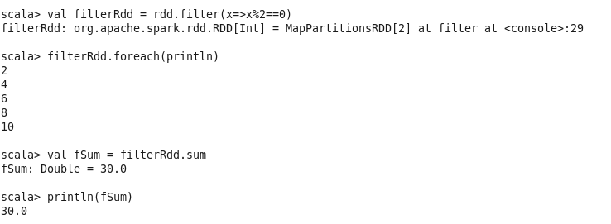

**5) Find the total number of elements in the list divisible by both 5 and 3**

