**Assignment 17.1**

**Problem Statement**

**1. Write a program to read a text file and print the number of rows of data in the document.**

**2. Write a program to read a text file and print the number of words in the document.**

**3. We have a document where the word separator is -, instead of space. Write a spark**

**code, to obtain the count of the total number of words present in the document.**

**Sample document :**

This-is-my-first-assignment.

It-will-count-the-number-of-lines-in-this-document.

The-total-number-of-lines-is-3

1. **Write a program to read a text file and print the number of rows of data in the document.**

**Input File**

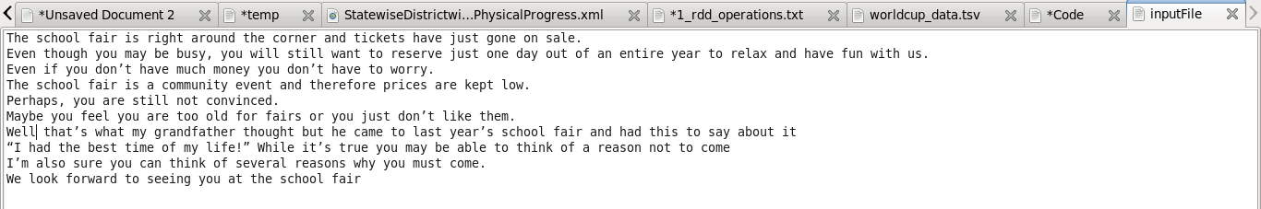

**Code**

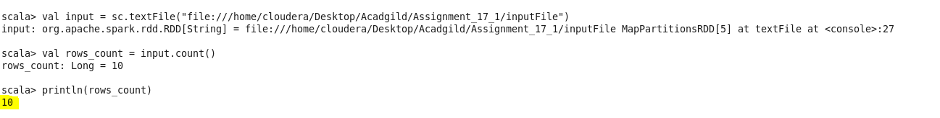

1. **Write a program to read a text file and print the number of words in the document.**

**CODE**

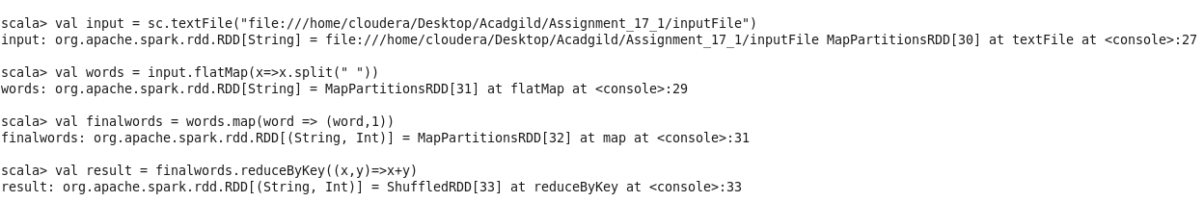

**Output**

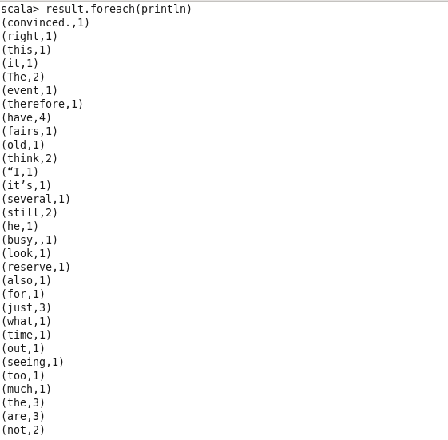

**3. We have a document where the word separator is -, instead of space. Write a spark code, to obtain the count of the total number of words present in the document.**

**Input**



**CODE**

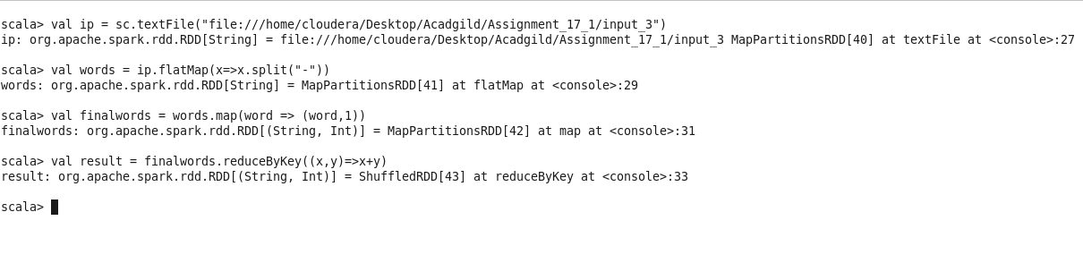

**Result**

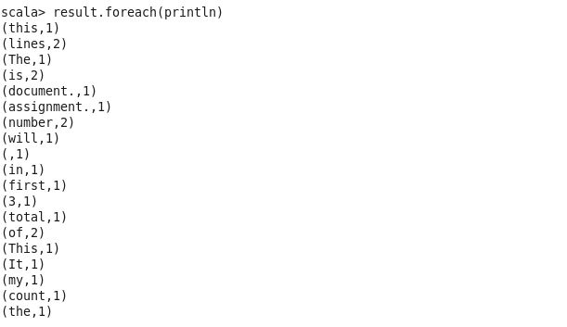

GITHUB REPOSITORY CONTAINS CODE, input files and word document.