**Assignment 18.2**

**Problem Statement**

1) Which route is generating the most revenue per year

2) What is the total amount spent by every user on air-travel per year

3) Considering age groups of < 20 , 20-35, 35 > ,Which age group is travelling the most

every year.

**Use the dataset given below:**

<https://drive.google.com/drive/folders/0B_P3pWagdIrrVThBaUdVSUtzbms>

**--1) Which route is generating the most revenue per year**

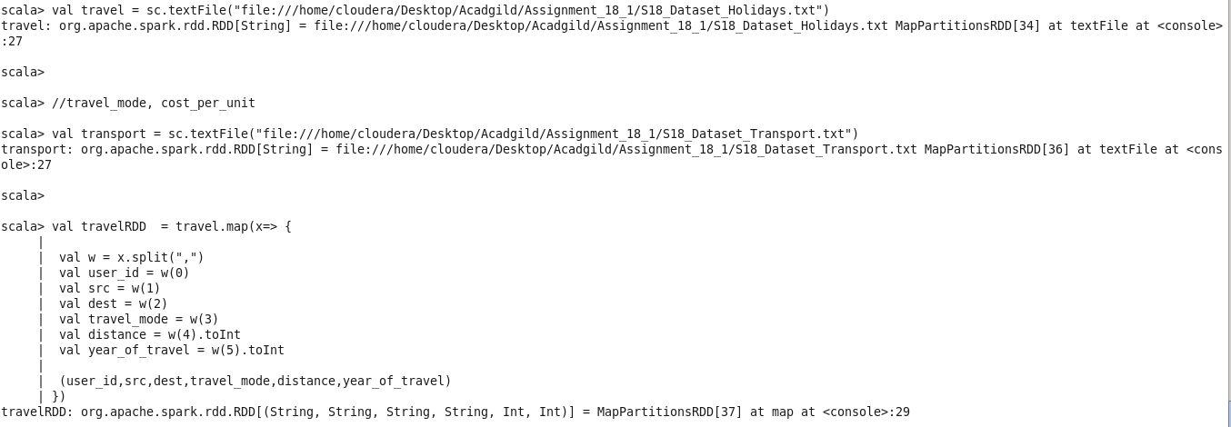





**--2) What is the total amount spent by every user on air-travel per year**



**--3) Considering age groups of < 20 , 20-35, 35 > ,Which age group is travelling the most every year.**



