**Assignment 18.3**

**Problem Statement**

1) Considering age groups of < 20 , 20-35, 35 > ,Which age group spends the most

amount of money travelling.

2) What is the amount spent by each age-group, every year in travelling?

**Use the dataset given below:**

[**https://drive.google.com/drive/folders/0B_P3pWagdIrrVThBaUdVSUtzbms**](https://drive.google.com/drive/folders/0B_P3pWagdIrrVThBaUdVSUtzbms)

**--1) Considering age groups of < 20 , 20-35, 35 > ,Which age group spends the most amount of money travelling.**

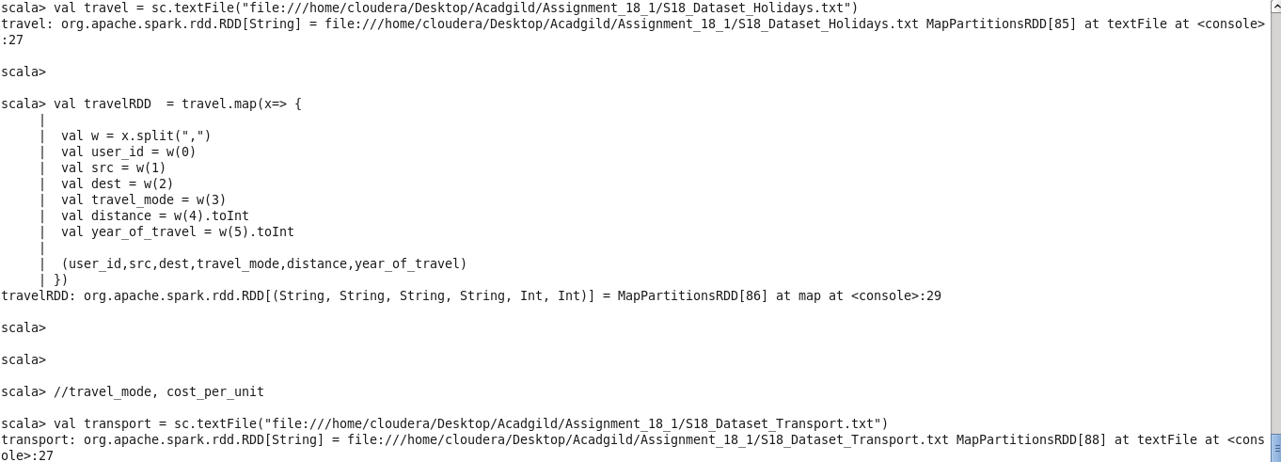

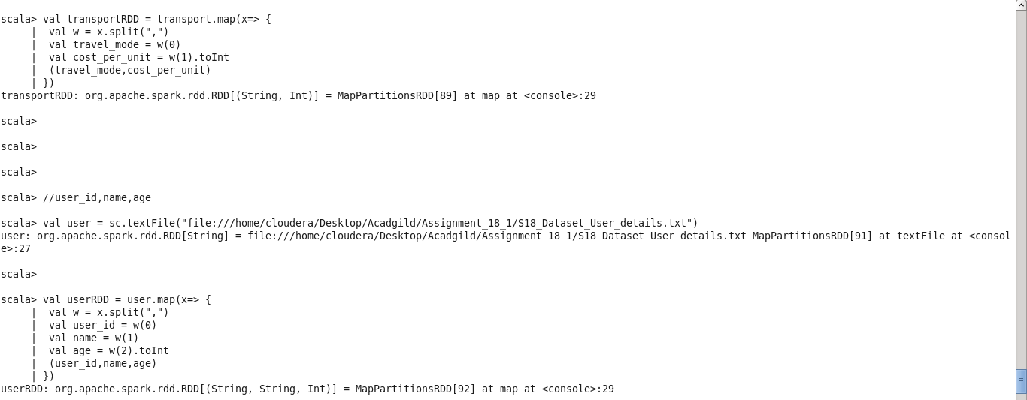



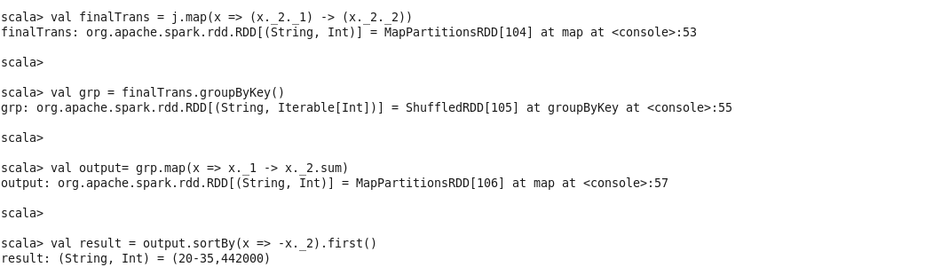

**--2) What is the amount spent by each age-group, every year in travelling?**



