**Assignment 19.1**

**Problem Statement**

**Using spark-sql, Find:**

1. What are the total number of gold medal winners every year

2. How many silver medals have been won by USA in each sport

**--1. What are the total number of gold medal winners every year**

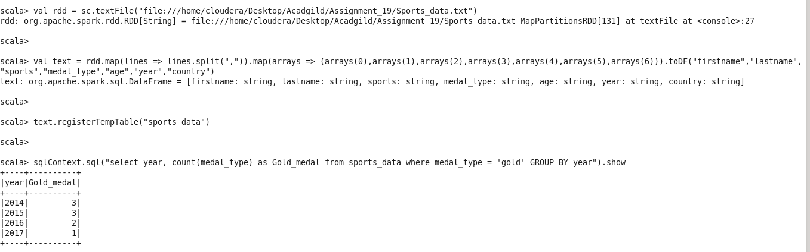

**--2. How many silver medals have been won by USA in each sport**

