**Assignment 19.2**

**Problem Statement**

**Using udfs on dataframe**

1. Change firstname, lastname columns into

Mr.first_two_letters_of_firstname<space>lastname

for example - michael, phelps becomes Mr.mi phelps

**2. Add a new column called ranking using udfs on dataframe, where :**

gold medalist, with age >= 32 are ranked as pro

gold medalists, with age <= 31 are ranked amateur

silver medalist, with age >= 32 are ranked as expert

silver medalists, with age <= 31 are ranked rookie

**Using udfs on dataframe**

**1. Change firstname, lastname columns into Mr.first_two_letters_of_firstname<space>lastname**

**for example - michael, phelps becomes Mr.mi phelps**

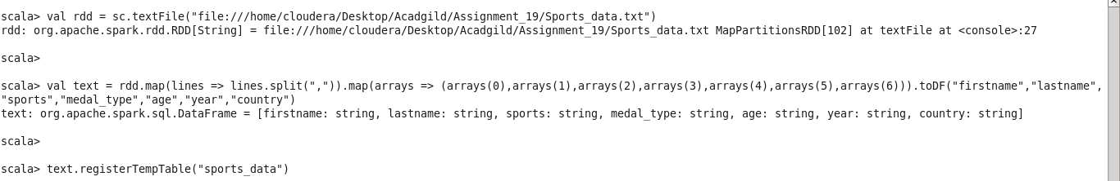

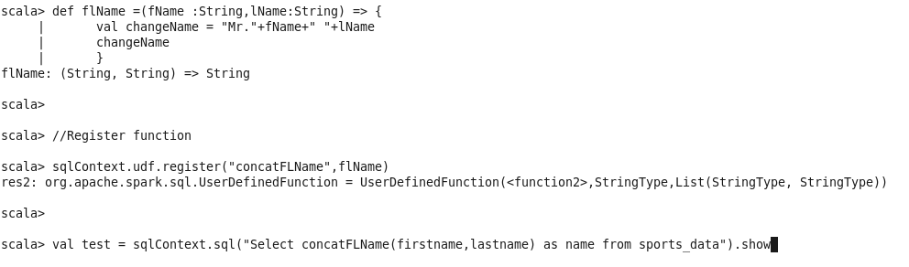

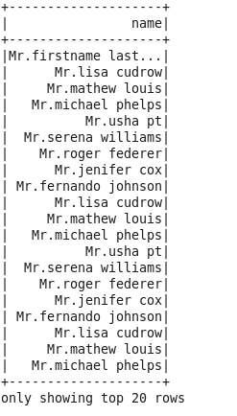

**2. Add a new column called ranking using udfs on dataframe, where :**

**gold medalist, with age >= 32 are ranked as pro**

**gold medalists, with age <= 31 are ranked amateur**

**silver medalist, with age >= 32 are ranked as expert**

**silver medalists, with age <= 31 are ranked rookie**

