**Assignment 22.1**

**Problem Statement**

**Implement the below blog at your end and send the complete documentation.**

**https://acadgild.com/blog/spark-streaming-tcp-socket/**

**CODE:**

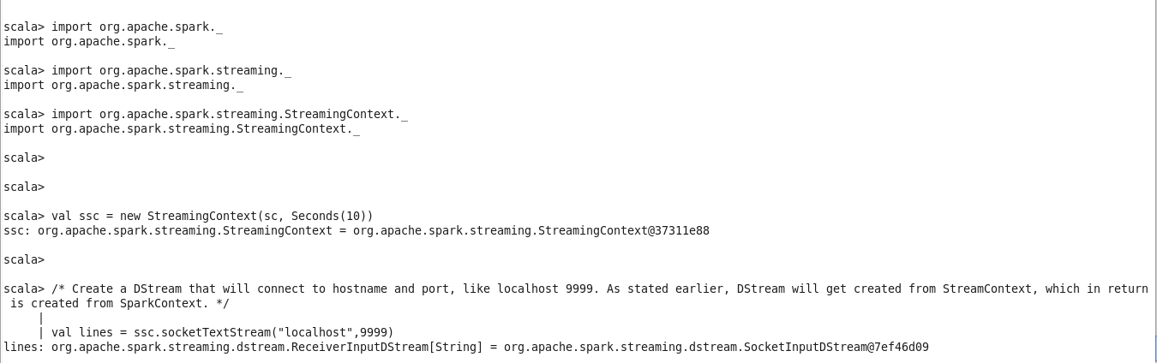

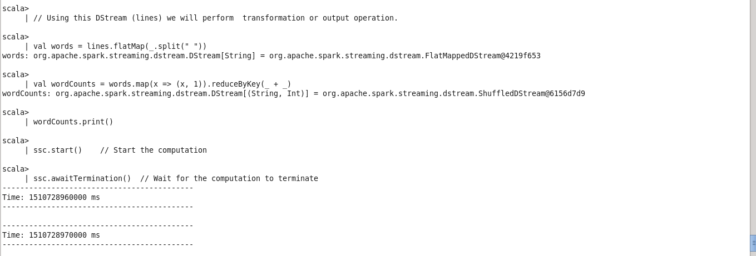

**TELNET , here we will post the words which we will read in spark program.**

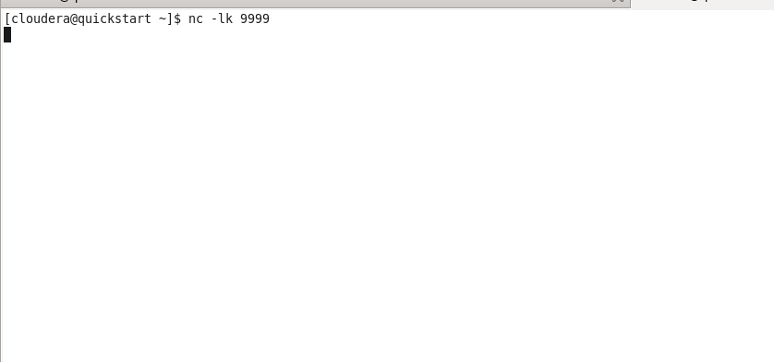

**Writing Words for word count problem.**

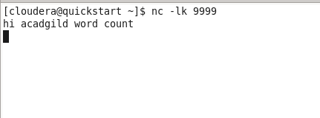

**OUTPUT Received**

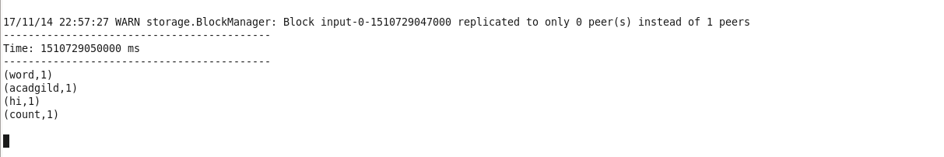

**Writing more words….**

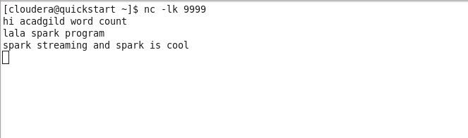

**Output received after 5 sec.**

