**Assignment 22.2**

**Implement the below blog at your end and send the complete documentation.**

**https://acadgild.com/blog/stateful-streaming-in-spark/**

**CODE:**

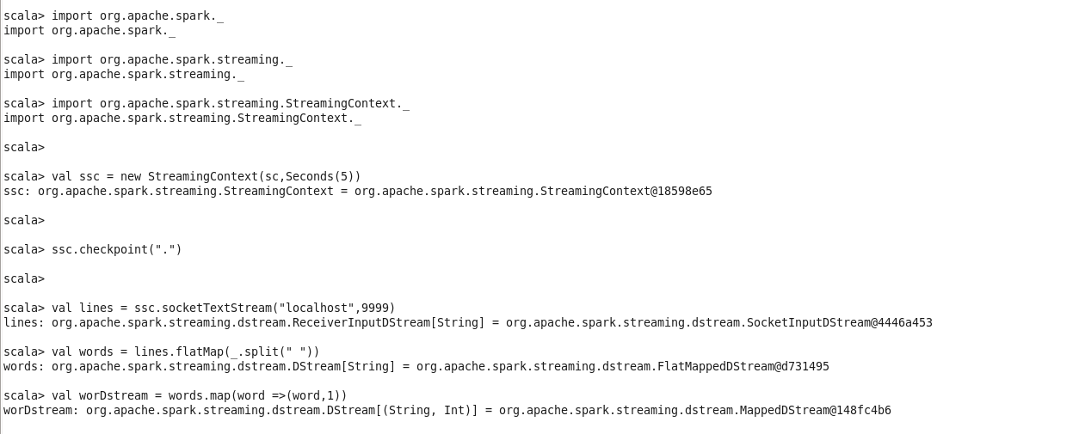

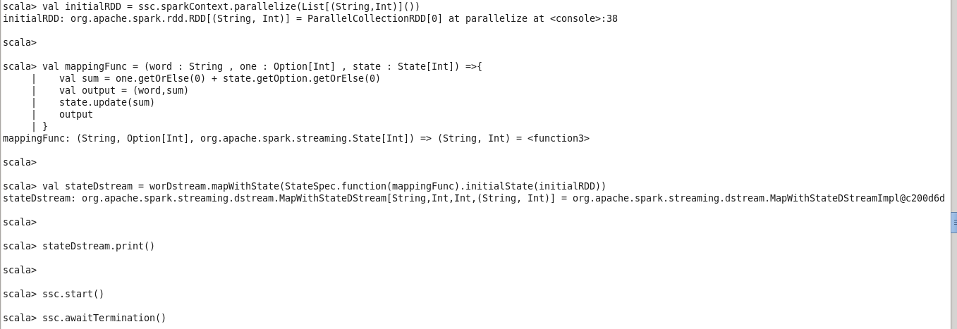

**STARTING TELNET with port 9999**

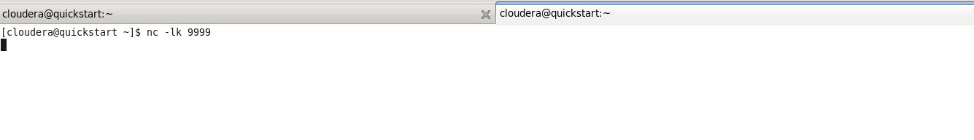

**STARTING SPARK STREAMING , streaming waiting for the words from port 9999**

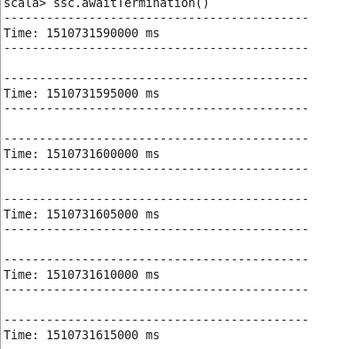

**Writing words in port 9999**



**Getting output in spark streaming**

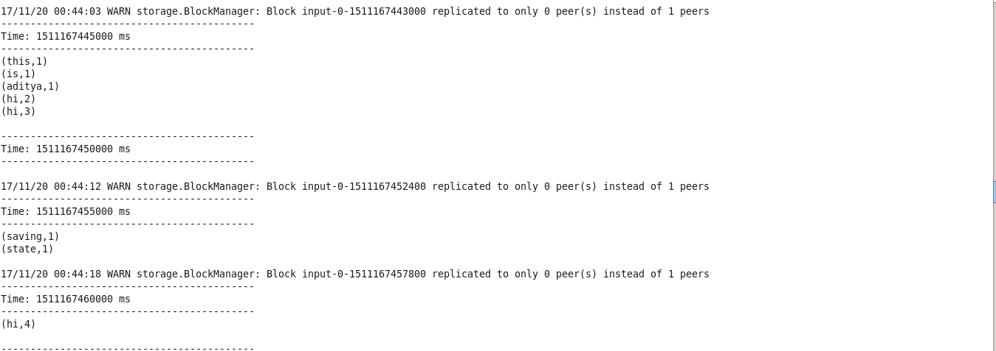

**Checking state of “HI”**

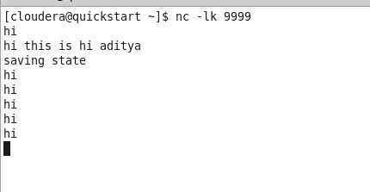

**Spark is storing the state of hi**

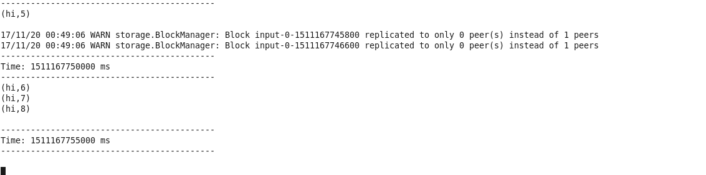

-------------------------------------------------------END-----------------------------------------------------------