**Assignment 23.2**

The U.S. Department of Transportation’s (DOT) Bureau of Transportation Statistics (BTS) tracks the on-time performance of domestic flights operated by large air carriers. Summary information on the number of on-time, delayed, canceled, and diverted flights appears in DOT’s monthly Air Travel Consumer

Report, published about 30 days after the month’s end, as well as in summary tables posted on this

website. Summary statistics and raw data are made available to the public at the time the Air Travel

Consumer Report is released.

**You can download the datasets from the following links:**

Delayed_Flights.csv

Delayed_Flights.csv Datasets

**There are 29 columns in this dataset. Some of them have been mentioned below:**

• Year: 1987 – 2008

• Month: 1 – 12

• FlightNum: Flight number

• Canceled: Was the flight canceled?

• CancelleationCode: The reason for cancellation.

**Problem Statement 1**

**Find out the top 5 most visited destinations.**



**Problem Statement 2**

**Which month has seen the most number of cancellations due to bad weather?**

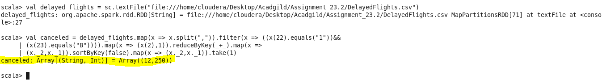

**Problem Statement 3**

**Top ten origins with the highest AVG departure delay**

val delayed_flights=sc.textFile("file:///home/cloudera/Desktop/Acadgild/Assignment_23.2/DelayedFlights.csv")

val avg = delayed_flights.map(x => x.split(",")).map(x => (x(17),x(16).toDouble)).mapValues((_,

1)).reduceByKey((x, y) => (x._1 + y._1, x._2 + y._2)).mapValues{ case (sum, count) => (1.0 *

sum)/count}.map(x => (x._2,x._1)).sortByKey(false).map(x => (x._2,x._1)).take(10)

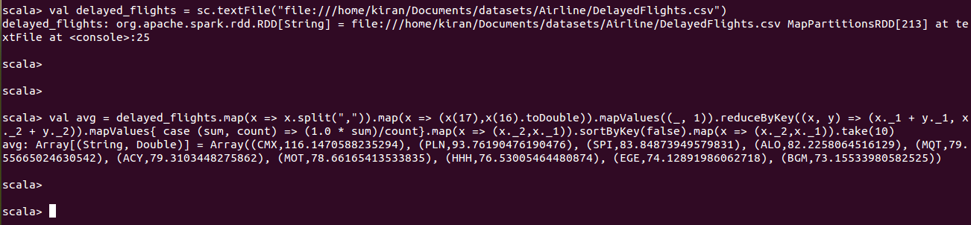

## Problem Statement 4

**Which route (origin & destination) has seen the maximum diversion?**

