**Assignment 1.2**

1. **PWD :** ‘PWD’ stands for ‘Print Working Directory‘. As the name states, command ‘pwd‘ prints the current working directory or simply the directory user is, at present. It prints the current directory name with the complete path starting from root (/).

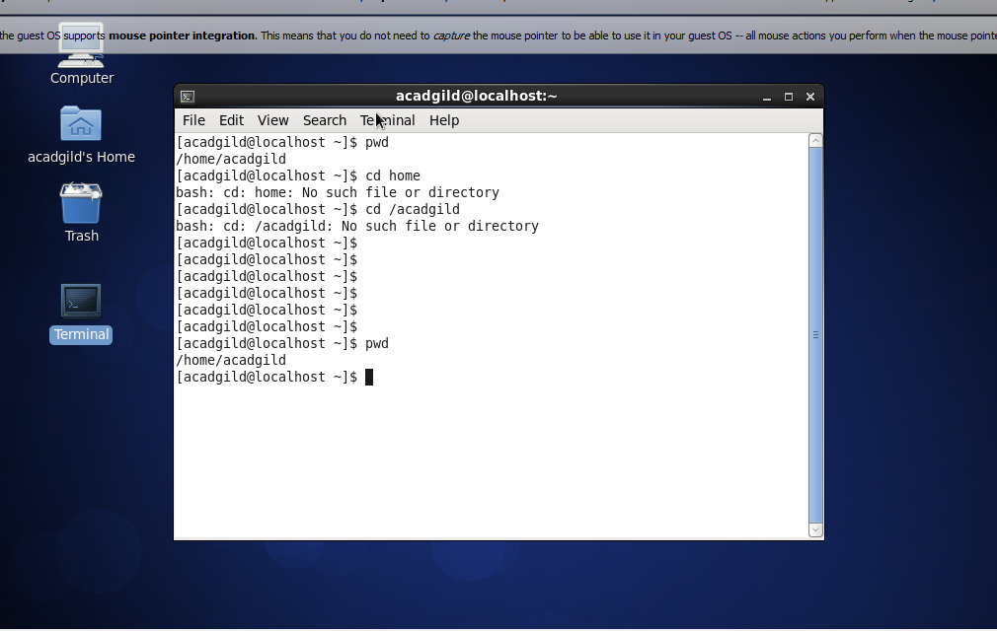

In the above screenshot , the pwd command shows our current directory on which we are working ( **/home/acadgild )**

**2)VI :** There are many ways to **edit files on a Linux** operating system. You can either use the **GUI or work on the Terminal**. For those who like to go with the Terminal, the **VI** editor is the most popular and classic text editor in the Linux family.

There are two modes in Vi. **Insert** (or Input) mode and **Edit** mode. In input mode you may input or enter content into the file. In edit mode you can move around the file, perform actions such as deleting, copying, search and replace, saving etc.

Creating a file :

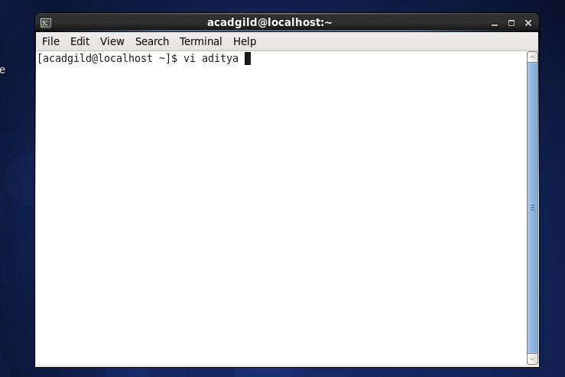

**Entering the data :**

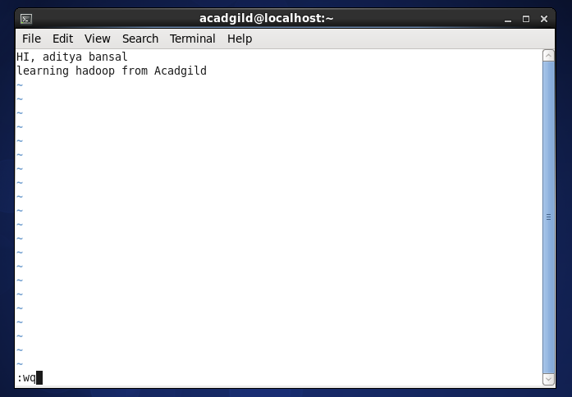

1. **Touch :** The **touch command** is a standard program for **Unix/Linux** operating systems, that is used to create, change and modify timestamps of a file.

**Creation of file/ multiple file**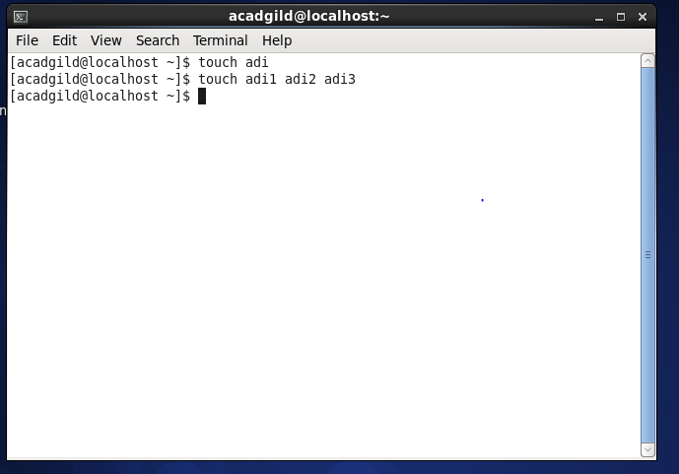

To change or update the last access and modification times of a file called **leena**, use the **-a** option as follows. The following command sets the current time and date on a file. If the **leena** file does not exist, it will create the new empty file with the name.

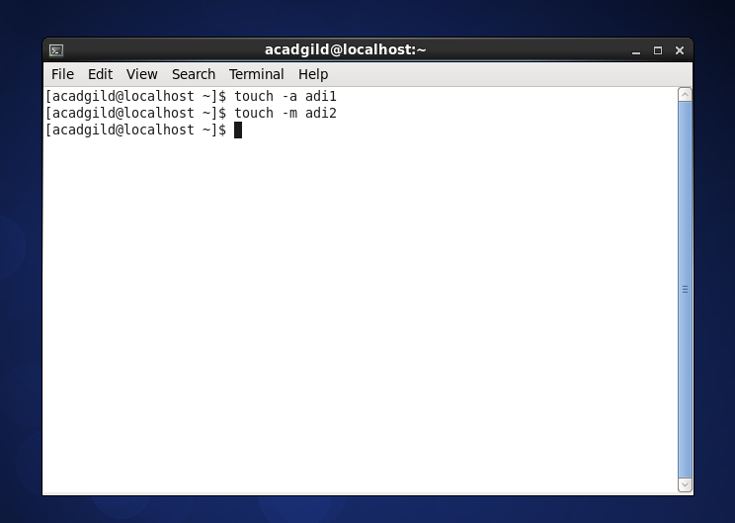

If you like to change the only modification time of a file called **leena**, then use the **-m** option with touch command. Please note it will only updates the last modification times (not the access times) of the file.

1. **Mkdir :** The mkdir command allows users to create directories or folders as they are referred to in some operating systems. The mkdir command can create multiple directories at once and also set permissions when creating the directory. The user running the command must have appropriate permissions on the parent directory to create a directory or will receive a permission denied error.

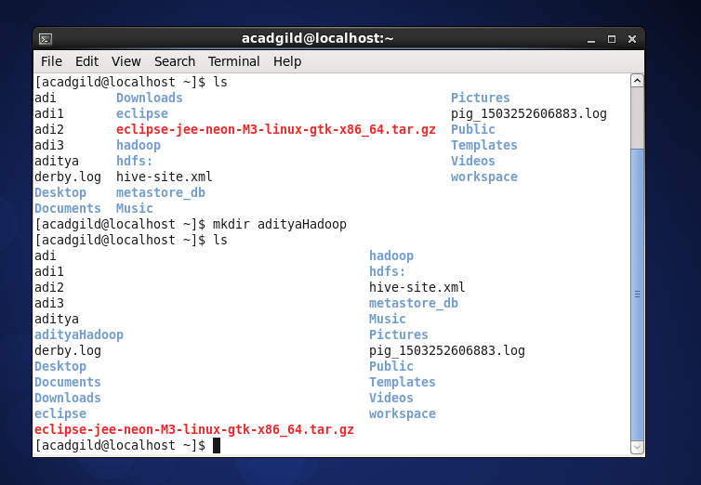

1. **RM : rm**removes each specified file. By default, it does not remove directories.Using –R with rm will help in removing directory.

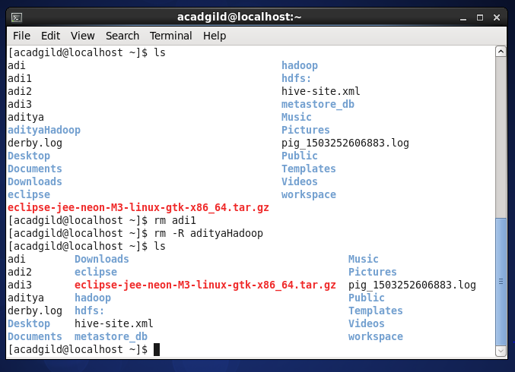

1. **LS :** The ls is the list command in Linux. It will show the full list or content of your directory.

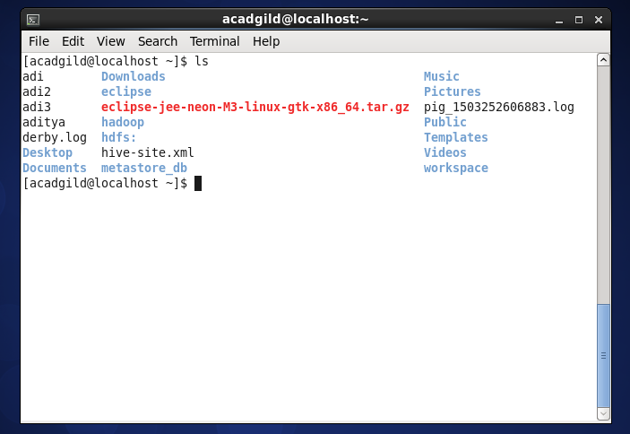

1. **ECHO :** echo is a fundamental command found in most operating systems that offer a command line. It is frequently used in scripts, batch files, and as part of individual commands; anywhere you may need to insert text. Many command shells such as bash, ksh and csh implement echo as a built-in command.

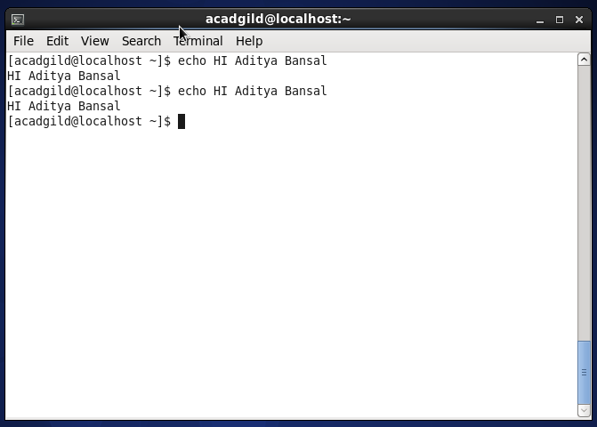

1. **CAT :** The cat (short for “**concatenate**“) command is one of the most frequently used command in Linux/Unix like operating systems. **cat** command allows us to create single or multiple files, view contain of file, concatenate files and redirect output in terminal or files

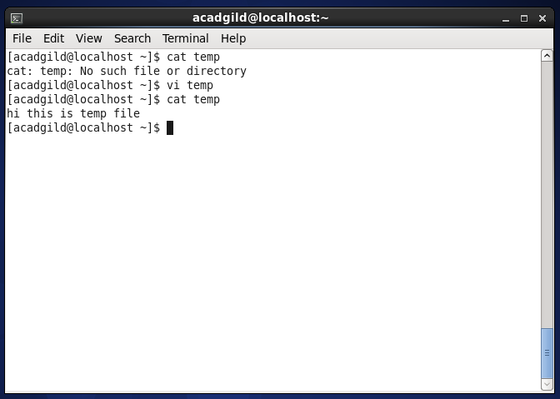

1. **Who :** The **who** command prints information about all users who are currently logged in.

### Get the information on currently logged in users

### 

### Get the time of last system boot

### 

### 10 CD :

### Linux ‘****cd****‘ (****Change Directory****) command is one of the most important and most widely used command for newbies as well as system administrators. For admins on a headless server, ‘****cd****‘ is the only way to navigate to a directory to check log, execute a program/application/script and for every other task.

### 

### 11)Date : Date command is helpful to display date in several formats. It also allows you to set systems date and time.

### 

### 12)CAL : The cal command is a command line utility for displaying a calendar in the terminal. It can be used to print a single month, many months or an entire year. It supports starting the week on a Monday or a Sunday, showing Julian dates and showing calendars for arbitrary dates passed as arguments.

### 

### 13) MV : The mv command is a command line utility that moves files or directories from one place to another . It supports moving single files, multiple files and directories. It can prompt before overwriting and has an option to only move files that are new than the destination.

### 14)CP :

### cp command in Linux used to copy file from one location to other location. It is very basic command and used in most of Linux distributions.

### 

### 15)Which :

### In theory, all programs should run from the /usr/bin folder but in reality, this is not the case. The sure fire way of finding out where a program is located is by using the which command.

### 