**Assignment 5.3**

**PIG Use Case: Pokemon Data Analysis**

First of all, we will load the dataset inside PIG.



**Ques 1: Find the list of players that have been selected in the qualifying round (DEFENCE>55).**

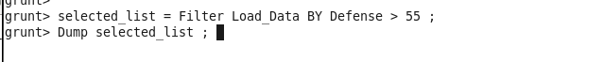

Filtering the pokemons who have defense greater than 55 using filter command.

**Sample Output**

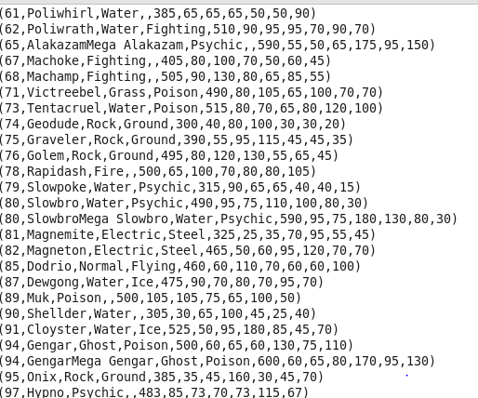

**In this we have filtered out pokemons who have defence greater than 55**

#### **Ques 2: State the number of players taking part in the competition after getting selected in the qualifying round.**

**CODE:**



Grouping the data for counting the selected pokemons.

Counting the grouped data for finding the pokemon who are selected.

**OUTPUT :**



#### **Ques 3: Using random() generate random numbers for each Pokémon on the selected list**.

**CODE:**



Using Random function , to generate a Random number for each pokemon and printing the name , type etc.

**Sample Output:**

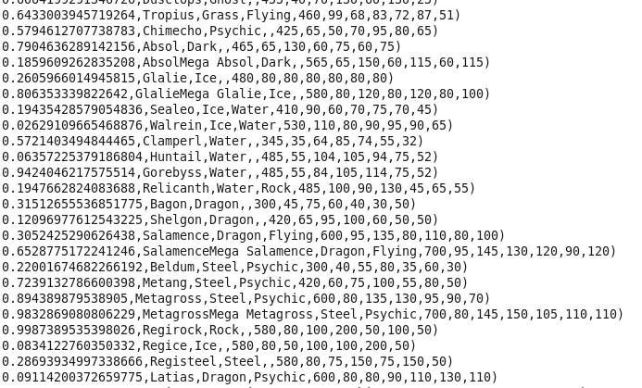

#### **Ques 4: Arrange the new list in a descending order according to a column randomly.**

**Explanation**: This will give us consequently a layer arranged to pick the random list which 1st player will choose.

**CODE :**

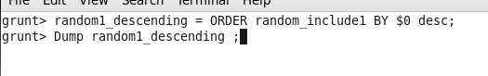

We are ordering our 1st Random list according to the random number which was generated , and we are order in the descending manner.

**SAMPLE OUTPUT :**

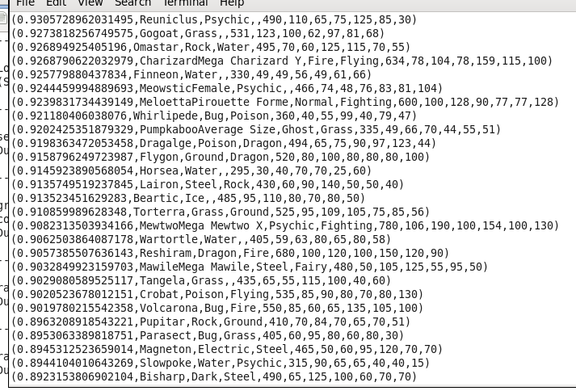

#### **Ques 5: Now on a new relation again associate random numbers for each Pokémon and arrange in descending order according to column random.**

**Explanation**: We will be repeating above two steps again to form the 2nd list.

**CODE:**



**Sample Output:**

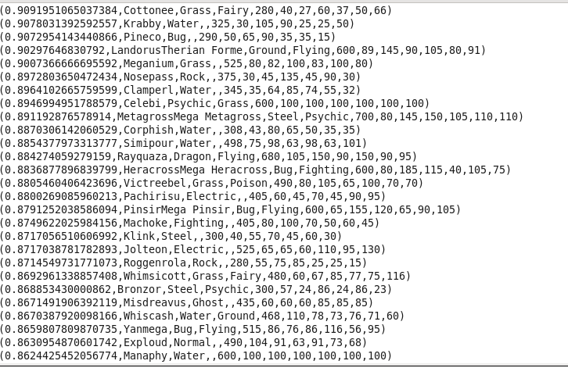

#### **Ques: From the two different descending lists of random Pokémons, select the top 5 Pokémons for 2 different players.**

**CODE:**

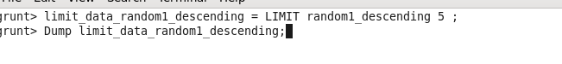

We are limiting the Top 5 Output

**OUTPUT**

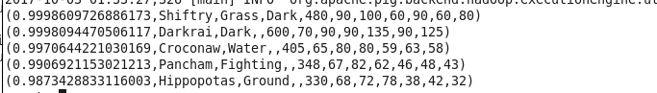

**CODE:**



**OUTPUT**

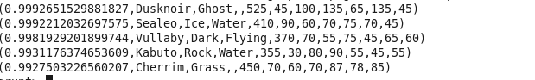

#### **Ques: Store the data on a local drive to announce for the final match. By the name player1 and player2 (only show the NAME and HP).**

**CODE:**



**OUTPUT:**

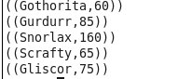

**STORING THE DATA IN THE LOCAL FS**



**FINAL OUTPUT**

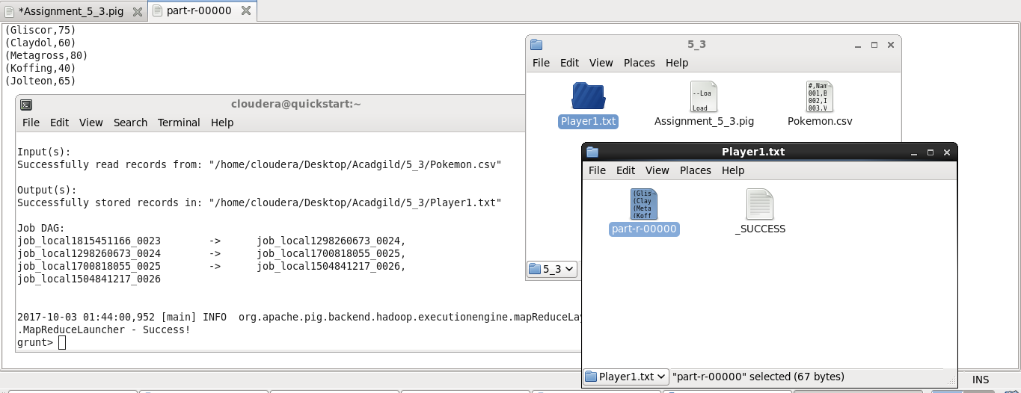

**2nd Output File**

**CODE:**



**Output:**

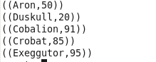

**STORING THE DATA INTO LOCAL FS**



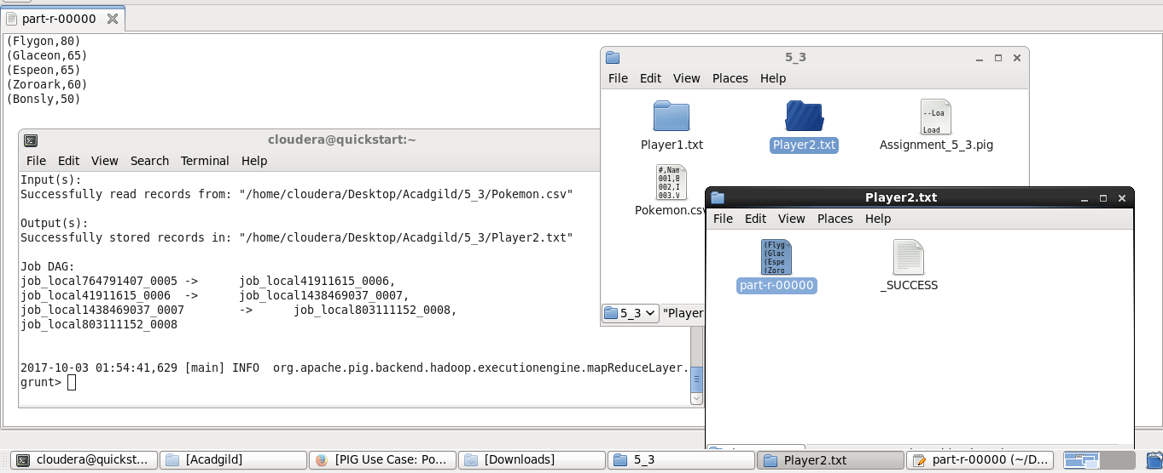

**GITHUB REPOSITORY WILL CONTAIN:**

**1)Assignment_5_3.docx  
2)Assignment_5_3.pig : code file**