**Assignment 6.2**

**Problem Statement**

**• Fetch date and temperature from temperature_data where zip code is greater than**

**300000 and less than 399999.**

**• Calculate maximum temperature corresponding to every year from temperature_data**

**table.**

**• Calculate maximum temperature from temperature_data table corresponding to those**

**years which have at least 2 entries in the table.**

**• Create a view on the top of last query, name it temperature_data_vw.**

**• Export contents from temperature_data_vw to a file in local file system, such that each**

**file is '|' delimited**

**1)** **Fetch date and temperature from temperature_data where zip code is greater than**

**300000 and less than 399999.**

**CODE AND OUTPUT**

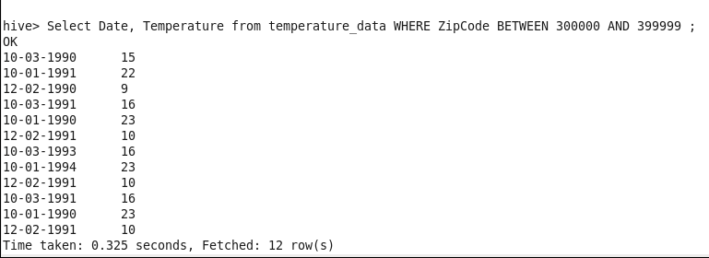

**2)** **Calculate maximum temperature corresponding to every year from temperature_data**

**table.**

**CODE:**

Select SUBSTR(Date,7,10) as year , MAX(Temperature) FROM temperature_data

GROUP BY SUBSTR(Date,7,10);

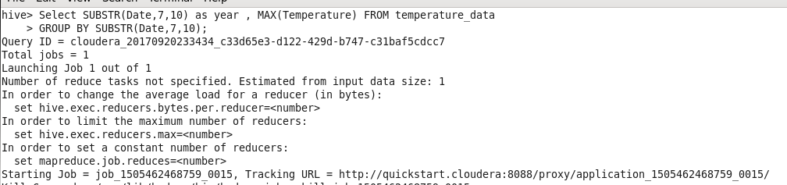

**OUTPUT** :

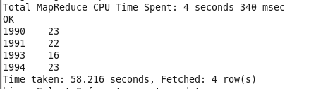

3**) Calculate maximum temperature from temperature_data table corresponding to those**

**years which have at least 2 entries in the table.**

**Code:**

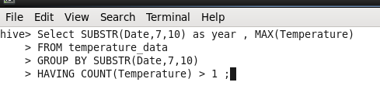

1990,1991,1993,1994 have at least 2 Entries.

**Output :**

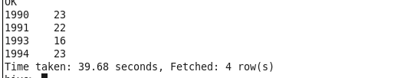

**4)** **Create a view on the top of last query, name it temperature_data_vw.**

**Input:**

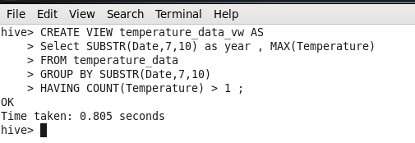

**Output :**

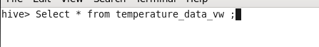

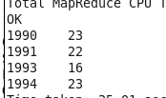

**5) Export contents from temperature_data_vw to a file in local file system, such that each**

**file is '|' delimited.**

**Input:**

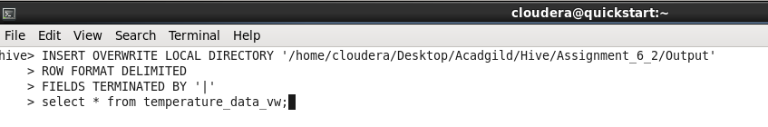

**Output:**

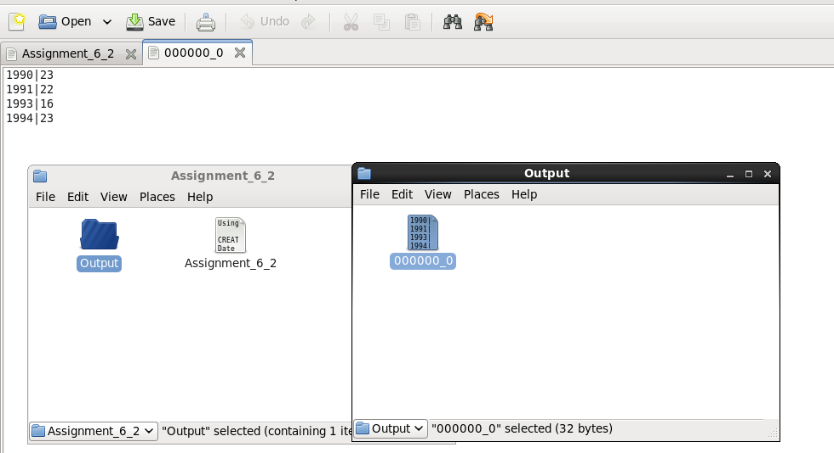

**NOTE: Repository contains Code , assignment document and Output of Storing view.**