**Assignment 7.1**

**Problem Statement**

**Calculate the number of employees corresponding to each skill from the table 'employee' which is**

**loaded in the Demo.**

**INPUT:**

Amit,Big Data,1,BBSR

Venkat,Web Technology,2,BBSR

Aditya,DBA,1,BNG

Ravinder,Java,2,BBSR

Sunil,C#,1,BBSR

Anil,ASP,2,BNG

Mihir,Big Data,3,BBSR

Mohit,Java,1,BBSR

**CREATING TABLE EMPLOYEE AND LOADING THE INPUT**

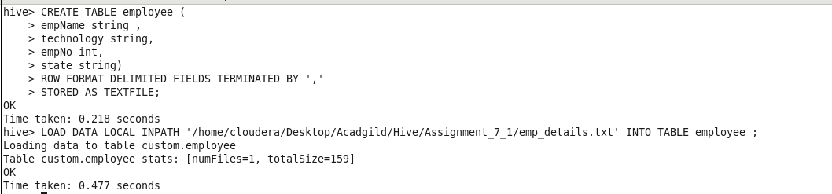

EXPLANATION :

IN this we are creating table with delimeter ‘,’ and storing as Textfile.

We are loading the data from the Local FS using Load Data Local INPATH.

**Calculate the number of employees corresponding to each skill from the table 'employee'**



**EXPLANATION:** We are grouping the data by skill of the employee we have stated Skill as technology and counting the employees with each skill.

**OUTPUT:**

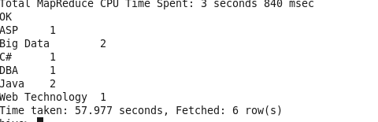

**GITHUB REPOSITORY CONTAINS :**

1. **DOCUMENT**
2. **CODE FILE**