Assignment 7.2
Problem Statement
1. Write a Hive program to find the number of medals won by each country in swimming.
2. Write a Hive program to find the number of medals that India won year wise.
3. Write a Hive Program to find the total number of medals each country won.
4. Write a Hive program to find the number of gold medals each country won.

CREATE TABLE

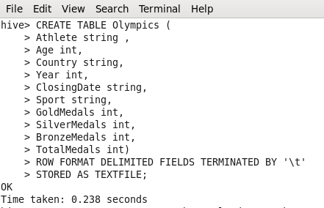
Explanation : We are creating table which we will use for hive programs.

LOADING DATA

Loading the Olympics CSV data into out table

Problem Statement

1. Write a Hive program to find the number of medals won by each country in swimming.

We are filtering the data which only have Swimming as Sports and grouping the data on the basis of country and summing the total medals on basis of each country

Output Sample

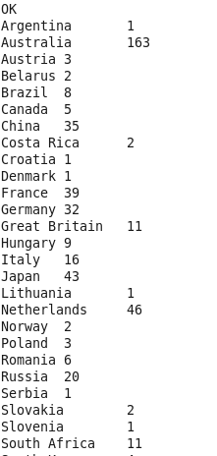

2. Write a Hive program to find the number of medals that India won year wise.

CODE:

We are filtering the data on the Country “India” and summing the medals on the basis of year.

OUTPUT :
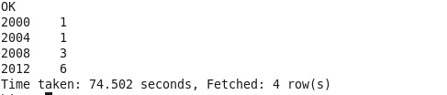

3. Write a Hive Program to find the total number of medals each country won.

CODE :
We are grouping the data on the basis of country and summing the Total medals on basis of Country.

SAMPLE OUTPUT:
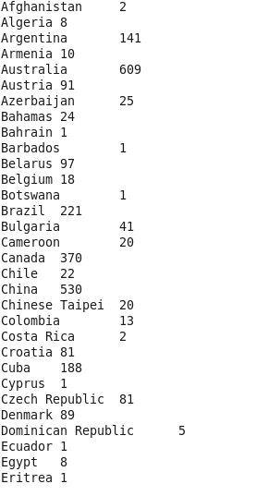

4. Write a Hive program to find the number of gold medals each country won.
CODE :
We are Grouping the data on basis of the Country and doing the sum on the grouped data to find the total number of Gold Medals.

SAMPLE OUTPUT:
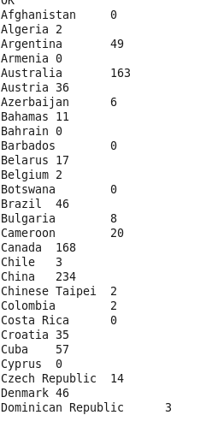

NOTE : Repository contains
- Assignment Document
- Assignment Code

