**Assignment 8.1**

**INPUT DATA**

001 Amit 105 Data Minning002 Pankaj 85 Data Engineer003 Kiran 110 Data Scientist004 Arpitha 95 Data Engineer005 Viraj 105 Data Mining006 Smitha 80 Data Analyst007 Supriya 90 Data Engineer008 Vihan 120 Data Scientist009 Emma 100 Data Engineer010 Siddharath 100 Data Engineer

**CREATE TABLE**

CREATE TABLE EmplSalary (

Id int,

Name string,

Salary int,

Unit string)

ROW FORMAT DELIMITED FIELDS TERMINATED BY '\t'

STORED AS TEXTFILE;

**LOAD DATA IN TABLE**



**Problem Statement**

**Get a list of employees who receive a salary less than 100, compared to their immediate employee with higher salary in the same unit**

**CODE:**



Select a.* from EmplSalary as a inner join (Select Unit,Max(Salary)as max from EmplSalary Where Salary<100 Group BY Unit)as b ON a.Unit = b.Unit and a.Salary = b.max;

**EXPLANATION :** In this code we are using Inner Join , for getting the result.

We are getting Max Salary which are less then 100 by grouping them on basis of Unit , in the subquery.

We are doing inner join on Unit and Salary with unit and max salary from sub query

**OUTPUT:**

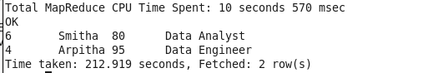

**Problem Statement**

**List of all employees who draw higher salary than the average salary of that department**

**CODE :**



**EXPLANATION:**

In this code we are using subquery , and Using Window function for getting the Desired Output

SELECT Name, Salary, Unit, avg_salary FROM ( SELECT avg(Salary) OVER (PARTITION BY Unit) AS avg_salary, Id,Name,Salary,Unit FROM EmplSalary ) temp WHERE Salary > avg_salary;

**OUTPUT:**

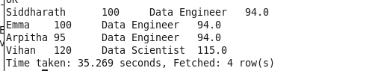

**NOTE: Github Directory will Contain**

1. **Assignment Document**
2. **Assignment Code**