**Assignment 8.2**

**Problem Statement**

**Write a hive UDF that implements functionality of string concat_ws(string SEP, array<string>).**

**This UDF will accept two arguments, one string and one array of string.**

**It will return a single string where all the elements of the array are separated by the SEP.**

1. **Hive UDF CODE :**

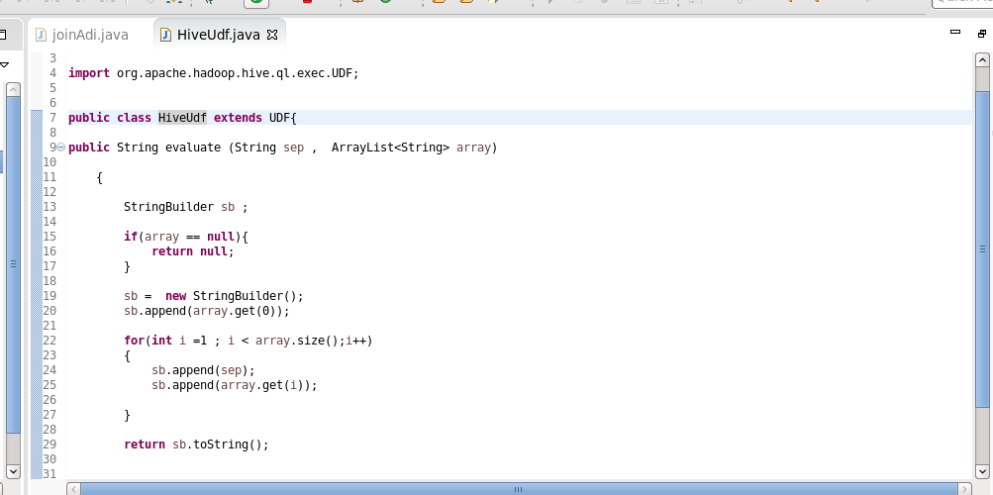

**Explanation :**  For creating hive udf first we have to extend the UDF class and override the Evaluate method.

In the evaluate method we have used stringbuilder which will append the separator with our designation.

We are returning the final ans using sb.toString()

Evaluate method takes two parameter sep and array .

Sep is the separator and array is list in which we will add sep.

1. **Create Jar of the UDF**

We created the jar mentioned below

**HiveConcat.jar**

1. **CREATE TABLE**

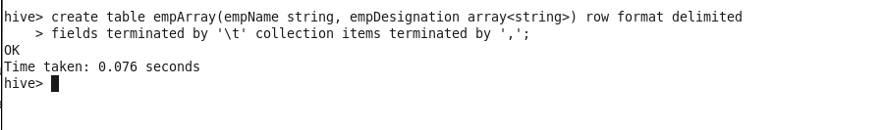

1. **Load the Input data into the table.**

**Adi Data,Engi,Science**

**Ban Data,rah,devops**

**aadi Data,Java,Python**

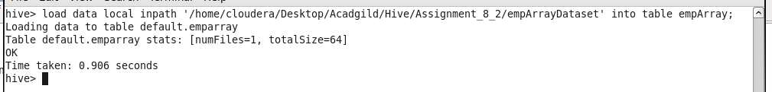

1. **Checking the Loaded Data**

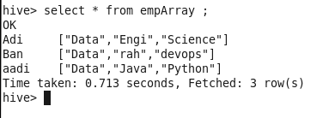

1. **Adding the HiveUdf Jar in the Hive**

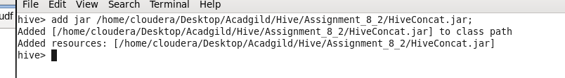

1. **Creating Temporary Function**

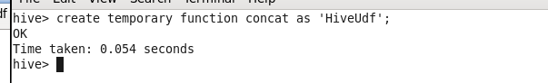

1. **Result of Problem Statement**

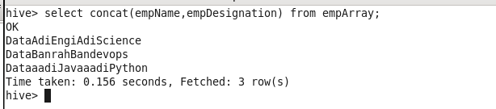

**NOTE: Github Repository contains**

1. **Assignment Document**
2. **Assignment Code**
3. **Input Data**
4. **UDF JAR**