**Assignment 8.3**

**Transactions in hive**

Transactions in Hive are introduced in Hive 0.13, but they only partially fulfill the ACID properties like atomicity, consistency, durability, at the partition level. Here, Isolation can be provided by turning on one of the locking mechanisms available with zookeeper or in memory.

But in Hive 0.14, new API’s have been added to completely fulfill the ACID properties while performing any transaction.

Transactions are provided at the row-level in Hive 0.14. The different row-level transactions available in Hive 0.14 are as follows:

Insert

Delete

Update

**Before creating a Hive table that supports transactions, the transaction features present in Hive needs to be turned on, as by default they are turned off.**

The below properties needs to be set appropriately in hive shell , order-wise to work with transactions in Hive:

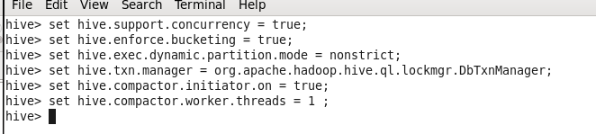

**Creating a Table That Supports Hive Transactions**



In this table bucketing the table on basis of clg_id and using ORC format.

We have also enabled the Transactional to true for supporting transactional.

**Inserting Data into a Hive Table**



**Checking the inserted Data**

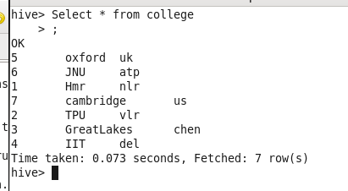

**NOTE** : The Update command is not supported on the columns that are bucketed.

In this table, we have bucketed the ‘clg_id’ column.

So we can’t update the bucketed column.

**Updating the Data in Hive Table**



**Checking the updated Data**

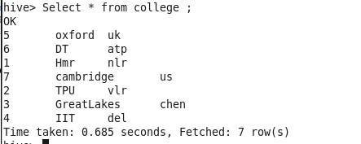

**Deleting a Row from Hive Table**



**Checking the Data**

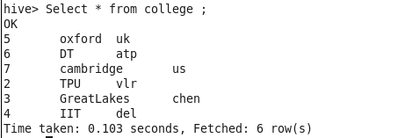

**NOTE: Repository contains**

1. **Assignment Code**
2. **Assignment Document**