**Assignment 10.1**

**Implement the concept given in below blog link and share the complete steps along with**

**screenshots.**

**https://acadgild.com/blog/oozie-job-scheduling-in-hive/**

**CREATE DIRECTORY IN OOZIE**



**CREATE HIVE HQL Script**

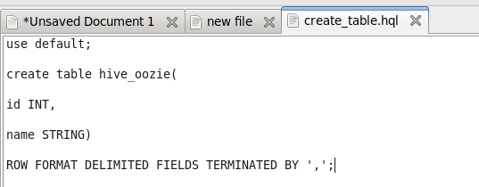

**OOZIE Properties File**

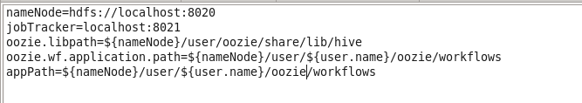

**CREATE WORKFLOW.XML**

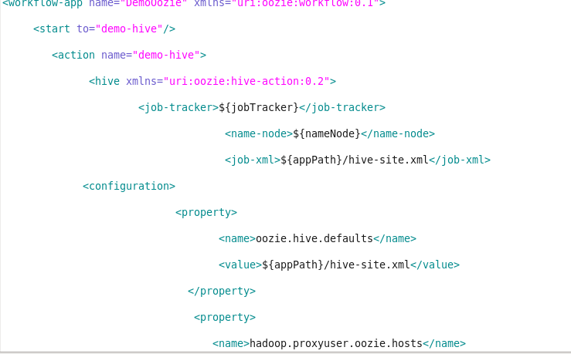

**COPY THREE FILES TWO OOZIE HDFS PATH**





**RUNNING OOZIE JOB**



**OOZIE JOB**

