**Assignment 10.2**

**Problem Statement**

**Implement the concept given in below blog link and share the complete steps along with**

**screenshots.**

<https://acadgild.com/blog/loading-data-into-hbase-using-pig-scripts/>

**INPUT DATASET**

[**https://drive.google.com/open?id=0B1QaXx7tpw3SVUlWTUQyNTMzdG8**](https://drive.google.com/open?id=0B1QaXx7tpw3SVUlWTUQyNTMzdG8)

**StudentName,sector,DOB,qalification,score,state,randomName**

ABROSER,goverenment,18-11-2002,MBBS,3.5,Pennsylvania,prattville*ALEXANDER,goverenment,20-10-2000,BSC,2.5,vermont,gadsden+ALEXANDER,private,20-10-2000,BE,8.5,arizona,decatur!ALEXANDER,goverenment,01-01-2003,BTECH,4.5,oregon,huntsville/AGNEW,goverenment,20-10-2000,BCOM,7.5,california,dothan@ATNEST,goverenment,20-10-2000,MTECH,8.5,arizona,decatur!BELL,goverenment,10-07-2004,BBA,9.5,alaska,auburn~BURR,goverenment,12-12-2001,BE,100,alabama,madison`BURD,goverenment,20-10-2000,ME,6.5,louisiana,hoover#BACHTEL,goverenment,28-04-2005,BE,100,alabama,madison`MULVETS,goverenment,20-10-2000,MS,8.5,arizona,decatur!BURTNER,goverenment,20-10-2000,BE,100,alabama,madison`

**LOADING THE DATA INTO HDFS**

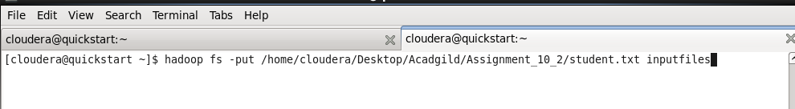

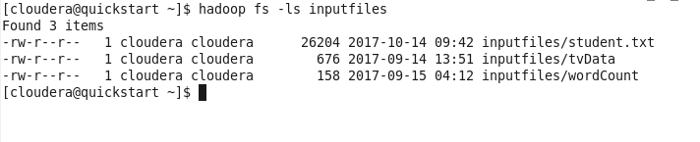

**Start HBase shell and create a table.**

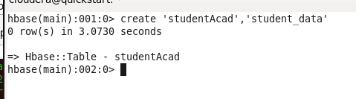

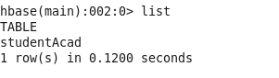

**We can come out from HBase by typing exit and switch to PIG grunt shell.**

**Once we are inside PIG mode we can load data from HDFS to Alias relation.**



**Transfer the data inside HBase by STORE command.**





**CHECKING THE DATA WHICH IS LOADED IN HBASE**



**Sample Output**

