**Assignment 11.1**

**Perform and explain the code flow and the associated result for the below tasks. Candidates should create and use their own employee dataset for the same. Share the screenshot of the commands used and its associated result.**

1. **Transfer data between Mysql and HDFS (Import and Export) using Sqoop.**

**CREATING employee table in MYSQL**

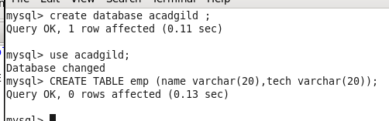

**Inserting value in employee table**

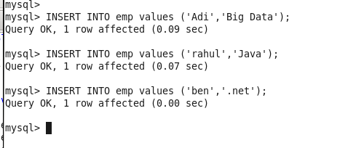

**Table data**

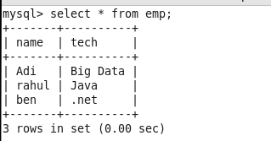

**IMPORTING employee table from MYSQL to HDFS**

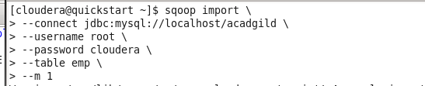

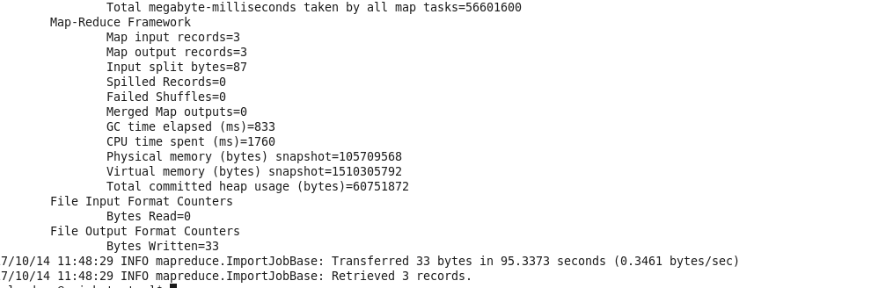

**OUTPUT**

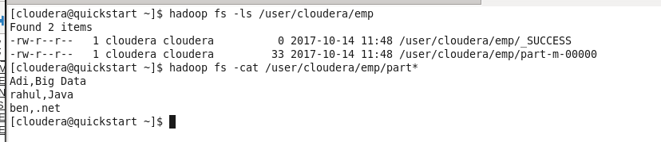

**EXPORT DATA FROM HDFS FILE TO MYSQL TABLE**

**KEEP IN MIND THE TABLE SHOULD HAVE SAME SCHEMA WITH THE HDFS FILE**

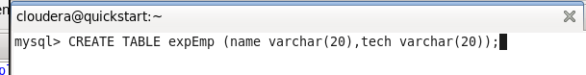

**EXPORTING DATA FROM HDFS TO NEW CREATED EXPORT TABLE**

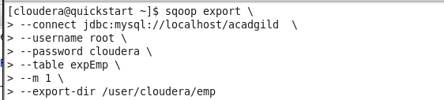

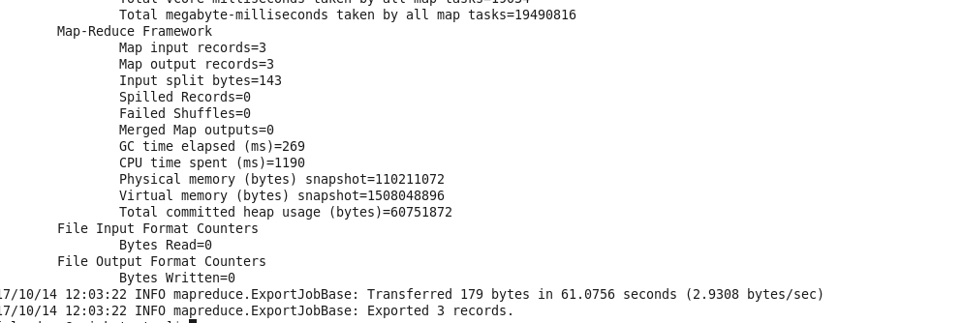

**CHECKING DATA (OUTPUT)**

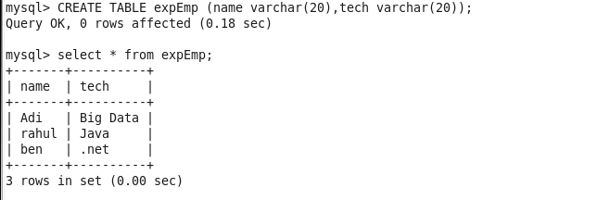

**PROBLEM 2: Transfer data between Mysql and Hive (Import and Export only selected columns) using Sqoop.**

**CREATE NEW TABLE IN MYSQL with new employee data**

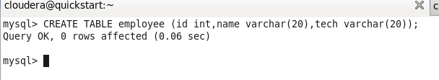

**INSERTING DATA**

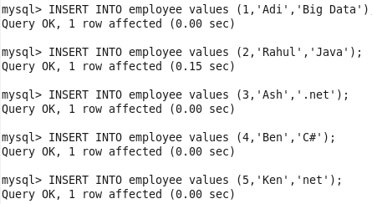

**View the data**

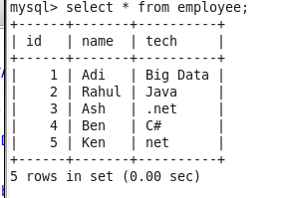

**IMPORTING THE DATA FROM MYSQL TO HIVE (FEW COLUMNS)**

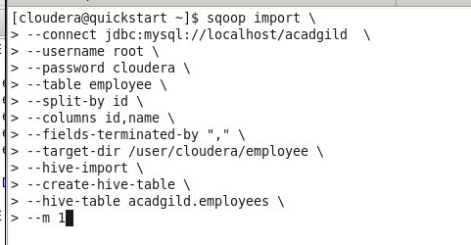

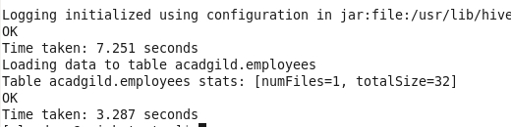

**CHECKING Table in hive**

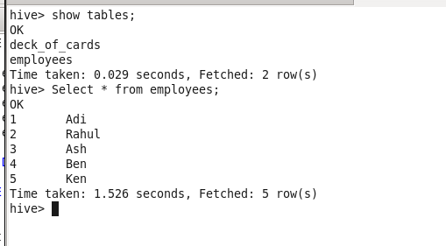

**EXPORTING DATA FROM HIVE TO MYSQL (FEW COLUMNS)**

**CREATED A TEMP TABLE IN HIVE WITH DATA**

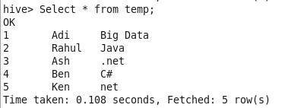

**CREATE TABLE IN MYSQL on which the data will be loaded**



**Validating the data in the MySQL table;**



**EXPORTING THE DATA FROM HIVE TO MYSQL**

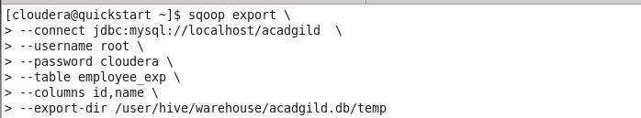

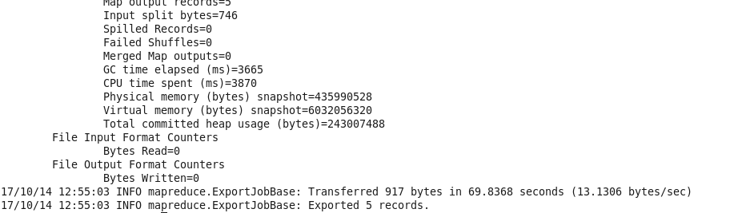

**CHECKING THE DATA IN MYSQL**

