**Assignment 12.2**

**Problem Statement**

Given a list of strings - List[String] (“alpha”, “gamma”, “omega”, “zeta”, “beta”)

- find count of all strings with length 4

- convert the list of string to a list of integers, where each string is mapped to its corresponding length

- find count of all strings which contain alphabet ‘m’

- find the count of all strings which start with the alphabet ‘a’

**1) Find count of all strings with length 4**

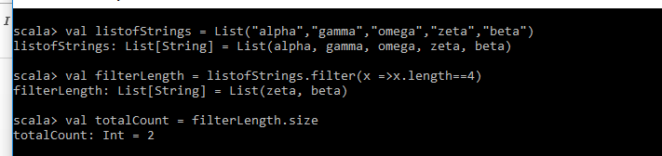

**2) Convert the list of string to a list of integers, where each string is mapped to its corresponding length**

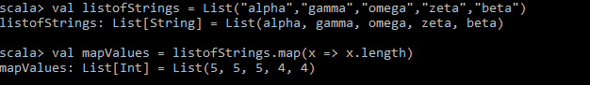

**3) Find count of all strings which contain alphabet ‘m’**

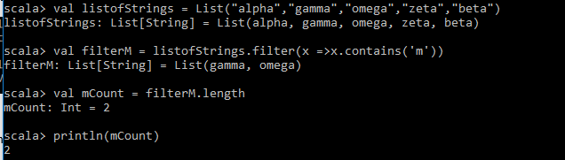

**4) Find the count of all strings which start with the alphabet ‘a’**

