**Assignment 12.3**

**Create a list of tuples, where the 1st element of the tuple is an int and the second**

**element is a string.**

Example - ((1, ‘alpha’), (2, ‘beta’), (3, ‘gamma’), (4, ‘zeta’), (5, ‘omega’))

- For the above list, print the numbers where the corresponding string length is 4

- find the average of all numbers, where the corresponding string contains alphabet ‘m’

or alphabet ‘z’

**1) For the above list, print the numbers where the corresponding string length is 4**

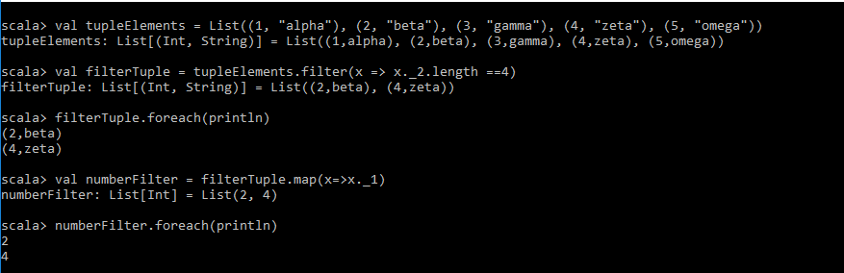

**2) Find the average of all numbers, where the corresponding string contains alphabet ‘m’ or alphabet ‘z’**

