**Assignment 9.2**

**Problem 1:**

**Create an HBase table named 'clicks' with a column family 'hits' such that it should be able to**

**store last 5 values of qualifiers inside 'hits' column family.**

CREATE TABLE in hbase (clicks) with Column family Hits having 5 version.

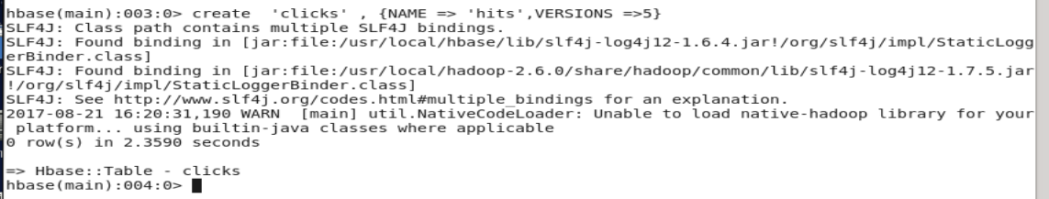

**Problem 2:**

**Add few records in the table and update some of them. Use IP Address as row-key. Scan the**

**table to view if all the previous versions are getting displayed.**

Putting Data in the hbase table clicks with IP address as ID and Column family hits having column location

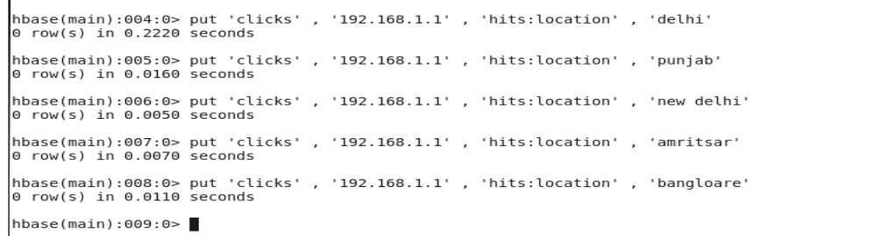

**GETTING THE VALUES**

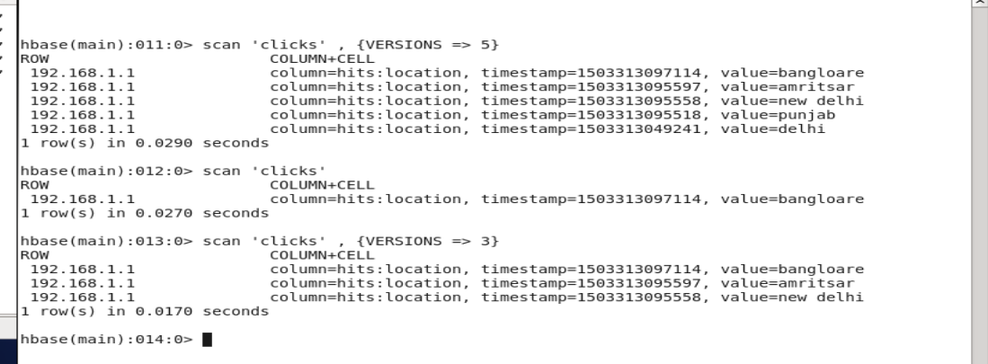

When we specifying the versions its giving us the Versions we have mentioned ,

Like in 5 we are getting last 5 values

In 3 we are getting last 3 values

If we don’t specify the version we are getting only the last latest value.