**Name:** Dev Kamlesh Bhanushali

**PRN:** 22070126032

**Java Assignment 1**

Input Methods and Menu Based Calculator

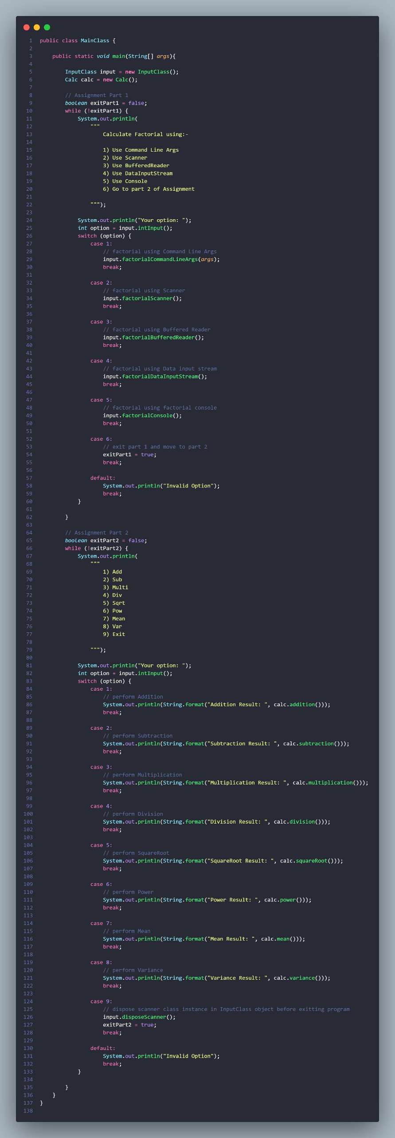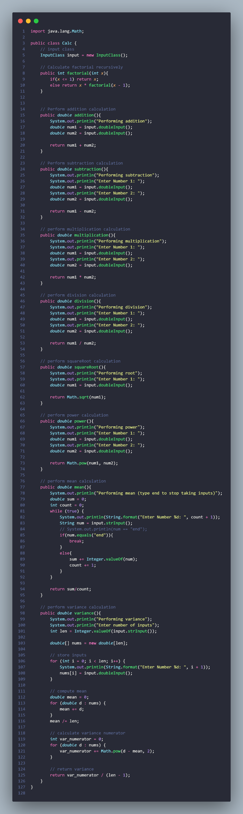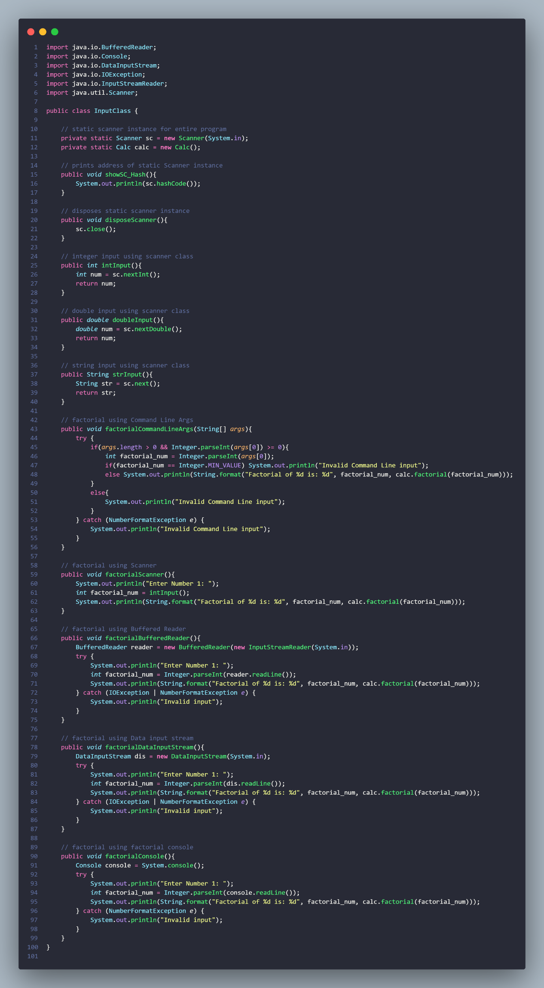

**Output**

