**Name:** Dev Kamlesh Bhanushali

**PRN:** 22070126032

**Java Assignment 2**

Odd Even Array

Shortest distance Between Neighbours

ArrayList to Array and Vice Versa

**Github:** <https://github.com/devilb2103/Sem-4/tree/main/Java/Assignments/Assignment2>

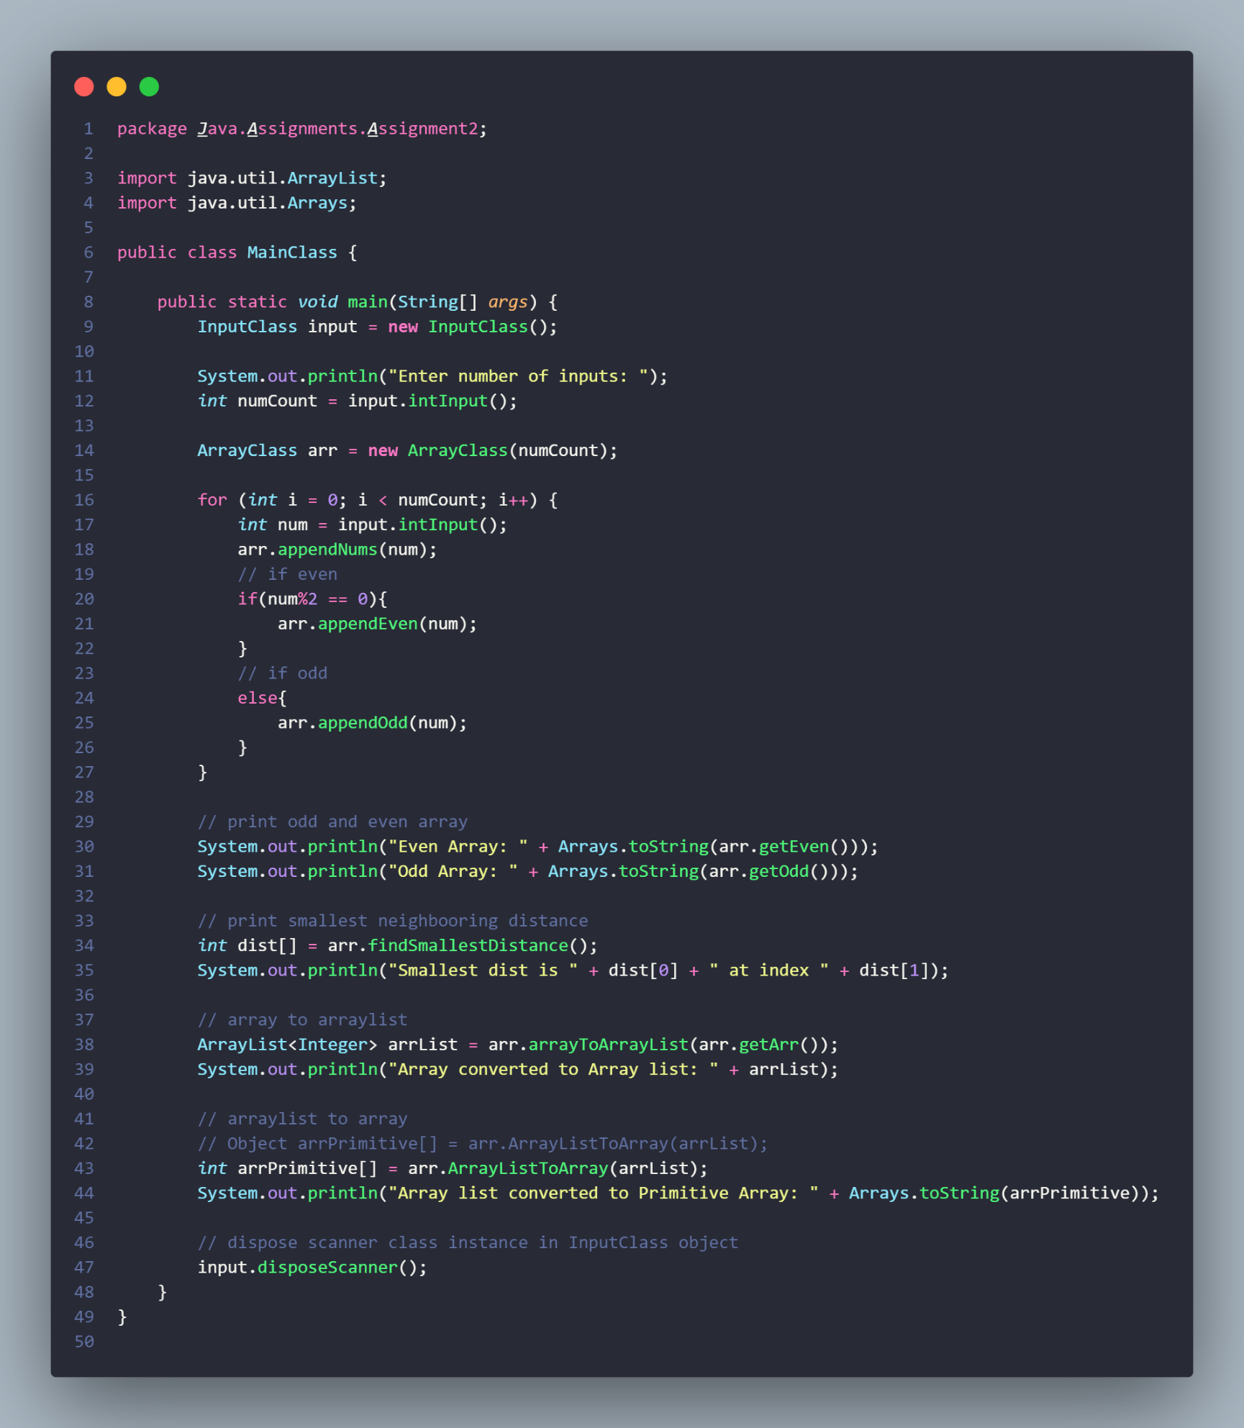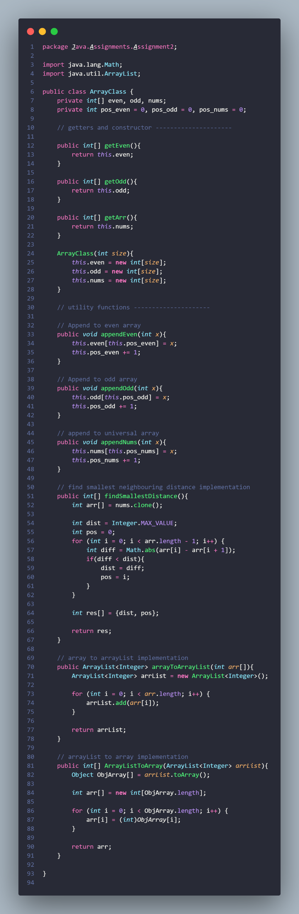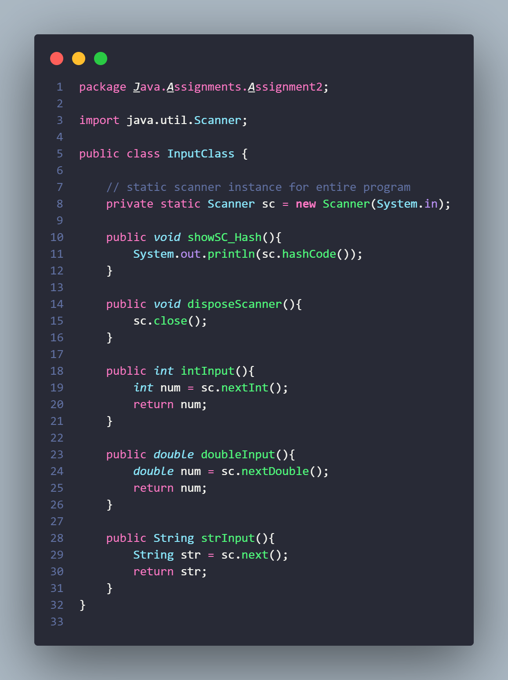

**Output**

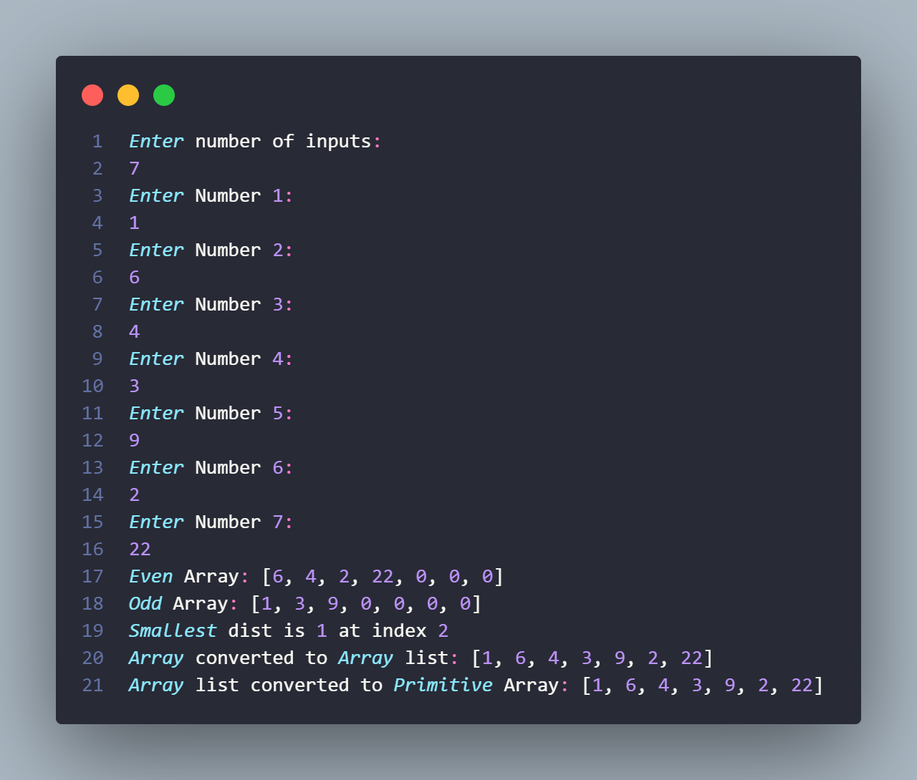

**Github:** <https://github.com/devilb2103/Sem-4/tree/main/Java/Assignments/Assignment2>