**Name:** Dev Kamlesh Bhanushali

**PRN:** 22070126032

**Java Assignment 6**

**Part - 2**

Student Marks Calculator

**Github:** <https://github.com/devilb2103/Sem-4/tree/main/Java/Assignments/Assignment6>

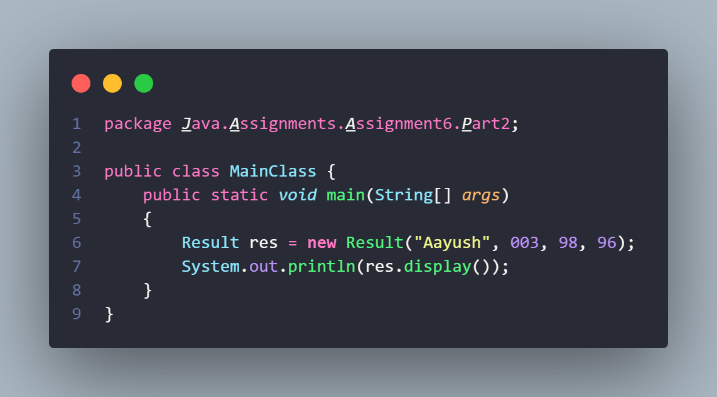 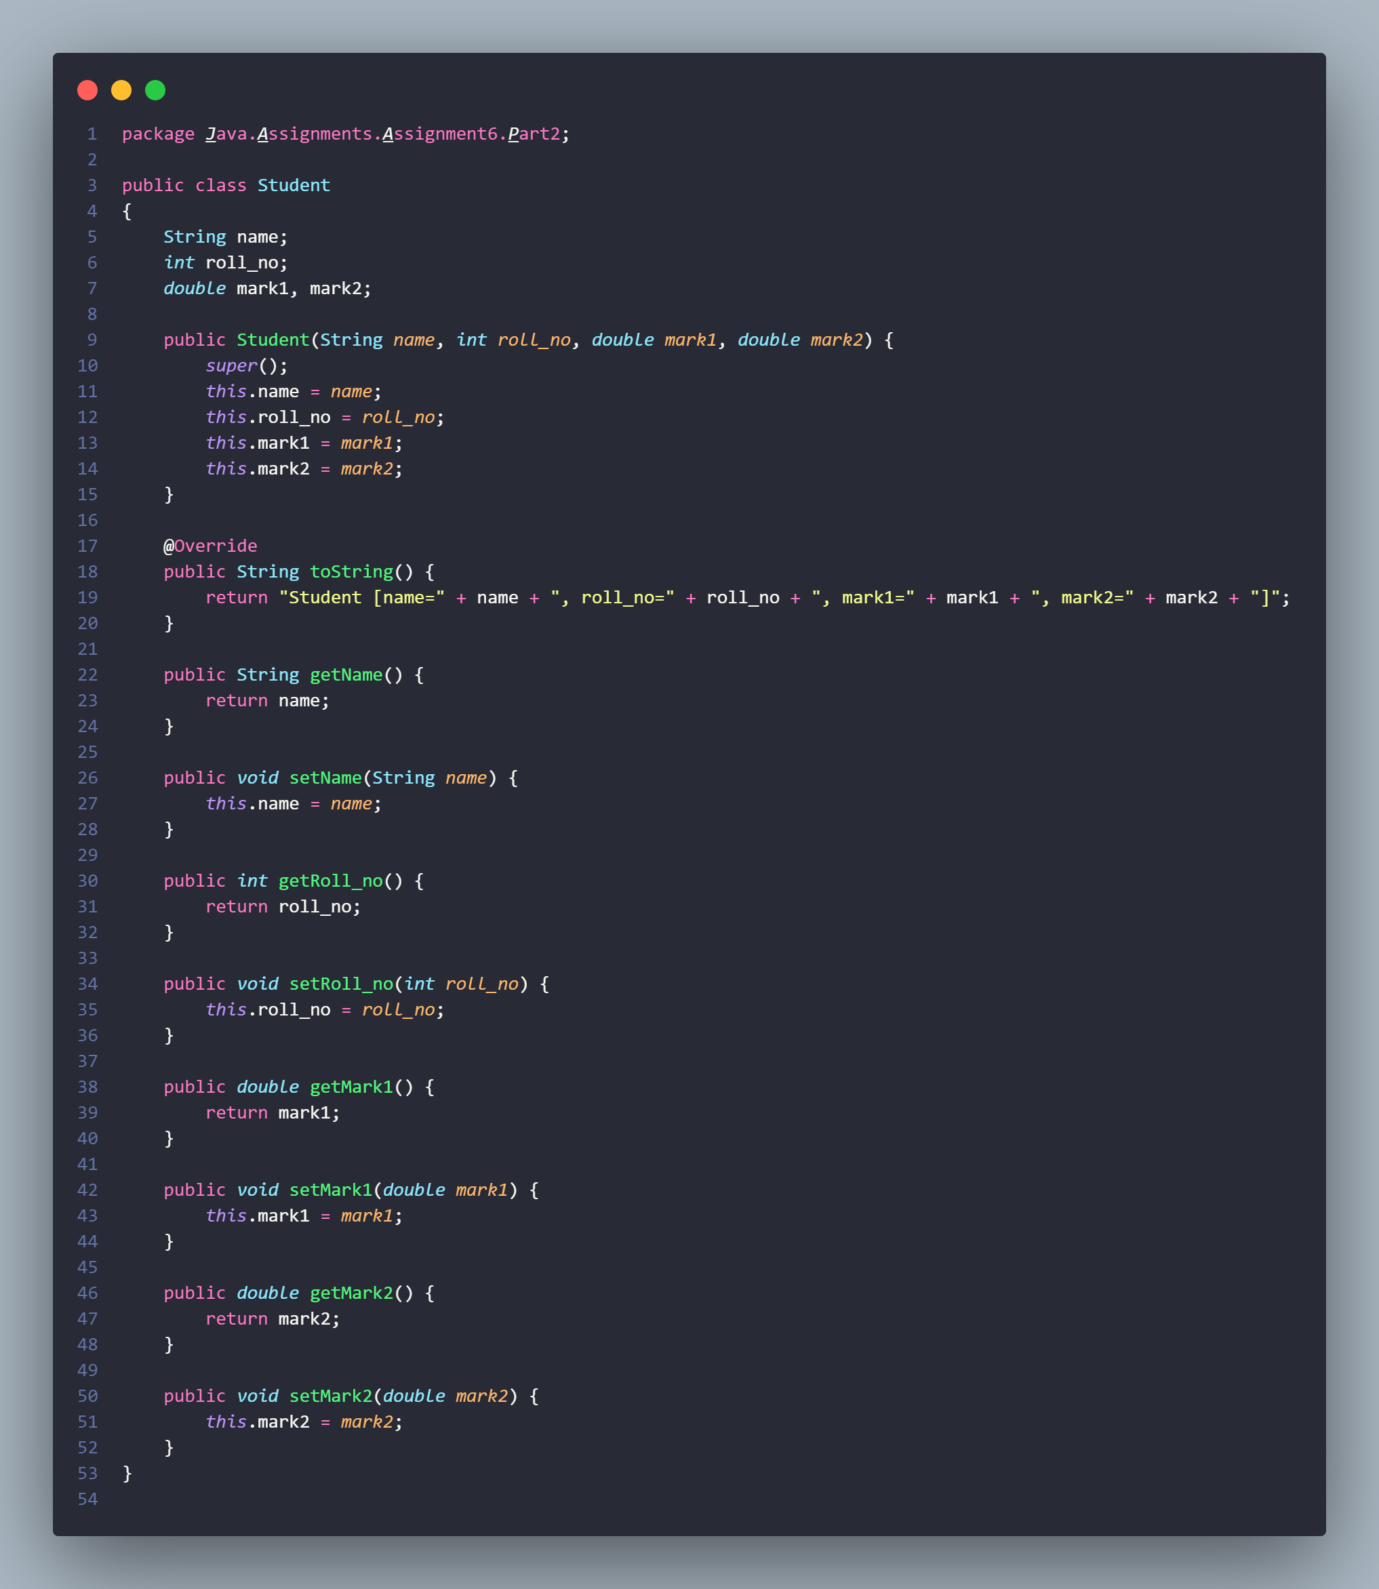

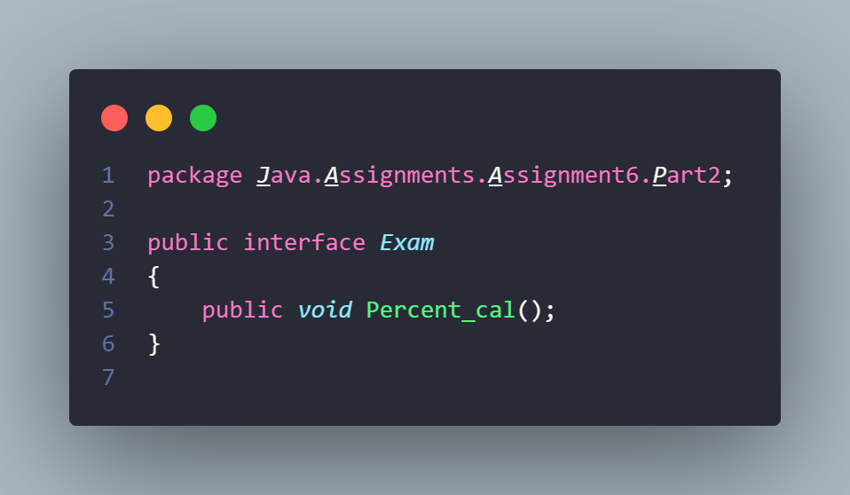

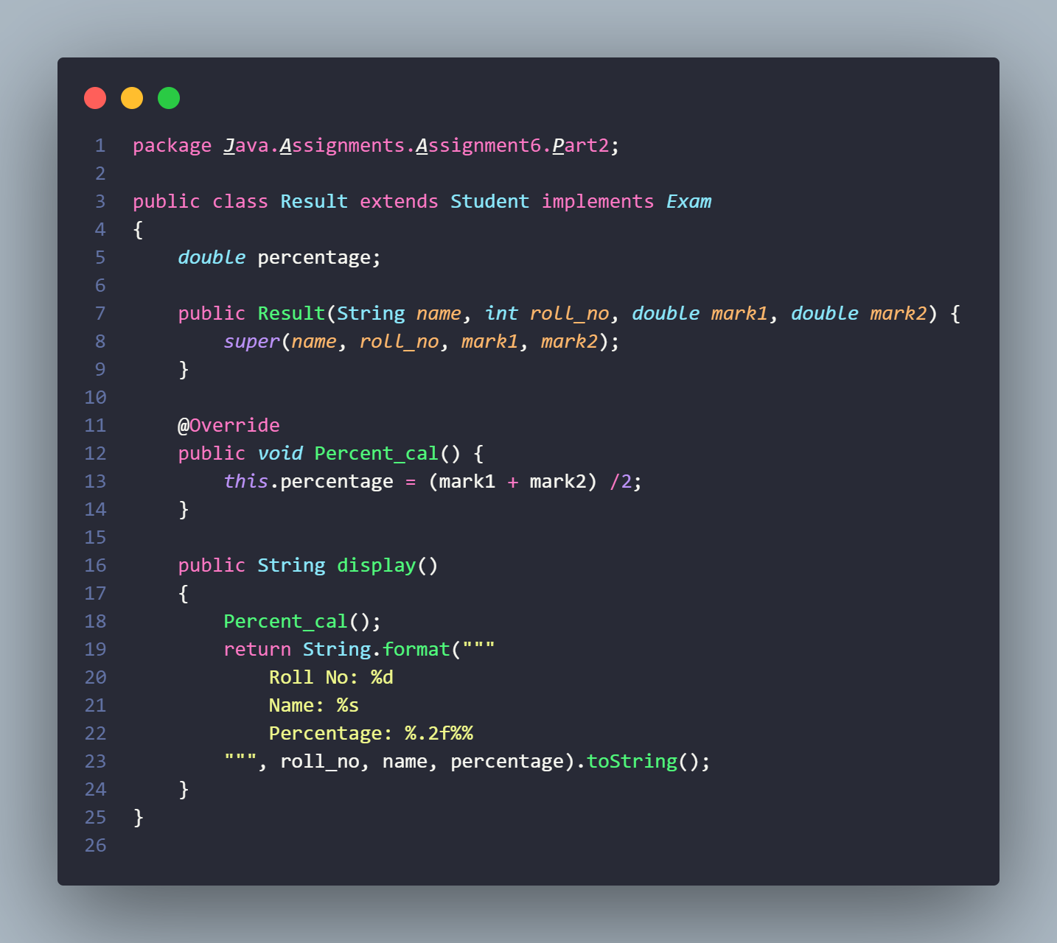

**Output**

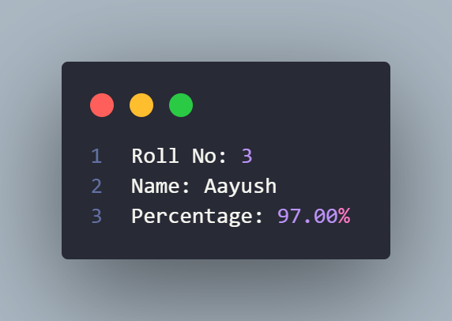

**Github:** <https://github.com/devilb2103/Sem-4/tree/main/Java/Assignments/Assignment6>