**Name:** Dev Kamlesh Bhanushali

**PRN:** 22070126032

**Java Assignment 1**

Input Methods and Menu Based Calculator

**Github:** <https://github.com/devilb2103/Sem---4/tree/main/Java/Assignments/Assignment1>

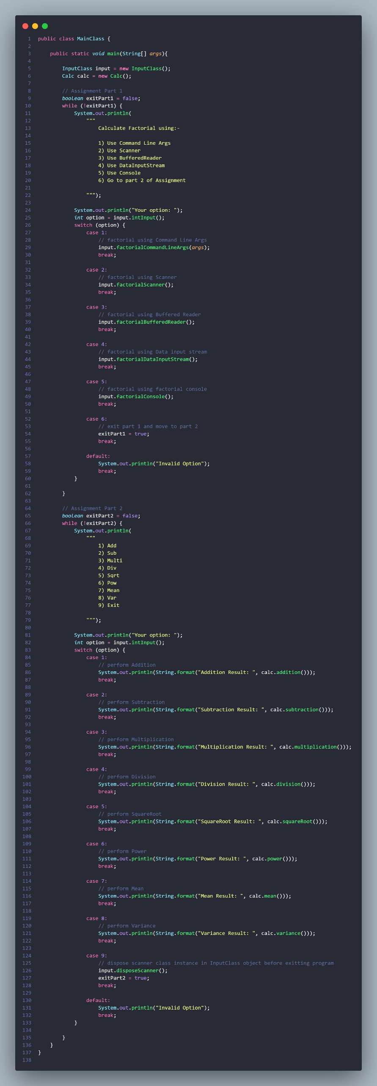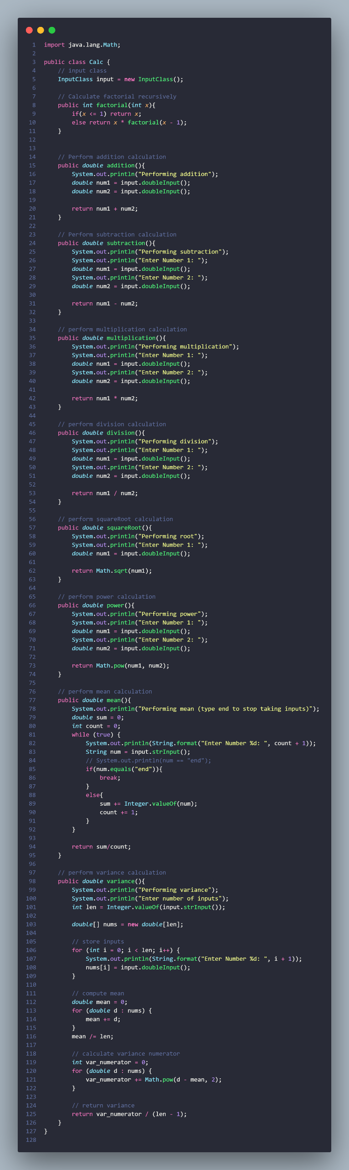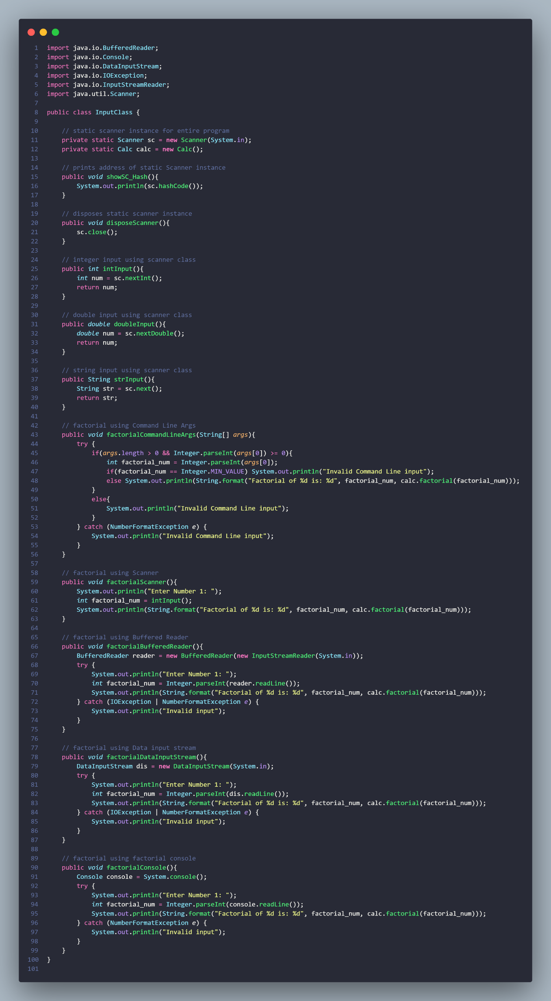

**Output**

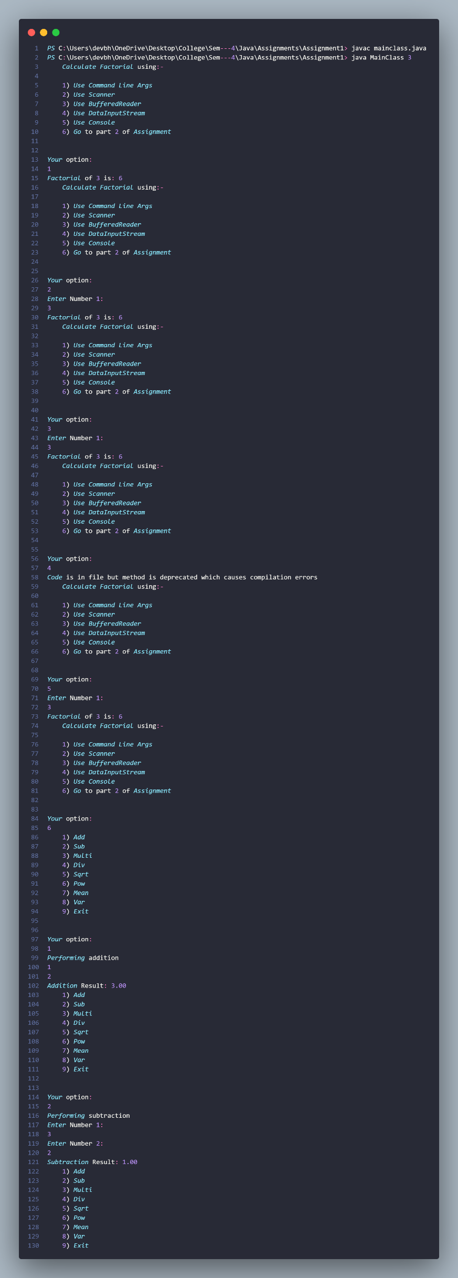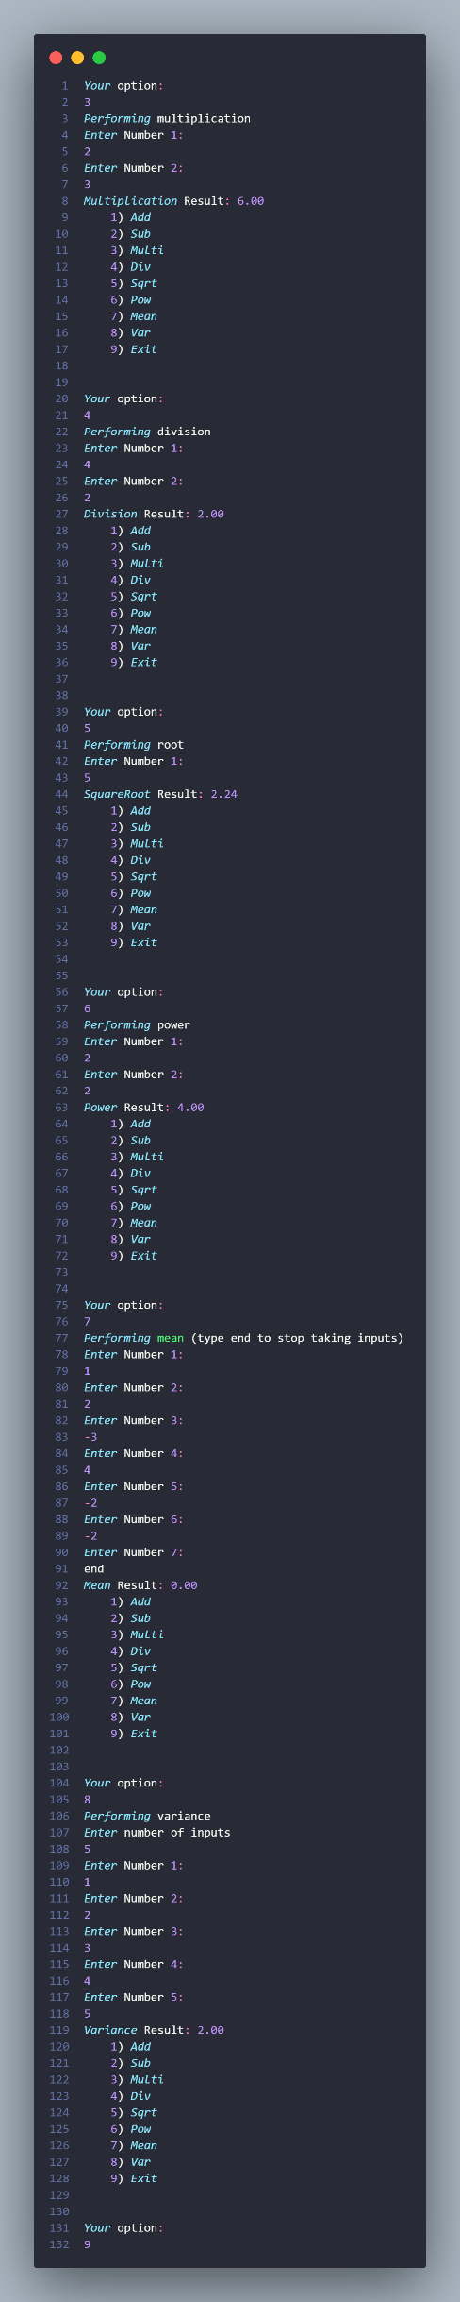

**Github:** <https://github.com/devilb2103/Sem---4/tree/main/Java/Assignments/Assignment1>