**Full-Stack Development Assignment**

**Problem Statement**

Create a Product Gallery of 3*3 grid (3 rows and 3 columns) with the details below each product image will be product name, description and price.

1. At the top of the product gallery there will be add button where I should able to add the product
2. When I click on the product image it should open the product in edit mode so that I can update the product details like name, description and price
3. Below each product there will be delete button, if I click on it the product should be deleted
4. At the top next to add button there should be search button, if I put the name it should filter out the given product from the product gallery

**Screenshots**

1. Add Product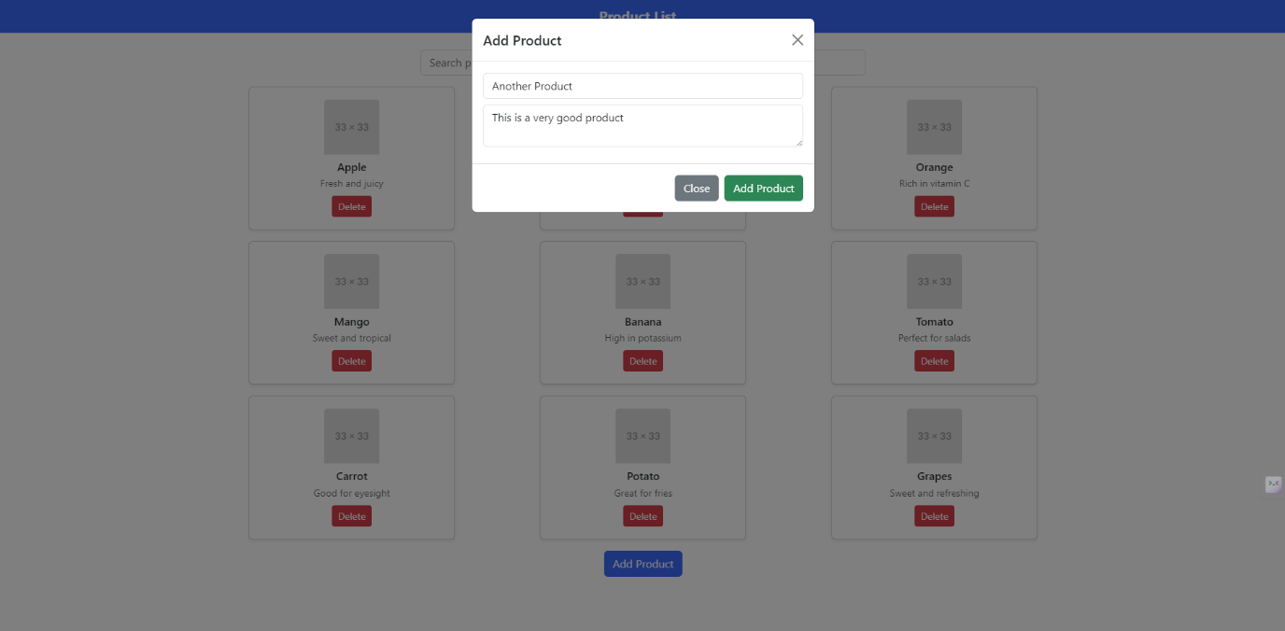
2. Cannot add more products (9 exist already)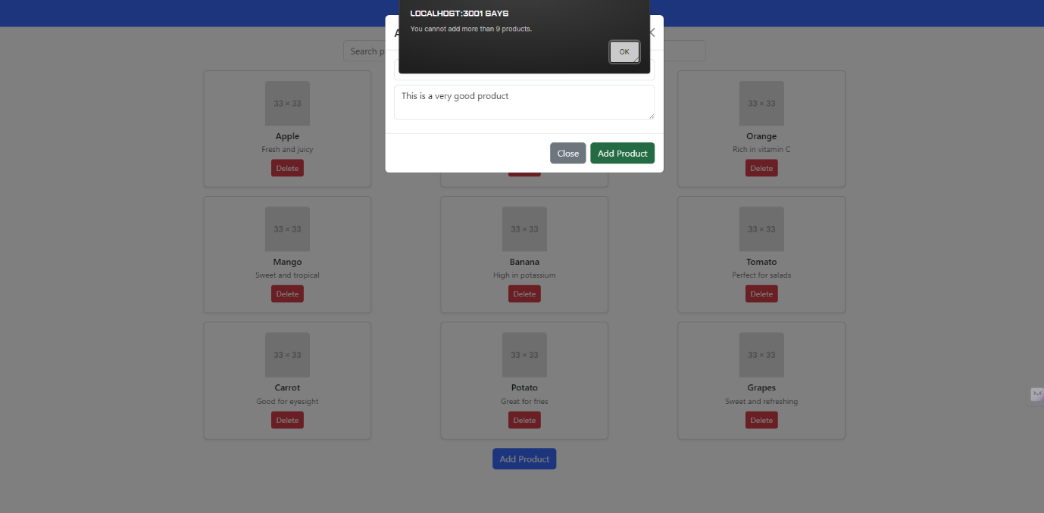
3. Main Page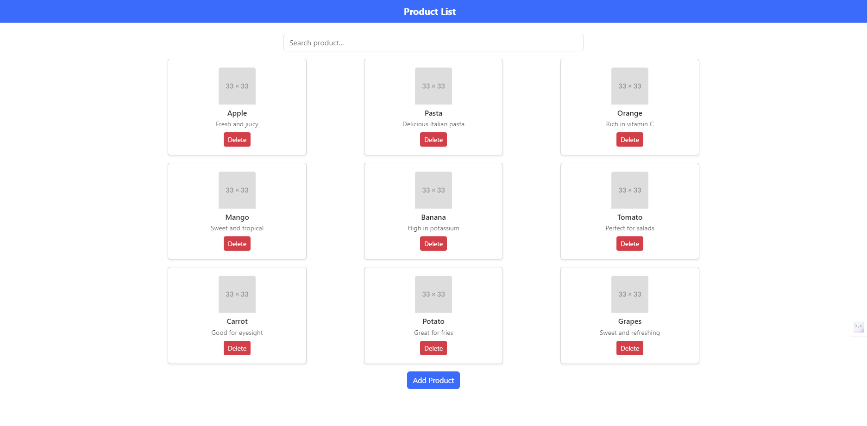
4. Edit Product Feature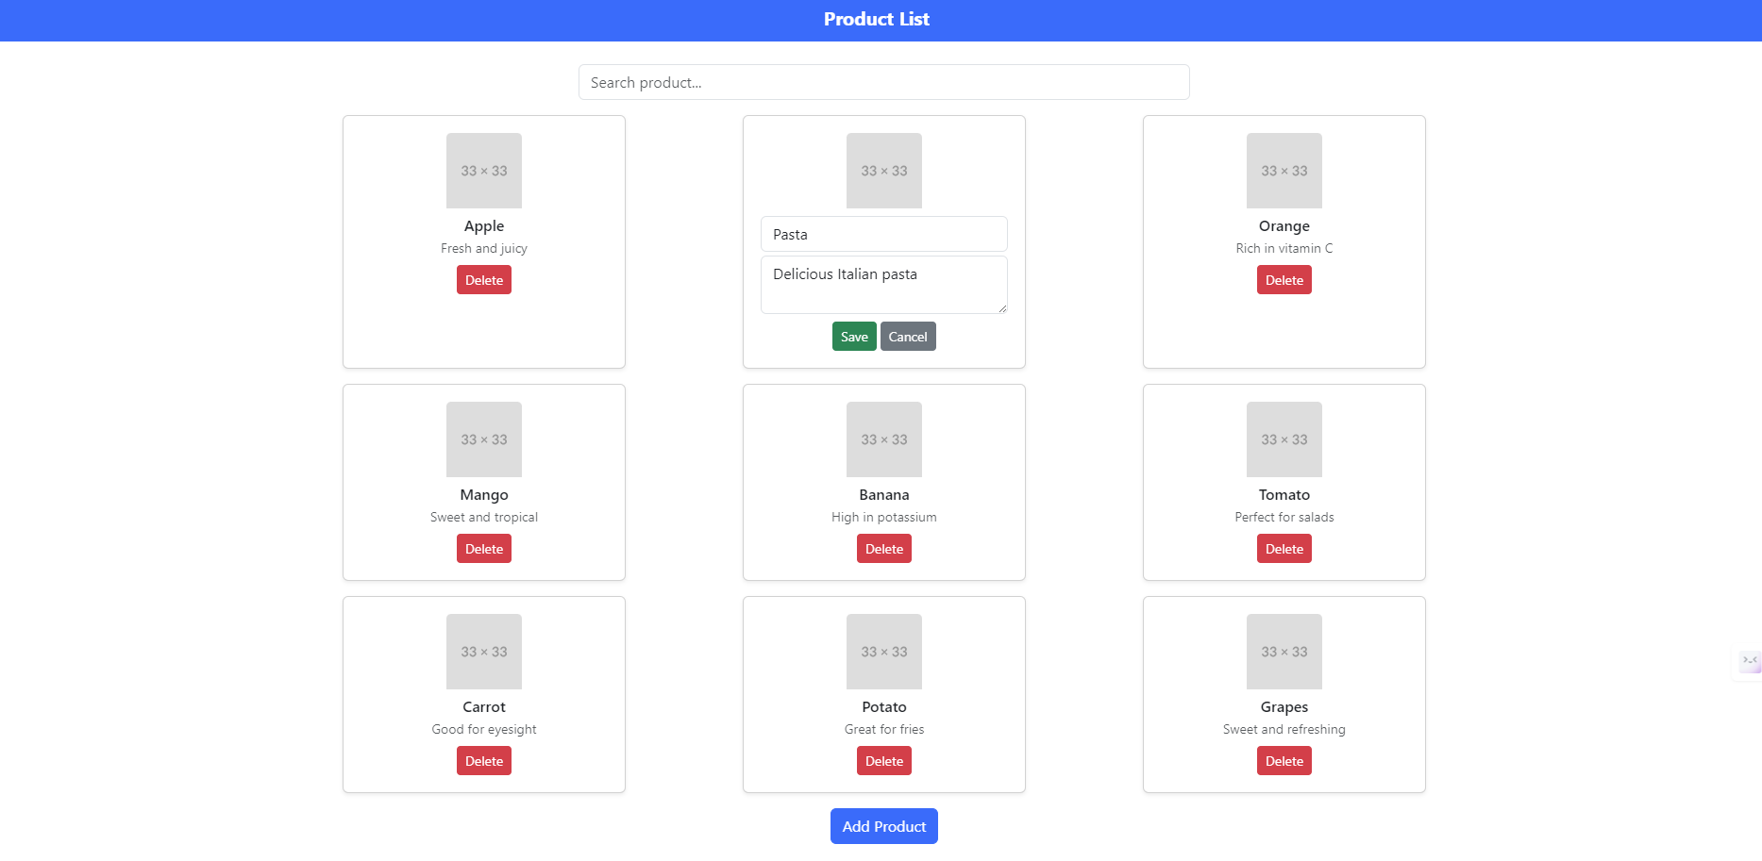
5. Filter Items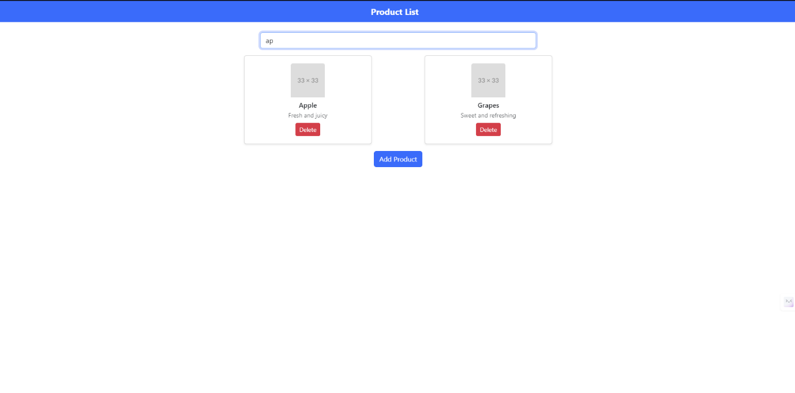

**Github Link:** [**https://github.com/devilb2103/product-website-fullstack-assignment**](https://github.com/devilb2103/product-website-fullstack-assignment)