The backend for the Library system is provided. This is a simple server application that allows the University to track the books that they have, the library users, and which users have borrowed which books. The goal was to create a front-end application to given simple REST API library server.

The code for the Library server is available in the SourceCode_0 file. Full usage instructions are included in the Readme.md file.

The applications itself provides a simple server with a REST API which has the following functionality:

• API endpoints:

/users

/books

/loans

Each API endpoint accepts HTTP requests with the verbs GET, POST, PUT and DELETE. The application also comes with an .sqlite database in which the data for the application is stored, and an ORM mapping between the database objects and JavaScript objects. Further documentation on the API server is available in the SourceCode_0 file.

The task is to create a front-end website that interfaces with this API to provide the library functionality requested by the University. Most of the forms are already created, so that it requires only develop Javascript functionalities. Feel free to change or add forms/classes/ids-s when necessary. I do not need animations and cool staff, only the required funcionalities. Just provide all usefull comments how te fucntions work and so on.

**Functionality:**

**- U1 - Add a new User to the Library system with the fields Name, Barcode and Member Type:**

Functionality available in Users navigation "/add_user.html", Add New User button should be clicked to open the add user form. After submitting new user, the updated search form should be appear.

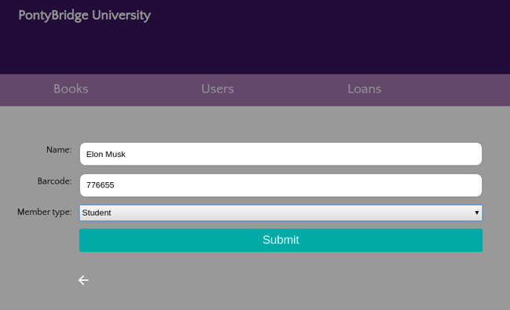

**- U2 - Get a User’s details from the Library system by searching on Name or Barcode**

Functionality is available in Books navigation on "/users.html". Initially, it should show all students records. When a user types Name or Barcode on a search bar it should automatically filter and display the results on the form.

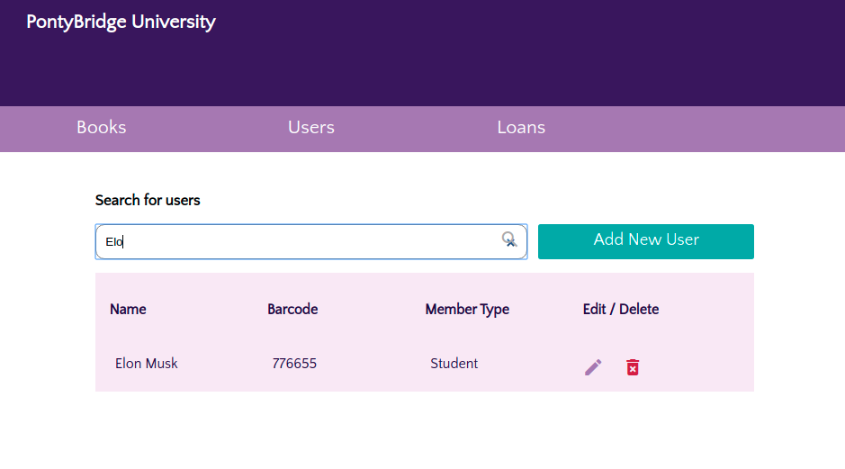

**- U3 - Update a User’s Name or Member Type.**

Functionality available in Users navigation on "/users.html". To modify a user pen icon  should be clicked. Update Form should be populated with appropriate values.

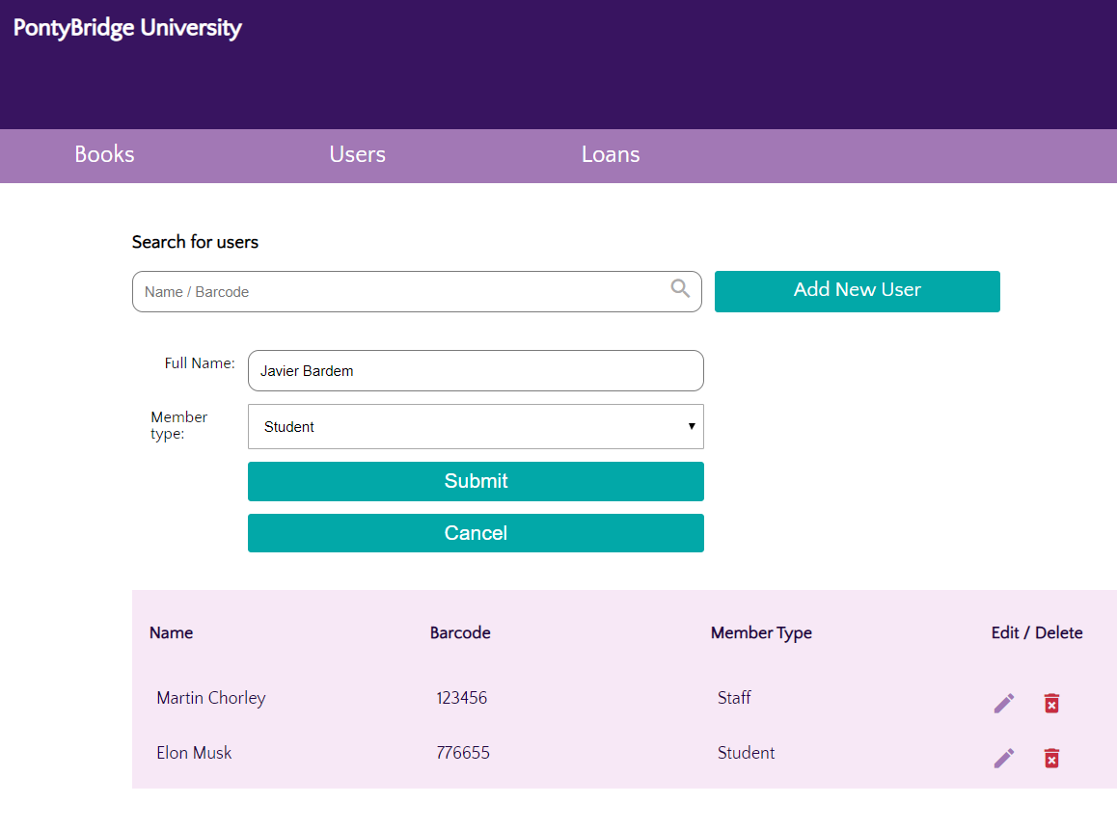

**- U4 - Remove a User**

Functionality available in Users Navigation on "/users.html". To remove a user bin icon should be clicked. Before deleting the user the system should ask: “Are you sure t delete the user?” The user should be removed only after the confirmation.

**- B1 - Add a new Book to the Library system with the fields Title, ISBN, Authors.**

Functionality available in Books navigation on "/add_book.html", Add New User button should be clicked to open the add user form. After submitting new book, the updated search form should be appear.

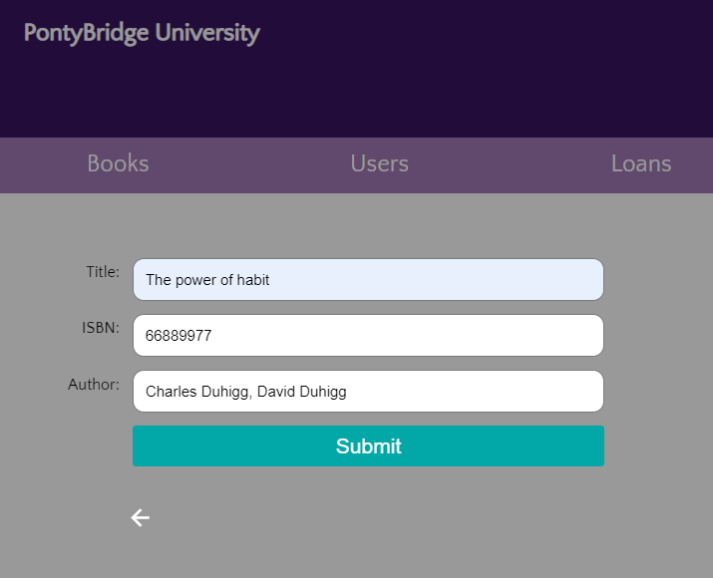

**- B2 - Get a Book’s details by searching on Title**

Functionality is available in Books navigation on "/books.html". It should show all books records.

When a user types Title on a search bar it should automatically filter and display the results on the form.

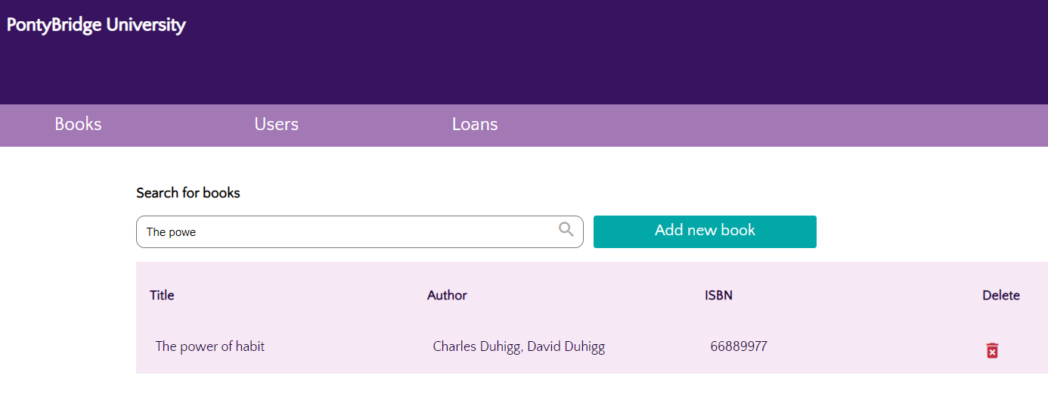

**- B3 - Remove a Book**

Functionality available in Books navigation on "/books.html". To remove a book bin icon should be clicked. Before deleting the book the system should ask: “Are you sure to delete the book?” The book should be removed only after confirmation.

**- L1 - Loan a Book to a User (if it is not already out on Loan), specifying the Due Date**

**- L2 - Get a list of a User’s current Loans**

**- L3 - Get the User currently borrowing a Book**

Functionalities available in Loans navigation on "/loans.html". User must first "login" with barcode. After "logging" the user name and list of user loaned books should be displayed.

User then can search for a book (by title) and loan it if the book is available by clicking on plus icon. If book is unavailable clicking should be disabled. Use should be able to pick-up the Due Due date.

Affter confirming the loan, the updated user’s current loans should be displayed.

